# Alternate Project 1: Magic Square

Created by Brian Weinfeld

Using Python, you will use variables, input, and casting to create a Magic Square.

## Overview

Pick a number from 21-65. **42**, you say? OK! Check this out!

22 01 12 07  
11 08 21 02  
05 10 03 24  
04 23 06 09

If you add up all the numbers in each row, they total 42. (22 + 1 + 12 + 7 = 11 + 8 + 21 + 2 = 42)

If you add up all the numbers in each column, they total 42. (22 + 11 + 5 + 4 = 1 + 8 + 10 + 23 = 42)

If you add up all the numbers in each diagonal, they total 42. (22 + 8 + 3 + 9 = 7 + 21 + 10 + 4 = 42)

It is the same for each of the four corners, and each 2x2 block as well. (22 + 4 + 9 + 7 = 42)

This is called a **Magic Square** and for this project, you are going to create a program that lets users select a number and create a magic square from that number.

## Details

### Behavior

Welcome to Magic Square  
 Enter a number from 21 to 65: 42  
 You have entered 42  
  
 Here is your Magic Square:  
  
 22 01 12 07  
 11 08 21 02  
 05 10 03 24  
 04 23 06 09

### Implementation Details

Believe it or not, Magic Squares are not difficult to make! Watch the following video to see how to make a Magic Square for any given number:

[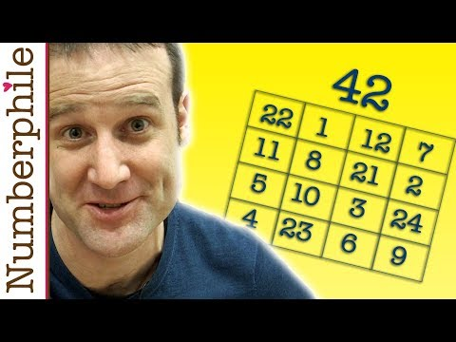](https://www.youtube.com/watch?v=aQxCnmhqZko)

### Challenge

This section contains additional components you can add to the project. These should only be attemped **after** the project has been completed.

* What happens if the user enters a number outside the range of 21-65? Try to check for this and print an error message!
* What happens if the user doesn’t enter a number at all and enters a word instead? Try to check for this and print an error message!
* Build a Magic Square with a small number like 22. The Magic Square isn’t aligned properly and hard to read. Try to fix this!