Remote procedure call is an [inter-process communication](https://en.wikipedia.org/wiki/Inter-process_communication) that allows a [program](https://en.wikipedia.org/wiki/Computer_program) to cause procedure to execute in another [address space](https://en.wikipedia.org/wiki/Address_space) without explicitly coding the details for this remote interaction.

I have 3 classes: CalculatorServer.java, CalculatorClient.java, CalculatorGUI.java

And 1 interface: Calculator.java

Program runs CalculatorGUI.java. Pressing on buttons calls actions in CalculatorServer.java.

CalculatorServer.java implements all functions of calculator.

This is how my application looks.

Calculating cos(30)

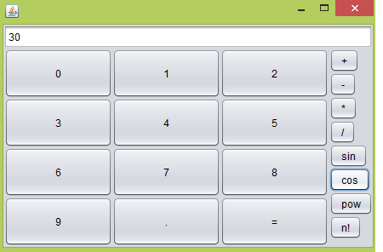

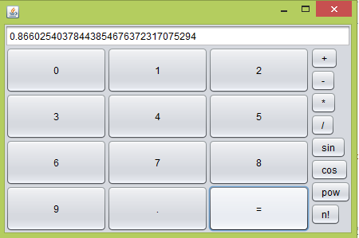

Calculating sin(30)

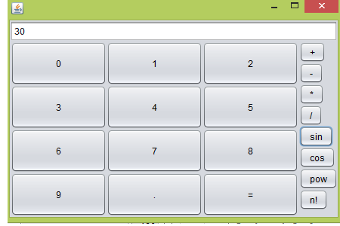

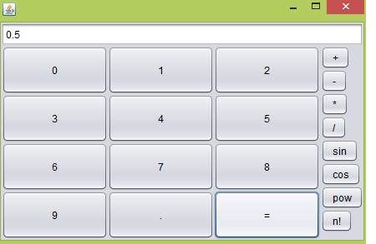

Calculating factorial 4

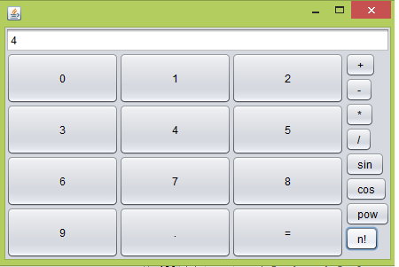

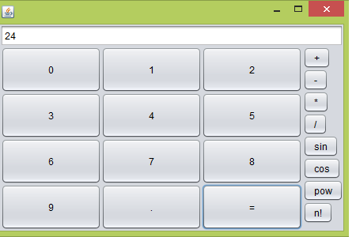

Divide 80/2

