Final Year Project

**Full unit – Report**

**F1Tenth car hardware, sensors, and communication Report**

**Kacper Buksa, 100941661**

A report submitted in part fulfilment of the degree of

**BSc (Hons) in Computer Science (Software Engineering)**

**Supervisor: Ferreira Ruiz, Francisco**



Department of Computer Science

Royal Holloway, University of London

## ­­­Introduction

In this report, I will be discussing the hardware components of the F1Tenth, mainly their importance of how they work together to create an autonomous vehicle. It will cover the basis of the robot’s chassis, describing the different features that create the smooth manoeuvrability on different indoor surfaces. Afterwards, I will discuss how the hardware’s aspects may appear similar within the F1Tenth simulator, seeing how similar their performances can be transferred from testing in the virtual environment and the live one.

## F1Tenth Hardware

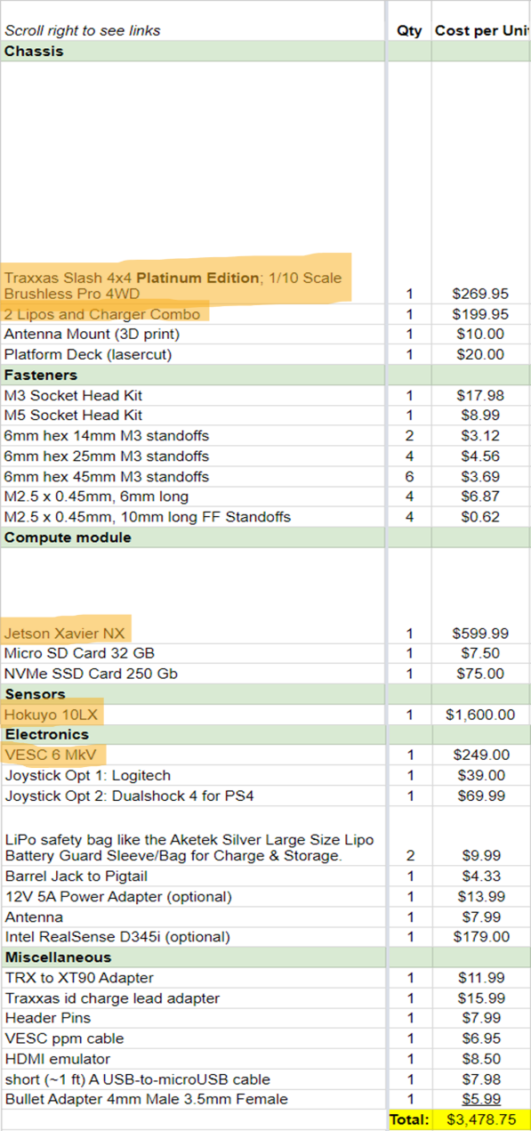The car has multiple components that are combined to create the final product, I will discuss the main ones that have a major impact on its performance (as highlighted in Figure 1).

### Traxxas Slash 4x4 Premium Chassis

Figure 1 - Bill of Contents showing F1Tenth components. Main components highlighted [2]

The car chassis is based off the Traxxas Slash 4x4 Premium Chassis (Figure 2), where all its components are attached onto its body [8]. This chassis was created to have a low centre of gravity be having the battery and electronics to be held low to position the weight of car low in the chassis. Because of the low centre of gravity, it is possible that the car’s stability and ability to take on corners at an increased speed is improved. The chassis itself is ultra-smooth, which documented by the Traxxas says it reduces drag and improves ability to take on many types of terrain.

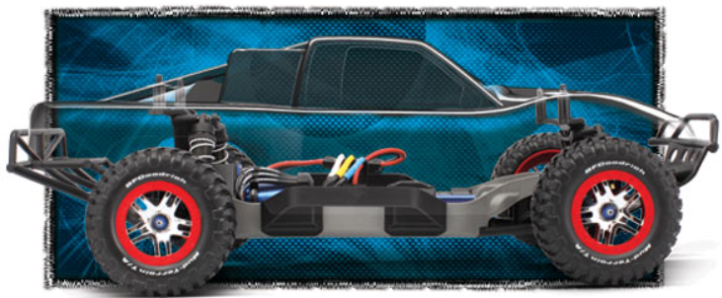Included with the chassis, you have the GTR Shocks suspension system, a power system, wheels, and the body itself to hold all these components [8].

Figure 2 - Traxxas 4x4 Premium Chassis used for F1Tenth car

### High-capacity GTR Shocks (suspension)

The shock system has a near frictionless piston travel due to its “PTFE-coating”, allowing for smooth suspension work when driving through ridged terrain. This also allows for smooth and comfortable suspension action for extended periods of time before potential replacing. The shocks have an option to also change spring reload and ride height of the car, which can be done simply by turning threaded spring collars. This allows for fast and easy adjustment to the suspension, making the F1Tenth versatile [8].

### Traxxas Velineon Power System

The power system has been optimised for high-speed performance while maintaining smooth driving, to preserve control over the vehicle [8].

### LiPo batteries & Charger

[1]These rechargeable lithium polymer (LiPo) batteries (Figure 3) are the main source of power for the car to work, along with a charger for these batteries. Due to them being rechargeable, it allows the car to be a long-term investment, saving up on money as you do not have to restock on additional batteries. With the two ‘5000mAh’ batteries, the car will have a possibility of reaching speeds of over 60mph (Figure 4).

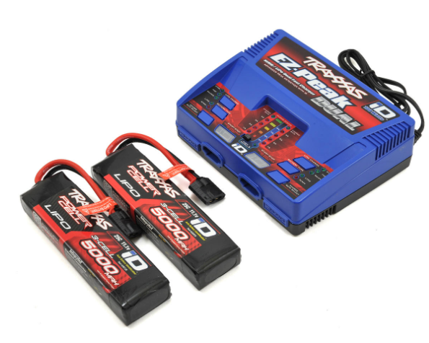

Figure 3 - Traxxas EZ-Peak 3S "Completer Pack" Dual Multi-Chemistry Battery Charger w/Two Power Cell Batteries (5000mAh)

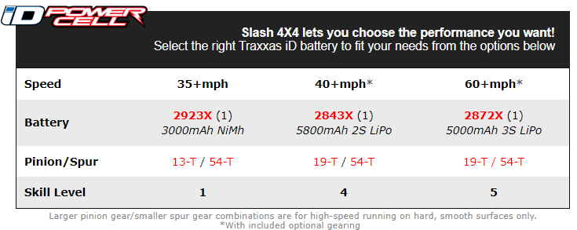

Figure 4 -Traxxas EZ-Peak 3S "Completer Pack" Dual Multi-Chemistry Battery Charger w/Two Power Cell Batteries (5000mAh)

### VESC 6 Mk VI

The VESC (Figure 7) allows you to control and adjust the speed and steering of the car. This is caused by a command (from the Jetson Xavier NX as discussed in next section) fed to the VESC to increase or lower the voltage of the motor as necessary, which changes the propeller speed. The MK VI contains three phase shunts and an adjustable current/voltage filter, which allows a more precise and reliable detection of attached motors. This also allows motors to run smoothly and react linear to throttle input commands.

Figure 7 - VESC 6 Mk VI

### NVIDIA Jetson Xavier NX

The NVIDIA Jetson Xavier NX Developer Kit [9] (will be simplified to JXNX) will be the primary component of the F1Tenth’s system, due to it having control over the VESC, which is a controller that oversees controlling and regulating the speed of the car’s motor [2]. The JXNX will have the possibility to give out commands on the steering and speed control of the car due to having control over VESC, feeding it these commands. The JXNX also can receive information from the LIDAR sensor (Figure 6), which will be one of the primary sources of information that dictate the regulation of speed.

The way that JXNX receives these commands is through the host computer that will be used to code and control the software of the F1Tenth, connecting remotely through SSH [2].

## Ranging Sensors – Lidar & radar

Lidar sensors in the robotics field are used for many different reasons to help the robot in completing its set tasks. It can, for example, assist in navigation and obstacle avoidance. It is an active remote sensor, which judges an object’s (or wall’s) distance by measuring the time taken for the light beam to return to the sensor [8].

### Hokuyo UST-10LX Scanning Laser Rangefinder

This Lidar light sensor[2] (Figure 6) is used for the physical car, which can detect obstacles at a long distance of maximum being 30 metres, allowing the F1Tenth to conduct localisation of the car, with the scan being at a 270-degree angle (Figure 5). The sensor uses a light source as a way of obstacle detection, which in effect allows for a near immediate detection time, with scan speed measured to be 25ms. If the obstacle is to be a moving one (such as another car in a race), trajectory estimation is used – the estimation of where the object detected may move next to avoid colliding with it. It also helps identifying pose estimation of an object/obstacle – ability to predict the object’s position and how long it is, to estimate the possible manoeuvre needed to not hit this object.

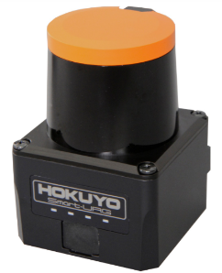

Figure 6 - Hokuyo UST-10LX Scanning Laser Rangefinder

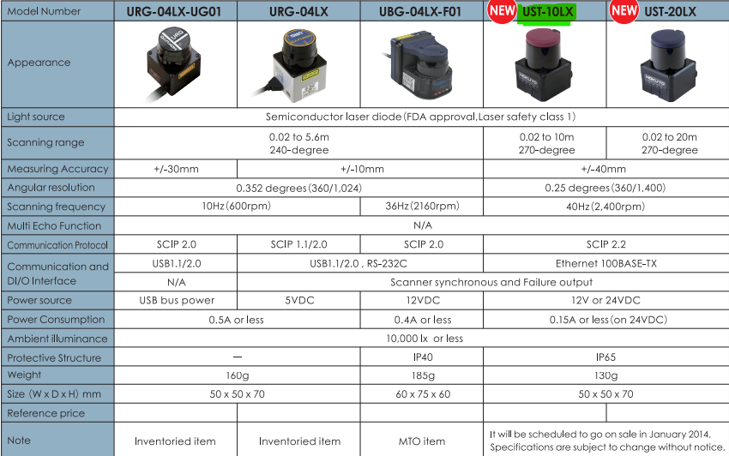

Figure 5 - Lidar UST-10LX Scanning Laser Rangefinder Specifications

## Hardware Communication with ROS

Figure 8 - Depiction of Data Flow of the F1Tenth Car [2]

The NVIDIA Jetson NX is the primary way that programs from the F1Tenth Autonomous Vehicle System are run for the car to operate and can communicate with the vehicle (as seen in Figure 8)[3].

The Host laptop is the main computer that access the car and its data, also to start its software. This is the main way of connecting with the NVIDIA Jetson NX via SSH in a remote way (Figure 9), due to the Jetson having WiFi capabilities. This allows the user to create a way to use the car for different purposes. Figure 8 & 9 both show that a monitor, mouse, and keyboard can be used to connect to the car, but only if its stationary. With WiFi capabilities, the car can be connected to at any time without any wired connections needed. This creates a possibility to access the car while driving.

As discussed in the Jetson NX section, this component will take up data input from the LIDAR sensor to assess the current environment it’s driving in and use it to regulate speed by overseeing the VESC. This is where this data is used, regulating the motor speed and steering control.

Figure 9 - Diagram showing possibility to connect to Jetson via WiFi

## F1Tenth Car Similarities to Simulator

One similarity that the F1Tenth car has to the simulator is the way that obstacle detection works. With the car itself, the Lidar (Figure 6) is used to detect obstacles via light sensor readings. This allows a precise detection of up to 30 metres from the sensor and near instant data collection.

Meanwhile, the simulator uses a ‘sensor’ of its own, by tracking in a 270-degree cone (just like the actual Lidar sensor) all obstacles to a specific distance. The simulator produces constant updates of obstacle distance from the car every frame. To display the sensor distance, a heat map is used to show the distance of the object detected (Figure 10), the closer the obstacle is, the hotter the colour (e.g., red for very close, blue/purple for far).

The difference in the simulator and real-life car is that there is no obstacle detection delay in the simulator, apart from potential delay from program execution time if computer specifications are weak. Meanwhile, the real sensor will have some delay (even though its minute) since it must account for the light travel speed to gather information and return it to the car.

Figure 10 - F1Tenth Simulator heatmap of obstacles

NOTE: add “Like with the real car, information gathered from sensor reading used to regulate speed – if turn detected car will regulate speed (motor speed in real car) and adjust steering at the turn”

[8] Unknown, “Slash 4x4 Platinum: 1/10 scale 4WD Electric Short Course Truck with low CG chassis,” traxxas.com, 02-Apr-2013. [Online]. Available: https://traxxas.com/products/models/electric/6804Rslash4x4platinum?t=details. [Accessed: 05-Dec-2022].

[9] H. Gim et al., “Suitability of Various Lidar and Radar Sensors for Application in Robotics: A Measurable Capability Comparison,” IEEE robotics & automation magazine, pp. 2–18, 2022, doi: 10.1109/MRA.2022.3188213.

1. <https://www.amainhobbies.com/traxxas-ezpeak-3s-completer-pack-dual-multichemistry-battery-charger-tra2990/p474595>
2. <https://www.robotshop.com/en/hokuyo-ust-10lx-scanning-laser-rangefinder.html> - Light sensor details
3. <https://f1tenth.readthedocs.io/en/stable/getting_started/software_setup/index.html> - F1Tenth Configuration Site