PyPSA Interview Assignment: Response
Kuma Erkisso | Funded Ph.D. position, Alberta REM PyPSA Modelling Project, Delta E+ Research Lab, SFU
GitHub repository: https://github.com/kbuni123/pypsa-interview-assignment
The repository contains one Jupyter notebook per task, with the code, outputs and markdown explanations, plus the environment file and a README with setup instructions. This document summarises the answers.

Preliminary task: environment
I used the Anaconda Prompt to create a dedicated conda environment (conda create -n pypsa312) and installed PyPSA following the ReadTheDocs instructions (pip install pypsa), together with JupyterLab and matplotlib. PyPSA ships with the open-source HiGHS solver, so no commercial licence was needed. Python 3.15 turned out to be too new for some of PyPSA's compiled dependencies, so I used Python 3.13. The installation check returned PyPSA 1.4.0, and I ran the notebooks in JupyterLab. The meshed AC-DC example was loaded with pypsa.examples.ac_dc_meshed(), with the Norwich converter fixed as in the documentation.

Task 1: System composition and the 05:00 dispatch

What the system is made of
- 9 buses: 6 AC buses (London, Norwich, Manchester, Bremen, Frankfurt, Norway) and 3 DC buses (Norwich DC, Bremen DC, Norway DC).
- 7 lines: 4 AC lines (a UK triangle London, Manchester, Norwich and the Bremen to Frankfurt line) and 3 DC lines forming a meshed DC triangle between Norwich, Bremen and Norway.
- 4 links: three AC-DC converters and one point-to-point HVDC link from London to Bremen.
- 6 generators and 6 loads: one wind farm and one gas plant at each of Manchester, Norway and Frankfurt, and a load at every AC bus.
- 10 hourly snapshots (00:00 to 09:00, 1 January 2015) and a CO2 cap of 1000 t over the whole period.
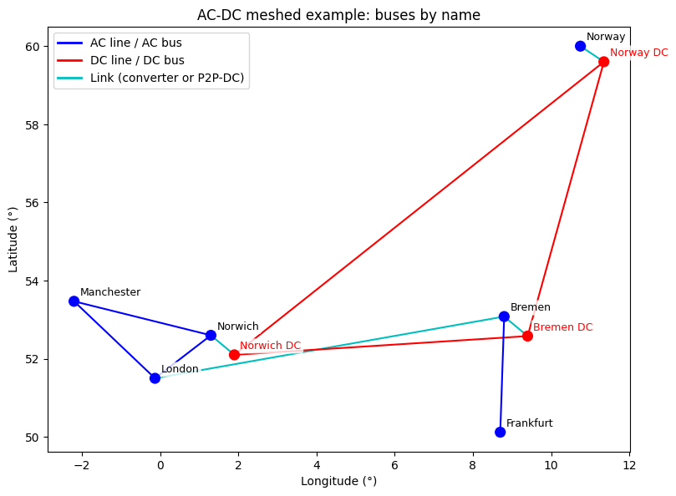
Figure 1. Network topology

Size of the generators
All generators are extendable, so their sizes come out of the optimisation. The p_nom values in the input file are only starting points; wind farms have a minimum of 100 MW and gas plants can be built from zero.
Generator | Capital cost (EUR/MW) | Marginal cost (EUR/MWh) | Optimal capacity (MW) | Energy (MWh)
Manchester Wind | 2,793.7 | 0.11 | 4,090.8 | 16,218
Norway Wind | 2,184.4 | 0.09 | 1,533.6 | 7,725
Frankfurt Wind | 2,129.5 | 0.10 | 1,667.7 | 7,139
Frankfurt Gas | 102.7 | 4.09 | 982.0 | 1,465
Norway Gas | 158.3 | 5.89 | 0 | 0
Manchester Gas | 196.6 | 4.53 | 0 | 0

Total installed capacity is about 8.3 GW against a peak load of 4.3 GW. Wind is overbuilt because its output varies strongly from hour to hour. Total system cost is about 18.44 million EUR.

Why Frankfurt Gas runs at 05:00 and the other gas plants do not
Why gas is needed at all. 05:00 has the highest load (4,344 MW), and Norway Wind is almost still (p_max_pu of 0.0097). All wind farms run at their maximum and still only supply 3,362 MW, so about 982 MW must come from gas. This hour sets the size of the gas plant.
Why Frankfurt. The CO2 cap is binding (shadow price about 2,180 EUR/t), so gas can only produce about 1,465 MWh in total and works as a peaking plant. For a peaker, the capital cost per MW decides the choice. Frankfurt Gas is the cheapest to build (102.7 EUR/MW against 158.3 for Norway and 196.6 for Manchester) and also has the lowest fuel cost. Manchester Gas is worse on capital cost, fuel cost and CO2 intensity. Norway Gas is slightly more efficient, but that does not make up for a capital cost about 55% higher. Transmission is not the reason: nodal prices at 05:00 are almost equal everywhere (about 1,594 EUR/MWh), and Frankfurt is actually exporting. A plant that is built at 0 MW cannot be dispatched, which is why Norway and Manchester Gas do not run.
Check. If Frankfurt Gas is not allowed, the optimiser builds 992 MW of Norway Gas instead, and total cost rises by about 26,300 EUR.

Task 2: Generation, curtailment and storage
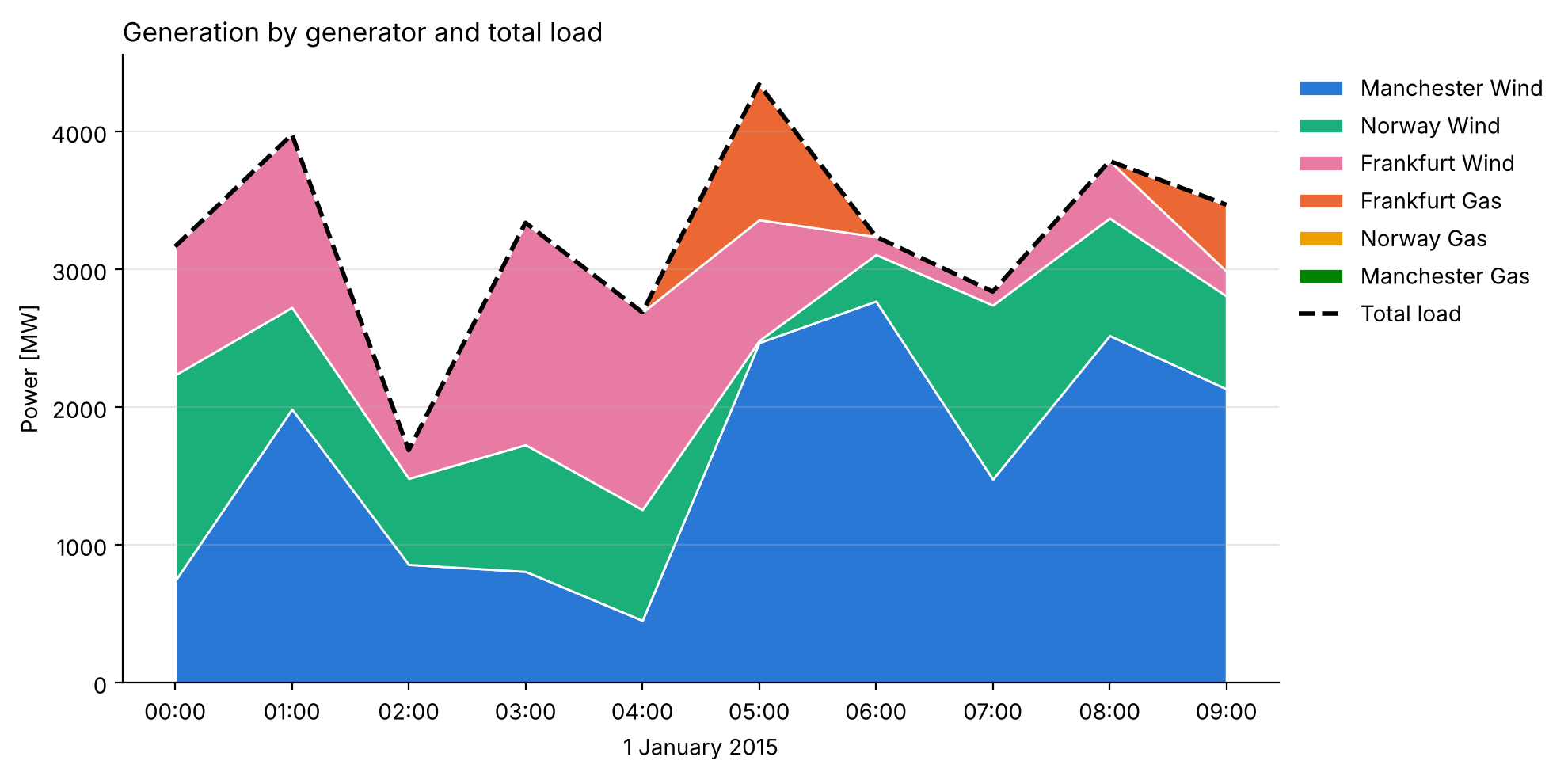
Figure 2. Generation by generator (stacked) and total load (dashed)

Why Frankfurt Gas only runs in two snapshots
Gas runs only at 05:00 (982 MW) and 09:00 (483 MW). These are the only two hours where available wind is lower than load: 05:00 because of almost no wind in Norway at peak demand, and 09:00 because of low wind in Frankfurt. With the CO2 price included, gas costs about 1,490 EUR/MWh compared with roughly 0.1 EUR/MWh for wind, so it only runs when wind physically cannot meet demand. Building extra wind just for those two hours costs more than using the CO2 budget, so the 1,465 MWh of gas uses the full 1000 t cap. Prices show the same picture: 0.11 EUR/MWh in surplus hours, about 1,490 to 1,590 EUR/MWh in the gas hours.

Curtailment
Curtailment (available wind minus dispatched wind) occurs in 6 of 10 hours and adds up to about 5,550 MWh, 15% of available wind, all at Manchester. The largest values are at 00:00 (3,065 MW) and 04:00 (2,112 MW). Manchester Wind is built large (4.1 GW) to carry the system through the low-wind hours at 05:00 and 06:00, so in windy, low-demand hours it produces more than the network can use or transport.
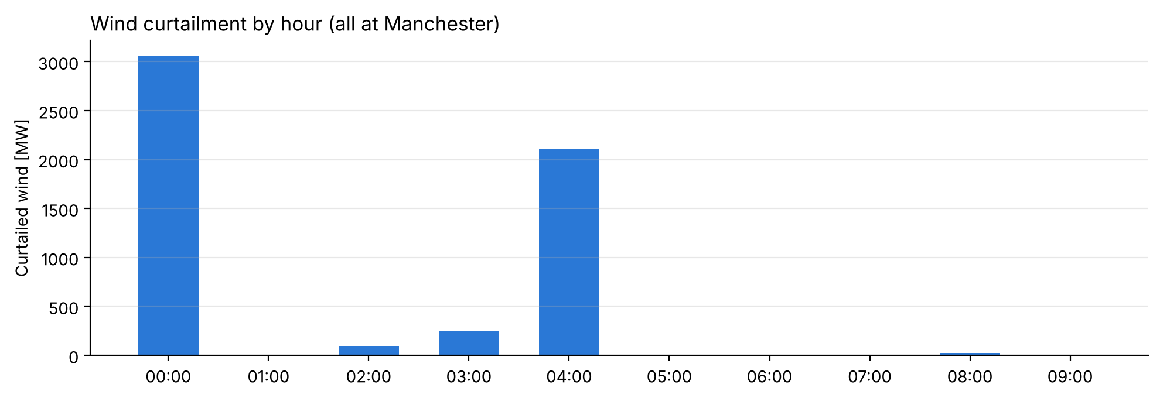
Figure 3. Curtailed wind by hour
In the real world, curtailment would occur in the same kind of situation: windy nights and early mornings with low demand (00:00 to 04:00 here), grid congestion (for example north to south in Great Britain and in Germany, represented here by the UK lines and the Bremen to Frankfurt line), and hours when inflexible thermal units must keep running, which this model does not include.

How storage helps
Surplus wind (00:00, 04:00) and shortfall (05:00, 09:00) happen at different times, and storage can shift energy from one to the other. I added an illustrative 4-hour battery at Frankfurt (90% charge and discharge efficiency, cyclic state of charge, assumed capital cost of 200 EUR/MW on the same scale as the toy model). Total system cost fell from 18.44 to 14.93 million EUR (about 19%), curtailment dropped to zero, and about 800 MW less wind was needed. The best wind site also changed: once timing matters less, Norway Wind wins because it delivers the most energy per euro. Gas energy stays at the CO2 cap. With 10 snapshots and assumed costs, the numbers are illustrative; the mechanism is the point.
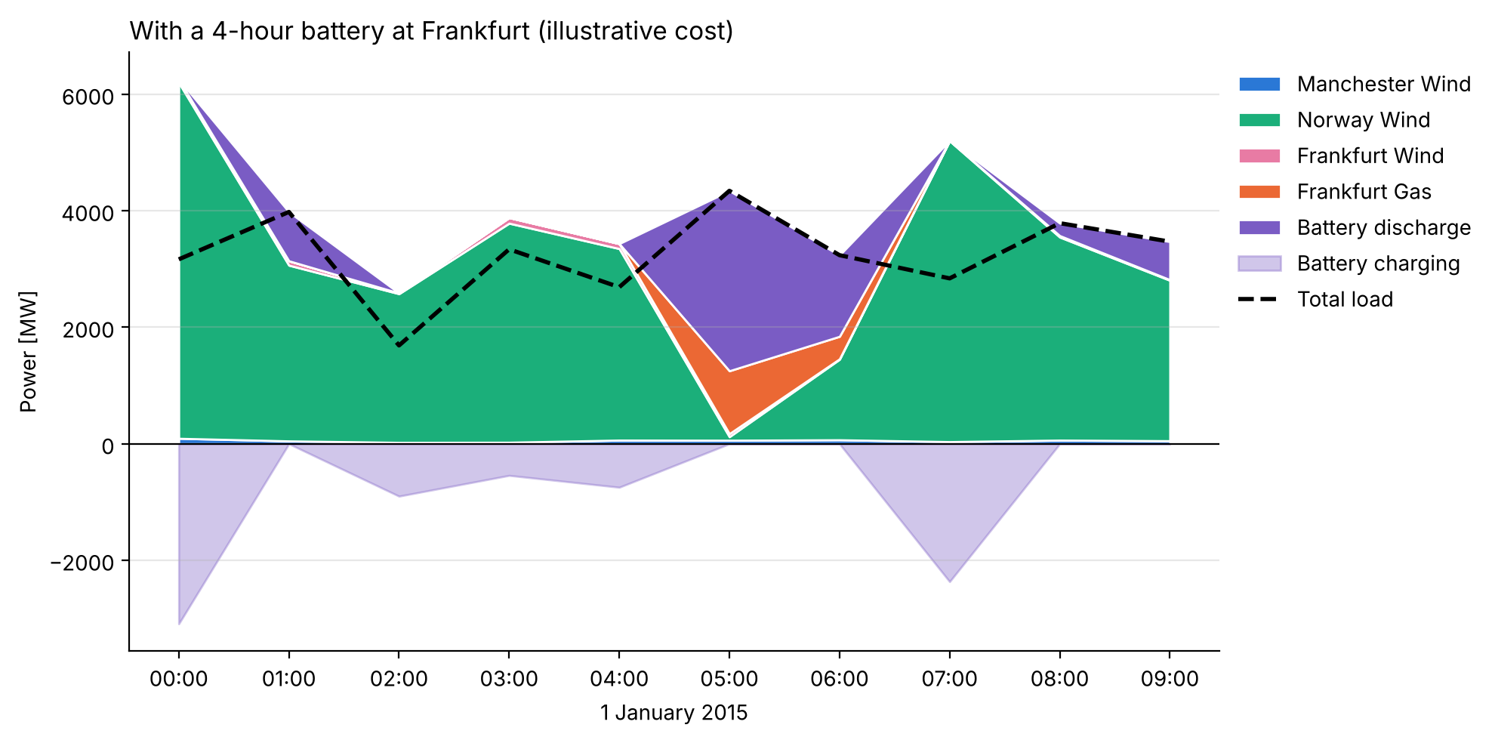
Figure 4. Dispatch with an illustrative battery at Frankfurt

Task 3: Single node and the Norway Wind capital cost threshold
All generators and loads were moved to the Frankfurt bus, Norway Wind p_max_pu was set to 1 for all snapshots, and p_nom_min of Manchester and Frankfurt Wind was set to 0. Lines and links then carry no flow.
Base result. Norway Wind is built at 3,549 MW and covers the base load, and Frankfurt Gas is built at 794 MW and covers the peaks at 01:00, 05:00 and 08:00. Gas is still built because per MW it is about 21 times cheaper to build than Norway Wind, and the peaks only last one to three hours. Gas output is exactly 1,465 MWh, the maximum the CO2 cap allows.
Threshold. A 1 MW slice of load needed for h hours costs 102.677 + 4.0863h with gas and c + 0.09h with Norway Wind. Wind takes over when c < 102.677 + 3.9963h. The lowest gas slice (3,549 to 3,788 MW) is needed for 3 hours, so:
Gas slice (MW) | Hours needed | Threshold capital cost (EUR/MW) | Result below threshold
3,549 to 3,788 | 3 | 114.67 | Replacement starts: gas 794 to 555 MW
3,788 to 3,981 | 2 | 110.67 | Gas 555 to 363 MW, runs only at 05:00
3,981 to 4,344 | 1 | 106.67 | Gas fully replaced, Norway Wind 4,344 MW

Answer: the optimisation starts replacing Frankfurt Gas with Norway Wind when the Norway Wind capital cost drops below about 114.67 EUR/MW (from the original 2,184 EUR/MW). A sweep of re-optimisations confirms the change between 114.65 and 114.68 EUR/MW, and the other two steps at 110.67 and 106.67. Above 114.67, lowering the wind cost only lowers the CO2 shadow price, which reaches zero at exactly the threshold. At each threshold both options cost the same, so the LP has several optimal solutions, which is a likely source of the numerical instability mentioned in the assignment.
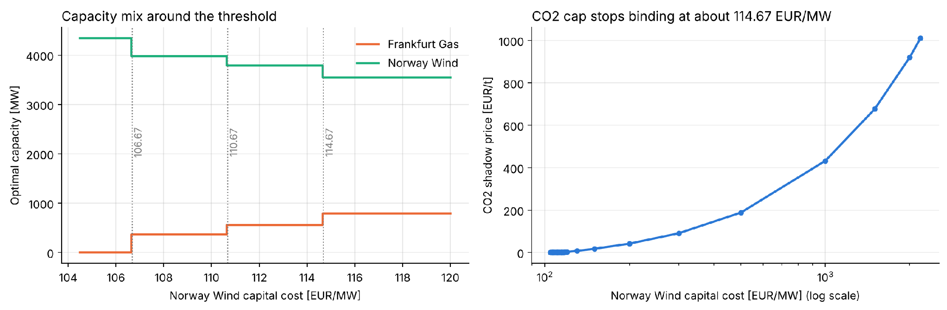
Figure 5. Optimal capacities and CO2 shadow price against Norway Wind capital cost

