# bamazon

Node.js and mySQL app

A mySQL database is created to simulate an Amazon-like store front.

This app takes in orders from a customer and deletes stock as the items are removed from the inventory.

This is a command line interface app.

Customer requests items and stock is reduced.

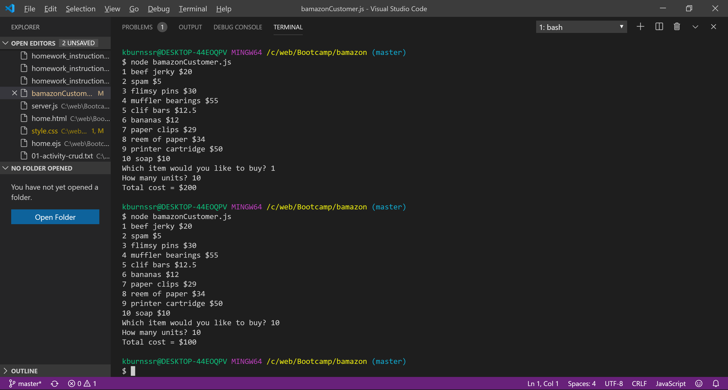

The number of available items is less than requested by customer.

