CS 420

Project 2

**Ksenia Burova**

February 24, 2017

**Activation/Inhibition Cellular Automata**

**Project report**

**Abstract:**

In this project, the goal is to investigate and measure the creation of spatial structures by an activator/inhibitor cellular automata (AICA). There are 3 experiments where each uses different but fixed $J_{1}$ and $J_{2}$ parameters, and different combinations of another 3 parameters - $R_{1},R_{2}, h$. Spatial structure gets initialized randomly with 2 possible states, 1and -1, and then it gets updated (asynchronously), depending on experiment parameters and rules, until all cells converge into a stable state. After CA is converged, the task is to calculate spatial correlation and mutual information, and to analyze data. For each combination of all 5 parameters, there were 4 Runs complete and average of results were taken and stored into .csv file.

(For the ease of this experiment, I’ve written Java application (from scratch) that automates the process of generating/updating cell grid, along with calculating all the required measurements. Simulator also outputs all the pictures, data in *.csv* format and creates *.html* files for each experiment with its pictures.)

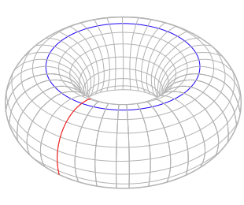**Variables:**

Cellular space dimension – 30 x 30, space is torus

States:

+1 – pink (alive cell)

-1 – yellow (dead cell)

Interaction strength:

$J_{1}$– activation system (activates cell replication )

– inhibition system (suppresses the activity of the activator)

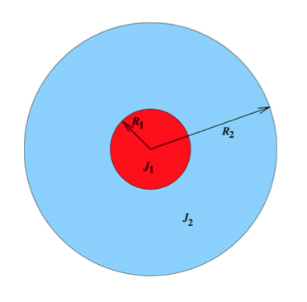Interaction range:

$R_{1}$– center

$R_{2}$– around center

$h$– bias parameter, towards activation

– distance between 2 cells

– mutual information

– joint entropy

*H* – overall entropy

- spatial correlation ( how much cells are correlated to each other at distance *l*)

– characteristic correlation length (how quickly spatial correlation decreases with distance)

**Observations and Discussion:**

**Experiment 1.**

In this experiment, the inhibition system gets disabled ( =0 ) opposed to the activator that is set to 1. Because is disabled, also has no influence here. Technically, this means that nothing prevents or slows down activator from diffusing. There are 5 combinations used (3 suggested ones + 2):

1. = -1
2. = -1
3. = -2
4. = 0
5. = 3

Using all of these parameters converged cell space into completely yellow or completely pink. Obviously, all, and , just like other measurements are completely zeroed. Here is a little snippet:

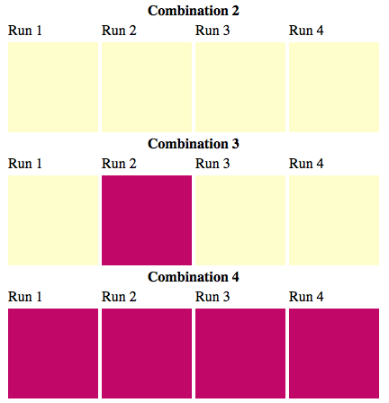

Figure . Experiment 1

There were some more combinations tried with these Js parameters, but all results were the same, and so were removed form the experiment.

Experiments results here depend pretty much on *h* and , which explains why we have different colors, when *h* is positive, we have stronger activation – pink square, when *h* is negative picture is likely to be yellow

Combination 3 has yellow and pink results, although *h* is negative there, is pretty high, so activator concentration is also higher, that may result in producing pink (+1) states.

**Experiment 2.**

In this experiment, the activation system gets disabled ( =0 ) opposed to the activator that is set to -0.1. Because is disabled, also has no influence here. There were 17 combinations run here, the ones suggested in write-up (snippet below shows values that were fed into simulator, *i*th element in each vector corresponds to , *i*th combination). This experiment also produces nice results for all combinations used, which is completely different from Experiment 1, that had homogeneous structures only.

possibleR1 = new int[]{ 1, 1, 1, 1, 1, 1, 1, 1, 1, 4, 4, 4, 4, 4, 9, 9, 9 };  
possibleR2 = new int[]{ 2, 4, 4, 4, 6, 6, 6, 9,13, 5, 7, 7, 7,12,12,12,12};  
possibleh = new int[]{ 0,-2,-1, 0,-5,-3, 0, 0, 0, 0,-5,-3, 0, 0, -6, -3, 0};

In general, longer is, thicker structures we can observe. So, for example if *h = 0,* we get this:

,

Macintosh HD:Users:kseniaburova:Documents:school:spring2017:cs420:Bio-inspired-computations:project2:Experiments:Experiment_2:Combination_1:Run_1.pngMacintosh HD:Users:kseniaburova:Documents:school:spring2017:cs420:Bio-inspired-computations:project2:Experiments:Experiment_2:Combination_4:Run_2.pngMacintosh HD:Users:kseniaburova:Documents:school:spring2017:cs420:Bio-inspired-computations:project2:Experiments:Experiment_2:Combination_10:Run_3.pngMacintosh HD:Users:kseniaburova:Documents:school:spring2017:cs420:Bio-inspired-computations:project2:Experiments:Experiment_2:Combination_7:Run_2.pngMacintosh HD:Users:kseniaburova:Documents:school:spring2017:cs420:Bio-inspired-computations:project2:Experiments:Experiment_2:Combination_13:Run_3.pngMacintosh HD:Users:kseniaburova:Documents:school:spring2017:cs420:Bio-inspired-computations:project2:Experiments:Experiment_2:Combination_8:Run_1.pngMacintosh HD:Users:kseniaburova:Documents:school:spring2017:cs420:Bio-inspired-computations:project2:Experiments:Experiment_2:Combination_14:Run_4.pngMacintosh HD:Users:kseniaburova:Documents:school:spring2017:cs420:Bio-inspired-computations:project2:Experiments:Experiment_2:Combination_9:Run_4.png

Figure Experiment 2. h = 0, R2 = 2,4,5,6,7,9,12,13

So, it is clear on this set of pictures, how correlates to distance between yellow and pink cell regions.

Just like in previous experiment, higher value of *h* is more likely to produce picture with activating cells, whereas very low values will cause more inhibitor activity and cell death in picture. For example, for , we have 3 results:

,

Macintosh HD:Users:kseniaburova:Documents:school:spring2017:cs420:Bio-inspired-computations:project2:Experiments:Experiment_2:Combination_5:Run_2.pngMacintosh HD:Users:kseniaburova:Documents:school:spring2017:cs420:Bio-inspired-computations:project2:Experiments:Experiment_2:Combination_6:Run_2.pngMacintosh HD:Users:kseniaburova:Documents:school:spring2017:cs420:Bio-inspired-computations:project2:Experiments:Experiment_2:Combination_7:Run_1.png­

Figure Experiment 2. R2 = 0, h= -5 ,-3, 0

There is a clear, that leftmost picture with lowest *h* has many more dead cells. is only 6, so this is probably why we have some alive cells left.

**Experiment 3.**

In this experiment, both, inhibitor and activator parameters were set, . There were 48 different combinations tried, going form high to low values of all other 3 parameters. Here is a code snippet with values used:

possibleR1 = new int[]{ 1, 1, 1, 1, 1, 1, 1, 1, 1, 1, 1, 1, 1, 1, 1, 1, 1, 1, 1, 1, 1, 3, 3, 3, 3, 3, 3, 3, 3, 3, 3, 3, 3, 3, 4, 4, 4, 7, 7, 7, 7, 7, 9, 12, 6, 6, 6, 6, 6};  
possibleR2 = new int[]{ 3, 6, 6, 6, 2, 4, 5, 5, 5, 5, 5, 9, 9, 9, 9, 9,13,14,14,14,14,14, 5, 5, 9, 9, 9, 9, 9,14,14,14,14,14, 5, 7,12,14, 9,12,12,14,14, 14, 9,12,12,12, 8};  
possibleh = new int[]{ 0, 0 -3,-5, 0,-2,-1,-4,-2, 0, 2,-3, 0, 3, 6,-6, 0, 3, 0,-3, 6,-1, 0,-1,-3, 0, 3, 6,-6,-3, 0, 3, 6,-1, 0, 0, 0,-1, 0, 0, 2, 0, 0, 0, 0, 0,-1,-3, 0};

There was a whole spectrum of pictures created, including homogeneous structures, small and big, lined and spotty, organized and chaotic.

First, there are some interesting observation is for .

For , , and h = -4, -2, 0, there are similar patterns to those observed in Experiment 2:

Macintosh HD:Users:kseniaburova:Documents:school:spring2017:cs420:Bio-inspired-computations:project2:Experiments:Experiment_3:Combination_8:Run_2.pngMacintosh HD:Users:kseniaburova:Documents:school:spring2017:cs420:Bio-inspired-computations:project2:Experiments:Experiment_3:Combination_9:Run_1.pngMacintosh HD:Users:kseniaburova:Documents:school:spring2017:cs420:Bio-inspired-computations:project2:Experiments:Experiment_3:Combination_10:Run_1.png

Figure Experiment 3, fix R1 and R2

The difference between and is not very large, so we don’t observe wide patterns, but with *h* being lower, there are more dead cells. All pattern form maze-like structures, in some runs there were just striped.

Let’s look at the data:

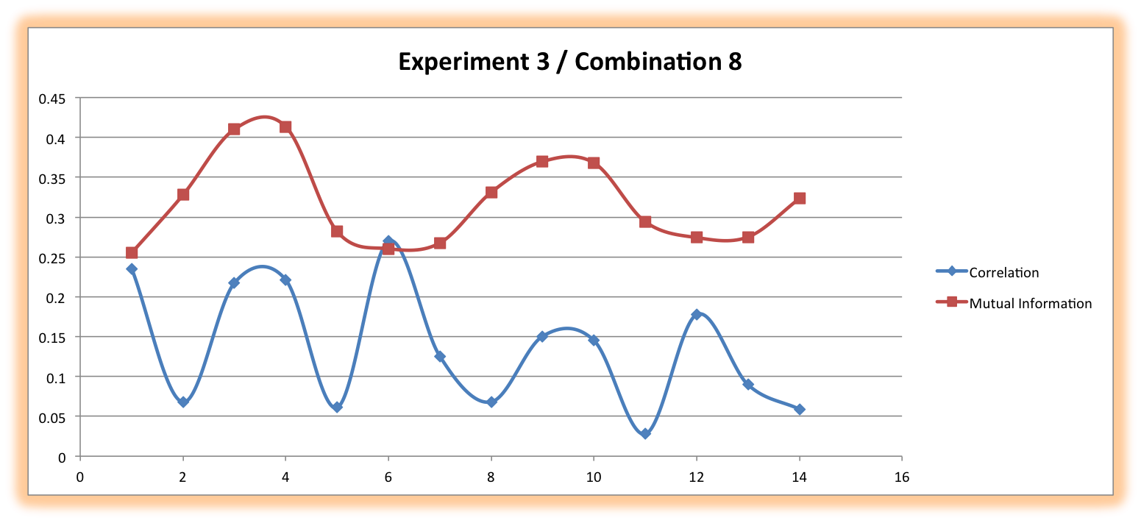

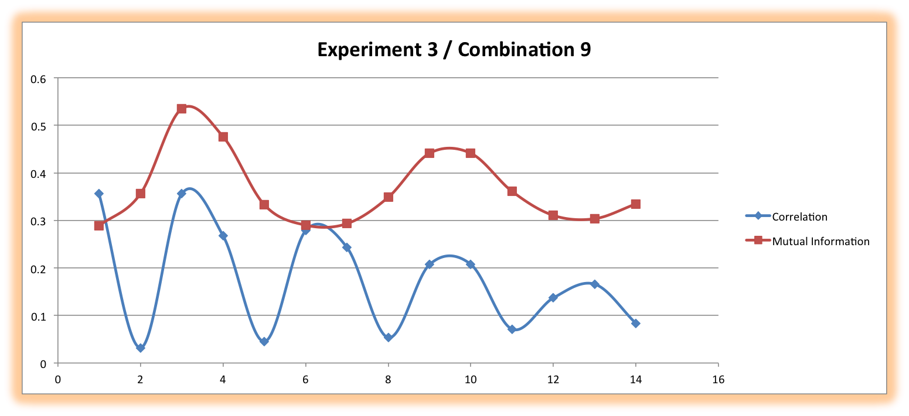

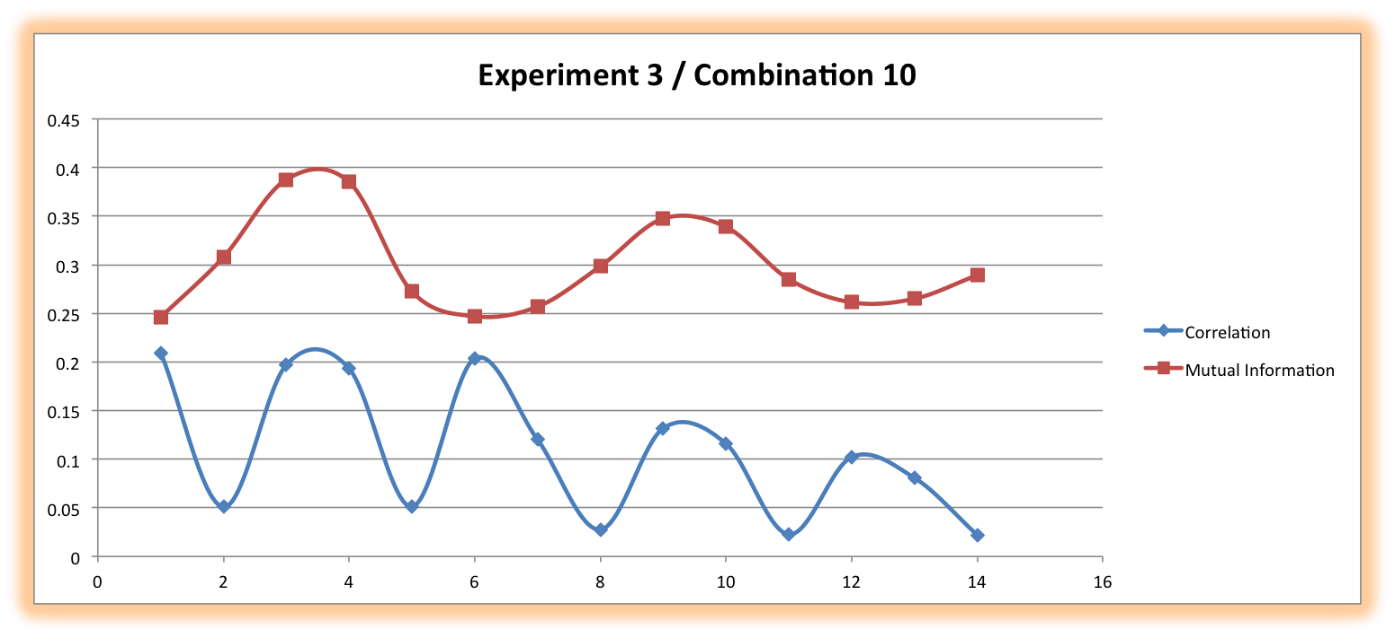

Figure Experiment 3, Combination 8,9,10

It’s not hard to see, that mutual information is higher for the middle picture, also it seems like there is the same amount of yellow/pink cells. According to mutual information, cells are likely to be in a same state if distance between them is ~4 or 10 cells. That’s how we can observe those lined patterns. Those graphs differ a little demonstrating that width of lines is different.

Those pikes in correlation graphs say that that cell state depends on those stripes edges.

Another interesting pair of pictures:

Macintosh HD:Users:kseniaburova:Documents:school:spring2017:cs420:Bio-inspired-computations:project2:Experiments:Experiment_3:Combination_7:Run_1.pngMacintosh HD:Users:kseniaburova:Documents:school:spring2017:cs420:Bio-inspired-computations:project2:Experiments:Experiment_3:Combination_11:Run_1.png

they look similar, indeed, they got same and values, 1 and 5 correspondingly. Bias value is also similar, one has -4, another -3. The one that has lower one has less alive pink cells.

Taking a look at the graphs:

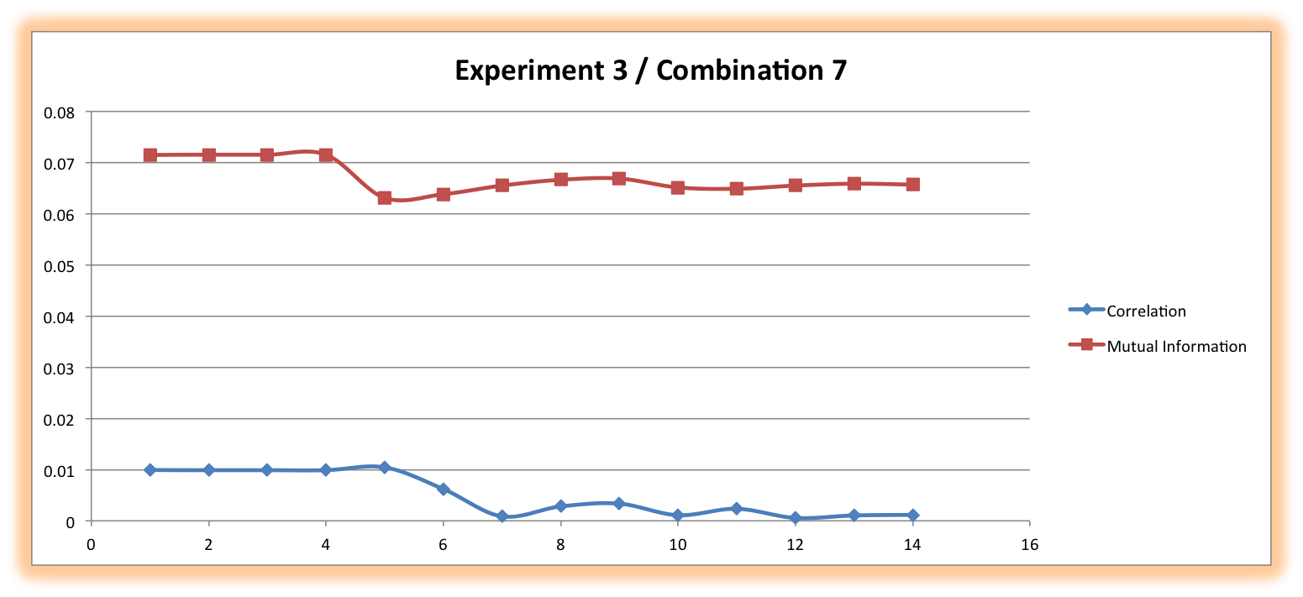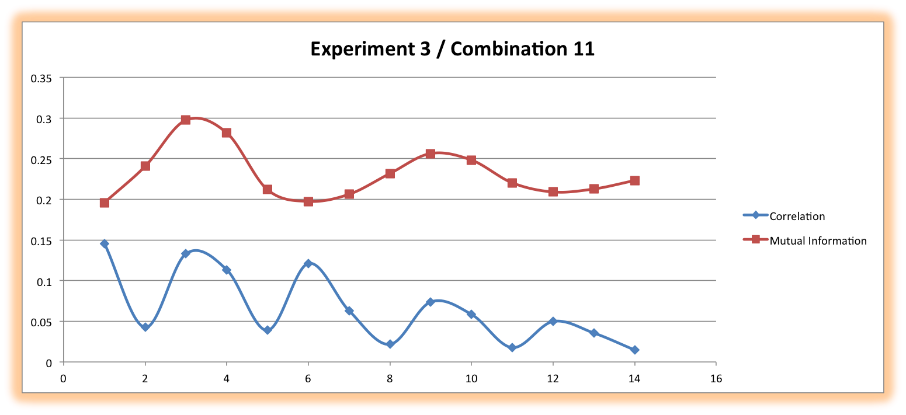

Combination 7 has very low correlation and mutual information, and no matter how far cells are away from each other. And it’s kind of obvious that new states would likely to die there, since we can literally count number of pink ones.

Combination 11 is slightly more complex, and overall mutual information and correlation numbers are higher. Correlation graph is wavy, it tells that there is dependence of cell state on distance. Mutual information also says that same cells are likely to be arranged within certain distance. And there is a pattern that proves that.

Another 2 combinations:

Macintosh HD:Users:kseniaburova:Documents:school:spring2017:cs420:Bio-inspired-computations:project2:Experiments:Experiment_3:Combination_18:Run_1.pngMacintosh HD:Users:kseniaburova:Documents:school:spring2017:cs420:Bio-inspired-computations:project2:Experiments:Experiment_3:Combination_22:Run_1.png

and 3 correspondingly, and .

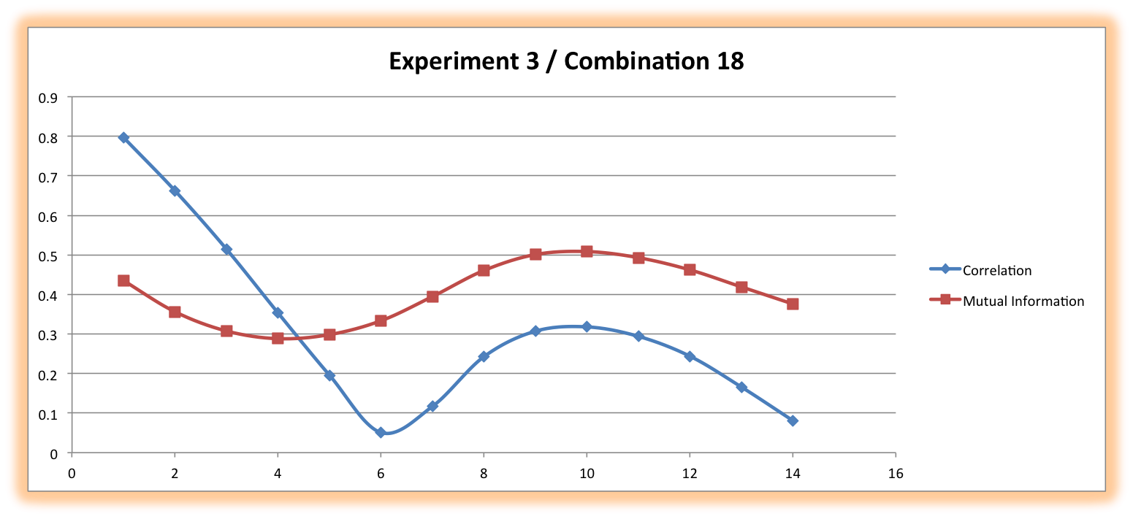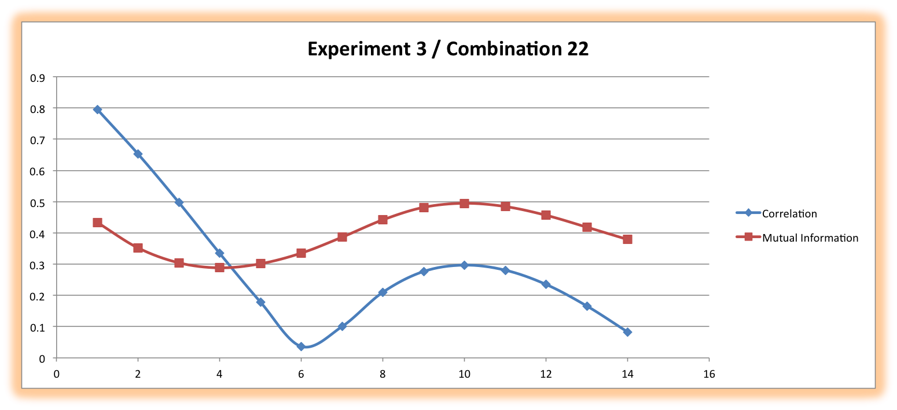

The graphs are almost identical. There is a high correlation between 2 cells when distance is 1-3. And cells are likely to be the same state within the distance that is < ~8, according to mutual information. Same patterns are observed for Combinations17 – 22, and 30- 34. So, the difference in R values is significant in all of those, and no matter what bias parameter is, only direction of pattern changes.

Let’s look at patterns, when difference in R values is very small:

Macintosh HD:Users:kseniaburova:Documents:school:spring2017:cs420:Bio-inspired-computations:project2:Experiments:Experiment_3:Combination_35:Run_3.pngMacintosh HD:Users:kseniaburova:Documents:school:spring2017:cs420:Bio-inspired-computations:project2:Experiments:Experiment_3:Combination_36:Run_3.png

h = 5 here, R1 = 4 for both, and R2 is 5 for first and 7 for second one. Larger R2 for second pattern explains why there are more yellow, because of a bigger radius of inhibitor.

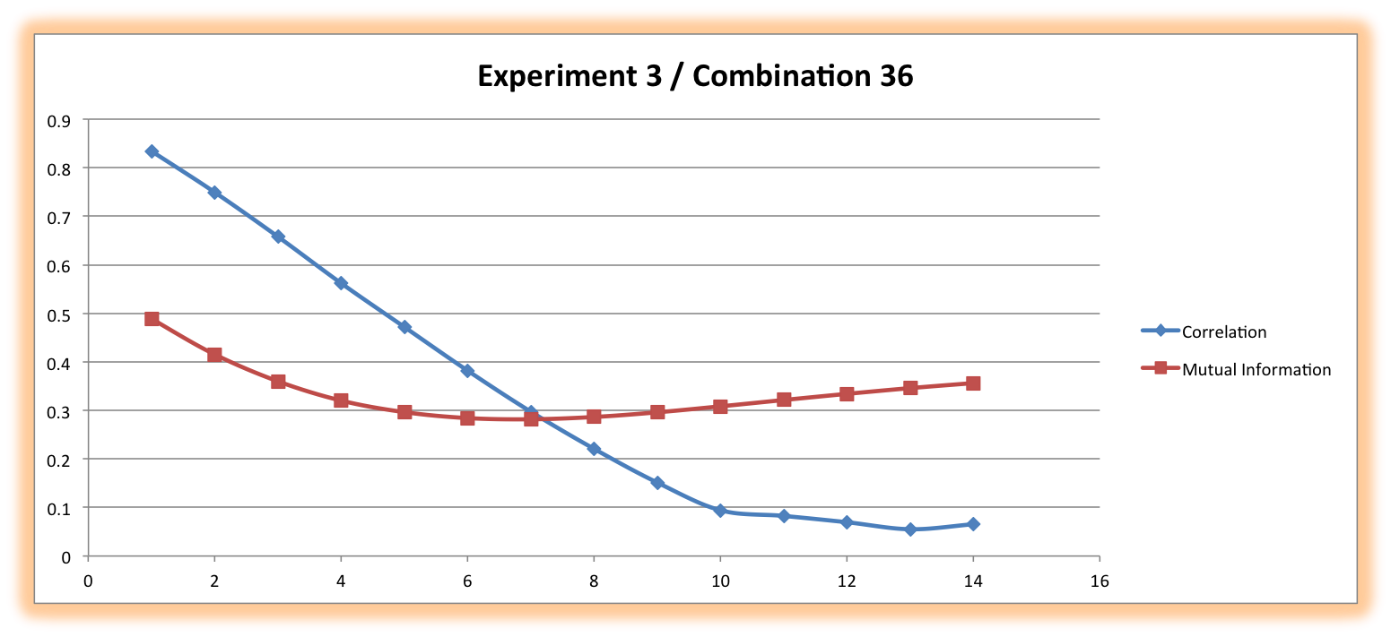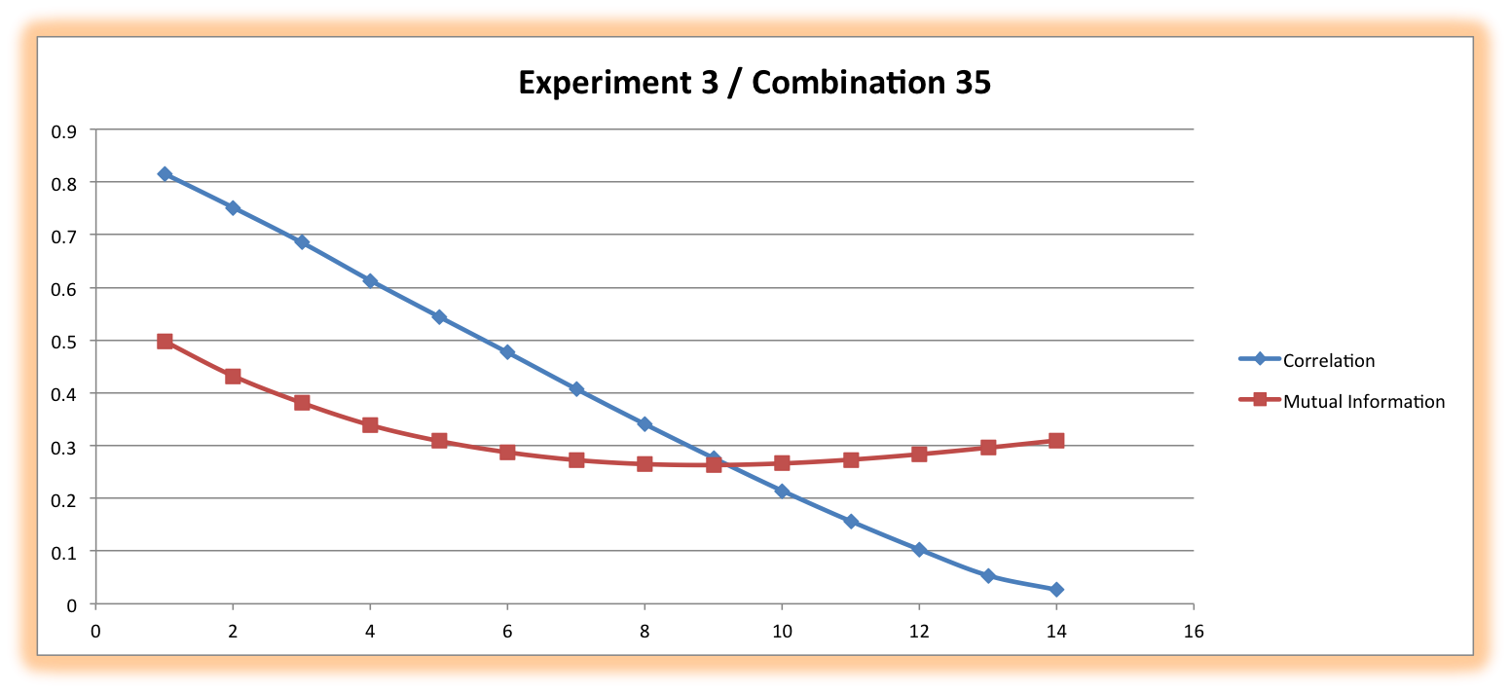

Mutual information is almost the same in both graphs. Cells are arranged in large 1-3 cluster in space, so it explains it. Bigger the distance between cells – harder to tell which state it’s going to be, because those clusters are kind of random.

So, so there very many different patterns, and mostly observation shows, if there is a slight difference in R values there are two outcomes:

that if R values are low, the pattern is going to have tiny structures like this -

Macintosh HD:Users:kseniaburova:Documents:school:spring2017:cs420:Bio-inspired-computations:project2:Experiments:Experiment_3:Combination_1:Run_2.png

if R values are bigger, structures are going to be thicker.

Longer R1 and R2, like 6 and 12, we get strange wavy patterns, that are large at the same time:

Macintosh HD:Users:kseniaburova:Documents:school:spring2017:cs420:Bio-inspired-computations:project2:Experiments:Experiment_3:Combination_46:Run_1.png

*h* value determines disposition towards one state. Lower values would show more yellow (inactive) cells, more pink cells were observed with higher values.

**Lambda (correlation length):**

From all the observations and some graphs, there was possible to see, that bigger the distance between cells, lower correlation is. In some examples, correlation would drop dramatically, in some it would look like decreasing amplitude.

For most graphs, that are built in excel spread sheet for experiment 3, lambda value equals to distance when correlation graph drops.