Project 3

CS 420

**Ksenia Burova**

March 10th, 2017

## Hopfield Net

**Abstract**:

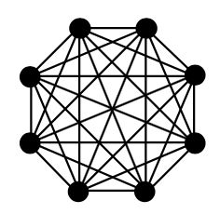In this project, the goal was to investigate the associative memory capacity of Hopfield network, where Hopfield network is a form of recurrent artificial neural network. Hopfield network has following parameters: symmetric synapses ( $J_{ij}= J_{ji}$), no self-action by neuron ($J_{ji}=0$), and binary values for neuron activity values ($s_{i}=±1$). Indices *i* and *j*  correspond to neurons acting on each other in a matrix of all neurons.

There were several experiments run. In each experiment, there was a fixed set of network patterns with a fixed amount of neurons, and each pattern was checked for stability according to number of imprinted patterns into weights. In addition, the size of the basins of attraction for each imprinted pattern of each value of *p* was estimated.

**Data and measurements:**

Number of experiments = 50

Number of patterns (p) = 50

Number of Neurons (N) = 100

The synapses were calculated according to following formula:

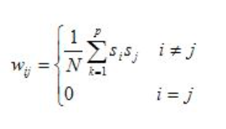

Where, 1/N is a way of normalizing synapses, *p* is a number of imprinted synapses, and $s_{i}s_{j}$ are values of neurons *i* and *j*  for each pattern.

Then for each imprinted network, number of patterns were updated to see if any changes were affected by imprints. Next formula was used to compute local field of neurons, that was used to compute new possible state of network.

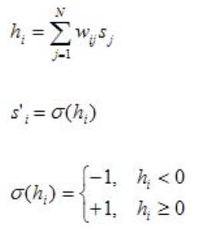

And so basically, N number of *h* values turned into a complete network. If network matched the one before imprints were applied, then it was stable, otherwise it was not.

Additionally, the basins were calculated.

Max number for basins was 50 – network always converges to imprinted one.

Min was 0 – network was unstable in general.

Otherwise, it was a min number of neurons that had to be flipped for network not being able to converge to imprinted pattern.

**Discussion and results:**

In this project, network operations were compared to associative memory. Capacity is a main property of memory, so in other words, if more things are added to memory, then harder it is to retrieve it from the memory. For example, if human looks at 2 pictures vs. 20, there is definitely a better chance that human reconstructs 2 pictures and not 20 in from his memory afterwards.

There were two graphs built in this project. The one below shows how many patterns are stable for a certain number of imprinted patterns.

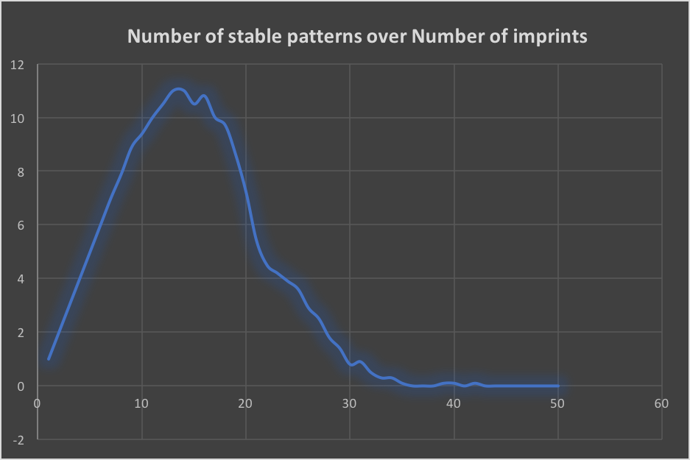

Figure 1. Stable patterns vs. Number of Imprints

Stable pattern is the one, that doesn’t get affected by the number and values of imprinted patterns.

**Figure1** shows how number of stable patters increase almost linearly after new pattern is imprinted, but until a certain point. After ~9 patterns are imprinted, there is slightly less stability, but still, most patterns are stable. After ~13 stability starts to drop and eventually, after about 35 patterns imprinted, all of them become instable. There results were averaged over 50 experiments, the roughly showed the same numbers. So, the observation shows, the best chance to recover original state of networks if ~9-12 pattern are imprinted, if more used, then some state will not be recoverable. So, it sort of explains the capacity property of associative memory – more you try to remember, less you can recover for each thing remembered.

The next graph in **Figure 2** demonstrates the probability of networks instability depending on number of imprinted patterns. It also shows the there is a ~100% of recovery if ~9 network is imprinted, and then probability for of instability grows, and after ~30 becomes constant, with 100% chance of impossibility of recovery of imprinted patterns.

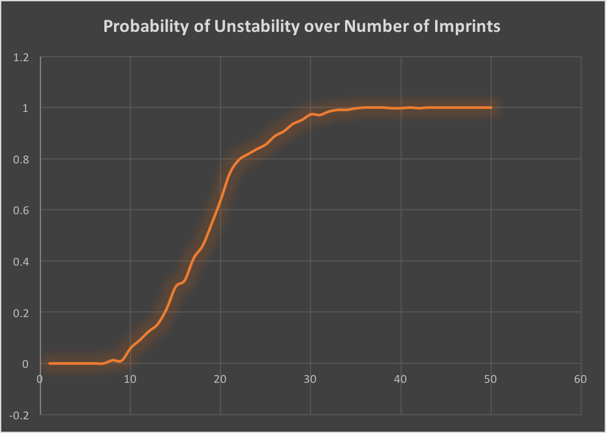

Figure 2. Instability vs. Number of Imprints.

The was observation of basins of attraction for each pattern done as well. Technically, stability of the pattern is a basin of attraction for that pattern. The value of basin basically tells the maximum number of neurons in network that can be changed, such that network can be restored. So, when network is already unstable, the is 0 basin of attraction, because there is no way to restore it already. Maximum number is possible, only if one network is imprinted. Obviously, one network can be restored because there is no other noise added to synapses.

Also, if high value of imprinted network is used, then harder it is already to have them all stable. And some of those stable are likely to become unstable with next imprint. So definitely, less number of neurons will have to be changed in order for network to be able to converge to initial its state.

There were no graphs built for this part of experiment, but the values were calculated and can be seen in attached excel spreadsheet (haven’t figured out how to build those graphs).

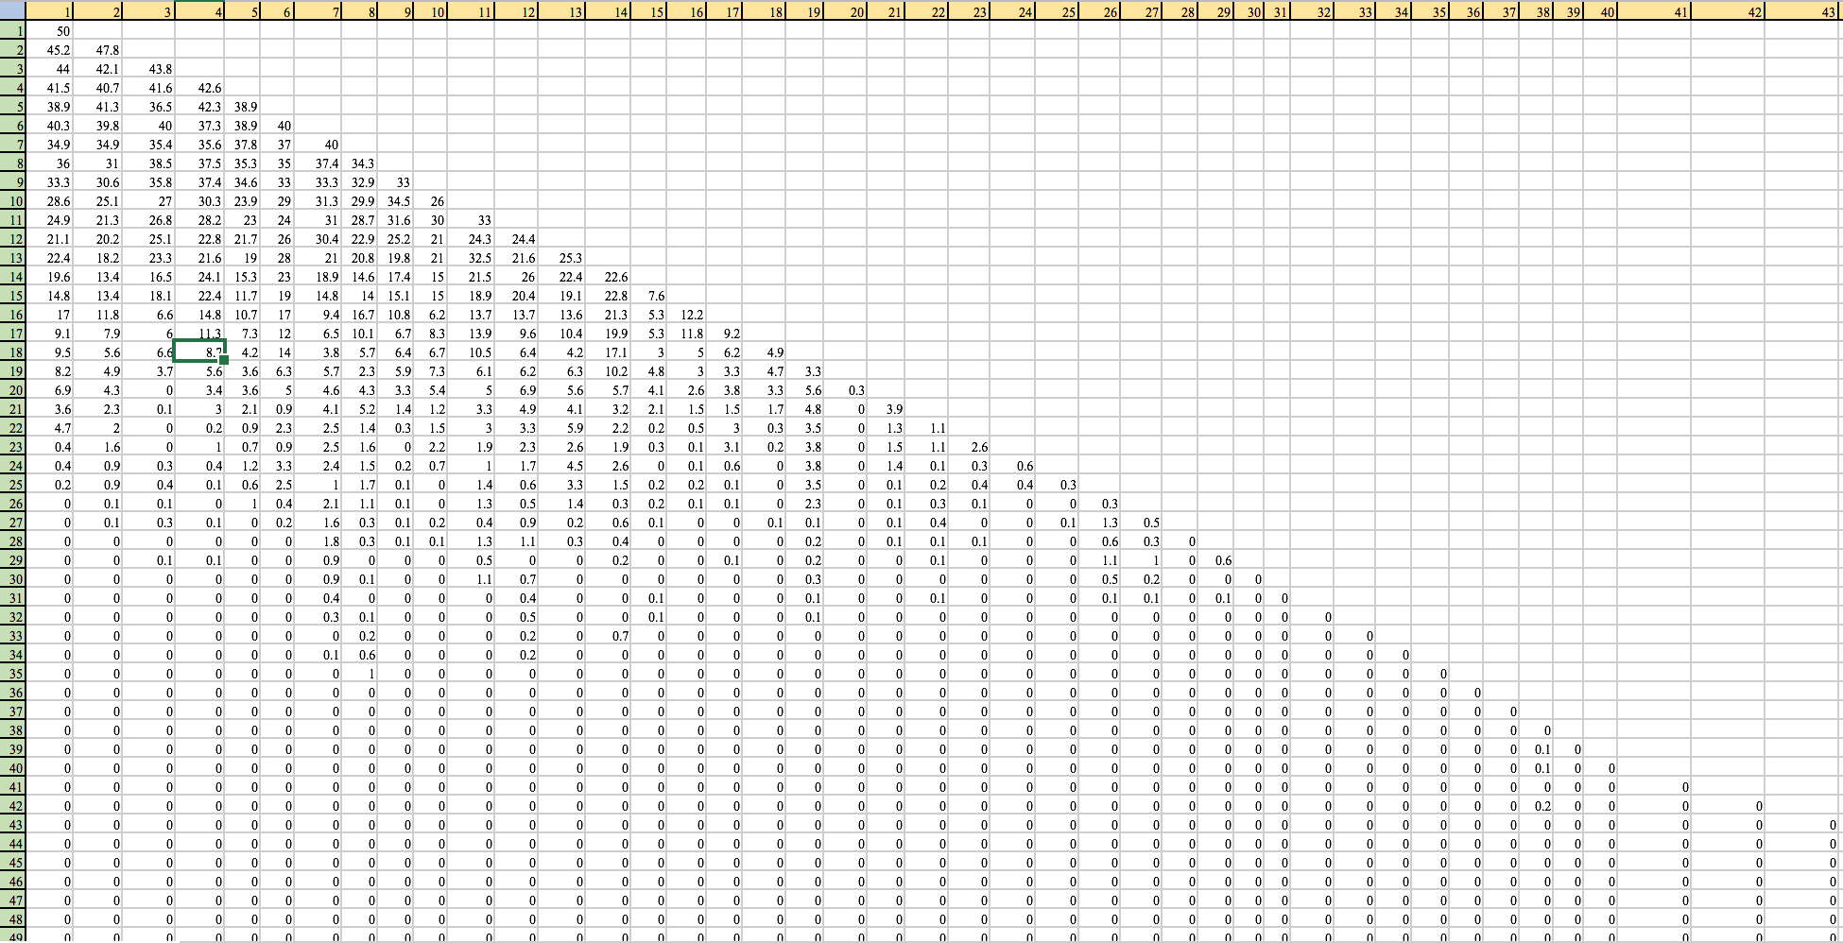

Figure 3. Basins of attraction

**Figure 3** is a Screenshot of some values of basins of attraction for each network depending on number of imprints.

It reminds of triangle matrix, that has all values zeroed out after roughly 35 imprinted networks (vertical green column indicates number of imprints). So, it proves the results from previous experiment, so instability of networks correlates with basin value of 0. Also, before it becomes zero, the assumption of decreasing number of possible neuron changes is proved. So, more networks get imprinted, memory becomes fuller, and so less changes can be done to network to keep them recoverable. And as it was said before, one network imprint has a basin of 50.

**Conclusion:**

There were different parameters observed in this project while investigating associative memory capacity of Hopfield networks. First was the number of stable networks among the increasing number of imprinted patterns, then the probability of instability of networks with imprinting more networks, and, finally, basins of attractions were computed for all nets for each possible number of imprints.

Last observation shows, that there is very little or no changes can be done to nets, once memory is full. First two indicate, what is the maximum of networks that can be imprinted so it all of them stay stable.

In general, all results show that it is possible to compute determine associative memory capability results, when measuring stability of imprinted patterns for given number of pattern and number of neurons, which is in general is the training of neural nets to do things.