Brainnetome fMRI Toolkit
BRAT 2.2 Manual
Designed by: Dr. Yong Liu, Dr. Tianzi Jiang
Coded by: Yong Liu, Kaibin Xu, Yafeng Zhan, and

From DICOM to Results, Brat Made it Easy

Brainneotme Center
National Laboratory of Pattern Recognition (NLPR)
Institute of Automation, Chinese Academy of Sciences (CASIA)
95 Zhongguancun East Road, Hai Dian District
BRAT is design for evaluate the network properties of Brain
The citation of this tool should be:
Yong Liu, Kaibin Xu, Yafeng Zhan and Tianzi Jiang, Brainnetome fMRI Tooklit: A GUI toolbox for analysing fMRI data, OHBM 2015,

Any suggestions/questions, please contact Dr. Yong Liu by yliu@nlpr.ia.ac.cn
www.brainnetome.org
Beijing 100190, P.R.China

Content
Brainnetome fMRI Toolkit 0
Content 1
1. Preface 3
2. Getting started 5
2.1. Download and Installation 5
2.2. Starting the toolkit 5
3. Basic Functions 6
3.1. Utilities 7
3.1.1 Dicom convert 7
3.1.2 Head motion estimate 9
3.1.3 Visual check 10
3.1.4 Time signal noise ratio (TSNR) 11
3.1.5 Mask to Table 12
3.1.6 Extract mean time series from 3D images 13
3.2. Prepocessing 15
3.2.1 Slice timing 17
3.2.2 Realign 18
3.2.3 Normalise 19
3.2.4 Denoise 21
3.2.5 Filter 22
3.2.6 Smooth 23
3.3. Function connectivity (FC) 23
3.3.1 Draw ROI 24
3.3.2 ROI calculation 25
3.4. Spontaneous brain activity 25
3.4.1 Amplitude 26
3.4.2 ALFF/fALFF 27
3.4.3 fGN 28
3.4.4 ReHo 29
3.5. Brain network analysis 29
3.5.1 Network construct 30
3.5.3 Network statistics 31
3.6. Statistical analysis 32
3.6.1 Matrix & voxel based statistical analysis 33
3.6.3 Matrix & voxel based IBMA 35
3.7. View 36
3.7.1 Surface mapping 36
3.7.2 ROI mapping 37
3.7.3 Network Visualization 38
4. Examples 43
4.1. Test Data 43
5. Appendix 44
6. Acknowledgements 48
7. References 49

Preface
Brainnetome fMRI toolkit (www.brainnetome.org/brat) is an open source toolbox for analysis/statistical/view of brain spontaneous activity and brain networks based on various neuroimaging datasets. Its initial aim is to integrate the studies on methodologies of brain spontaneous activity, functional connectivity, brain networks and their applications to neurological and psychiatric brain disorders and diseases, based on the resting functional magnetic resonance imaging (fMRI). Brainnetome fMRI toolkit is an extendable platform. Its longterm goal is to develop integrative platform and tools for analysis of brain activity and brain networks at different states (e.g., rest, tasks, and disorders), and based on different imaging technologies (e.g., structural MRI, diffusion tensor imaging, fMRI, functional nearinfrared spectroscopy, EEG/MEG).
Currently, Brainnetome fMRI toolkit can provide the human brain mapping community and others with methodologies of brain spontaneous activity (such as Amplitude of fMRI time series (AM), Amplitude of Low Frequency fluctuations (ALFF), fractional Gaussian noise (fGN), Regional homogeneity (ReHo)), functional connectivity based on region of interest, specific networks and the whole brain), brain networks and their applications to neurological and psychiatric brain disorders and diseases, based on the resting functional magnetic resonance imaging (fMRI). The Brainnetome fMRI toolkit provides the following utilities (1) Dicom convert; (2) head motion estimate; (3) Visual check about the data; (4) Time signal to noise ratio,(5) statistical tools for assessing significance within a group or significant differences between groups. Detail of the toolkit can be found at http://www.nitrc.org/projects/brat/.
Brainnetome Toolkit (brat) will also provide some methods developed by Brainnetome Center in the past few years in functional MRI, structure MRI, and diffusion tensor imaging (www.brainnetome.org/brat).
The Brainnetome fMRI Toolkit envisions prompting the studies in brain activity and networks analyses not only in human brain mapping community, but also in neuroscience, neurology, and psychiatry and related fields.
Several people have contributed to the toolkit.
Name | Time | function | Email
Valentin Schmutz | July –August 2013 | View surface beta version | valentin314@gmail.com
Yong Hu | July 2010- May 2011 | GUI beta version  Double check functions of network measures
Yafeng Zhan | May 2014-- | View Network | yafengzhanno1@gmail.com
Kaibin Xu | July 2013-- | Redesign GUI | kaibin.xu@nlpr.ia.ac.cn
Yong Liu | July 2012-- | GUI design  Basic functions | yliu@nlpr.ia.ac.cn

If you wish to contribute with a new function or set of functions, please contact LIU Yong by yliu@nlpr.ia.ac.cn or liuyong.ccm@gmail.com .

All efforts have been made to avoid errors, but users are strongly urged to independently verify the accuracy and suitability of toolbox functions for the chosen application. Please report bugs or substantial improvements to LIU Yong by yliu@nlpr.ia.ac.cn or liuyong.ccm@gmail.com

Getting started
Toolkit Requirements:
SPM8 or above
Matlab 2012

Download and Installation
Some of functions in the Brainnetome fMRI Toolkit run within SPM8. That is, SPM8 needs to be installed and added to your Matlab search path before the Brainnetome fMRI Toolkit can be installed (see http://www.fil.ion.ucl.ac.uk/spm/ and http://en.wikibooks.org/wiki/SPM ).

For example: copy the files into D:/toolkit
Then you can start Matlab, just

>> cd D:/toolkit/brat
>>brat_updatepath

Then all the paths within the brat will be added to your matlab.

Starting the toolkit
Start MATLAT, and make sure you have added folders including brat to the search path.
On the matlab prompt, type
>> brat
you will see the following information in the command window and figure.
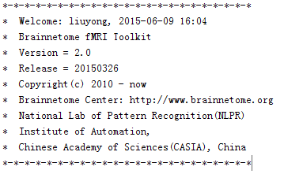
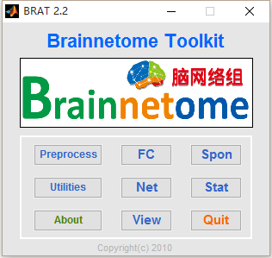
Fig 2. BRAT – Main Interface

Basic Functions
Till now, this toolkit provides some popular toolkit for dicom convert (based on dicom2nii), fMRI data preprocessing, functional connectivity, network analysis, surface view of your results etc.

Input directories in an .txt file
Before you start to do preprecessing of your image data, it will be great if you can package your data into a solid style. For example, if you have two groups of fMRI data, please tag the folder with an identified number for each subject as follows.
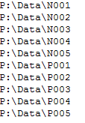
Then it will be fantastic for the following analysis.

Name position
name position: an number for input data to parse unique subject ids.
e.g.
name position: 1 for directories
d:\test_data\subject1
d:\test_data\subject2
d:\test_data\subject3
The output filename will be subject1.nii, subject2.nii, subject3.nii.

name position: 0
for data
d:\test_data\subject1.txt
d:\test_data\subject2.txt
d:\test_data\subject3.txt
The parsed subject names are subject1, subject2 and subject3.

Utilities
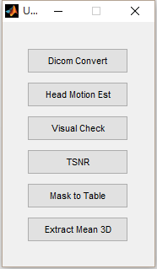 | Dicom Convert: convert dicom files to nii.  Headmotion Estimate: easimate the headmotion using the latest method  Visual check: check data quality.  TSNR: temporal signal-to-noise ratios.  Mask to Table: convert a set of ROI to theirs coordinates.  Extract Mean 3D: extract the mean time series from nii

3.1.1 Dicom convert
Convert dicom files to nifti format using dcm2nii in mricron http://www.mccauslandcenter.sc.edu/mricro/mricron/install.html.
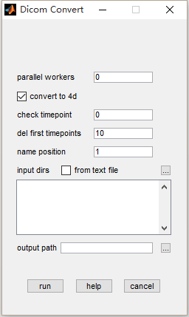 | parallel workers: select how many workers to start a parallel work. The default is 0.  convert to 4d: select to convert data to 4D format, otherwise to 3D.  check timepoint: check the number of timepoints if filled with a positive number.  del first timepoints: number of the timepoints to be deleted, the default is 10.  name position: subject identifier for input data  input dirs: directories can be input either using a .txt file or spm select window.  output path: an output directory for saving results.
Step 1. Fill in the number of parallel workers. (Notice: the more the workers, the faster the disk IO is needed).

Step 2. Choose whether to convert to 4D format.

Step 3. Fill in the number of timepoints and the program will check each converted data afterwards. (0 means do not check).

Step 4. Fill in how many timepoints do you want to discard for the converted data.

Step 5. Select input directories and name position, which is the location of the output filename for each input directories/data. Details can be found in Section 3, name position.

Step 6. Run.

3.1.2 Head motion estimate
The tool searches for rp*.txt in every input directories. Head motion of each subject will be estimated in a variety of methods (max translation, max rotation, FD, Dijk and etc.) and output.
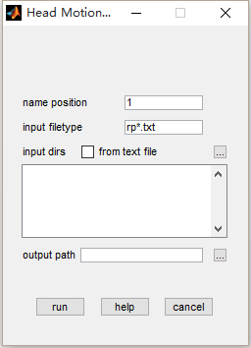 | Input:  name position: subject identifier for input data  input filetype: files in the filetype will be searched in input directories.  input dirs: directories can be input either using a .txt file or spm select window.  output path: an output directory for saving results.
Two txt files “brat_headmotion_result.txt” and “brat_headmotion_exclusions.txt” will provide the parameters of head motion and gross information for head movement.
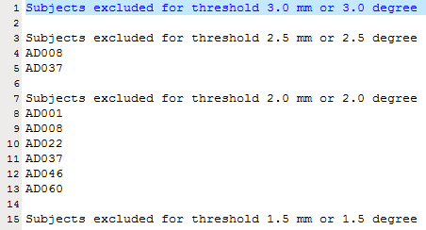
Step 1. Select input directories, input file type and name position, which is the location of the output filename for each input directories/data.

Step 2. Run.

3.1.3 Visual check
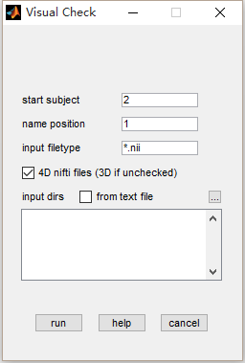 | The tool calls spm check registration to check data quality. Arrow keys and the keyboard W S A and D are used to change the current image and current timepoint.  name position: subject identifier for input data  input filetype: files in the filetype will be searched in input directories.  4D nifti files: if the input data is 4D, check this item. Otherwise uncheck.  input dirs: directories can be input either using a .txt file or spm select window.
For more information, check SPM manual.
Right click and you will get more information about the current image as follow:
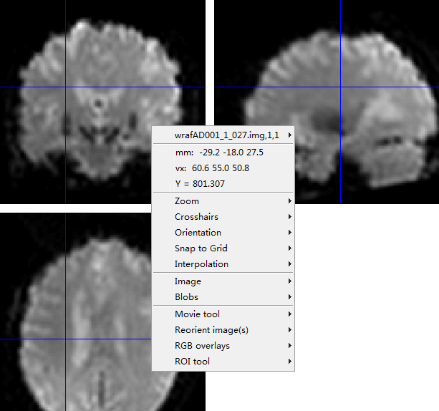
Step 1. specify the ith subject to start.

Step 2. input data directories and select file type, name position.

Step 3. Run

3.1.4 Time signal noise ratio (TSNR)
Extract mean and standard variation of each voxel using a whole brain mask. TSNR of each voxel is defined as mean intensity divided by standard variation .

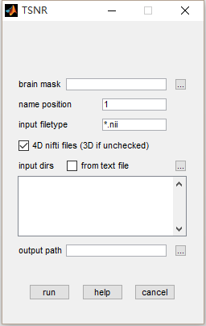 | brain mask: mask for the data  name position: subject identifier for input data  input filetype: files in the filetype will be searched in input directories.  4D nifti files: if the input data is 4D, check this item. Otherwise uncheck.  input dirs: directories can be input either using a .txt file or spm select window.

Step 1: input a whole brain mask.

Step 2: input data directories and select file type, name position.

Step 3: input output directory.

Step 4: run

3.1.5 Mask to Table
Input a mask labeled by numbers and find the center of gravity for each labeled roi. The results will be output to an excel table.

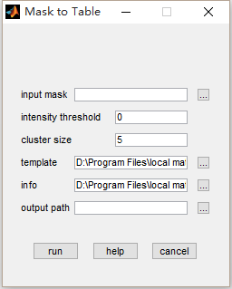 | intensity threshold: threshold of intensity.  cluster size: threshold of cluster size.  template: mask labeled by numbers.  info: two columns of information for each labeled cluster in a *.txt file. Such as provide a name for the clusters as:  e.g.  1 SFG  2 MFG  3 IFG  output path: an output directory for saving results.
Step 1: input a whole brain mask.

Step 2. specify a threshold of intensity and cluster size.

Step 3. input a mask with clusters labeled by numbers.

Step 4. Select a *.txt file contains the name of each labeled cluster.
E.g.
type d:\aal_info.txt
1 SFG
2 MFG
3 IFG

Step 5. Select an output directory.

Step 6. Run.

3.1.6 Extract mean time series from 3D images
The tool extract mean intensity of 3D images, which normally are results of a metrics such as ReHo. An excel file is used to specify the groups and covariates of the data. A correlation will be calculate between the extracted mean vectors and the scores in the table.
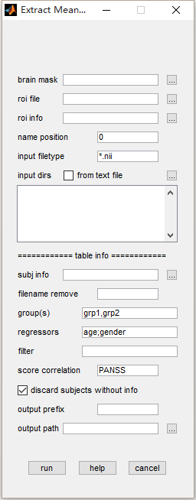 | brain mask: mask of whole brain.  roi file: extract mean intensity in the roi tagged by numbers.  roi info: labels of tagged ROIs. (optional)  name position: subject identifier for input data  input filetype: files in the filetype will be searched in input directories.  4D nifti files: if the input data is 4D, check this item. Otherwise uncheck.  input dirs: directories can be input either using a .txt file or spm select window.  subj info: subjects information in an excel file, including subject ids, group, regressors (optional), etc.  group(s) (optional): extract mean and do correlation for each group separated by ‘,’ or ‘;’, e.g. SZ;NC.  filename remove: inputs for the current program are normally results from calculations and a prefix/suffix will be added to the filename, sush as ReHo_subj1.nii. Input ‘ReHo_’ here will remove the prefix and make input file match the information in the table.  filter: exclude unwanted subjects in the table, a column with title ‘Filter’ is expected in the excel file.  score correlation: if specified, a correlation will be do between scores and mean intensity. More than one scores can be separated by ‘,’ or ‘;’.  discard subjects without info: when checked, if subjects’ information are not found in the table, a warning message will be shown; when unchecked, an error message will be shown.  output prefix (optional): prefix for output file.  output path: an output directory for saving results.

Step 1. Select a brain mask.

Step 2. Select a mask with clusters labeled by numbers.

Step 3. Select a *.txt file contains the name of each labeled cluster (Optional).
E.g.
type d:\aal_info.txt
1 SFG
2 MFG
3 IFG
Step 4. Select input directories, input file type and name position, which is the location of the output filename for each input directories/data.

Step 5. Select an excel table contains the columns of ’Group’, regressors (optional), ‘Filter’ (optional) and score columns (optional). Mean intensity of each subject will be extract and output to an excel table.

Step 6. Select an output prefix (optional) and directory.

Step 7. Run.

Prepocessing
The main preprocessing function of this sub toolkit based on SPM8. For the users, they just select the directory of the file list. If you have enough space in your disk, you can follow the next steps and then just simple click run.

Pre-processing procedures for functional MRI data are mainly divided into six parts, slice timing, realignment, normalise, de-noise, filter and smooth. When all the processes are selected, data will be processed in the order listed in the following Figure.
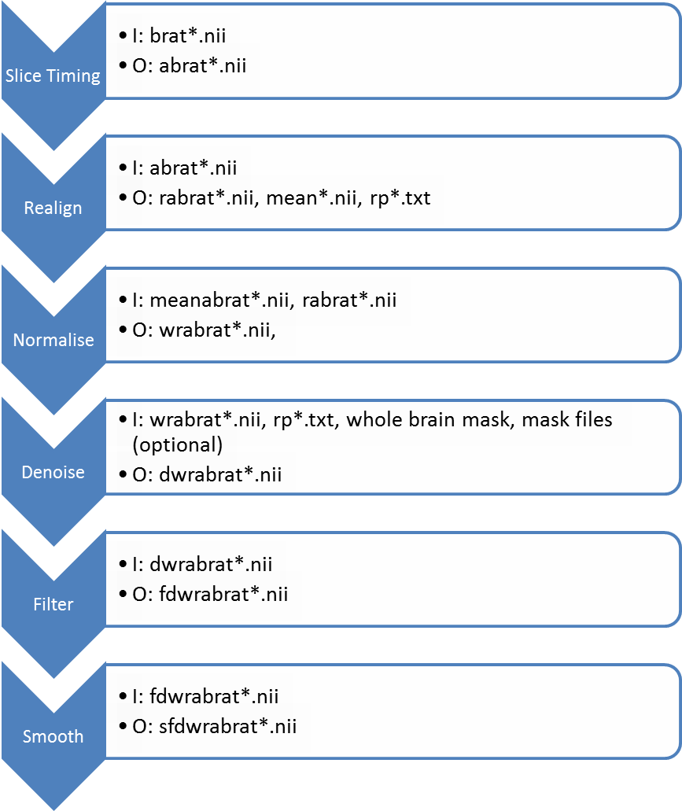
Figure . Order of processes and input/output files of each process. I: input files; O: output files.

The default GUI as follow:
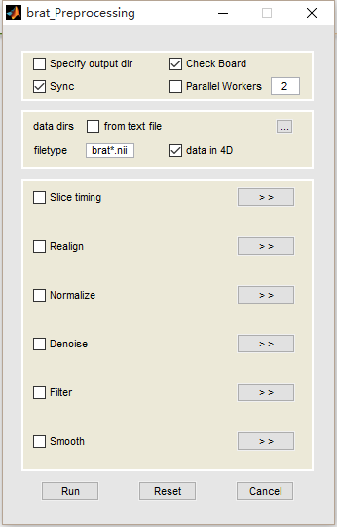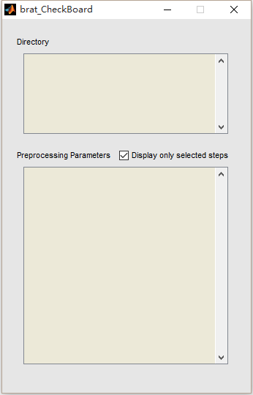

Options:
Step 1: input some basic selection
Specify output dir, if yes, then you will need to input or select a directory where you want to move and preprocess data at the out dir.
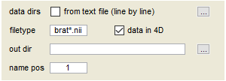

3.2.1 Slice timing
Different acquisition methods from different MRI scanners could cause a problem that slices of one volume are sampled at different time points. In order to minimize this effect, slice timing is normally performed after DICOM file converting. Aa simplified slice timing input interface of BRATp includes 4 parameters, slice order, TR, reference slice and prefix. Data and number of slices are prepared after the input of subject folders (see input/output module) and TA, which is the time between the first slice and the last slice, can be calculated by TA = TR(TR/nslices).
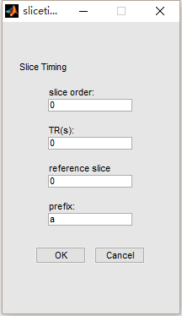 | Explanations of slice timing parameters are listed below.  slice order: The order of slices been sampled.  TR(s): Repetition time.  reference slice: A slice used as the reference of time points, which normally be the slice in the middle.  prefix: Output images will have a prefix of ‘a’.

3.2.2 Realign
Input: all defaults are suggested.

When a subject is in a MRI scanner, involuntary movement and physical noises (such as heart beating and breathing) could cause relative head motion between volumes sampled at different time points. Realign are brought in to estimate and minimize this effect. (E.g. A mean image will be generated from all the images of one subject. After estimating the head motion parameters, spatial transformations are applied to each image to correct for head motion). Meanwhile, an rp_*.txt file that contains the parameters of head motion will be generated.
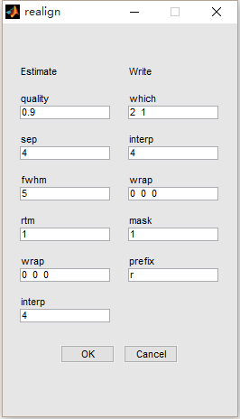 | Explanations of Realign parameters are listed below. (*Some explanations are edited from SPM8 manual)  ESTIMATE  quality: Highest quality (1) gives most precise results, whereas lower qualities gives faster realignment.  sep: The separation (in mm) between the points sampled in the reference image. Smaller sampling distances gives more accurate results, but will be slower.  fwhm: Full width at half maximum of the Gauss smoothing kernel (mm).  rtm: 1 indicates images are registered to the mean image, while 0 indicates images are registered to the first image in each subject’s folder.  wrap: 3 dimensions of wrapping, e.g. [1 1 1] for wrapping in X, Y and Z direction, [0 0 0] for no wrapping.
weight: Weighting image of the reference image.
interp: Indexes of interpolation methods. (1 for Trilinear; 2-7 for 2nd-7th Degree B-Spline)
WRITE
which: The first parameter allows 0, 1 and 2 as input (0: create only a mean resliced image; 1: don’t reslice the first image. 2: reslice all the image). The second parameter indicates whether to output a resliced mean image (0 for false and nonzero for true).
interp: Interpolation methods for write option. (0 for Nearest Neighbor; 1 for Trilinear; 2-7 for 2nd-7th Degree B-Spline; Inf for Fourier Interpolation).
mask: Mask output images (true/false). If any image has a zero value at a voxel, then all images will have zero (or NaNs if allowed) values at that voxel.
wrap: 3 dimensions of wrapping, e.g. [1 1 1] for wrapping in X, Y and Z direction, [0 0 0] for no wrapping.
prefix: Output images will have a prefix of ‘r’.

3.2.3 Normalise
Input: all leave default is suggested.
** If you want to normalised your data into a lower spatial resolution such as with voxel size 3*3*3, please remember to revise the folloing selection about brain masks for whole brain, white matter and csf etc.
Normalise function is used to transform MRI images into a standard space after registering to a template or a specific user defined volume. Default protocol of this procedure is to use a mean*.nii file generated from Realign, which is to be estimated to match the EPI template. After estimation, a transformation matrix will be applied to each image to wrap them into the selected space.
Explanations of Normalise parameters are listed below. (*Some explanations are edited from SPM8 manual)

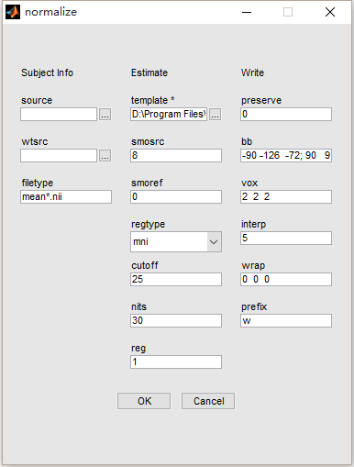
SOURCE
source: A text file of directories in which images for normalization are stored. Default value (empty) means program will search input directories for image in filetype.
wtsrc: weighting image of the source file.
filetype: Default value will automatically choose the mean*.nii/img file generated from realign in the same folder.

ESTIMATE
template: A standard template image which the source image will be registered to.
weight: weighting image of the template.
smosrc: Smoothing to be applied to the copy of the source image. (Source image and the template should have the same smoothness)
smoref: Smoothing to be applied to the copy of the source image. (The default templates of spm already have been smoothed by 8mm)
regtype: mni (affine registration into MNI space), subj (Registering to an image that has an almost same size of the source image.) and none (No registration)
cutoff: Cutoff of DCT bases.
nits: Number of nonlinear wrapping iterations.
reg: The amount of regularization for the nonlinear part of the spatial normalization.
WRITE
preserve: 0 (The warped images preserve the intensities of the original images) and 1 (Spatially normalised images are "modulated" in order to preserve the total amount of signal in the images.)
bb: Bounding box of the volume.
vox: The voxel sizes of the normalized images.
interp: Interpolation methods for write option. (0 for Nearest Neighbor; 1 for Trilinear; 2-7 for 2nd-7th Degree B-Spline; Inf for Fourier Interpolation).
wrap: 3 dimensions of wrapping, e.g. [1 1 1] for wrapping in X, Y and Z direction, [0 0 0] for no wrapping.
prefix: Output images will have a prefix of ‘w’.

3.2.4 Denoise
Denoise module uses general linear model to suppress noise. Constant shift and the effect that signal intensity increases with time can be regressed out if constant and linear drift are selected. Mask regression regresses out global signal, white matter signal, gray matter signal, and csf signal (optional). It should be noted that whether to remove global signal is still controversial. Motion correction will load the rp*.txt file generated from Realign, which contains 6 motion parameters of each volume.
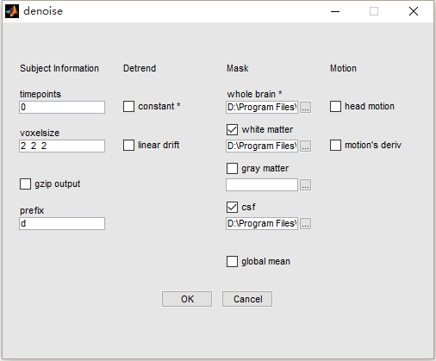

Explanations of Denoise parameters are listed below.
Subject information
timepoints: Number of sampled volumes (or the number of 3D files).
voxelsize: Voxel size of the input images.
gzip output zip the out image to *.nii.gz so that to save the disk space
Detrend:
constant: Regress out constant shift of time sequences when enabled.
linear drift: Regress out linear shift increases with time when enabled.
Mask
whole brain: Whole brain mask used to extract time sequences of fMRI data.
white matter: White matter mask of the regression option. Regress out white matter’s mean signal.
gray matter: Gray matter mask of the regression option. Regress out gray matter’s mean signal.
csf: Cerebrospinal fluid mask of the regression option.
global regress: When enabled, this option will regress out whole brain signal (mean value of all the voxels in whole brain mask at each time point).
Headmotion
head motion: Regress out head motion effects (Parameters are loaded from rp*.txt generated from Realign).
motion’s deriv: Regress out the derivatives of head motion effects.

3.2.5 Filter
FMRI noises are introduced by thermal noises, electric fluctuations, head motion, physiological noises and etc. In order to increase the signal-noise ratio, a band-pass filter is used to filter the time sequences.
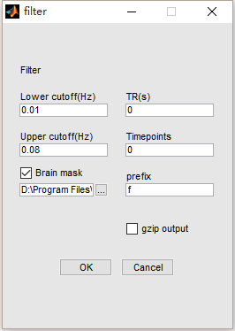 | Explanations of Filter parameters are listed below.  lower cutoff (Hz): The lower cutoff of the band-pass filter, default is 0.01 Hz  upper cutoff (Hz): The upper cutoff of the band-pass filter, default is 0.08 Hz  TR: Repetition time of the sampled volumes.  Timepoints: Number of the input 3D volumes.  prefix: The output images will have a prefix of ‘f’.  Brain mask: Mask data.

3.2.6 Smooth
Gauss smoothing kernel is used to smooth the image to suppress random noises. It should be noted that in some network analysis such as multi-voxel pattern analysis, in order to get high resolution images, smoothing is not selected.
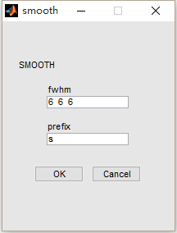 | Explanations of Smooth parameters are listed below.  fwhm: Full width at half maximum of the Gauss smoothing kernel (mm). The default value is 6 6 6  prefix: The output images will have a prefix of ‘s’.

Function connectivity (FC)
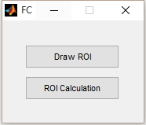 | draw roi: draw regions of interest for input coordinates  roi calculation: calculate mean roi time series, roi-roi correlation and roi-whole brain correlation

3.3.1 Draw ROI
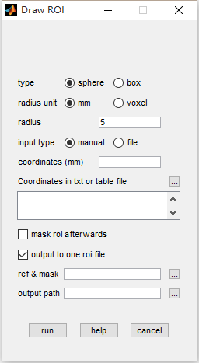 | type: draw roi as sphere or cubic  radius unit: unit of input radius  radius: radius of sphere or 1/2 edge length for cubic  input type: manual: input coordinates in coordinates (mm), e.g. 25,5,10; file: input a text file with 3 columns for x,y,z  mask roi afterwards: mask generated roi using input mask  output to one roi file: instead of output one file for each roi, brat will generate one roi file with each roi labeled by number  ref&mask: reference and mask file. for extracting information of origin, voxel size, bounding box, etc..  output path: directory for output
Step 1: input or type coordinates.

Step 2: select parameters for type, unit and radius.

Step 3: input a mask and output path.

Step 4: run.

3.3.2 ROI calculation
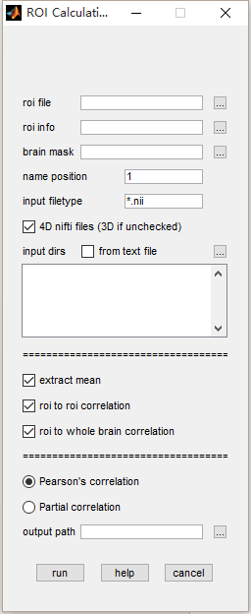 | roi file: ROIs in one nifti file  roi info: labels of tagged ROIs in an .txt file. (optional)  E.g.  1 SFG  2 MFG  3 IFG  brain mask: mask for the data  name position: subject identifier for input data  input filetype: files in the filetype will be searched in input directories.  4D nifti files: if the input data is 4D, check this item. Otherwise uncheck.  input dirs: directories can be input either using a .txt file or spm select window.  extract mean: extract mean time series for each ROI  roi to roi correlation: calculate correlation between pairs of ROI  roi to whole brain correlation: calculate correlation between each ROI’s mean time series and voxels in the mask.  Pearson’s correlation: correlation type  Partial correlation: when calculating correlation, between one roi mean time series and voxels/other time series, the rest of roi mean time serieses will be regressed out from the calculation.  output path: an output directory for saving results.
Step 1: input brain mask and roi file.

Step 2: input data directories and select file type, name position.

Step 3: select what to calculate: mean time series, roi to roi correlation and roi to whole brain correlation.

Step 4: choose correlation type.

Step 5: run.

Spontaneous brain activity
This toolkit was used to calculate the four measures for spontaneous brain activity, that is, amplititude of the time series in time domain (AM), amplitude of low frequency fluctuations (ALFF) and fractional ALFF, fraction gaussion noiseand regional homogeneity (ReHo).
All the input parameters are very simple for the users just need to input the subject list which is included in a txt file.
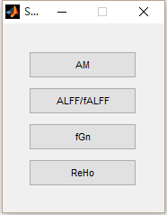 | AM: amplitude strength in time domain  ALFF/fALFF: (fractional) amplitude of low-frequency fluctuation  fGn: fractional Gaussian noise  ReHo: regional homogeneity

3.4.1 Amplitude
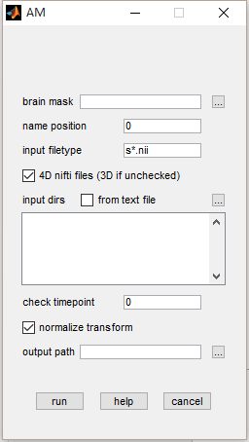 | brain mask: mask for the data  name position: subject identifier for input data  input filetype: files in the filetype will be searched in input directories.  4D nifti files: if the input data is 4D, check this item. Otherwise uncheck.  input dirs: directories can be input either using a .txt file or spm select window.  normalize transform: in output file, a suffix of ‘_m’ means the output is divided by mean intensity in the mask; a suffix of ‘_z’ means the output is subtracted by mean intensity and divided by standard deviation.  check timepoint: check each file for number of time points if the input number is a positive number.  output path: an output directory for saving results.
Step 1: input a whole brain mask.

Step 2: input data directories and select file type, name position.

Step 3: input output directory.

Step 4: run

3.4.2 ALFF/fALFF
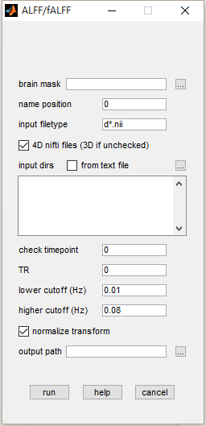 | brain mask: mask for the data  name position: subject identifier for input data  input filetype: files in the filetype will be searched in input directories.  4D nifti files: if the input data is 4D, check this item. Otherwise uncheck.  input dirs: directories can be input either using a .txt file or spm select window.  check timepoint: check each file for number of time points if the input number is a positive number.  TR: repetition time, used as sample frequency 1/TR to estimate width of frequency band.  lower cutoff (Hz): lower cutoff for band pass filter.  higher cutoff (Hz): higher cutoff for band pass filter.  normalize transform: in output file, a suffix of ‘_m’ means the output is divided by mean intensity in the mask; a suffix of ‘_z’ means the output is subtracted by mean intensity and divided by standard deviation.  output path: an output directory for saving results.
Step 1: input a whole brain mask.

Step 2: input data directories and select file type, name position.

Step 3: input TR, lower cutoff and higher cutoff.

Step 4: input output directory.

Step 5: run

3.4.3 fGN
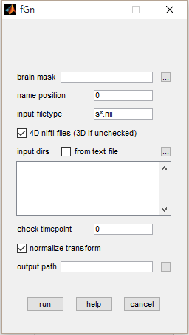 | brain mask: mask for the data  name position: subject identifier for input data  input filetype: files in the filetype will be searched in input directories.  4D nifti files: if the input data is 4D, check this item. Otherwise uncheck.  input dirs: directories can be input either using a .txt file or spm select window.  check timepoint: check each file for number of time points if the input number is a positive number.  normalize transform: in output file, a suffix of ‘_m’ means the output is divided by mean intensity in the mask; a suffix of ‘_z’ means the output is subtracted by mean intensity and divided by standard deviation.  output path: an output directory for saving results.
Step 1: input a whole brain mask.

Step 2: input data directories and select file type, name position.

Step 3: input output directory.

Step 4: run

3.4.4 ReHo
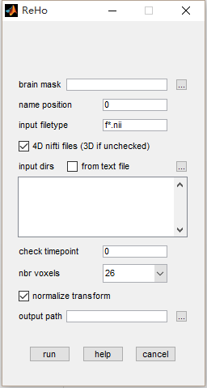 | brain mask: mask for the data  name position: subject identifier for input data  input filetype: files in the filetype will be searched in input directories.  4D nifti files: if the input data is 4D, check this item. Otherwise uncheck.  input dirs: directories can be input either using a .txt file or spm select window.  check timepoint: check each file for number of time points if the input number is a positive number.  nbr voxels: number of neighbor type, 6 face neighbor, 18 for edge neighbor and 26 for vertex neighbor.  normalize transform: in output file, a suffix of ‘_m’ means the output is divided by mean intensity in the mask; a suffix of ‘_z’ means the output is subtracted by mean intensity and divided by standard deviation.  output path: an output directory for saving results.
Step 1: input a whole brain mask.

Step 2: input data directories and select file type, name position.

Step 3: choose neighbor type.

Step 4: input output directory.

Step 5: run

Brain network analysis
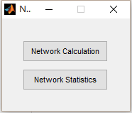 | network calculation: calculate network properties using roi-roi correlation file  network statistics: two-sample’s t-test for network properties

3.5.1 Network construct
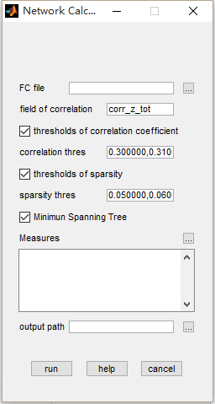 | FC file: file generated from roi-roi correlation, one ‘.mat’ file contains a 3D correlation matrix. The third dimension is subjects.  field of correlation: a variable of correlation stored in the FC file.  thresholds of correlation coefficient: a vector of correlation threshold, for each element, threshold the input matrix’s intensity to a binary network.  thresholds of sparsity: a vector of sparsity threshold, for each element, threshold the input matrix using the fraction of the matrix’s largest number of connection n * (n+1)/2;  minimum spanning tree: a process to avoid unconnected network.  measures: click ‘...’ and a window of network properties will be shown for selection.  output path: an output directory for saving results.  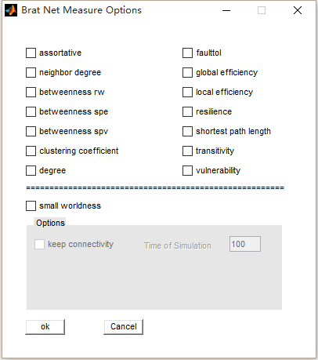
Step 1: input a FC file and specify the variable for correlation matrix in the file.

Step 2: input thresholds of correlation coefficient and sparsity separated by comma or follow matlab input syntax, e.g. 0.3:0.03:0.7

Step 3: choose network properties.

Step 4: input output directory.

Step 5: run.

Measure of brain network is important, which implicate information about network property. BRAT supplies 14 different measures’ either of global or nodal level.
Table 1. List of Measures
Name\Type | Binary | Directed | Weighted | Remarks
Assortative | √ | √ | √
Average Neighbor Degree | √ | √ | √
Average Shortest Path | √ | √ | √ | basic
Clustering Coefficients | √ | √ | √
Global Efficiency | √ | √ | √
Local Efficiency | √ | √ | √
Nodal Degree | √ | √ | √ | basic
Resilience Degree Distribution | √ | √ | √
Random-Walk Betweenness | √ | × | ×
Small Worldness | √ | √ | √
Shortest Path Betweeneess | √ | × | √
Synchronization | √ | × | ×
Transitivity | √ | √ | √
Vulnerability | √ | × | √

3.5.3 Network statistics
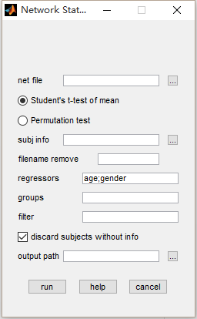 | net file: network file in ‘.mat’ generated by network calculation.  student’s t-test of mean/pemutation test: options for two-sample test.  subj info: subjects information in an excel file, including subject ids, group, regressors (optional), etc.  groups: two groups for two-sample t-test, e.g. SZ;NC.  filter: exclude unwanted subjects in the table, a column with title ‘Filter’ is expected in the excel file.  discard subjects without info: when checked, if subjects’ information are not found in the table, a warning message will be shown; when unchecked, an error message will be shown.  output path: an output directory for saving results.
Step 1: input a network file and choose the type for two-sample t-test.

Step 2: input information for subject and specify fields.
e.g. in an excel file,
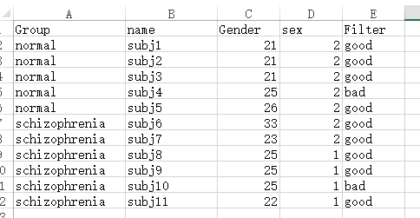
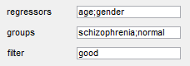
Step 3: input output directory.

Step 4: run.

Statistical analysis
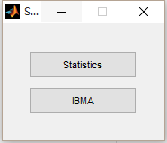 | statistics: one sample and two-sample t-test  IBMA: image based meta-analysis, which is used for combining statistical maps from multiple centers

3.6.1 Matrix & voxel based statistical analysis
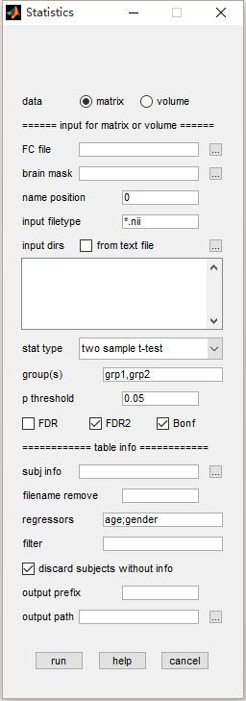 | data: input data can be either matrices or volumes  FC file: file generated from roi-roi correlation, one ‘.mat’ file contains a 3D correlation matrix. The third dimension is subjects.  brain mask: mask for the data  name position: subject identifier for input data  input filetype: files in the filetype will be searched in input directories.  4D nifti files: if the input data is 4D, check this item. Otherwise uncheck.  input dirs: directories can be input either using a .txt file or spm select window.  stat type: one sample t-test and two-sample t-test.  group(s): groups separated by ‘,’ or ‘;’ for one and two-sample t-test, two groups must be fill when selecting two-sample t-test.  P threshold: threshold of p value for multiple comparison correction.  FDR: a parsimonious FDR correction.  FDR2: a loose FDR correction.  Bonferroni: bonferroni correction.  subj info: subjects information in an excel file, including subject ids, group, regressors (optional), etc.  filename remove: inputs for the current program are normally results from calculations and a prefix/suffix will be added to the filename, such as ReHo_subj1.nii. Input ‘ReHo_’ here will remove the prefix and make input file match the information in the table.  filter: exclude unwanted subjects in the table, a column with title ‘Filter’ is expected in the excel file.  discard subjects without info: when checked, if subjects’ information are not found in the table, a warning message will be shown; when unchecked, an error message will be shown.  output prefix (optional): prefix for output file.  output path: an output directory for saving results.
Step 1: choose the input data type.

Step 2: input brain mask, data directories and select file type, name position or one file of correlation matrices.

Step 3: choose statistics type and specify a threshold of p value and multiple comparison correction.

Step 4: input information for subject and specify fields.
e.g. in an excel file,
Step 3: input output prefix (optional) and directory.

Step 4: run.

3.6.3 Matrix & voxel based IBMA
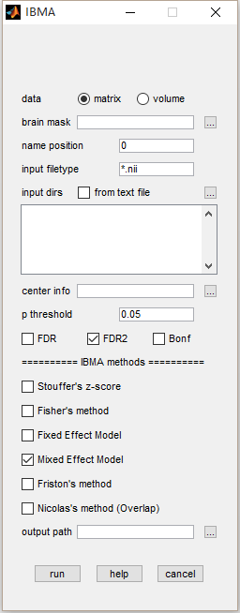 | data: input data can be either matrices or volumes  brain mask: mask for the data. (optional for matrix input)  name position: subject identifier for input data  input filetype: files in the filetype will be searched in input directories.  input dirs: directories can be input either using a .txt file or spm select window.  center info: number of subjects for different centers  P threshold: threshold of p value for multiple comparison correction.  FDR: a parsimonious FDR correction.  FDR2: a loose FDR correction.  Bonferroni: bonferroni correction.  subj info: subjects information in an excel file, including subject ids, group, regressors (optional), etc.  output path: an output directory for saving results.
Step 1: choose the input data type.

Step 2: input brain mask, data directories and select file type, name position or one file of correlation matrices.

Step 3: input an excel file for center information. columns of ‘center’, ‘group1’ and ‘group2’ are needed.
The number specified the number of subjects in the two-sample t-test for group1 > group2.
e.g. 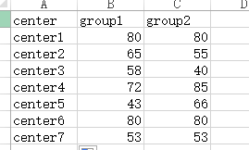

Step 4: select IBMA methods.

Step 5: run.

View
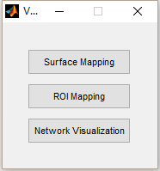 | surface mapping: map volume to surface  roi mapping: display roi in 3D  network visualization: visualization for network

3.7.1 Surface mapping
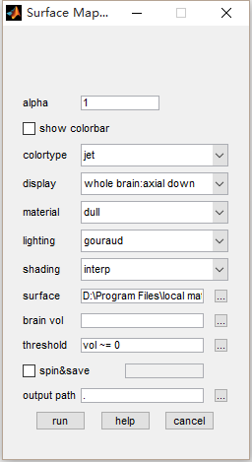 | alpha: degree of transparency  show colorbar: display colorbar  colortype: different colormaps  display: mode of display  material: material of surface  lighting: type of light  shading: type of shader  surface: surface file  brain vol: volume to map to the surface  threshold: use matlab syntax to generate a mask for input volume.  spin&save: spin around a certain degree and save screenshots.  output path: an output directory for saving results.
Step 1: input brain volume.

Step 2: specify other fields. (optional)

Step 3: run.
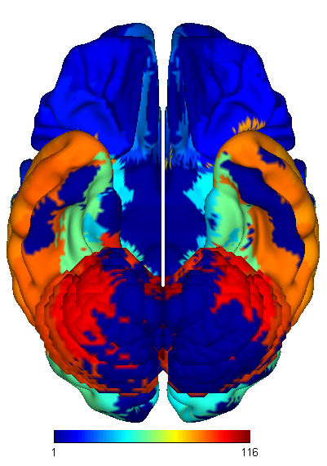

3.7.2 ROI mapping
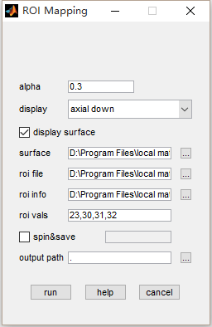 | alpha: degree of transparency  display: mode of display  display surface: show surface  surface: surface file  roi file: extract mean intensity in the roi tagged by numbers.  roi info: labels of tagged ROIs. (optional)  roi vals: select which roi to display  spin&save: spin around a certain degree and save screenshots.  output path: an output directory for saving results.
Step 1: input roi file.

Step 2: specify other fields. (optional)

Step 3: run.
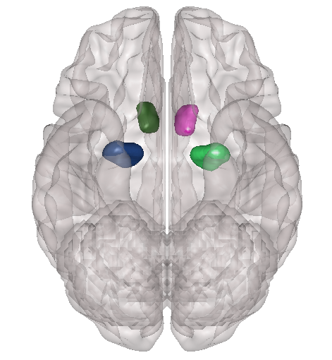

3.7.3 Network Visualization
The Network Visualization is a sub-function of brat that can display node and edge defined as graph theory on the brain surface.
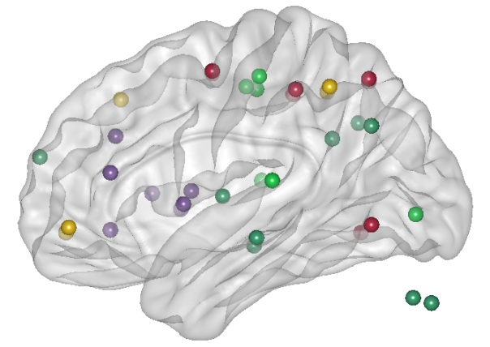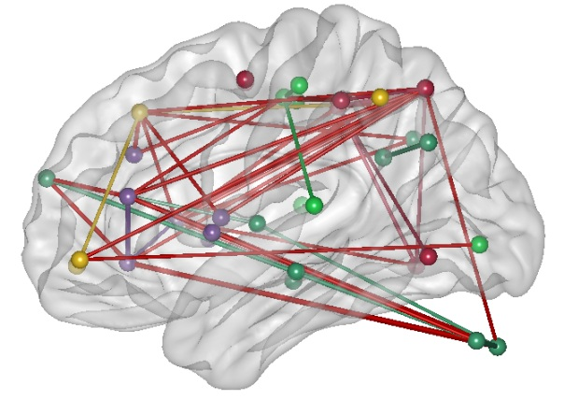

Step 1. Select a surface map
  - standard cerebrum map
  - smooth cerebrum map
  - stand whole brain map with cerebellum (default)

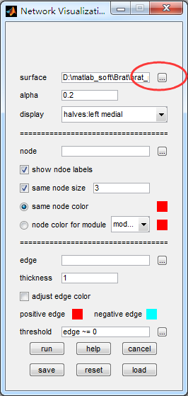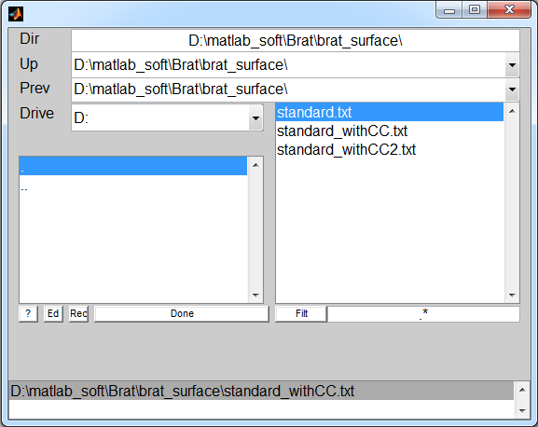

Step 2: Select the alpha value
  - ranges from 0 to 1, is to set the transparency of the brain surface
Step 3: Select the display type
  - halves
  - whole brain
Note: the havles means that the brain will presented as hemisphere and the whole brain means that the brain will presented as a whole brain.
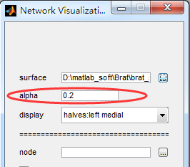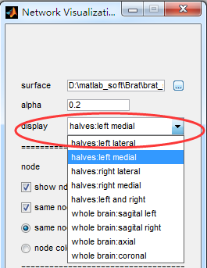

Step 4: Preparation of node file
First prepare a text file or excel file for node information. The text file must contain the coordinates and size of the node which will be displayed on brain surface. Specifically, the first three columns are the MNI coordinates of the node; the fourth column is the node’s size. User can define module for each node using number in the fifth column, user can also define the module color in RGB format in the following three columns. You can add another column to define the node name at last. The excel file is similar with the text file, but there must be a name for corresponding column such as label, coordinates, color, module, and size in the top row.
Options:
  - Node loading
Load the prepared node file in the corresponding folder. For example, /test/node.txt
  - show node labels
Determine whether to show the node names (if have).
  - same node size
Adjust node for same size according to the input in the edit text.
  - same node color
Default is red, if you want to change, just click the color button, then select the use color is fine.
  - node color for module
Users can adjust the node color according to the defined module (if have) on GUI. For each module, just left-click on the colored block, then select color which you prefer on the popup dialog.
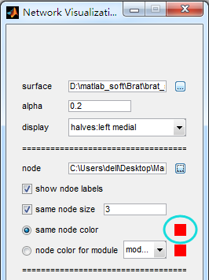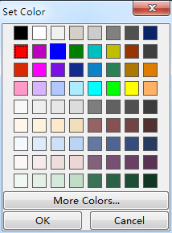

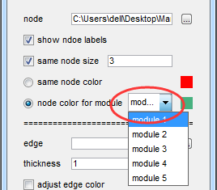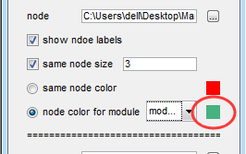
Step 5: Preparation of edge file
Options:
  - Edge loading
The edge file is the correlation matrix of the nodes. Click the pushbutton to load edge file in the right folder. For example.. /test/edge.txt
  - thickness
The thickness can modulate the thickness of edges to present.
  - adjust edge color
The checkbox is to distinguish positive edge and negative edges if necessary. Select color for positive and negative by the same steps aforementioned.
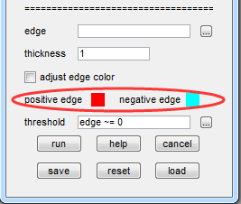
  - Threshold
By this selection, the toolkit will draw the edges according to the defined strength. For example, if you just want to show edges which correlations range from -0.5 to 0.5, you can input ‘edge > -0.5 & edge < 0.5’ in the edit text.
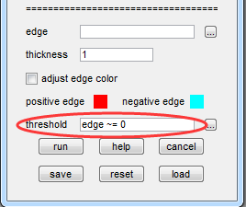
Step 6: Run
Click button of run to run the GUI.
Surprise, you will get…
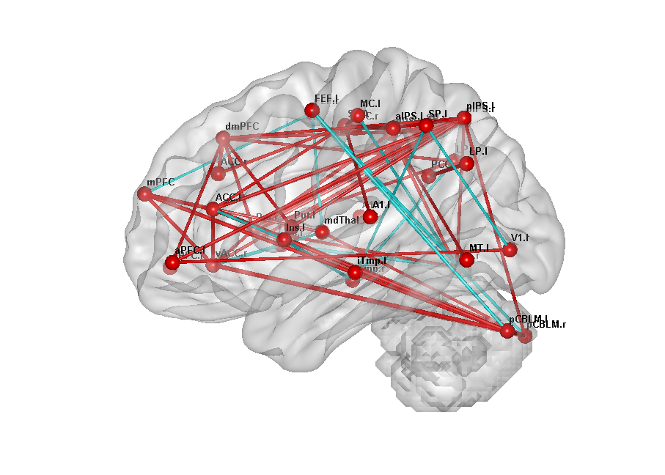
If you want to revise the selection of node or change the color maps of the nodes or edges, please revise the relative check box,then click run.

Examples
In the directory ../brat_test/, there are some test-data.

Test Data

Note: If you have groups of network data, then you can use matlab to make group analysis.

Appendix
The human brain has been described as a large, sparse, complex network characterized by efficient small-world properties, which assure that the brain generates and integrates information with high efficiency. Recently, many researchers have studied this complex structure using the graph theory based on network topological measures. These results showed that the human brain demonstrated small world attributes and modular structure . These kinds of organization can ensure different functional brain regions working together to interact with the world around us at a rapid speed .
An N×N binary graph, G, consisting of nodes (brain regions) and undirected edges (functional connectivity) between nodes. We define the subgraph 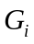 as the set of nodes that are the direct neighbors of the 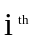node, i.e., directly connected to the i^{th} node with an edge.
Most measures formula were reported in . There we just provide a short introduce to some measures, and where the algorithm appear.

Assortative: In the study of complex networks, assortative mixing, or assortativity, is a bias in favor of connections between network nodes with similar characteristics.
A simple way to say that, a network is said to show assortative mixing if the nodes in the network that have many connections tend to be connected to other nodes with many connections.

Degree: The degree of each node,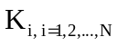, is defined as the number of nodes in the subgraph. The degree of connectivity, 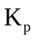, of a graph is the average of the degrees of all the nodes in the graph:
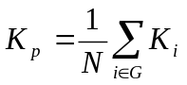,
which is a measure to evaluate the degree of sparsity of a network.
Cost: The total number of edges in a graph, divided by the maximum possible number of edges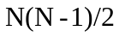:
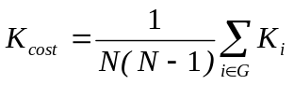,
is called the cost of the network, which measures how expensive it is to build the network .
Clustering coefficients: The absolute clustering coefficient of a node is the ratio of the number of existing connections to the number of all possible connections in the subgraph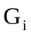:
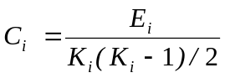,
where 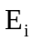 is the number of edges in the subgraph. The absolute clustering coefficient of a network is the average of the absolute clustering coefficients of all nodes:
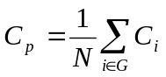.
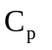is a measure of the extent of the local density or cliquishness of the network.
Shortest absolute path length: The mean of a node is:
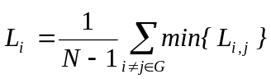,
in which 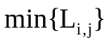is the shortest absolute path length between the node and the 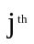node, and the absolute path length is the number of edges included in the path connecting two nodes. The mean shortest absolute path length of a network is the average of the shortest absolute path lengths between the nodes:
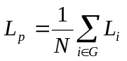
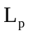is a measure of the extent of average connectivity or overall routing efficiency of the network.
Smallworldness: Compared with random networks, small-world networks have similar absolute path lengths but higher absolute clustering coefficients, that is 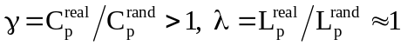 . These two conditions can also be summarized into a scalar quantitative measurement, small-worldness,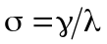, which is typically 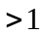 for small world networks . To examine the small-world properties, the values of 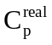and 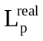of the functional brain network need to be compared with those of random networks. The theoretical values of these two measures for random networks are 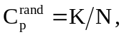 and 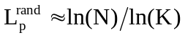. To obtain a better control for the functional brain networks, here we generated 100 random networks for each K and threshold T of each individual network by a Markov-chain algorithm . In the original matrix, if i₁ was connected to j₁ and i₂ was connected to j₂, for random matrices, we removed the edge between i₁ and j₁ but added an edge between i₁ and j_{2.} That means that a pair of vertices (i₁,j₁) and (i₂,j₂) was selected for which 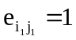, 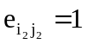, 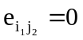, and 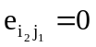. Then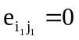,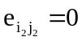, 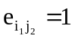 and 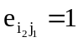. Then we randomly permuted the matrixs which assured that the random matrix had the same degree distribution as the original matrix. This procedure was repeated until the topological structure of the original matrix was randomized . Then we averaged across all 100 generated random networks to obtain a mean 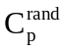and a mean 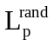 for each degree K and threshold T.
Global efficiency：The global efficiency of a node is:
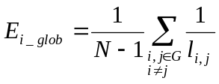
The global efficiency of the network is:
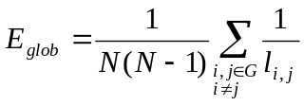
which is the inverse of the harmonic mean of the shortest path lengths of each pair of nodes, demonstrating the global efficiency of parallel information transfer in the network .
Local efficiency：The local efficiency of a node is:
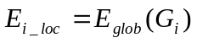
in which subgraph G_{i} is defined as the set of nodes that are the direct neighbors of the node i, demonstrating how efficient the information transfer in G_{i} when the node i is eliminated . The local efficiency of the network is:
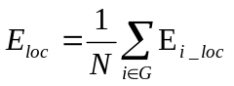
which is the mean local efficiency across all nodes in the network.
Betweenness centrality. The betweenness centrality B_{i} of a node can be calculated as follows: 1) for each pair of nodes in the network (h,j), compute all the shortest paths between them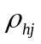, 2) for each pair of nodes in the network (h,j), compute all the shortest paths between them that pass through the node i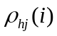, 3) summarize the fraction 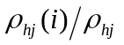 over all pairs of nodes in the network . The normalized betweenness centrality b_{i} was defined as:
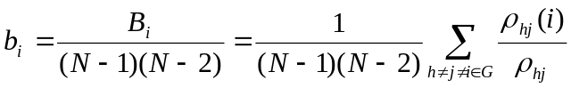
which captures the influence of a node over information flow between other nodes in the network.

Acknowledgements
This work was partially supported by the National Key Basic Research and Development Program (973)(No. 2011CB707800); the Natural Science Foundation of China (Nos. 81270020, 81471120); the Natural Science Foundation of Beijing (No.7152096); the Beijing Nova Program (No. Z1511000003150112).
We thanks for the constructive suggestion by Dr. Nianming Zuo
.

References
[1] Murphy K, Bodurka J, Bandettini PA (2007) How long to scan? The relationship between fMRI temporal signal to noise ratio and necessary scan duration. Neuroimage 34, 565-574.
[2] Liu Y, Yu C, Zhang X, Liu J, Duan Y, Alexander-Bloch AF, Liu B, Jiang T, Bullmore E (2014) Impaired long distance functional connectivity and weighted network architecture in Alzheimer's disease. Cereb Cortex 24, 1422-1435.
[3] Zang YF, He Y, Zhu CZ, Cao QJ, Sui MQ, Liang M, Tian LX, Jiang TZ, Wang YF (2007) Altered baseline brain activity in children with ADHD revealed by resting-state functional MRI. Brain Dev 29, 83-91.
[4] Zou QH, Zhu CZ, Yang Y, Zuo XN, Long XY, Cao QJ, Wang YF, Zang YF (2008) An improved approach to detection of amplitude of low-frequency fluctuation (ALFF) for resting-state fMRI: fractional ALFF. J Neurosci Methods 172, 137-141.
[5] Liu Y, Liu Y, Wang K, Jiang T, Yang L (2009) Modified periodogram method for estimating the Hurst exponent of fractional Gaussian noise. Phys Rev E Stat Nonlin Soft Matter Phys 80, 066207.
[6] Zang Y, Jiang T, Lu Y, He Y, Tian L (2004) Regional homogeneity approach to fMRI data analysis. Neuroimage 22, 394-400.
[7] Bassett DS, Bullmore E (2006) Small-world brain networks. Neuroscientist 12, 512-523.
[8] Gong G, He Y, Concha L, Lebel C, Gross DW, Evans AC, Beaulieu C (2009) Mapping anatomical connectivity patterns of human cerebral cortex using in vivo diffusion tensor imaging tractography. Cereb Cortex 19, 524-536.
[9] Hagmann P, Kurant M, Gigandet X, Thiran P, Wedeen VJ, Meuli R, Thiran JP (2007) Mapping human whole-brain structural networks with diffusion MRI. PLoS One 2, e597.
[10] He Y, Chen ZJ, Evans AC (2007) Small-world anatomical networks in the human brain revealed by cortical thickness from MRI. Cereb Cortex 17, 2407-2419.
[11] Sporns O, Zwi JD (2004) The small world of the cerebral cortex. Neuroinformatics 2, 145-162.
[12] Watts DJ, Strogatz SH (1998) Collective dynamics of 'small-world' networks. Nature 393, 440-442.
[13] Chen ZJ, He Y, Rosa-Neto P, Germann J, Evans AC (2008) Revealing modular architecture of human brain structural networks by using cortical thickness from MRI. Cereb Cortex 18, 2374-2381.
[14] Hagmann P, Cammoun L, Gigandet X, Meuli R, Honey CJ, Wedeen VJ, Sporns O (2008) Mapping the structural core of human cerebral cortex. PLoS Biol 6, e159.
[15] Meunier D, Achard S, Morcom A, Bullmore E (2009) Age-related changes in modular organization of human brain functional networks. Neuroimage 44, 715-723.
[16] Achard S, Bullmore E (2007) Efficiency and cost of economical brain functional networks. PLoS Comput Biol 3, e17.
[17] Bullmore E, Sporns O (2009) Complex brain networks: graph theoretical analysis of structural and functional systems. Nat Rev Neurosci 10, 186-198.
[18] Sporns O (2011) The non-random brain: efficiency, economy, and complex dynamics. Front Comput Neurosci 5, 5.
[19] Sporns O (2010) Networks of the brain, The MIT Press.
[20] Rubinov M, Sporns O (2009) Complex network measures of brain connectivity: Uses and interpretations NeuroImage 5, 11.
[21] M.E.J.Newman (2002) Assortative Mixing in Networks. The American Physical Society 208701, 4.
[22] Latora V, . , Marchiori M (2003) Economic small-world behavior in weighted networks. Eur. Phys. J. B 32, 249-263.
[23] Strogatz SH (2001) Exploring complex networks. Nature 410, 268-276.
[24] Humphries MD, Gurney K, Prescott TJ (2006) The brainstem reticular formation is a small-world, not scale-free, network. Proc Biol Sci 273, 503-511.
[25] Achard S, Salvador R, Whitcher B, Suckling J, Bullmore E (2006) A resilient, low-frequency, small-world human brain functional network with highly connected association cortical hubs. J Neurosci 26, 63-72.
[26] Stam CJ, Jones BF, Nolte G, Breakspear M, Scheltens P (2007) Small-world networks and functional connectivity in Alzheimer's disease. Cereb Cortex 17, 92-99.
[27] Milo R, Shen-Orr S, Itzkovitz S, Kashtan N, Chklovskii D, Alon U (2002) Network motifs: simple building blocks of complex networks. Science 298, 824-827.
[28] Maslov S, Sneppen K (2002) Specificity and stability in topology of protein networks. Science 296, 910-913.
[29] Latora V, Marchiori M (2001) Efficient behavior of small-world networks. Phys Rev Lett 87, 198701.
[30] Freeman LC (1978) Centrality in social networks conceptual clarification. Social Networks 1, 215-239.
[31] Girvan M, Newman ME (2002) Community structure in social and biological networks. Proc Natl Acad Sci U S A 99, 7821-7826.
[32] He Y, Chen Z, Evans A (2008) Structural Insights into Aberrant Topological Patterns of Large-Scale Cortical Networks in Alzheimer's Disease. The Journal of Neuroscience 28, 4756-4766.

