Dyntrace: An Instruction-Level Dynamic Tracer for Characterization of Processor-Bound Workloads
Kelly Yancey
CSC 697 – Senior Project, Fall 2004
Supervised by Dr. Dujmović

Introduction 1
Design Overview 3
Dynamic Tracing 5
Region Differentiation 9
Opcode Identification 12
Instruction Fetching 12
Instruction Decoding 13
Instruction Timing 16
Case Study: Intel Pentium 4 Processor 17
Results 18
Conclusions 20
Future Work 21
Summary of Appendices 22
Bibliography 24

Introduction

For this project, a dynamic trace tool was developed for collecting application execution profiles including instruction frequencies and timings for the purpose of facilitating research in the field of workload characterization. The goals of this project were:
- To gather a complete profile of every instruction executed by an application for the purpose of compiling a histogram of instruction frequencies.
- To be able to get timings for all instructions executed on systems that support CPU cycle-resolution timers.
- To differentiate the regions of the traced program’s memory in order isolate instructions executed in runtime-generated code from those of the main program or its libraries.
- To be portable across a variety of UNIX and UNIX-like systems.
- To be easy to use.

All development has been done concurrently on FreeBSD 4.10 and FreeBSD 5.3; preliminary work was performed for porting to Solaris in order to verify the portability of the trace tool’s design. The tool is written in ANSI C, utilizing POSIX-specified library routines as much as possible. The primary obstacles to portability are differences between make tool implementations, C headers and libraries, and kernel interfaces.
The dyntrace utility executes another process a single instruction at a time, collecting a profile of the instructions executed, their frequencies, and optionally, their timings and location within the program’s virtual memory map. The output is written as an XML document that can be manipulated by other utilities. Included in the dyntrace distribution are tools for simple opcode grouping and visualization. It is a key design feature that dyntrace perform no filtering itself, collecting all possible data about the target process’ execution; this allows the researcher the freedom to experiment with various transformations on the execution profile without having to re-collect the trace anew each time.
The basic functionality of dyntrace is that of gather frequencies of executed instructions in the traced process. This functionality is implemented by the ptrace interface, which was first implemented on Version 7 of AT&T UNIX [Bach, 1986]. While there appear to be slight differences in the services offered by various systems via the ptrace interface, all appear to implement sufficient services for dyntrace to collect instruction frequencies. In particular, dyntrace uses the ptrace API for single-stepping the traced application one instruction at a time, read the traced process’ registers to get the value of the program counter, and read the traced process’ virtual memory to get the instruction currently pointed to by the program counter.
The region differentiation feature is implemented via the procfs filesystem. The procfs filesystem is a virtual filesystem which was first implemented in Sun Unix 2.0 in 1985. While many systems implement procfs, its semantics vary widely from system to system, posing a portability issue. Furthermore, even if an operating system implements procfs, depending on the system administrator’s policy, it may not be accessible to the user running dyntrace. For example, while FreeBSD 5.3 implements procfs, it is not mounted by default; the system administrator must choose to mount the procfs filesystem such that it is readable to the user running dyntrace. The dyntrace tool will log a warning in procfs is not available but continues the trace without region differentiation.
Instruction timing is by far the most hardware and operating system specific feature implemented by dyntrace. To include instruction timings in the execution profile, it is required that the CPU supports a CPU cycle counter which only increments when executing user-land code (as opposed to kernel code) and that the operating system virtualizes this counter per process. All Intel CPUs in the x86 processor family since the Pentium Pro, as well as the Pentium MMX, support the necessary CPU cycle counter, as do many late-model x86 work-alike processors. The issue, then, is operating system support for further refining the counter to per-process resolution. No version of FreeBSD currently has this feature; Joseph Koshy of the FreeBSD Project is currently porting this feature, in the form of the PMC API, to the FreeBSD 6.0 development branch. We have ported this API to FreeBSD 5.3 as a set of patches with the hopes of getting the functionality included in either the FreeBSD 5.4 or 5.5 release. Furthermore, his work only supports the Intel Pentium 4 and AMD K7 processors; we are working with him to include support for earlier model Pentiums at a future date. The dyntrace tool must be specially compiled to enable using the PMC API (since it is not available without our patches). Even if the API is available, if the CPU is not an Intel Pentium 4, dyntrace logs a warning and continues the trace without gathering instruction timings.
With regards to ease of use, dyntrace follows the UNIX paradigm of “small, sharp tools”; that is, dyntrace does one thing and attempts to do it well: collect an execution profile by tracing an application. The execution profile output by dyntrace is an XML document that can be post processed by other tools as the researcher desires. A few such tools are included in the dyntrace distribution. Furthermore, while dyntrace accepts command-line flags to modify its behavior, the defaults were chosen such that use of such flags is not required for normal operation. As a result, the vast majority of applications can be traced simply by prefixing their command line with “dyntrace”. For example, to trace the command:
gzip –-best somefile
the user would issue the command:
dyntrace gzip –-best somefile

Design Overview

For the purpose of the instruction tracing, the CPU hardware can be reasonably modeled as simply an instruction stream in memory, a program counter indicated the processor’s current instruction in that stream, a trace trap flag indicating whether the processor should generate a trace trap after the next instruction executed, and optionally a set of performance counters. However, under a multi-user operating system like UNIX, each process has its own CPU state and virtual memory that is not accessible to other processes except via special OS-provided facilities. The operating system is responsible for multiplexing access to the real hardware between all user applications. For the most part, this virtualization is transparent to applications.
The operating system does not always present an exact replication of the hardware functionality to processes via virtualization. One example is the file system: the operating system does not present applications with a virtualized via of the raw storage device, but rather presents storage to applications as an organized, hierarchical structure. Another, more immediate, example is virtual memory: the operating system presents the application with the view that it is the only program in memory and, potentially, that there is much more memory available to the program than there is physical memory. One implication of the virtual memory system is that the operating system must track which parts of the processes’ memory spaces are backed with physical memory, swap space, or files in the file system. Memory regions that are backed by files in the file system usually represents executables or libraries loaded into the process memory map; the operating system must keep track of which file backs the virtual memory so that pages of memory can be loaded from the file as they are accessed. The implementation detail is common to most modern UNIX-like systems and is thus used by dyntrace to implement region differentiation.
UNIX-like operating systems provide a number of such high-level services including interprocess communication and networking. For the purpose of tracing, however, we are only interested in a subset of these services. In particular, if the CPU can be modeled as physical memory and CPU state then the operating system can be modeled as virtual memory and virtualized per-process or per-thread CPU state. Furthermore, hardware interrupts are handled by the operating system and may be translated into signals, which like interrupts are delivered to processes asynchronously. Generally this virtualization is transparent, however interfaces such as ptrace and procfs make the abstraction visible to applications that are interested.
Figure 1 – Example system relationships
userland
kernel

Analysis and Visualization
Dyntrace
Registers
Performance Counters
Trace Flag
CPU Hardware
ptrace

procfs
PMC
Operating System
Physical Memory
Process Isolation
libpmc
Dyntrace
Opcode Grouping
Postprocessors
Opcode Filtering

Signals
Interrupts and Traps
Hardware Virtualization

Dynamic Tracing

In the context of dynamic tracing, the virtualization of the CPU trace trap flag is particularly relevant. The trace trap flag is typically stored in a separate process control word, however it is stored as part of the general register set’s EFLAGS register in x86 processors. As such, it is saved and restored along with the other registers each time the operating system’s scheduler preempts or reschedules a process. As a result, the CPU hardware only generates trace traps after executing each instruction processes which have the trace flag set, allowing one to selectively trace processes. The predominant method for implementing a dynamic tracer is to replace or extend the operating system’s trace trap handler to collect information about the process executing when the trace trap occurred. The general logic of such a tracer is:
- Initialize execution profile.
- Install trace trap handler.
- Set the virtualized trace flag for the process to trace.
- Start process’ execution
- Trace trap handler is invoked:
  - Update execution profile with instruction at current program counter.
  - Set the virtualized processor trace flag for the current process.
  - Continue execution (go to step #5) until process exits.

Note that without the trace flag being virtualized, there is no way to selectively trace just a single process in a multi-user system. With virtualization of the trace flag, tracing multiple processes concurrently merely requires the trace trap handler maintain separate execution profiles per traced process. This method seems ideal except that it requires the ability to install a new trace trap handler. None of the operating systems investigated by the author support user-installable trace trap handler routines. While the possibility exists with open source operating systems to modify the trace trap handler and recompile a custom kernel, such customizations are intimately tied to the operating system and hence are not portable between systems. Nevertheless, kernel modifications are generally out of the question for commercial operating systems.
However, every POSIX-compliant operating system’s default trace trap handler translates the trace trap into a SIGTRAP signal that is delivered to the process that caused the trap. By itself, this is not particularly useful, as the trace tool needs to be external to the process being traced in order to collect an accurate execution profile of the process. The ptrace system call, first introduced with AT&T’s System 7, solves the issue by allowing users to control their own processes via another process. Predominately used for implementing debuggers, the ptrace interface allows one process to control another process, intercept their signals, and read or write their virtual memory or CPU state. The dyntrace utility uses this API, effectively acting as the process debugger, to trace the target process. The advantage of this approach is that it is portable across numerous operating systems running on a variety of hardware platforms. Almost every modern UNIX-like operating system has implemented this API, abstracting the machine-dependent implementation behind a mostly opaque interface. In addition, the ptrace API is available to all users of the operating system to trace their own processes; this allows dyntrace to be used to trace applications without requiring operating system modifications or administrator-level privileges on the system.
The ptrace interface provides applications the ability to view the virtualized processor state and virtual memory of another process. In addition, the interface allows applications to control the execution of the target process. Control is implemented by stopping the target process, removing it from the OS scheduler’s run queue, whenever a signal is received. Whenever the target process stops, a SIGCHLD signal is delivered to the controlling (e.g. debugger) process notifying of the event. The target process calls the wait(2) system call to learn the signal number that caused the target process to stop. The controlling process can then issue commands to the kernel via the ptrace system call to read or write the target’s virtual memory, examine or modify the target’s virtualized register set, or continue the target process with or without the trace trap flag set and optionally specify a signal to be delivered to the target process when it resumes. The latter functionality allows the signal learned from wait(2) to be forwarded to the target process or the signal may be filtered by resuming execution without passing the signal to the target.
Keeping in mind that the operating system translates trace traps into SIGTRAP signals delivered to the traced process, the general logic of dyntrace is:
- Initialize execution profile.
- Attach to target process as debugger.
- Request that the OS set the virtualized trace trap flag for the target process.
- Start process’ execution.
- Operating system’s default trace trap handler is invoked:
  - Send SIGTRAP to process that caused the trap.
  - Suspend the target process, removing it from the OS run queue.
  - Send SIGCHLD to controlling process (dyntrace).
  - Dyntrace catches SIGCHLD.
    - Call wait(2) to get the process ID of the stopped process and original signal to be sent to it (SIGTRAP).
    - Update execution profile with instruction at current program counter.
    - Continue the target process’ execution with the trap bit set (go to step #5) until process exits. Do not forward SIGTRAP to the traced process.

In this manner, the traced application is unaware that it is being traced as the SIGTRAP signals are filtered by dyntrace while any other signal is forwarded to the target process as usual. Furthermore, it is crucial that SIGTRAP signals not be delivered to the process being traced as the default action is for the process to terminate on receipt of a SIGTRAP. Since the application is unlikely to have installed a custom SIGTRAP handler in anticipation of being traced, forwarding the SIGTRAP signal to the traced process will usually trigger this default action.
The ptrace interface provides two methods for attaching to processes in order to control them: the process to be traced can be specified by its process identifier (pid) or a child process can request to be traced by its parent. The latter method allows the tracer to fork a child process, have it request to be traced, and then execute a new program; the trace begins with the first instruction of the new program. The dyntrace utility uses this child process tracing by default, as it is the only method of the two to allow an entire program to be traced from start to finish. Attaching to an existing process by pid is supported by dyntrace using the –p command-line option, however its usefulness is questionable since it only allows one to trace a portion of a program without much control over which portion is traced.
Finally, during the implementation of dyntrace, we discovered a bug in FreeBSD in which children of a traced process would inherit the parent’s trace flag without inheriting the parent’s debugger attachment. The result was that any child process forked off of the process being traced would immediately generate a trace trap after their first instruction, the operating system would translate the trap into a SIGTRAP signal and deliver it to the new process. However, since the ptrace attachment was not inherited by the new process, the signal could not be intercepted by the tracer. As the default SIGTRAP handler is to terminate the process, this would cause the new process to immediately terminate. We identified the offending code in the FreeBSD kernel and wrote a patch to correct the behavior. This patch is included in the dyntrace distribution under the “patches” subdirectory, however it has since been committed to the FreeBSD source management system for inclusion in future releases including FreeBSD 5.4 and later. The kernel code affected appears to have been inherited by FreeBSD from 386BSD so it is likely the other BSD-derivatives contain the same bug. Note that this bug does not affect the traced process itself, only child processes that it forks. As a result, even if the operating system contains the bug described here, it is possible to trace programs that do not fork additional processes.
Only common operating system interfaces are used to access and control the target process, making this method useable across multiple UNIX and UNIX-like operating systems, open source or commercial. Comparing the logic for a prototypical dynamic trace tool with that of dynprof, it is obvious that using the debugger interface dyntrace incurs additional overhead per trace trap. However, using the operating system’s debugger facilities for dynamic tracing makes it possible to collect instruction-level traces even on platforms for which the operating system’s trace trap handler cannot be modified or the user lacks sufficient privilege to modify it.

Region Differentiation

The primary purpose of region differentiation is to determine whether the program counter is in program code, library code, or runtime-generated code. While UNIX-like operating systems present a single virtual address space to the application, this address space is divided into regions based on the type of backing store for the memory or the access permissions of the pages comprising the region. For virtual memory backed by files in the filesystem, such as the program or library binaries, the regions generally correspond to linker sections in the binary. Systems that implement the Solaris /proc filesystem (procfs) or a reasonable work-alike export a list of these memory regions in the form a virtual file readable from userland via the filesystem. However, the amount of information the operating system exports about processes’ memory maps varies from system to system. For example, FreeBSD 5.0 and later report the filename of files that back virtual memory regions whereas prior versions do not.
If procfs is available on the host operating system, dyntrace then reads the procfs file corresponding to the traced process’ memory map. Based on the information available in the map, dyntrace attempts to categorize the traced process’s memory regions as program text, library text, heap data, or stack. If enough information is not available for full differentiation, then a region may be simply categorized as text or non-text. Finally, if the operating system does not export any information about the traced process’s memory map, the entire process virtual memory may be considered a single region of unknown type.
text:program
data
08048000-0804a000
0804a000-0804c000
non-text
0804c000-0804e000
text:library
40000000-40013000
data
40013000-40014000
text:library
40016000-40129000
data
40129000-4012f000
data
4012f000-40133000
stack
bfffe000-c0000000
r-x
rw-
rwx
r-x
rw-
r-x
rw-
rw-
rwx
Address Range
Permissions
Figure 2 – Sample memory map (/bin/cat under Debian with Linux 2.4.18 kernel)
Each time the traced process stops, dyntrace uses the ptrace interface to request a copy of the contents of the traced process’ virtualized register set, including the process’ program counter. The memory map is then searched to locate which region contains the address corresponding to the current program counter. Separate opcode frequency and timing counters are maintained per type of memory region. The opcode usage and timing counts are then reported separately by memory region type in the execution profile output by dyntrace, providing an extra dimension for workload characterization. As a trivial example, one could consider only opcodes executed in non-text regions (stack and data regions). This allows the native instructions emitted by runtime compilers to be characterized and compared without including the opcodes of the runtime compiler itself. Region differentiation information could also be used for opcode weighting in workload difference formulas.
Using FreeBSD 5.3 as an example, it is possible to distinguish a memory region holding program text from one that holds library text because the procfs map file indicates the file, if any, that backs the pages in the memory region. Furthermore, on FreeBSD, the address of the top of the process’ main stack is the same for every process and can be obtained via the sysctl interface, making it possible to uniquely identify the region ending at that address as being stack. However, the remaining regions cannot be uniquely identified as being data; such regions may also represent per-thread stacks in a multithreaded process. As such, dyntrace simply assigns the type of non-text to the remaining regions. It is likely that the resolution of differentiation will be different as dyntrace is ported to use the procfs facilities available on other platforms.
One issue with region differentiation is that the memory map may change as the traced program executes. At the most trivial, a data region representing the program heap may be extended to accommodate dynamic allocations made via the C malloc routine (which in turn uses the sbrk UNIX system call to extend the heap). Other possibilities include stacks that auto-grow at runtime or programs that explicitly call a dynamic linking interface like dlopen to load addition code into their virtual address space. Nonetheless, to guarantee correctness, dyntrace must accommodate the possibility that the memory map may change during the traced process’ lifetime. As loading the memory map is a non-trivial operation, we would prefer to not have to reload the map after every instruction. The general logic implemented by dyntrace is to record the memory map once when the trace starts and then reload the map any time the program counter is not located in any region currently in the memory map. The rationale is that regions may grow and new regions may be added to the map, but regions never shrink.
Regions may be removed however, for example by calling dlclose on a library previous brought into the virtual address space via dlopen or calling munmap on a region that was previously created via mmap. The removal of regions is generally of no concern as the program counter can be reasonably assumed to never be in unpopulated regions of memory. In this case, it does not matter that dyntrace’s copy of the memory map is stale and still contains the removed region. However, if another region were to be loaded using dlopen or mmap or if an existing region were to be extended into the address space previously occupied by the removed region, there is a chance that dyntrace may continue using the stale map, potentially attributing the instructions to the wrong type of memory region. In practice, however, this does not appear to be an issue as few applications use the dlopen interface; those that do tend to leave the library loaded for the program’s entire lifetime. Even if libraries are repeatedly loaded and unloaded in the same memory range, dyntrace only differentiates regions based on their type and type of the region, library, does not change. The mmap system call presents extra challenges in that it allows both text and non-text regions to be loaded into the process address space dynamically; fortunately, it appears that most applications that use the mmap interface only map regions of a single type, usually data, allowing dyntrace the same margins of safety as in the dlopen case. That said, the current caching of the traced process’s memory map is an area where additional development could be focused in order to handle even the most creative uses of these two interfaces. Similarly, the issue of memory map caching would need to be revisited if dyntrace were ever to be extended to differentiate regions not just by type, but also differentiate library regions by the library filenames.

Opcode Identification

For each instruction executed by the traced process, the tracer has to read the instruction at the current program counter and identify the instruction’s opcode in order to update the appropriate opcode usage and timing counters. For the purpose of discussion, we use the term “instruction” to refer to an entire unit of execution by the CPU hardware, which can be further subdivided into its constituent opcode, operands, and optional prefixes. Currently, dyntrace only identifies the opcode and any prefixes; operands are ignored.

Instruction Fetching

Since dyntrace runs as a user-land process, it does not have direct access to the memory of the traced process in order to read the instruction stream. As a result, it uses the either the operating system’s ptrace system call or the procfs filesystem to read the instructions. Dyntrace implements interfaces for both methods on FreeBSD, although only the ptrace interface is actually used in the current implementation. On some operating systems, applications are limited to reading four bytes at a time via ptrace; on such systems the procfs filesystem offers an alternative for reading larger amounts of data from the target process’ instruction stream with a single system call. Unless the CPU’s instructions could be longer than four bytes, even on systems implementing the restricted ptrace interface, the entire instruction could be read in a single system call using the ptrace.
In addition to the region types described in the previous section, memory regions may have further permissions attributes associated with them to indicate whether the region may be modified (for example, as shown in Figure 2). If a memory region is immutable, it is possible for dyntrace to cache its contents. Since reading the target process’ memory requires at least one system call, dyntrace implements an instruction cache up to 1 megabyte in size per read-only region in order to minimize the tracing overhead. It is when populating the cache that having an interface that allows reading more than four bytes at a time is advantageous. On FreeBSD, arbitrarily large mounts of process memory can be read via the ptrace interface.
Only read-only regions are cached so that the trace is consistent even for self-modifying code. Nonetheless, the cache still needs to be invalidated whenever the target application calls a system call in the execv family of calls that load new executable images into the current process. These system calls completely replace the contents of the process’ virtual memory with new contents loaded from an executable and its libraries, removing or changing the contents of even “immutable” memory regions. Support for detecting when a new executable image is loaded varies considerably depending on the operating system. Under FreeBSD, for example, the kqueue [Lemon, 2001] API is used to receive notification whenever the traced process loads a new executable image. If dyntrace is ported to an operating system that cannot provide such notification, the system-specific region map parsing code must mark all regions as mutable in order to guarantee correctness of operation at the expense of speed.

Instruction Decoding

For many virtual machine and RISC instruction sets, isolating the opcode in an instruction is a trivial bit mask operation, the result of which can be used as an index into a small array of counters. However, CISC architectures do not fit this model as they tend have large instruction sets usually with sparsely populated opcode spaces. The ubiquitous Intel IA-32 instruction set architecture, the instruction set targeted by all dyntrace development thus far, has variable-length instructions and inconsistent instruction encoding, complicating opcode identification. In order to support quickly identifying opcodes from CPU instructions across a variety of instruction sets, dyntrace utilizes a modified radix tree [Sedgewick, 1990] with masking capabilities. The data structure used is the same as used to implement routing table lookups in 4.4BSD and descendent operating systems [McKusick, 1996]; it is optimized for finding the best matching bit string in the tree where each bit string represents a known opcode encoding. When dyntrace starts, it populates this tree with a list of opcode encodings loaded from an opcode description file for the CPU. During the trace, the bit string pointed to by the traced process’ program counter is used as a search key in the tree to locate the corresponding opcode. Unknown opcodes are matched by a default least-specific matching entry with the artificial mnemonic of “unknown”.
The IA-32 instruction set architecture presents another obstacle to opcode classification in that opcodes may be preceded by multiple prefix bytes. These prefix bytes modify the operation of the instruction’s opcode, for example locking the processor bus for the duration of the instruction or modifying the size of the data the instruction operates on, hence their presence can affect the instruction’s timing. The order of any prefix bytes is irrelevant. Dyntrace allows prefix bytes to be included in the opcode description file and stores these prefix bytes in the opcode tree just as it does actual opcodes. As the opcode tree is populated, dyntrace assigns a unique integer number to each prefix, up to 32 of them, which will be later used to compose a bitmask of all prefixes applied to a single opcode.
Each time the traced process is stopped, the opcode tree is searched using the bit string at the process’s program counter as the search key; if the lookup returns a prefix byte, the prefixed matched is recorded and the opcode tree is queried again using the bit string following the prefix byte. This process is repeated until the tree search returns an opcode record. Empirically, it is rare for an instruction to have even a single prefix so the common-case is that the opcode is located on the first search. Meanwhile, the IA-32 instruction set guarantees that the length of an entire instruction cannot exceed 15 bytes so the pathological case is that it takes 15 tree lookups for a single instruction [Intel 2004]. In all cases, though, it is guaranteed that an opcode record will be located by the search, even if it is the default “unknown” opcode. Each prefix byte identified in the search for the opcode is added to a prefix set. Since prefixes may affect the instruction timing, dyntrace maintains separate frequency and timing counters for each combination of prefixes used with an opcode. For example, consider the follow bit string starting at the traced process’ program counter:
Figure 3 - Sample instruction encoding; opcode highlighted
LOCK
CMPXCHG
…
11110000
000011111011000111
0010000000001111101101101…
1st lookup:
2nd lookup:

The first lookup in the opcode tree is performed with the word of data (i.e. 32 bits) from the instruction stream starting at the traced process’ program counter; in the example above, it will locate the entry for the LOCK prefix. Since the opcode has not been identified yet, a second lookup is performed with the next word of data from the instruction stream starting immediately after the prefix; in this case, the entry for the CMPXCHG opcode is located and the search terminates. Any operands for the opcode will follow the opcode in the instruction stream, but those are currently of no interest to dyntrace and are thus ignored.
For each prefix found, a prefix mask is constructed by setting the bit in the position corresponding to the prefix’s unique identification number assigned when dyntrace started. The opcode tree contains a list of counters organized by memory region type; this list always contains a single entry per region representing the opcode count with no prefixes. If the prefix mask for the current instruction is non-zero, meaning at least one prefix was present, the list of counters for the current memory region is searched for an existing counter matching the current prefix mask. If one is found, it is updated to include the current instruction’s execution and timing; if no counter exists for the current prefix mask, a new counter is appended to the counter list. The general logic for updating an opcode counter is:
- Get region type for current program counter.
- Initialize prefix mask to zero.
- Initialize instruction scan position to current program counter.
- Lookup an entry in opcode tree using the word at the instruction scan position.
- If entry represents an opcode prefix,
  - Set bit #prefix.id in the prefix mask.
  - Increment the instruction scan position.
  - Go to step #4.
- Iterate through opcode’s counter list for region type
  - If an existing counter record has the same prefix mask, increments its usage count and update CPU cycle coun.
  - If no existing counter has the same prefix mask, append a new counter record to the list with an initial usage count of 1 and CPU cycle counter of however many cycles it took to execute the current instruction.

Instruction Timing

Many modern processors implement hardware performance counters that can be used to count various events within the CPU. Gradually, operating systems have been adding support for these counters in the form of per-process virtualization and APIs to access these counters from userland. If the operating system supports a CPU cycle counter that only increments when executing instructions in a given user-land process, dyntrace uses it to measure the timing of each instruction executed in the traced process. If no such support is available, a warning is issued at run-time and timings are omitted from the execution profile.
However, instruction timing is currently the least well-supported feature of dyntrace, requiring special compilation to enable it; one significant reason for this condition is the lack of support for accessing the CPU’s performance counters on FreeBSD, where most of the development of dyntrace has been done until now. There is however, a porting effort underway by Joseph Koshy of the FreeBSD Project to add support to FreeBSD 6.0 for the PMC interface, which first appeared in NetBSD 2.0. The current state of his porting work is sufficient for dyntrace to collect instruction timings on Pentium 4 processors. We have produced patches, backporting his development from the 6.0 development branch of FreeBSD to FreeBSD 5.3. We are currently working with Joseph Kishy to add support for earlier model Pentium processors.
The major caveat with regards to instruction timings is that the act of tracing greatly perturbs their values. Modern processors have multi-cycle pipelines in which multiple instructions may be executing simultaneously; dyntrace traps to the system trace trap handler after each instruction, eliminating all such parallelism. In addition, processors rely on branch prediction to pre-fetch instructions; the Intel Pentium line of processors cannot predict the return from interrupt handlers so the odds of the processor stalling on return from the trace trap handler while the next instruction is being read from memory is increased. Another issue is the disturbance of the CPU’s code and data caches. The trace trap handler and dyntrace together execute hundreds of instructions for every single instruction executed by the traced process. As a result, it is much less likely for the traced process’s code and data to be cached by the CPU than if it were not being traced. Any and all of these factors prevent instruction timings from being exact.
However, the effect of tracing should be uniform on all instruction timings, making them eligible for normalization by a post-processing utility. These normalized timings can then be used to compute relative timings of the opcodes for use as weights in workload difference equations.

Case Study: Intel Pentium 4 Processor

With the Pentium 4 architecture, Intel has moved to extremely long fetch/decode/execute/store pipelines in the processor [Intel, 2004]. Currently, the pipeline is between 20 and 28 stages long, making pipeline stalls an obstacle to peak performance. As a result, the CPU aggressively tries to prefetch data, predict branches, and execute as many independent instructions concurrently in order to keep the pipeline full. However, far calls, interrupt returns, and software interrupts are not branch predicted so they always incur a pipeline stall. Since the act of tracing a running program requires an interrupt per instruction, and returning from an interrupt is not branch predicted, we can expect instruction timings to always be 20-28 cycles higher than they would be in normal execution. On top of that, since the pipeline is cleared after each instruction, all implicit parallelism in the original program is also eliminated during profiling. The Pentium 4 also has instructions for explicit parallelism (Single Instruction Multiple Data, i.e. vector, instructions) that are not affected by the profiling process. In any event, the Pentium 4 can execute up to four instructions simultaneously if there are no dependencies between their results. Again, though, since instruction-level software trace tools like dyntrace cause a trace trap for every instruction and the pipeline is cleared on return from the operating system’s trace trap handler, this parallelism is lost. The 3.06Ghz and faster model Pentium 4 processors further increase parallelism via simultaneous multithreading ("HyperThreading"). This feature allows a single CPU core to execute instructions from two threads simultaneously in order to keep all function units busy. It does this by presenting two logical processors to the operating system, each with their own program counter and register sets, however both are actually implemented in the same silicon and share function units. Since this level of parallelism is between separate threads of execution rather than between instructions in a single thread, it is not expected that this will introduce any additional difference in instruction timings with and without tracing.
In summary, the act of dynamically tracing an application using a software trace tool will eliminate all pipelining of instructions and implicit parallelism in the original application. The elimination of pipelining can skew instruction timings by up to 28 cycles, but the skew should be able to be compensated for. The elimination of implicit parallelism may further skew the timings by up to four instruction times (normal execution speed cycle counts). However, we are not currently aware of any way to easily determine how much this factors into the instruction timing so it cannot be compensated for. The issues involved are the lack of ability to determine either a) the number of instructions the processor would have scheduled simultaneously if we were not interrupting after each instruction and b) how many cycles would have been "eliminated" by running those instructions in parallel.

Results

Using dyntrace to trace the execution of the prime number generator /usr/games/primes on FreeBSD, differentiating between opcodes executed from the program itself and libraries it calls, and grouping by opcode mnemonic the sample results on the following page were obtained. See Appendix 6 for the raw trace and intermediate postprocessor files.
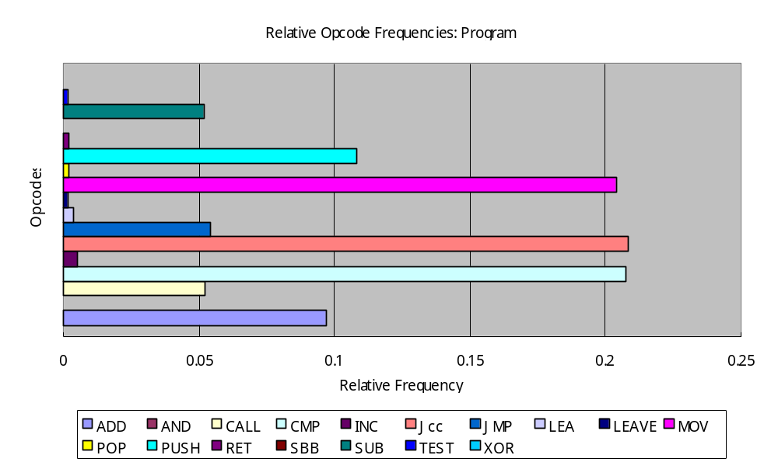
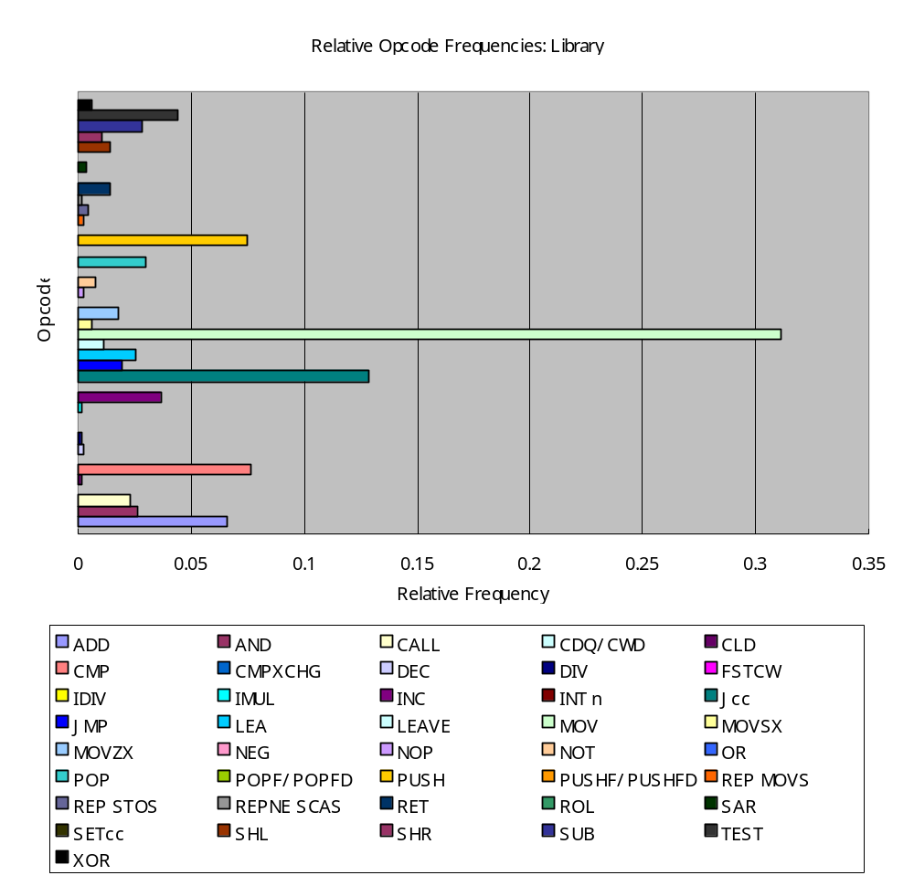

Conclusions

A large number of obstacles were encountered while trying to implement a portable dynamic tracing utility; the most persistent obstacle being the overhead required to circumvent the operating system’s process isolation mechanisms to obtain a consistent view of the traced process’ state. A tracer implemented within the operating system kernel is guaranteed to always have a consistent view without incurring any overhead, but would be inherently non-portable.
We found that the existing kernel interfaces for accessing another process’ state from a userland process account for a large percentage of the wall-time required for dyntrace to trace an application. If nothing else, it can be expected that 10 context switches are required between dyntrace and the kernel:
- One context switch to request the kernel set the trace flag on the target process and resume its execution.
- One context switch for the kernel to notify dyntrace when it stops the traced process due to a trace trap,
- Another two for dyntrace to get what signal caused the traced process to stop (SIGTRAP for tracing or some or signal that needs to be forwarded to the traced process),
- Two more for dyntrace to get the register set of the traced process,
- Two context switches to read the process’ memory map,
- At least two more in order to read the instruction pointed to by the traced process’s program counter.
- Finally, up to two more context switches to read the performance counter representing the CPU cycles spent executing the traced process’ last instruction.
The dyntrace utility attempts to reduce this number by caching the memory map and the contents of the traced process’s read-only memory, however it still requires two context switches to detect when the target process calls execv, invalidating the caches. As a result, the number of context switches is reduced to 8 per traced instruction.
Speed aside; preliminary results do suggest that every instruction is being traced although further work is necessary to develop verification tools to ensure this is the case and prevent regressions in the future. Furthermore, dyntrace also meets the goal of identifying the memory regions. The support for instruction timings is still a bit lacking, but is expected to improve as dyntrace is ported to additional operating systems or FreeBSD’s support hardware performance counters improves. Finally, the goal of portability appears to have been achieved, if not realized. We began preliminary work toward porting dyntrace to the Solaris and Linux operating systems, but were unable to complete it in time to be included in this report.

Future Work

- Currently, dyntrace only runs on the Intel x86 port of FreeBSD. Preliminary work has been performed toward porting the utility to Linux/x86 and SunOS/sparc. Further development will focus on completing this work as well as porting dyntrace to other hardware architectures supported by FreeBSD. The dyntrace utility currently uses the PMC (Performance Monitoring Counters) API to collect instruction timings under FreeBSD. Support for the PAPI library [London, 2001] will be added to facilitate collecting instruction timings on other platforms.
- The caching of the target process’ region map should be investigated for ways to ensure correctness even tracing programs that use dlopen and mmap in creative ways.
- The relative frequencies of library routine calls may be another useful metric for workload characterization. The dyntrace utility can be extended to use the dynamic symbols present in shared libraries to identify library entry points. Combined with region differentiation, it will be possible to break down library calls based on their origin: calls from the application itself, from other libraries, internal calls from the same library, or calls from dynamically-generated code.
- The utility should be extended to report opcode usage and timing counters per program executed during the process’s lifetime. In most cases there will only be a single program, the executable the process was created to run, however if that executable calls a system call in the execv family then it can load a new program in its place. For example consider a shell script which uses the built-in exec command to run another program; currently, both the opcodes of /bin/sh and the other program would be combined in the execution profile.
- The Dynascope directing server [Sosic, 1995] implements nearly all of the process control and inspection primitives needed for dyntrace to dynamically trace a process’ execution. It may be worthwhile to extend dyntrace to use Dynascope if it is available on the host system.
- Platform-specific optimizations could be considered to improve performance on popular operating system/hardware combinations. Ideally, a robust kernel API could be developed in hopes that proprietary operating systems would adopt the interface as well.
- Extend opcode grouping postprocessor to support multi-level grouping.

Summary of Appendices

- Source code for dyntrace utility.
- Patch to fix bug in FreeBSD’s ptrace implementation.
- Source code for support utilities, including:
  - extract.pl, perl script to extract list of opcodes from the electronic version of Intel’s Instruction Set Reference.
  - opfreqs.pl, perl script to annotate a trace file with relative frequencies for each opcode.
  - opgroup.pl, perl script to group counters in a trace file by opcode or mnemonic.
  - oplist-to-html.xsl, XSLT transform for converting the XML opcode list file into HTML for viewing in a web browser.
  - trace-to-html.xsl, XSLT transform for converting the XML trace output file into HTML for viewing in a web browser.
- XML Document Type Definition files for the opcode list and trace files.
- Opcode list file for Intel x86 processors.
- Trace files used for Results discussion:
  - primes.trace, trace file generated by running
dyntrace /usr/games/primes 1 1000
  - primes.trace.grouped, generated by the opgroups.pl postprocessor script by running
opgroups.pl mnemonic < primes.trace > primes.trace.grouped
  - primes.trace.grouped.freqs, grouped trace file with relative frequency annotations. Generated by the opfreqs.pl postprocessor script by running
opfreqs.pl region < primes.trace.grouped > \
primes.trace.grouped.freqs
- User’s Manual

Bibliography

[Bach, 1986] | Bach, M. J., The Design of the Unix Operating System. Prentice-Hall, 1986.
[Eggers, 1990] | Eggers, S., Keppel, D., Koldinger, E. and Levy, H. “Techniques for efficient inline tracing on a shared-memory multiprocessor.” Proceedings of the 1990 SIGMETRICS Conference on Measurement and Modeling of Computer Systems, Boulder, CO, pp. 37-47, 1990.
[Intel, 2004] | Intel Corporation, IA-32 Intel Architecture Software Developer’s Manuals. http://www.intel.com/design/pentium4/manuals/index_new.htm
[Lemon, 2001] | Lemon, J., “Kqueue - A Generic and Scalable Event Notification Facility.” Proceedings of the FREENIX Track: 2001 USENIX Annual Technical Conference, pp. 141-153, 2001.
[London, 2001] | London, K., Moore, S., Mucci, P., Seymour, K., and Luczak, R., "The PAPI Cross-Platform Interface to Hardware Performance Counters." Department of Defense Users' Group Conference Proceedings, Biloxi, Mississippi, June 18-21, 2001.
[McKusick, 1996] | McKusick, M., Bostic, K., Karels, M., and Quarterman, J., The Design and Implementation of the 4.4BSD Operating System. Addison-Wesley, 1996.
[Sedgewick, 1990] | Sedgewick, R., Algorithms in C. Addison-Wesley, 1990.
[Sosic, 1995] | Sosic, R., “The Dynascope Directing Server: Design and Implementation.” USENIX Association, Computing Systems, Vol. 8(2), pp. 107-133, 1995.

