1: Upgrade Planning and Deployment

In-Place Upgrade: In an in-place upgrade, SQL Server 2014 Setup replaces the legacy instance of SQL Server

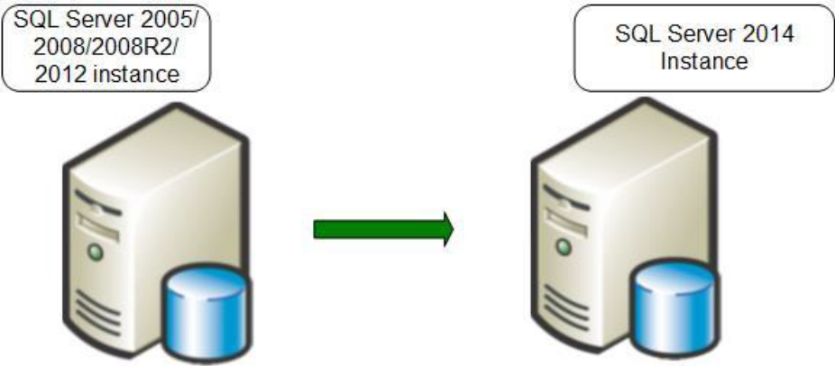
Here are the major steps that the SQL Server 2014 Setup program takes when you perform an in-place upgrade:
1. The SQL Server 2014 Setup prerequisites—Microsoft .NET Framework 3.5 Service Pack 1 (SP1) or a later version, SQL Server Native Client, and so on—are installed. The legacy instance databases continue to be available.

2. The Setup program checks for upgrade blocking issues, a small set of issues that will completely block an upgrade. If the Setup program finds any, it will list them. You must fix them and restart the upgrade process.
3. If a pending restart exists, you will have to restart the computer.
4. The Setup program installs the required SQL Server 2014 executables and support files.
5. The Setup program stops the legacy SQL Server service. At this point, the legacy instance is no longer available.
6. SQL Server 2014 updates the selected component data and objects.
7. The Setup program removes the legacy executables and support files. Legacy SQL Server 2005/2008/2008 R2 client tools are not removed.
The new instance of SQL Server 2014 is now fully available. The legacy instance of SQL Server has been replaced and must be reinstalled from a backup if the need arises.

Side-by-Side Upgrade : A side-by-side upgrade to another server leaves the legacy instance of SQL Server unchanged

In a side-by-side upgrade, instead of directly replacing the older instance of SQL Server, required database and component data is transferred from a legacy instance of SQL Server 2005/2008/2008 R2/2012 to a separate instance of SQL Server 2014. It is called a "side-by-side" method because the new instance of SQL Server 2014 runs alongside the legacy instance of SQL Server, either on the same server or on a different server.
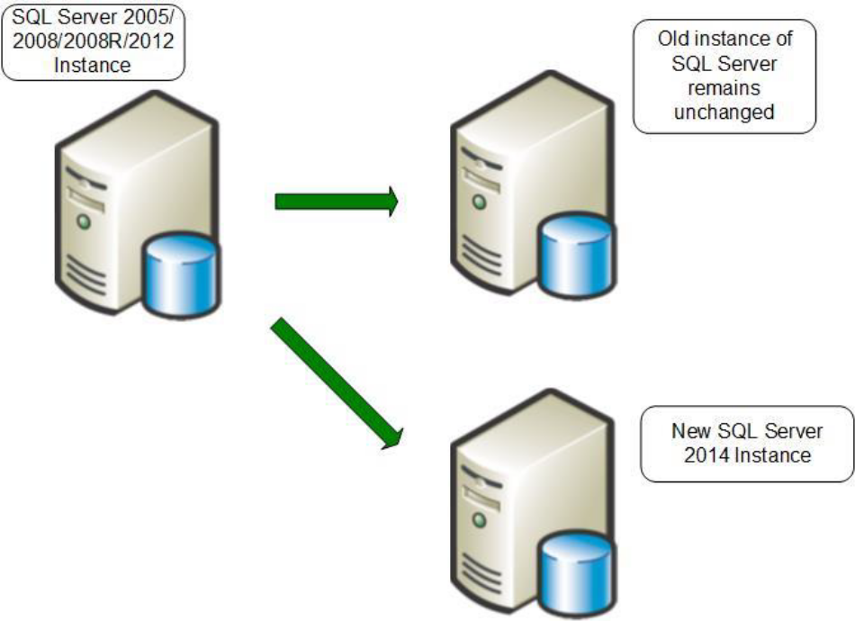
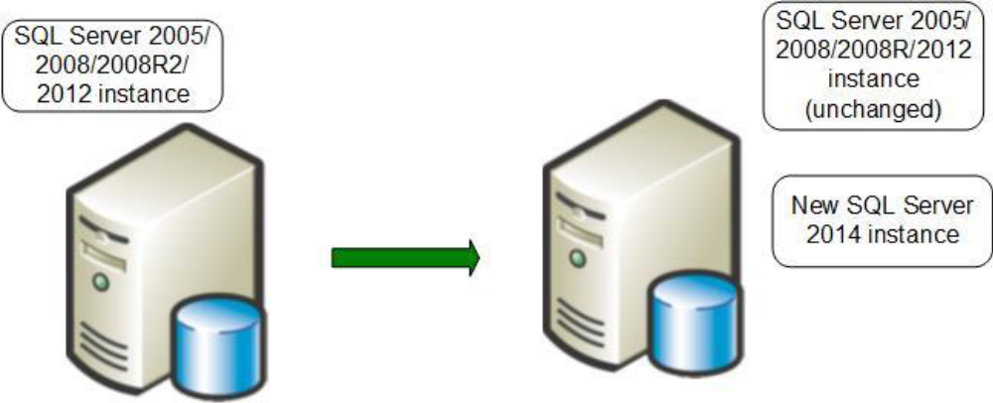
Performing a side-by-side upgrade on the same server, leaving both instances running

The main steps that you must perform when doing a side-by-side upgrade of SQL Server 2005/2008/2008 R2/2012 to SQL Server 2014:
1. Install a separate instance of SQL Server 2014 on the legacy server or on a separate server. The legacy instance continues to be available.
2. Run the SQL Server 2014 Upgrade Advisor against the legacy instance, and remove any upgrade blocking issues it finds.
3. Stop all update activity to the legacy instance. This might involve disconnecting all users or forcing applications to read-only activity.
4. Transfer data, packages, and other objects from the legacy instance to the instance of SQL Server 2014.
5. Apply supporting objects such as SQL Server Agent jobs, security settings, and configuration settings to the new instance of SQL Server 2014.
6. Upgrade SSIS (and potentially Data Transformation Services—DTS) packages to SSIS. (See Chapter 17, "Integration Services," for more information.)
7. Verify that the new instance supports the required applications by using validation scripts and user-acceptance tests.

8. If the new instance passes validation and acceptance tests, redirect applications and users to the new instance. At this point, the new instance is available and databases are online.
9. Keep your legacy instance for data recovery until you are absolutely confident that no problems exist on your new production database instance.

Troubleshooting an Upgrade
The best time to discover problems with an upgrade is when validating the upgrade plan in a test environment. Most upgrade issues related to the static code and objects in the instance, as well as the techniques recommended to resolve them, are fully documented in Upgrade Advisor. Dynamic code requires a workload to verify and troubleshoot.
General troubleshooting techniques include the following:
• Troubleshooting an in-place upgrade is basically the same as troubleshooting a SQL Server 2014 installation. The SQL Server 2014 Setup program logs a summary of its actions in the Summary.txt file in the Program Files\Microsoft SQL Server\120\Setup Bootstrap\LOG\ folder. The Summary.txt file contains a section for each SQL Server component's installation summary.
• Detailed log files are located in the Files folder under the path just mentioned, providing one file for each component and for many subcomponents. For information about interpreting the log files, see How to: Read a SQL Server Setup Log File (http://msdn.microsoft.com/en-us/library/ms144287.aspx).

• You use the same log files for troubleshooting a side-by-side upgrade as an in-place upgrade, except that the actual data transfer will not be logged because it is a manual process that is not under the control of SQL Server 2014 Setup.
• The steps for troubleshooting a side-by-side upgrade are based on the technique that you use for transferring data. If you use the backup/restore or detach/attach side-by-side upgrade method, capturing the output of those processes to text files is possible as long as you use the SQLCMD command-line tool and redirect the output to a file. If you use the Copy Database Wizard to transfer data, the process is interactive, so you have to watch it live for potential errors.

