Chapter 1 Case Studies

FAQ: - What range of ports can be used for SQL Server?

Default port no for SQL Server for default instance is 1433
For database engine we can use 1436 to 1954.
- Dynamic Port – Assigned by windows
- Static Port – Manually we have to assign
-- Check the error log for port number
EXEC xp_ReadErrorLog 0, 1, N'Server is listening on', N'any', NULL, NULL, 'DESC'
GO
FAQ: - How to change server collation settings?

We can change server level collation settings by running set as follows.
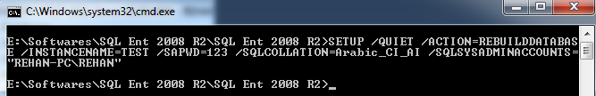
In the above example I am changing collation settings of Test instance to Arabic_CI_AI
Once the above command is completed by taking 2 to 3 minutes we can verify by taking server properties as follows.
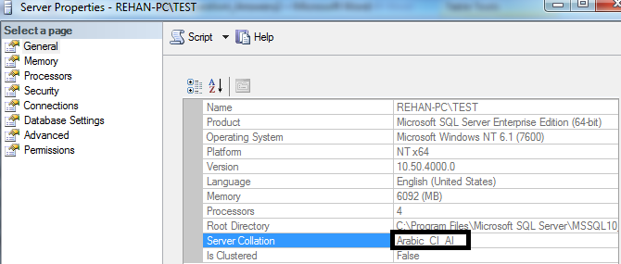

FAQ: - How to change edition of SQL Server?

We can change edition like from standard to enterprise edition etc by SQL Server installation center as follows.
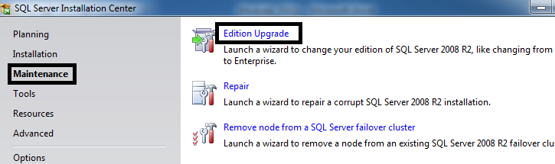

FAQ: - What is un-attended Installation?

- Continue installation until we reach "Ready to Install" step. Notice this page is showing configuration file path as follows.
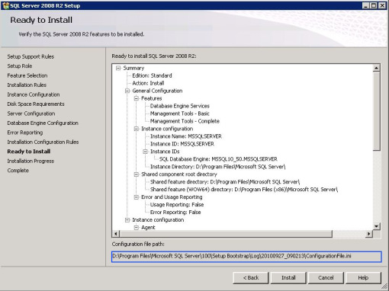
- Go to configuration file path and copy it into required folder or network shared folder where you want to install SQL Server.
- Cancel the setup in order to work with unattended installation.
- Edit configuration file as follows.
  - QUIET = "True"
  - Set SQLSYSADMINACCOUNTS="BUILTIN\Administrators"
  - IACCEPTSQLSERVERLICENSETERMS="True"
  - Remove ADDCURRENTUSERASSQLADMIN parameter.
  - Remove UIMODE
  - Remove INSTALLSHAREDDIR, INSTALLSHAREDWOWDIR, INSTANCEDIR
  - Change InstanceID and InstanceName

After creating the configuration file save it and run the following command from setup folder
"<path to SQL setup folder\>setup.exe" /ConfigurationFile="<path to config file>"

After the command execution is completed we can check in the configuration manager as well as SQL Server Management Studio.

Installation Issues

Scenario1: WMI Error
Generally while installing SQL Server if there is problem with WMI service then SQL Server installation fails.
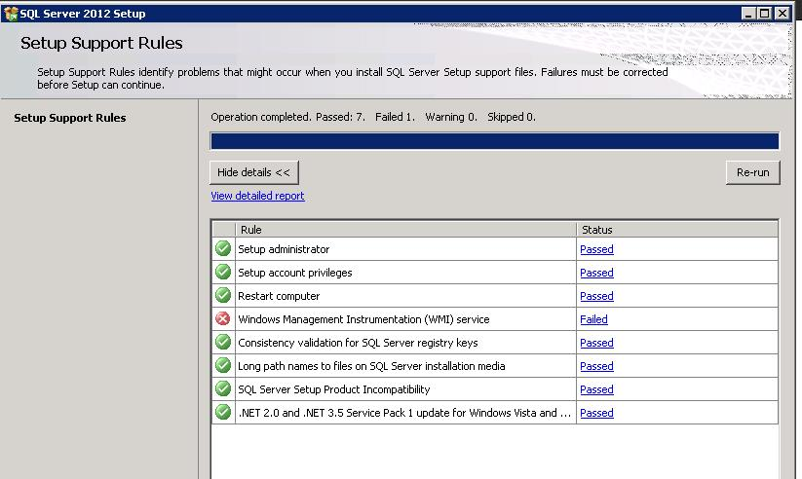
Solution:
We can solve this issue using the following code. Copy the following code in notepad and store as "wmiinstall.bat" or any name with .bat, then double click on the file, WMI service is installed automatically. After running the bat file click on Re-run button in the same page.

Script is available at
http://www.optimizesql.blogspot.in/2013/06/scripts.html

Scenario2: Performance counter registry hive consistency error

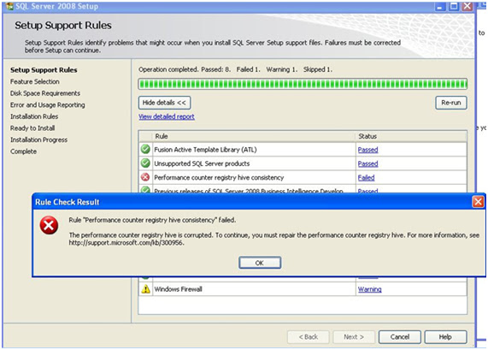

Problem with windows performance counter, setup process is trying to check the performance counter registry’s consistency, since the registry hive is corrupted it is unable to continue installation process.

Solution
According to BOL, to rebuild all Performance counters including extensible and third-party counters in Windows Server 2003, type the following commands at a command prompt. Press ENTER after each command
.
cd\windows\system32
lodctr /R
Notes
- /R is uppercase. You must have administrative rights on the computer to successfully perform this command.
- On a computer that is running a 32-bit edition of Windows XP, the Lodctr /R:<filename> command is the standard method to restore performance counter registry strings and information by using a file name.

Windows Server 2003 rebuilds all the counters because it reads all the .ini files in the C:\Windows\inf\009 folder for the English operating system.
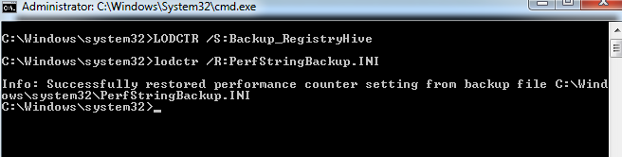

After running the above command we can click on re-run button and now we can view that there is no registry hive error. For more details you can visit at http://support.microsoft.com/kb/300956

Scenario3: Your computer needs to be restarted

This situation can occur where other software or updates have been installed or uninstalled and required the computer to be restarted by the install or uninstall actually completed
So, we get this error when we go to install a new instance of SQL 2008 on a dedicated Windows Server 2008 Standard x64 box:
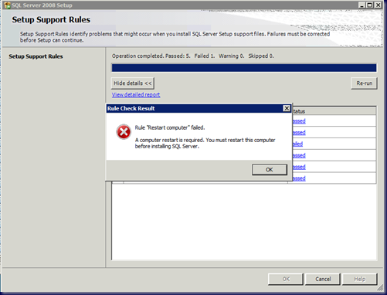
Rule Check Result
Rule “Restart computer” failed.
A computer restart is required. You must restart this computer before installing SQL Server.
But, we just restarted it because of that error?!?
A quick search turned up the following:

Microsoft SQL Forums: Not able to install SqlServer 2008 says Restart computer failed
The Forum post suggests that we look at the following registry key:

Startrunregedit
HKEY_LOCAL_MACHINE\SYSTEM\CurrentControlSet\Control\Session Manager\PendingFileRenameOperations
Sure enough, when we look into the registry, we find the culprit:
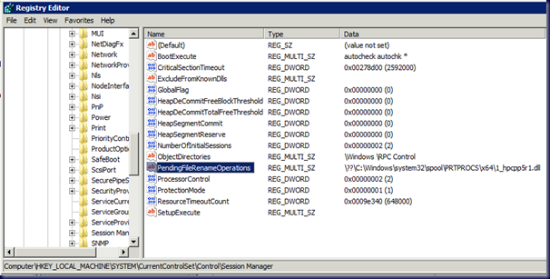
We deleted the content in that key since whatever the HP driver was trying to do it was failing at it miserably.
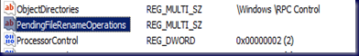

Of course, we Exported the Session Manager key _before_ deleting the content!
When we click the Re-run button in the SQL Server 2008 Setup window now it is passed

Scenario:4 SQL Server Browser Service Group does not exists.

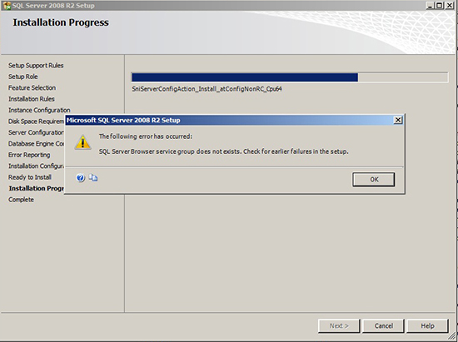
Solution
- We need to create a group manually in the domain for SQL Browser
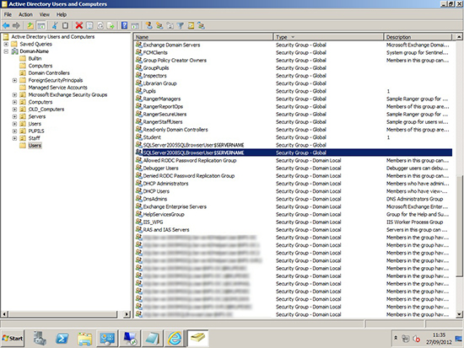
- Create two windows groups as follows
SQLServer2008SQLBrowserUser${ServerName}
SQLServer2005SQLBrowserUser${ServerName}
- Retry the installation

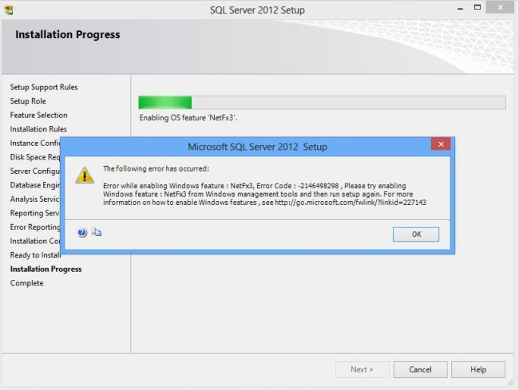
Step 1: Open Control Panel then select "Programs and Features" then click on "Turn Windows features on or off".
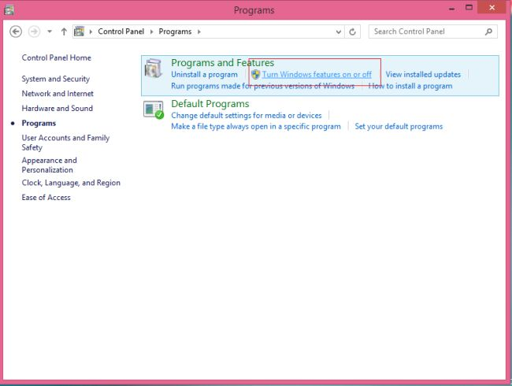
Step 2: Then check (select) ".NET Framework 3.5 (includes .NET 2.0 and 3.0)" and check the following items then click "Ok".
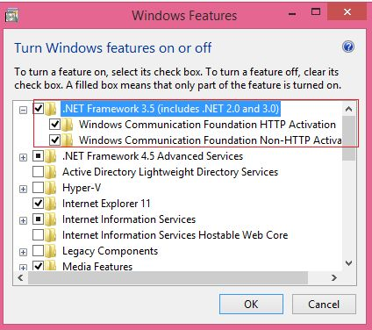
Step 3: You will ten encounter the .NET Framework 3.5 installation errors: 0x800F0906, 0x800F081F and 0x800F0907 as in the following windows:

Step 4: Use offline mode install of NetFx3 then "ISO image or DVD" > "D:\Windows_8.1 \sources\" > "sxs" > " File copy".
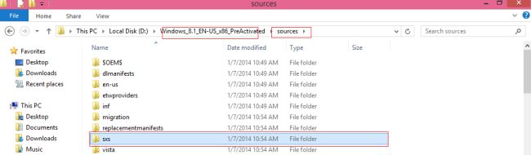
Step 5: Paste in the C:\ "sxs" file:
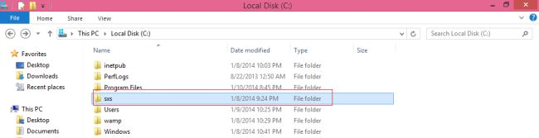
Step 6: Now open a "Command Prompt (admin.) Run".
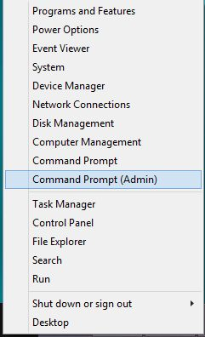
Step 7: "cmd" -> type.
"DISM /Online /Enable-Feature /FeatureName: Netfx3 /All /Limit Access /Source:C:\sxs"
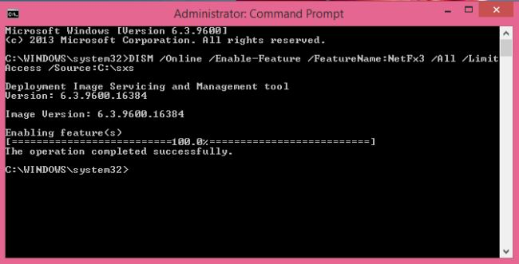
Step 8: Again open Control Panel and select "Program and Features " then click on "Turn Windows features on or off".
Step 9: Then again Then check (select) ".NET Framework 3.5 (includes .NET 2.0 and 3.0)" and check the following items then click "Ok".
Step 10: Then the Windows Features will be installed; it will say "Applying changes ".
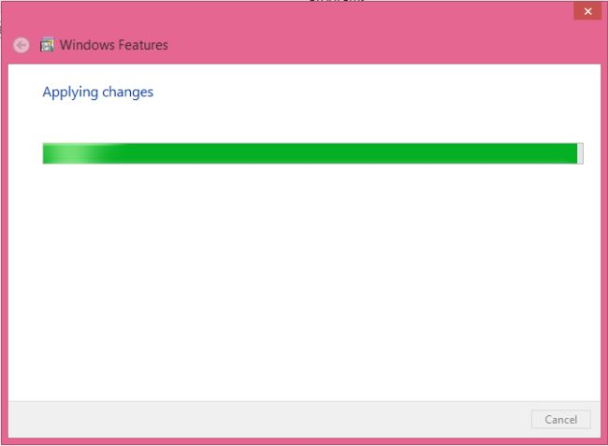
Step 11: Now it was installed successfully; it will say "Completed the requested changes".
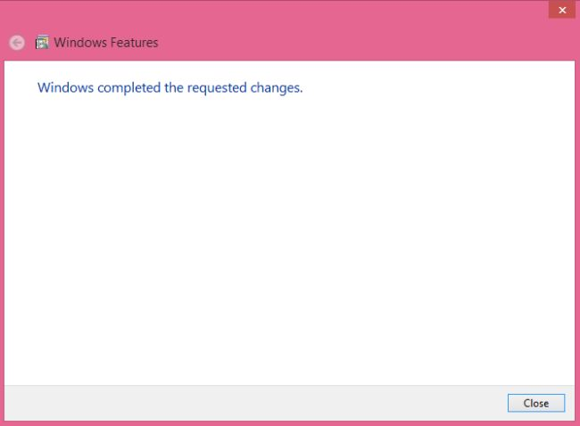

Module2 Case Studies

FAQ: - What are the drive specifications for SQL Server suggested by Microsoft?

Drive Notations as Per Microsoft Standards

C Drive - All OS Files present.
D Drive - All the Database files (log & data files) present in D:\MSSQL\Data folder.
E Drive - All the Database Backup files (Full & Differential) present in E:\MSSQL\BAK folder.
F Drive - All the Transaction Log Backup files present in F:\MSSQL\TRAN folder.
T Drive - All the data files of Tempdb database present in T:\MSSQL\DATA
S Drive – SQL Server S:\SQLServer

H Drive - All the database files (only Data) present in H:\MSSQL\DATA. This drive is used when server is in Cluster.
O Drive - All the Log files present in O:\MSSQL\DATA. This drive is used when server is in Cluster.

FAQ: - Possible issues while applying SP?

- MSP and MSI Errors (Summary.txt)
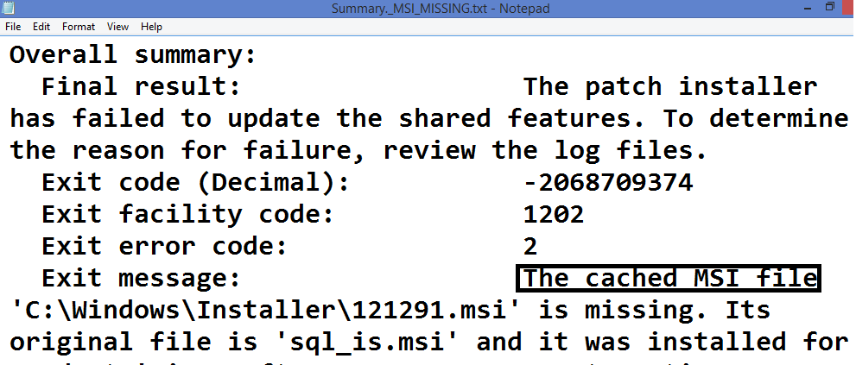

- Invalid transaction log file path mentioned in server properties?
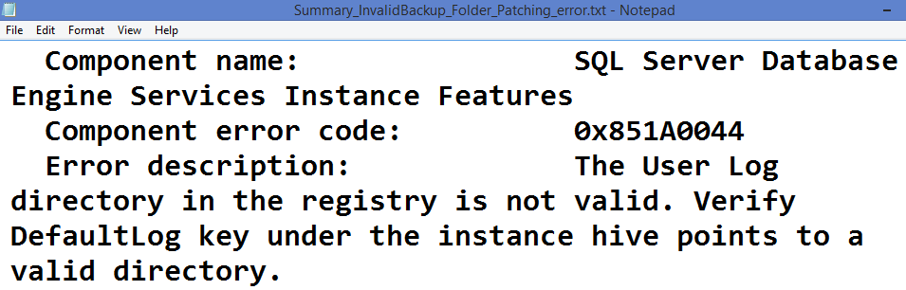

- Server in Script Upgrade Mode
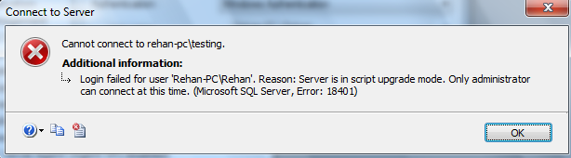
Solution: Apply CU13 for SQL Server 2012 if we are applying SP1

FAQ: - How to rollback service pack?

From control panel

FAQ: - What is trace flag. Give some examples?

Trace flag is a directive used to “set specific server characteristics or to switch off a particular behavior”. We can customize database engine behavior using trace flags.

We can control trace flags using the following DBCC commands.
DBCC TRACEON
DBCC TRACEOFF
DBCC TRACESTATUS

Examples
3226 | Prevents backup success message logging into error log
1204 | Writes deadlock information in text format in errorlog
1222 | Writes deadlock information in xml format in errorlog
3605 | Writes output into errorlog

SQL Server service is not started successfully. What are the possible reasons?
- Duplicate port was assigned
- Master database was corrupted.
- Model was corrupted
- Tempdb was not created successfully.
- Memory issue.
- While moving master or Tempdb or model database if it was not done properly.
- If current errorlog is damaged
- Issue with service account (Logon Failure).

SQL Agent startup Failed.

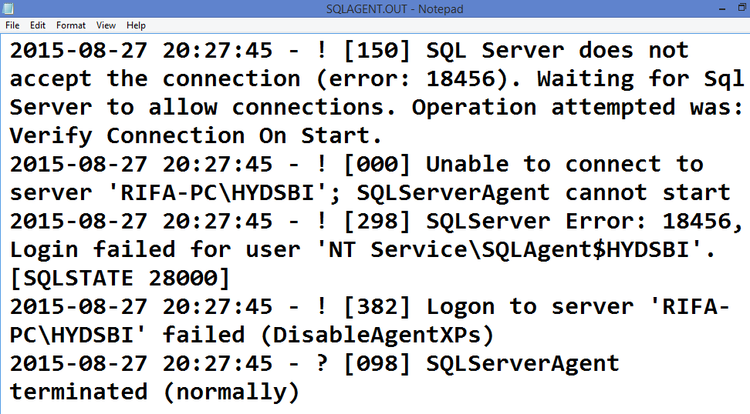

FAQ:- While connecting to the server, what are the possible errors, users get?
Possible Errors
1. Error: 26
* SQL Browser not started
* Firewall on, but server or port is not added
* No connectivity between client and server
* Issue with SNAC
* Host name and IP was not binded

2. Error: 28
* Instance TCP/IP was disabled
3. Error: 40/10061
* Instance is not running
4. Error: 18456/18452
* Login failed. (invalid login or pwd)
5. Expired Timeout
* Network issue
* Server is busy
* In server max sessions are open
* No available session memory
6. Error: 18401
* After applying patch, restart the instance or windows.
7. Error: 64
* Not enough memory in buffer cache for new connections.
* Use DAC to troubleshoot this problem.

FAQ: - What is AWE?

In 32 bit windows we have to enable AWE (Address Windowing Extensions) to configure more than 2GB for SQL Server.

Startup Option Use if system RAM is...
Default settings <4GB
/3GB 4GB
/3GB and /PAE 5-16GB
/PAE >16GB

Scenario

I have 3 SQL Server instances running on box SERVER1. I have 64 GB of RAM in SERVER1. I have set Max. Server Memory on each of the three instances to 60 GB leaving 4 GB to operating systems. Is it a right configuration?

We can configure 20G for each instance

Scenario
I have SQL server 2008 R2 installed on machine. Machine has 8 GB of RAM. SQL consumes around 7 GB of RAM causing other application on that machine to run slow. What may be the possible reason?

Set max server memory to 6GB (Approx)
FAQ: - How can we check the no of sessions currently running in the server?

* By default once the user connects to the server automatically one session is created.
* By default SS supports 2 types of sessions
1. System defined (sa) spid<51
2. User defined >=51
* We can display sessions using
sp_who
sp_who2
select * from sys.dm_exec_sessions (DMV)
select * from sys.sysprocesses
Activity Monitor
Sp_who2 active (To check active sessions)

* To check recent/currently executing command in a session
dbcc inputbuffer(spid)
--DMF
Select * from sys.dm_exec_sql_text (sql_handle)
-- To find sql_handle of spid 53
select most_recent_sql_handle from sys.dm_exec_connections
where session_id=53

select * from sys.dm_exec_sql_text(0x0200000094CBC82F312B3AF511C959E5CDB3274D967E37EE0000000000000000000000000000000000000000)

* To stop session
kill <spid>
* To display login names and their sessions
select login_name, COUNT(*) as No_sessions from sys.dm_exec_sessions
group by login_name

Note: Normal user can view only their own sessions. But sysadmin and ProcessAdmin
members can view all sessions.

SPIDs and their Status

Status | Description
Background | The SPID is running a background task, such as deadlock detection.
Sleeping | The SPID is not currently executing. This usually indicates that the SPID is awaiting a command from the application.
Runnable | The SPID is in the runnable queue of a scheduler and waiting to get scheduler time.
Running | The SPID is currently running on a scheduler.
Suspended | The SPID is waiting for an event, such as a lock or a latch.
Rollback | The SPID is in rollback of a transaction.

Module-3 Working with Databases -- Scenarios
FAQ: - How to move master database?
* Connect to your instance
* Create one folder and grant read write permissions to service account
d:\master_files
* Find the current path
sp_helpdb master
* Stop SQL Server
* Move the files (master.mdf, mastlog.ldf) into new folders
* Go to SSCM --> R.C on respective instance SQL Server Service --> properties --> Advanced --> Startup Parameters--> Change the path of data and Log file
-dd:\master_files\master.mdf;-e....
-le:\master_files\mastlog.ldf
* Apply --> OK
* Start the service.
* Go to SSMS --> check the new path
sp_helpdb master
FAQ: - What are possible errors while moving master database?
* 3417 (OS Error 5)
* Permissions are not granted on target folders where we have moved
master files.
* 17113
* If we have not mentioned correct path in startup parameters
* 17058
* If we have not mentioned all the 3 startup parameters
-d
-e
-l
* Service cannot respond in timely fashion
* check parameters and try to stop some other instances and start later.
Check all the three scenarios
Note: To check the errors
Start --> Run --> Eventvwr--> WindowsLogs
System
In the right side double click on error
or
Check ERRORLOG of respective instance.

FAQ: - How to move MSDB files?
1. Create folder d:\msdb_files
2. Check current path
sp_helpdb msdb
3. Alter the path
use master
go
ALTER database MSDB modify file
(name='msdbdata',
filename='d:\msdb_files\msdbdata.mdf')
ALTER database msdb modify file
(name='msdblog',
filename='d:\msdb_files\msdblog.ldf')
4. Stop server and move the files(msdbdata.mdf, msdlog.ldf) into d:\msdb_files
5. start the server
6. Check current path
sp_helpdb msdb

FAQ: - How to move Tempdb?
* Create folder d:\tempdb_files
* Grant read write permissions on the folders to service account
* Change the file paths
use master
go
ALTER database tempdb modify file
(name='tempdev',
filename='d:\tempdb_files\tempdb.mdf')
ALTER database tempdb modify file
(name='templog',
filename='d:\tempdb_files\templog.ldf')
* Check now new path
sp_helpdb tempdb
* Stop server after some times (when required)
* Start instance and check that files are created in new path

FAQ: - TempDB is growing fastly. How u know which transaction is causing the problem?
Scenarios
1. Long running queries
2. Creation or rebuilding indexes
3. DBCC CHECKDB (To check consistency of db)
4. SORT_IN_TEMPDB property
5. Isolation Levels which needs row versions.
Solutions
1. Add extra data file.
2. Check long running queries and stop some of them.
and submit the queries for optimization.
dbcc opentran(tempdb)
3. Find out the sessions taking more space and troubleshoot the queries.
select * from [sys].[dm_db_session_space_usage]
4. Try to shrink log file if possible using WITH TRUNCATEONLY option
use tempdb
dbcc shrinkfile(templog, 0)
5. Restart the server when possible.

FAQ: - My transaction log file is full. How to troubleshoot the scenario.
Error No. 9002
Scenarios
- If there are no scheduled log backups or log backups are not working.
- If there are active transactions in the log file.
- If there are long running queries
- In database mirroring if mirror server fails
- In replication if distributor fails
- If there is no disk space to grow the Transaction Log file
- If bulk data was imported without dividing into multiple batches or transactions.

Troubleshooting
- Check why log file cannot be reused using the following query:
- select name, log_reuse_wait_desc from sys.databases where name='dbname'
- Depending on the 2nd column value, we have to troubleshoot by using the following solutions:
  - Backing up the log (in case of the above scenario)
  - Freeing disk space so that the log can automatically grow
  - Moving the log file to a disk drive with sufficient space
  - Increasing the size of a log file
  - Adding a log file on a different disk
  - Troubleshoot replication or mirroring issue

FAQ: If database goes into suspect mode. How to recover it?
Scenario1: If the data file was damaged. (17204)
* Take T.Log backup
* Restore last Full backup
* Restore T.Log backup
* Database comes online
Scenario2 : If the T.Log file was damaged (17207)
Ex:
* Take any user defined db for example : MyDB
* Check the current location of files
sp_helpdb MyDB
* Stop server or take db offline
* Move the T.Log file into different folder
* Start server --> DB goes into suspect mode
select databasepropertyex('mydb','status')
Steps to Recover
--step1: Make the db into single user
Alter database mydb set Single_User
--step2: Set the db into emergency mode
Alter database mydb set Emergency
--step3: Run checkdb with required repair level
DBCC CheckDB ('mydb', REPAIR_ALLOW_DATA_LOSS)
--step4: Set the db into multi user mode
Alter database mydb set Multi_User

FAQ: - How to rebuild master database?

Case Study
Recently, one of my instances was corrupted and I was unable to restart SQL Server. I did the following steps to get it back. First I checked the SQL Server ERRORLOG. Please go through the following steps.
Step 1: Check the error log where it is showing master was corrupted.
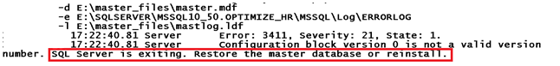
Step 2: Rebuild system databases from command prompt. Go to the following path and run setup as follows: C:\Program Files\Microsoft SQL Server\100\Setup Bootstrap\SQLServer2008R2
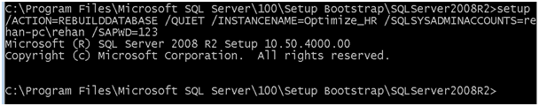
Step 3: Once the above command runs successfully, check in the summary.txt file as follows and look at the Requested action.
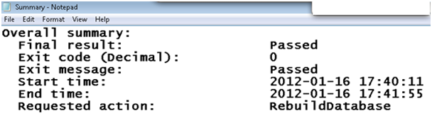
Step 4: Start SQL Server service.
Step 5: Connect to the instance. But you cannot see any user defined databases. The rebuilding process has created a fresh master database so there are no other databases and all previous configuration values are lost.
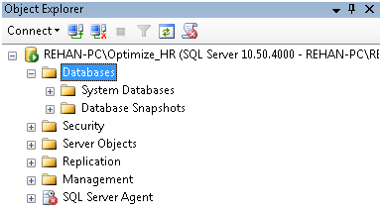
Step 6: Now we can restore the master database to get the previous configuration settings. Go to command prompt and run server in single user mode as follows:
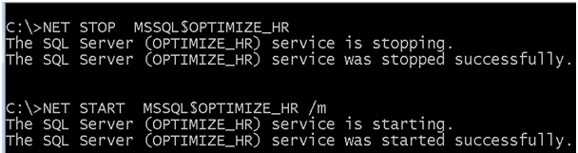
Step 7: Connect to the instance and take new query to restore master database. Once we restore master database, then we can get all the previous configuration values including user defined databases.
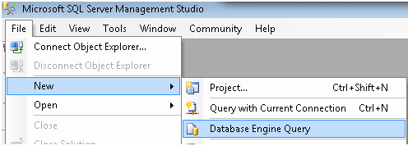
Step 8: Click on Connect button and connect to the instance as follows:
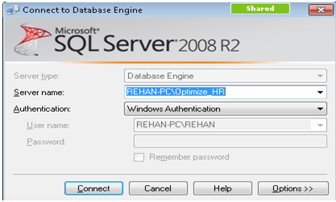
Step 9: Restore master database as follows
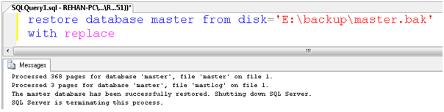
Step 10: Restart SQL Server instance in multi user mode and connect to SQL Server Management Studio. We can see all user databases as follows:
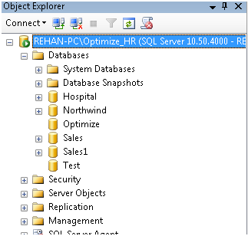

Troubleshooting
Sometimes, the rebuild process may fail if there is problem with files present in Binn\Templates folder. Once you check summary.txt file, let's say it is saying one message as follows:
Collapse | Copy Code
Configuration error description: The file C:\Program Files\Microsoft SQL Server \
MSSQL10_50.MSSQLSERVER \MSSQL\Binn\Templates\master.mdf is missing
In the above scenario, we have to copy file (master.mdf) from SQL Server dump or DVD into Binn\Templatesfolder and retry.

Summary
We can summarize the key points as follows according to BOL regarding rebuilding system databases:
- SQL Server 2000
  - We can use RebuildM.exe
  - Need setup media for system database files
- SQL Server 2005
  - We can use setup.exe
  - Need setup media for setup.exe and system database files
- SQL Server 2008
  - We can use setup.exe
  - Setup media not required and system database files are there in Binn\Templates folder

Example: Moving database files using Offline and Online method
--Check current path
sp_helpdb sales
--Create folder and grant read/write permissions to service account
--ex. d:\Data\SalesFiles
--step3: Modify the file path
use master
go
alter database Sales modify file
(name='Sales',filename='D:\DATA\SalesFiles\Sales.mdf')
go
alter database Sales modify file
(name='Sales3',filename='D:\DATA\SalesFiles\Sales3.ndf')
go
alter database Sales modify file
(name='Sales_log',filename='D:\DATA\SalesFiles\Sales_log.ldf')
go
--step4: Take database offline
--step5: Move the files into new folder(s)
--step6: Bring online

FIX: Rollback causes database to go to suspect mode in SQL Server 2012 or SQL Server 2014

Symptoms
Consider the following scenario:
- You have a database that has Snapshot Isolation or Read Committed Snapshot Isolation level enabled in Microsoft SQL Server 2012 or SQL Server 2014.
- The database contains a non-empty table that has a multi-column clustered index. The leading key of the clustered index is set to NOT NULL.
- You begin a transaction and add a column into the table. The value of this column is updated.
- You alter the leading key of the clustered index to allow NULL value.
- You insert rows with NULL values for the leading key of the clustered index, and then abort the transaction.
In this scenario, the rollback causes the database to go suspect and only "repairable" withDBCC CHECKDB REPAIR_ALLOW_DATA_LOSS command. Additionally, you may receive the following error message:
Msg 3316, Level 21, State 2, Line 135
During undo of a logged operation in database '%.*ls', an error occurred at log record ID %S_LSN. The row was not found. Restore the database from a full backup, or repair the database.

Resolution
To resolve this issue, obtain Service Pack 1 for SQL Server 2014.
Service pack 2 for SQL Server 2012

How to Attach Database Without a Transaction Log File in SQL Server
Download Free Guide "Waiting on Waits, Find why SQL Server is Waiting Using DMVs"

Introduction
This article demonstrates how to attach a database in SQL Server when transaction log file is missing. The steps mentioned in this article are applicable on SQL Server 2005 and higher versions. To know more about how to Attach Database in SQL Server with transaction log file refer the following article “Attach Database in SQL Server”.

Different ways to Attach Database without a transaction log file in SQL Server
- Attach Database without a transaction log file in SQL Server Using SQL Server Management Studio (SSMS)
- Attach Database without a transaction log file in SQL Server Using TSQL Script

Permissions to Attach Database in SQL Server
You need membership in the db_owner fixed database role to Attach Database in SQL Server.
Important Notes:
You will not be able to detach and attach database from a higher version of SQL Server to a lower version of SQL Server this is by design from Microsoft. To know more read the following article “Why an SQL Server Database from a higher version cannot be attached onto a lower version of SQL Server?”
Downgrade of a database from higher version to lower version cannot be achieved using Database Backup and Restore Method and also by using Database Detach and Attach Method. However, you can downgrade a database to a lower version using SQL Server Integration Services. To know more read "How to Downgrade SQL Server Database Using SQL Server Integration Services".
Let us go through each of the above mentioned options in detail.

Attach Database without a transaction log file in SQL Server Using SQL Server Management Studio (SSMS)
1. In Object Explorer, right click the Databases node and then click Attach… from the drop down menu as shown in the clip below.
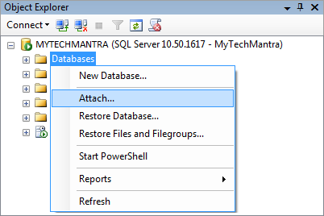
2. In Attach Databases dialog box, click Add… button.
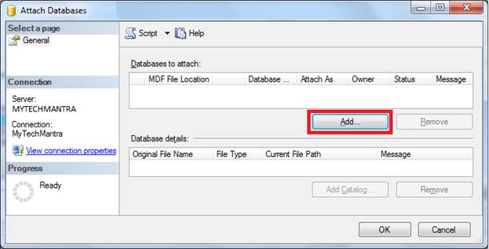
3. In Locate Database Files dialog box, browse to the location where you database MDF file is available and then choose the file and click OK and to return to parent Attach Databases dialog box.
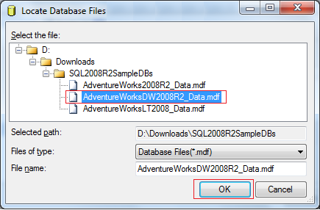
4. In Attach Database dialog box; you will see under database details as highlighted that SQL Server is unable to locate the LDF file. To attach the database without the LDF file select the LDF file and then click remove button. Finally, click OK to successfully attach the database. In this case SQL Server will create a new log file while attaching the database.
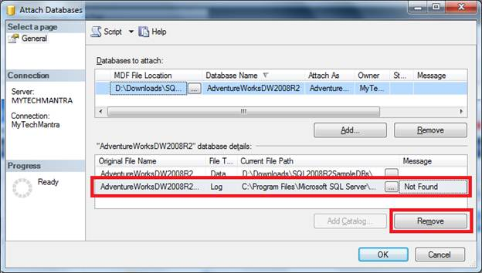
Important Note: -The above mentioned steps will work only when your database which was cleanly shutdown and you have the .MDF file of the database.

Attach Database without a transaction log file in SQL Server Using TSQL Script
Using the below script you can attach database in SQL Server which has a missing transaction log file.
USE [master]
GO

CREATE DATABASE [AdventureWorksDW2008R2] ON
( FILENAME = N'D:\Downloads\SQL2008R2SampleDBs\AdventureWorksDW2008R2_Data.mdf' )
FOR ATTACH
GO

Execute DBCC CHECKDB
Once you have successfully attached a MDF file without a transactional log (LDF) file go ahead and execute DBCC CHECKDB to check the logical and physical integerity of all the objects in the specified database.

Example for Detach and Attach
--Step1: Check current path note down
sp_helpdb Sales
--step2: Taking into single user mode
alter database Sales set single_user with rollback immediate
--step3: Detaching
sp_detach_db Sales
--step4: Create new folder(d:\data)
-- and copy the files into new folder
--step5: Attach db
sp_attach_db @dbname='Sales',@filename1='d:\data\Sales.mdf',
@filename2='d:\data\Sales_log.ldf')

Cannot shrink the log – now what

Now this one really asks for a blog post, since I saw it too many times on various forums and I just got it on one of my production servers.
I just got an alert that we’re running low on space on the BIZTALK machine. So, quick and dirty check:
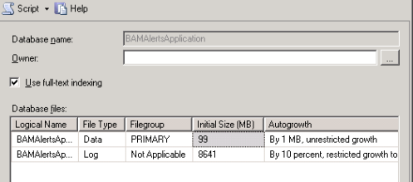
Uh-oh, this is not good, 99 MB for the data file and almost 10 times the size for the log file. Since I’m in FULL recovery model, this tells me that there’s no transaction log management (read transaction log backups). Sure enough, when I run:
select log_reuse_wait_desc from sys.databases
where name = ‘BAMAlertsApplication’
I get the following:
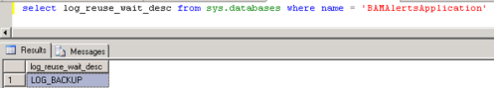
OK, I did a log backup, then I tried to shrink the log file, guess what, I’m still with the same log file size! What to do, what to do…
Well, run the dbcc loginfo
And look for the status column, for anything that spells “2” – that is the active portion of the VLF. And now for the culprit:
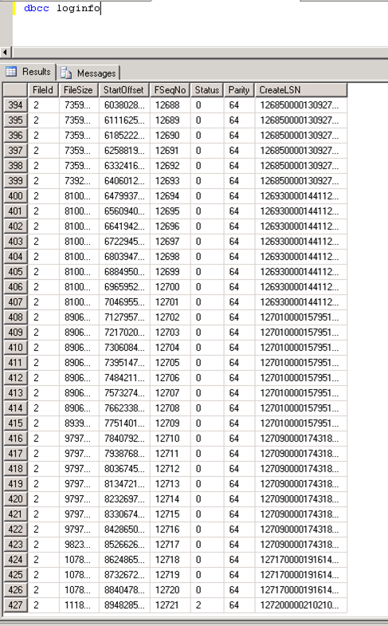
Sorry for the ugly print screens, it’s a quick post, I’m in the middle of troubleshooting this☺.
Anyway, going back, the last record shows me the status of 2. And it just so happens that whenever you want to shrink your log, it will do it backwards, starting with the VLFs that are at the end. The only condition for the space to be released is that the VLFs are inactive (that is, the status is 0). In my case, I have all the conditions not to have my transaction log shrunk, since the very last VLF is marked as active, so the space cannot be given back to the operating system.
But I really need that space, what to do, what to do…
Easy enough, backup the log again☺. And now if I run the same DBCC:
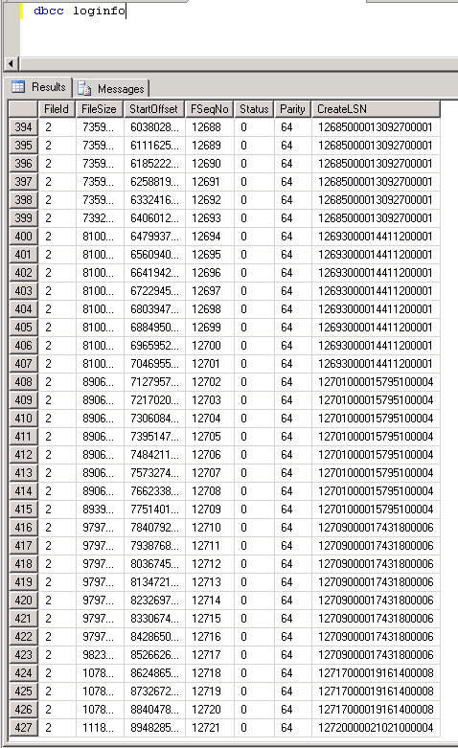
Now I can try to shrink the log again. And here’s the result:
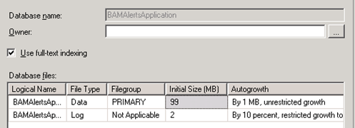

FAQ:- MODEL was corrupted. How to start SQL Server without rebuilding system databases

Error:
The database ‘model’ is marked RESTORING and is in a state that does not allow recovery to be run.
Error: 927, Severity: 14, State: 2.
Database ‘model’ cannot be opened. It is in the middle of a restore.
Could not create tempdb. You may not have enough disk space available. Free additional disk space by deleting other files on the tempdb drive and then restart SQL Server. Check for additional errors in the event log that may indicate why the tempdb files could not be initialized.

Cause
We get above error if the Model database is corrupted. TempDB is recreated every time when SQLServer restarts using model database, We receive "Could not create tempdb" because model database is corrupted
Resolution
1. Start SQLServer with Traceflag 3608,3609,-c,-f
-T3609 Will keep the existing TEMPDB, Which means when SQLServer is restarted SQLServer uses the existing tempdb instead of re-creating it as long as checkpoint in the tempdb had been done immediately before the last server shutdown
{
Sqlservr.exe -sInstanceName -T3608 -c -f -T3609
}
2. Open SQLCMD and make DAC connection
{
SQLCMD -A –S ADMIN:Servername\InstanceName
}
3. Use Tempdb
Go
{
Above command will open the TempDB. If you get error while executing "Use Tempdb" your tempdb is not cleanly shutdown.
To work around this copy a Tempdb.mdf and templog.ldf from Cleanly shutdown SQLServer of same version and replace it in TEMPDB location.
Also note Transaction log location is stored in Tempdb.mdf.So you may have to copy Tlog file in destination server in same directory structure as it existed source server .
Once you copy the file restart SQLServer using -T3608 -c -f -T3609 Then run
Use Tempdb
Go
}
4. sp_detach_db ‘model
5. Replace model.mdf and model.ldf from different server of same build
5. sp_attach_db ‘model’,’X:\PAth\model.mdf’,’x:\modellog.ldf’
{
Note: If you are in SQLServer2008 we can use "create database with attach" option
CREATE DATABASE [model] ON
( FILENAME = N'C:\Program Files\Microsoft SQL Server\MSSQL10_50.R2\MSSQL\DATA\model.mdf' ),
( FILENAME = N'C:\Program Files\Microsoft SQL Server\MSSQL10_50.R2\MSSQL\DATA\modellog.ldf' )
FOR ATTACH
go
}
Now we can start SQL Server normally and if you find any database in restoring state if can use RESTORE database DBNAME WITH RECOVERY to recover and open the database.

How to recover SQL Server after a tempdb database is marked suspect
This article was previously published under Q288809

SYMPTOMS
When you try to start a SQL Server service, the service may fail because the tempdb database is marked suspect. You may see the following text in the SQL Server error log:
2001-02-08 14:04:07.64 spid1 Clearing tempdb database.
2001-02-08 14:04:07.66 spid1 Creating file e:\MSSQL7\DATA\TEMPDB.MDF.
2001-02-08 14:04:07.87 spid1 Closing file e:\MSSQL7\DATA\TEMPDB.MDF.
2001-02-08 14:04:07.90 spid1 Creating file e:\MSSQL7\DATA\TEMPLOG.LDF.
2001-02-08 14:04:07.97 spid1 Closing file e:\MSSQL7\DATA\TEMPLOG.LDF.
2001-02-08 14:04:08.02 spid1 Opening file e:\MSSQL7\DATA\TEMPDB.MDF.
2001-02-08 14:04:08.03 spid1 Opening file e:\MSSQL7\DATA\TEMPLOG.LDF.
2001-02-08 14:04:08.32 spid1 Closing file e:\MSSQL7\DATA\TEMPDB.MDF.
2001-02-08 14:04:08.34 spid1 Closing file e:\MSSQL7\DATA\TEMPLOG.LDF.
2001-02-08 14:04:08.36 spid1 Starting up database 'tempdb'.
2001-02-08 14:04:08.36 spid1 Opening file e:\MSSQL7\DATA\TEMPDB.MDF.
2001-02-08 14:04:08.39 spid1 Opening file e:\MSSQL7\DATA\TEMPLOG.LDF.
2001-02-08 14:04:08.43 spid1 Bypassing recovery for database 'tempdb' because it is marked SUSPECT.
2001-02-08 14:04:08.47 spid1 Database 'tempdb' cannot be opened. It has been marked SUSPECT by recovery. See the SQL Server errorlog for more information.
2001-02-08 14:04:08.50 spid1 WARNING: problem activating all tempdb files.
2001-02-08 14:04:08.50 spid1 Trying just primary files.
2001-02-08 14:04:08.50 spid1 Database 'tempdb' cannot be opened. It has been marked SUSPECT by recovery. See the SQL Server errorlog for more information.
2001-02-08 14:04:08.50 spid1 Database 'tempdb' cannot be opened. It has been marked SUSPECT by recovery. See the SQL Server errorlog for more information.

Note There are multiple reasons as to why a database becomes marked suspect but those reasons are beyond the scope of this article.

WORKAROUND
The following steps explain how you can create a new tempdb database. With this workaround, you are able to successfully start the SQL Server service.
- If they exist, rename the current Tempdb.mdf and Templog.ldf files. If the files do not exist, that is one possible reason for the suspect status, the files are missing.
- Start SQL Server from a command prompt by using the following command:
sqlservr -c -f -T3608 -T4022
For SQL Server 2000 named instances you have to add the additional -s parameter.
On a SQL Server 7.0 cluster, you must first run this statement:
set _CLUSTER_NETWORK_NAME=YourSQLVirtualName
This will allow SQL Server to start from a command prompt.
Note Make sure that the command prompt window remains open after SQL Server starts. Closing the command prompt window terminates the SQL Server process.
- Connect to the server by using Query Analyzer, and then use the following stored procedure to reset the status of the tempdb database.

- exec master..sp_resetstatus Tempdb

- Shut down the server by pressing CTRL+C in the command prompt window.
- Restart the SQL Server service. This creates a new set of tempdb database files, and recovers the tempdbdatabase.
Note The environment variable creates a new set of tempdb database files when the SQL Server service is restarted. To remove the environment variable, run the following statement:
set _CLUSTER_NETWORK_NAME=

REFEREN

Security Login Issue

‘Cannot Generate SSPI Context’ and Service Account Passwords
Was working with Keith Elmore on one of our internal processes and he was hitting a “Cannot generate SSPI context” when trying to connect from Management Studio. I also saw this come up in a double hop situation (IIS to SQL) when I setup a local repro.

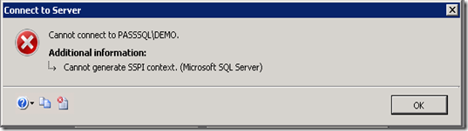
We went through the normal check list for Kerberos Troubleshooting, but really that just consisted of validating the SPN in the case of Management Studio as it was a single hop and we were just trying to do a direct connection without any delegation. The SPN checked out, and there was only one SPN. No duplicates.
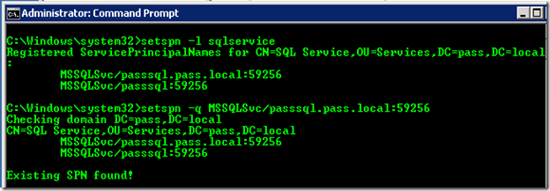
We have an internal tool called SSPIClient which will go through the motions of just trying the Windows API calls for Kerberos authentication (IntializeSecurityContext).
2009-12-30 21:11:16.185 Connecting via ODBC to [DRIVER=SQL Server;Server=tcp:passsql\demo;Trusted_Connection=Yes;]
2009-12-30 21:11:16.232 ENTER InitializeSecurityContextA
2009-12-30 21:11:16.232 phCredential = 0x0055ffb4
2009-12-30 21:11:16.232 phContext = 0x0055ffc4
2009-12-30 21:11:16.232 pszTargetName = ‘MSSQLSvc/PASSSQL.pass.local:59256′
2009-12-30 21:11:16.232 fContextReq = 0x00000003 ISC_REQ_DELEGATE|ISC_REQ_MUTUAL_AUTH
2009-12-30 21:11:16.232 TargetDataRep = 16
2009-12-30 21:11:16.232 pInput = 0x0018d55c
2009-12-30 21:11:16.232 pInput->ulVersion = 0
2009-12-30 21:11:16.232 pInput->cBuffers = 1
2009-12-30 21:11:16.232 pBuffers[00].cbBuffer = 112
2009-12-30 21:11:16.232 pBuffers[00].BufferType = 2 SECBUFFER_TOKEN
2009-12-30 21:11:16.232 pBuffers[00].pvBuffer = 0x03753870
2009-12-30 21:11:16.232 03753870 a1 6e 30 6c a0 03 0a 01 01 a2 65 04 63 60 61 06 .n0l……e.c`a.
2009-12-30 21:11:16.232 03753880 09 2a 86 48 86 f7 12 01 02 02 03 00 7e 52 30 50 .*.H……..~R0P
2009-12-30 21:11:16.232 03753890 a0 03 02 01 05 a1 03 02 01 1e a4 11 18 0f 32 30 …………..20
2009-12-30 21:11:16.232 037538a0 30 39 31 32 33 30 32 31 31 31 31 36 5a a5 05 02 091230211116Z…
2009-12-30 21:11:16.232 037538b0 03 01 0d b4 a6 03 02 01 29 a9 0c 1b 0a 50 41 53 ……..)….PAS
2009-12-30 21:11:16.232 037538c0 53 2e 4c 4f 43 41 4c aa 17 30 15 a0 03 02 01 01 S.LOCAL..0……
2009-12-30 21:11:16.232 037538d0 a1 0e 30 0c 1b 0a 73 71 6c 73 65 72 76 69 63 65 ..0…sqlservice
2009-12-30 21:11:16.232 phNewContext = 0x0055ffc4
2009-12-30 21:11:16.232 pOutput = 0x0018d574
2009-12-30 21:11:16.232 pOutput->ulVersion = 0
2009-12-30 21:11:16.232 pOutput->cBuffers = 1
2009-12-30 21:11:16.232 pBuffers[00].cbBuffer = 12256
2009-12-30 21:11:16.232 pBuffers[00].BufferType = 2 SECBUFFER_TOKEN
2009-12-30 21:11:16.232 pBuffers[00].pvBuffer = 0x03759d68
2009-12-30 21:11:16.232 pfContextAttr = 0x00000000
2009-12-30 21:11:16.232 ptsExpiry = 0x0018d548 -> 1601-01-01 00:00:00 *** EXPIRED *** (3585189:11:16 diff)
2009-12-30 21:11:16.232 EXIT InitializeSecurityContextA returned 0x80090322 SEC_E_WRONG_PRINCIPAL(The target principal name is incorrect)
2009-12-30 21:11:16.232
2009-12-30 21:11:16.232 ******************** ODBC Errors ********************
2009-12-30 21:11:16.232 Return code = -1.
2009-12-30 21:11:16.232 SQLError[00] SQLState ‘S1000′
2009-12-30 21:11:16.232 SQLError[00] NativeError 0
2009-12-30 21:11:16.232 SQLError[00] Message ‘[Microsoft][ODBC SQL Server Driver]Cannot generate SSPI context’
2009-12-30 21:11:16.232 ******************** ODBC Errors ********************
It was saying that the principal was incorrect, but you can see in the output that it is showing sqlservice, which is correct. We had rebooted the SQL Server in question, at which point the SQL Service wouldn’t even start. Keith asked if the password had been changed recently. We took a look, and sure enough, the password was changed yesterday. This happens to be an account that we use for multiple things.
We changed the service account password through SQL Server Configuration Manager and restarted SQL. SQL could start at that point, and the SSPI error disappeared. We were able to successfully connect to SQL at that point.
I’m sure other people have known about this type of condition, but in the years that I’ve been here, along with the number of Kerb issues that I’ve troubleshot in the past, this was the first time I had run across this. Thought I would throw it out there to share with everyone in case they maybe run across something like this that they can’t explain.
If you change your service password, be sure to recycle the SQL Service so that Kerberos can function properly.

Scenarios and FAQs

FAQ: - In which scenarios T.Log is truncated?
- When CHECKPOINT occurs in SIMPLE recovery model.
- When T.Log backup was generated in other recovery models.

FAQ: - Which transactions are not truncated by the checkpoint even if the recovery model is simple.
- Un committed transactions are not truncated.
- Unreplicated transactions.
FAQ: - How can we imagine or calculate size of backup?
Use <dbname>
Go
Sp_spaceused
Check reserved space (Approx Size)
FAQ: - What is your backup strategy?
- Backup strategy refers to types of backups and frequency which we have scheduled.
- It depends on
* Size of database
* Recovery model
* Transaction Rate
* Availability (24/7)
Scenario1
* My database size is 6GB and daily 500 transactions.
Suggestible strategy

- Daily Full backup
- Every 6hrs differential backup
- Every 2hrs T.Log backup
Scenario2
* My Database size is 800GB and daily 50000 transactions.
Suggestible strategy
- Weekly Full backup
- Daily differential backup
- Every 1hr T.Log backup

Exercise: Recovering crashed database. (17204)

- Check error log.
- If the error no 17204 (Data file was damaged)
- Take tail log backup using
BACKUP LOG <DBNAME> TO DISK=’PATH’ WITH NO_TRUNCATE
- Restore FULL BACKUP with NORECOVERY
- Restore latest differential backup if any WITH NORECOVERY
- Restore all log backup after recent differential backup then Tail log backup WITH RECOVERY

FAQ: - Difference between Transaction Log backups and Tail Log backup?

Transaction Log backup | Tail Log backup
- It is scheduled log backup which truncates T.log file | - It is not scheduled. It cannot truncate T.Log file
- It forces checkpoint | - Skip checkpoint
- Required to truncate T.Log file | - To recover data when data file was damaged.
- Taken with BACKUP LOG command | - Taken with BACKUP LOG … WITH NO_TRUNCATE

Scenario1
We have configured every Sunday 9pm FULL backup. Every day 9pm differential backups and every 1hr T.Log backups. Database was failed at 9:30pm on Friday. Then what are the db recovery steps?

Steps
- Take tail log backup to get 9- 9:30pm transactions.
- Restore last Sunday Full backup.
- Restore Friday 9pm differential backup
- Restore tail log backup
Scenario2
My database recovery model was SIMPLE and I have taken FULL backup. I was unable to take T.Log backup hence I have changed recovery model to FULL. Can I take T.Log backup now?
Not allowed. Full backup of SIMPLE recovery model cannot work as base for T.Log backups. We have to take first full backup then T.Log backup.
Scenario3
My Backup was failed. What may be the possible scenarios?
- Disk was full
- Server was busy.
- Problem with the n/w
- If domain is not running and SQL Server Service is running with domain account.
- Problem with MSDB and SQL Agent
- If there is disk I/O error while reading from data or T.Log files.
- CHECKSUM errors
- Database has entered into suspect or restoring.
- T.Log file was full. (Only log backups are allowed other backups fail)

Hi sir,
Getting this error while taking backup last 5 days
can you explain me what steps have to take?
error:
Could not allocate a new page for database 'NorthSideHospital'
because of insufficient disk space in filegroup 'PRIMARY'.
Create the necessary space by dropping objects in the filegroup, adding additional files to the filegroup, or setting autogrowth on for existing files in the filegroup.
    - Check that the space in drive where data file is located.
    - If other files are there then try to move to other drives.
    - Otherwise add extra data file to the database.

RTO stands for Recovery Time Objective. In simple terms, you can think of RTO as a measure of how much downtime is acceptable, or how quickly must the data be made accessible again. RTO is often talked about in terms of the number of nines of desirable up time or accessibility for the data/database/system. For example, 5-nines means 99.999% up-time, and if that’s being measured 24 hours a day, 365 days a year, then that translates into just over 5 minutes of allowable downtime per year. That’s really hard to achieve. It’s easier to meet 4-nines (52.5 minutes per year of downtime) or 3-nines (8.75 hours per year of downtime).
When discussing the desired up time, you have to decide whether it’s being measured 24×365, or 9am-5pm during weekdays, or some other time period. You also need to decide whether the measured downtime includes scheduled downtime for maintenance/patching or not, as it’s much easier to meet a high number of nines if scheduled maintenance is permitted.
RPO stands for Recovery Point Objective. Again, in simple terms, you can think of RPO as a measure of how much data or work it’s acceptable to lose. It’s relatively easy to achieve very minimal or even zero data/work loss using backups, but depending on the amount of damage the database suffered when the disaster hit, recovering might take a lot of time. For instance, if an entire database is destroyed, depending on the architecture of the database and the backups that exist, it may take a significant amount of time to recover the database up to the point of the disaster. Most RPOs are defined as the the amount of time for which work may be lost. For example, an RPO might be that the database should be recoverable to a point within thirty minutes of the disaster occurring, which means that up to 30 minutes of work may be lost.
Both of these terms are called SLAs – Service Level Agreements. For each database for which you’re responsible, you need to find out what the RTO and RPO requirements are, as you’re responsible for meeting them. This means pressing the business managers/owners for business-driven decisions on what acceptable RTO and RPO values are – these are not numbers that can be decided without considering the business implications of downtime and data loss.
The business management will likely want to have as little downtime and data loss as possible when a disaster occurs and it’s part of your job to figure out what’s possible using backups (and maybe high-availability technologies as well, if the budget permits) and make sure that the business management agrees on what’s practical to achieve with the resources you have available.
Tomorrow I’ll talk about recovery models and backup types, and then on day 8 I’ll discuss how to create a backup strategy that helps to minimize downtime and data loss.

Replication

* Database is in Bulk Logged Recovery model. I have configured Transactional Replication. User has done some bulk operation like INSERT..SOURCETABLE..FROM........
1000 rows...

When transactional replication is enabled, SELECT INTO and BULK INSERT operations are fully logged even under the Bulk Logged recovery model.
https://technet.microsoft.com/en-us/library/ms190203(v=sql.105).aspx
FAQs
https://msdn.microsoft.com/en-us/library/ms151740.aspx

High Availability Features

Difference between Log shipping and DB Mirroring?

Log Shipping | DB Mirroring
Introduced in 3.5 | SQL Server 2005
Works with T.Log backups | DB engine of principal sends transaction to mirror
Recovery model: Full or Bulk Logged | Full Recovery model
In Secondary server db may be in STANDBY/RESTORING… | Only RESTORING…
Enterprise, Standard, Workgroup, Web Edition | Enterprise  Standard (Only Synchronous)
No automatic fail over | Automatic fail over
No role switching | Role switching is supported
No auto page repair | Auto Page repair option
By maintaining db in STANDBY state reading is allowed | Through DB Snapshot we can allow reading from mirror server.
Database name may be different in secondary server | Same

Difference between DB Mirroring and AO
DB Mirroring | AO
From 2005 | From 2012
No direct reading from mirror db i.e. db snapshot is required | Direct reading is allowed
DB Snapshot is not dynamic | Latest changes are available
Witness is compulsory for automatic failover | No need
One-to-One | One-to-Many
No VNN | We can configure Listener VNN
No group level fail over and monitoring | Group level monitoring and fail over
No backups can be scheduled in mirror | We can schedule backups in secondary replicas
Windows Cluster is not required | Windows Cluster is required
Enterprise and Standard Editions | Enterprise Edition only

Why mirroring is not supported with BULK_LOGGED recovery model?
Minimal logged operations are not used to reflect in mirror database.

Why mirroring is not supported with STANDY?
T.Log changes cannot be applied to mirror db if it is in STANDBY state.

DB Mirroring Limitations
* One-to-One feature.
* No direct reading from mirror db we need to create db snapshot.
* DB snapshot is not dynamic. i.e. not updated with principal changes.
* No VNN
* Witness is compulsory for automatic fail over.
Solution: Always On (From 2012)

Scenarios
- Effect on T.Log file of principal db when mirror is down.
* unsent log grows i.e. active vlfs increases
* T.Log backup cannot truncate log file
* We can configure alert for errorno 1474 in both servers to get
mail when partner is down.
Solution:
* Try to bring mirror online if not possible first take T.Log backup
then break mirroring
* Restore T.Log backup into mirror
* Start mirroring

2. When a new data or log file is added to principal database.
* In mirror server if there is respective path then file is added to
mirror db successfully.
* If there is no path then mirroring state will change to suspended

Solution:
* Take principal db T.Log backup and manually restore using
WITH MOVE option by mentioning new path in mirror.
* Start mirroring

3. How to move files of mirror database?
* If there is drive or disk space issue in mirror server.
Solution:
* Move the files using ALTER command by modifying file paths.
* To check files of mirror db
select * from sys.sysaltfiles where dbid= db_id('Northwind')

Patching Scenarios

DeadLock bug in SQL Server 2008 and 2008R2

FIX: Error message when you use the system_health Extended Event session to capture a deadlock graph in SQL Server 2008: "Msg 9436: XML parsing: line 54, character 12, end tag does not match start tag"
Microsoft distributes Microsoft SQL Server 2008 fixes as one downloadable file. Because the fixes are cumulative, each new release contains all the hotfixes and all the security fixes that were included with the previous SQL Server 2008 fix release.

SYMPTOMS
Consider the following scenario. In a Microsoft SQL Server 2008 database, a deadlock occurs. Then, you use thesystem_health Extended Event session to capture the deadlock graph. In this scenario, you receive the following error message:
Msg 9436, Level 16, State 1, Line 1
XML parsing: line 54, character 12, end tag does not match start tag
For example, you run the following query to export the buffer_ring target from the system_health session when a deadlock occurs:
select XEventData.XEvent.value('(data/value)[1]', 'varchar(max)') as DeadlockGraph
FROM
(select CAST(target_data as xml) as TargetData
from sys.dm_xe_session_targets st
join sys.dm_xe_sessions s on s.address = st.event_session_address
where name = 'system_health') AS Data
CROSS APPLY TargetData.nodes ('//RingBufferTarget/event') AS XEventData (XEvent)
where XEventData.XEvent.value('@name', 'varchar(4000)') = 'xml_deadlock_report'
In this example, the query returns the correct result.
However, you can also run the following query to cast this deadlock graph in XML format:
select cast(XEventData.XEvent.value('(data/value)[1]', 'varchar(max)') as xml) as DeadlockGraph
FROM
(select CAST(target_data as xml) as TargetData
from sys.dm_xe_session_targets st
join sys.dm_xe_sessions s on s.address = st.event_session_address
where name = 'system_health') AS Data
CROSS APPLY TargetData.nodes ('//RingBufferTarget/event') AS XEventData (XEvent)
where XEventData.XEvent.value('@name', 'varchar(4000)') = 'xml_deadlock_report'
In this situation, you expect to see the deadlock graph in XML format. Even if the deadlock graph is displayed incorrectly, you still expect to see valid XML content from the xml_deadlock_report report. However, you receive the following error message:
Msg 9436, Level 16, State 1, Line 1
XML parsing: line 54, character 12, end tag does not match start tag

CAUSE
This problem occurs because the code path that generates the XML schema for the deadlock graph skips over the closing tag of the victim-list element. Additionally, the code path adds an unnecessary tag for the deadlockelement.

RESOLUTION
The fix for this issue was first released in Cumulative Update 6 for SQL Server 2008 Service Pack 1. For more information about this cumulative update package, click the following article number to view the article in the Microsoft Knowledge Base:
977443 Cumulative update package 6 for SQL Server 2008 Service Pack 1
Note Because the builds are cumulative, each new fix release contains all the hotfixes and all the security fixes that were included with the previous SQL Server 2008 fix release. We recommend that you consider applying the most recent fix release that contains this hotfix. For more information, click the following article number to view the article in the Microsoft Knowledge Base:
970365 The SQL Server 2008 builds that were released after SQL Server 2008 Service Pack 1 was released
Microsoft SQL Server 2008 hotfixes are created for specific SQL Server service packs. You must apply a SQL Server 2008 Service Pack 1 hotfix to an installation of SQL Server 2008 Service Pack 1. By default, any hotfix that is provided in a SQL Server service pack is included in the next SQL Server service pack.
SQL Server 2008 R2
Important You must install this fix if you are running SQL Server 2008 R2.
The fix for this issue was first released in Cumulative Update 1. For more information about how to obtain this cumulative update package for SQL Server 2008 R2, click the following article number to view the article in the Microsoft Knowledge Base:
981355 Cumulative Update package 1 for SQL Server 2008 R2
Note Because the builds are cumulative, each new fix release contains all the hotfixes and all the security fixes that were included with the previous SQL Server 2008 R2 fix release. We recommend that you consider applying the most recent fix release that contains this hotfix. For more information, click the following article number to view the article in the Microsoft Knowledge Base:
981356 The SQL Server 2008 R2 builds that were released after SQL Server 2008 R2 was released

