1. How to rebuild System Databases
We need to rebuild the system databases if the master database is corrupted or damaged. Let us discuss in detail how to rebuild system databases in SQL server 2005.
Step 1: Take a full backup of all the System and User databases prior to rebuilding the system databases as we need to restore it later to avoid data loss.
Step 2: Copy the SQL 2005 setup files from the CD to the hard disk. In the command prompt, navigate to the folder which contains the setup.exe file. In my case it is available in D:SetupsSQL 2005Servers folder. The SQL Server we are going to rebuild is currently running. Now type the below command,
start /wait setup.exe /qn INSTANCENAME=MSSQLSERVER REINSTALL=SQL_Engine REBUILDDATABASE=1 SAPWD=XXXX
where XXXX is the name of the password.
INSTANCENAME=MSSQLSERVER for default instance of SQL 2005 and
INSTANCENAME=MSSQL$INSTANCENAME for named instance of SQL 2005.
For example,
If you have a named instance named as DeepakTest then type as below,
INSTANCENAME=MSSQL$TEST in the above command
Refer the below screenshot for the same.

Step 3: After executing the command in step 2 the rebuild process will start and will complete within 5 minutes. You can verify whether the databases are rebuild by navigating to folder containing the data and log files for the system databases. If you arrange them using modified date it will clearly show the time when it was last modified and it is the time when we executed the command in Step 2.
Step 4: Once the rebuild is completed, connect to the SQL server using SSMS. In the object explorer only the system databases will be available.
If any user db were present prior to rebuild it will be lost and we need to perform as below to retrieve it.
1. Restore from the backup taken in Step 1 (or)
2. We can attach from the data and log files of the user db as they will not be cleaned up during rebuild process.
NOTE : No Need to detach all the user databases before rebuild as the ldf and mdf files will be present in the same path as usual and will not be overwritten.
Now we need to restore the system databases from the backup which we took in Step 1.
Master database can be restored only in Single user mode (refer Step 5) and other dbs can be restored normally.
NOTE : The ldf and mdf files of the system databases will be overwritten and hence we cannot perform detach/ attach operation.
Step 5: In order to restore master database perform the below steps,
Stop SQL server and start it using the below command from the command prompt
NET START MSSQLSERVER /c /m which will start SQL in single user mode
Note: For default instance its MSSQLSERVER, for named instance its MSSQL$instancename
Type as shown in the below screenshot. Once the restore is completed SQL server will shut down and hence we need to start it normally and access the databases.
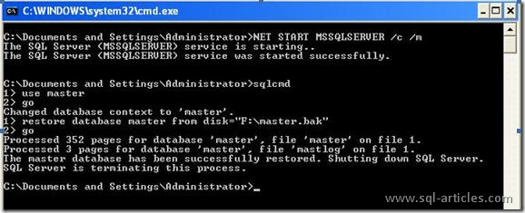

2. Using DAC

SQL Server 2005 provides a special diagnostic connection for administrators when standard connections to the server are not possible. This diagnostic connection allows an administrator to access SQL Server to execute diagnostic queries and troubleshoot problems even when SQL Server is not responding to standard connection requests.
SQL Server makes every attempt to make DAC connect successfully, but under extreme situations it may not be successful.
Connecting with DAC :
By default, the connection is only allowed from a client running on the server. Remote connections are not permitted unless they are configured by using the Surface area configuration for features and navigating to database engine to enable DAC or the sp_configure stored procedure as shown below,
1  2  3  4 | SP_CONFIGURE 'remote admin connections',1  GO  RECONFIGURE  GO
Only members of the SQL Server sysadmin role can connect using the DAC.
There are 2 options by which we can connect using DAC
1. Using SSMS
2. Using Sqlcmd
To use SQL Server Management Studio with the DAC, connect to an instance of the SQL Server Database Engine with Query Editor by typing ADMIN: before the server name. Object Explorer cannot connect using the DAC.
In SQL Server Management Studio, with no other DACs open, on the toolbar, click Database Engine Query. The Connect to Database Engine dialog box opens.
In the Server name box, type ADMIN: followed by the name of the server instance. For example, to connect to a server instance named DEEPAKTEST, type ADMIN:DEEPAKTEST.

Complete the Authentication section, providing credentials for a member of the sysadmin group, and then click Connect.The connection is made.If a DAC already exits, the connection will fail with an error indicating it cannot connect.
Using Sqlcmd we can connect to sql server as a dedicated administrator as follows,
Go to command prompt and type as shown below to connect using windows authentication.
Sqlcmd -S DeepakTest -E -A
or type as shown below
Sqlcmd -S Admin:DeepakTest
Go to command prompt and type as shown below to connect using Sql server authentication.
Sqlcmd -S DeepakTest -U sa -P XXXX -A
where XXXX is the password for the login sa
DAC Port :
SQL Server listens for the DAC on a dedicated TCP/IP port. The error log contains the port number the DAC is listening on. By default the DAC listener accepts connection on only the local port.
Once the remote administration connection is configured, the DAC listener is enabled without requiring a restart of SQL Server and a client can now connect to the DAC remotely. You can enable the DAC listener to accept connections remotely even if SQL Server is unresponsive by first connecting to SQL Server using the DAC locally, and then executing the sp_configure command to accept connection from remote connections.
The DAC port is assigned dynamically by SQL Server during startup. If SQL Server is configured to accept remote administration connections, the DAC must be initiated with an explicit port number as shown below,
sqlcmd Stcp:servername, port number
The SQL Server error log lists the port number for the DAC, which is 1434 by default. If SQL Server is configured to accept local DAC connections only, connect using the loopback adapter using the following command:
sqlcmd S127.0.0.1,1434
LIMITATIONS :
Because the DAC exists solely for diagnosing server problems in rare circumstances, there are some limitations on the connection:
1. To guarantee that there are resources available for the connection, only one DAC is allowed per instance of SQL Server. If a DAC connection is already active, any new request to connect through the DAC is denied with error 17810.
2. To conserve resources, SQL Server 2005 Express Edition does not listen on the DAC port unless started with a trace flag 7806.
3. The DAC initially attempts to connect to the default database associated with the login. After it is successfully connected, you can connect to the master database. If the default database is offline or otherwise not available, the connection will return error 4060. However, it will succeed if you override the default database to connect to the master database instead using the following command: sqlcmd A d master.
4. SQL Server prohibits running parallel queries or commands with the DAC. For example, error 3637 is generated if you execute either of the following statements with the DAC:
RESTORE and BACKUP
5. Only limited resources are guaranteed to be available with the DAC. Do not use the DAC to run resource-intensive queries (for example. a complex join on large table) or queries that may block. This helps prevent the DAC from compounding any existing server problems. You might be able to terminate the DAC session using CNTRL-C but it is not guaranteed. In that case, your only option may be to restart SQL Server.
6. Restrict usage to the following diagnostic and troubleshooting commands:
Querying dynamic management views for basic diagnostics such as sys.dm_tran_locks for the locking status, sys.dm_os_memory_cache_counters to check the health of caches, and sys.dm_exec_requests and sys.dm_exec_sessions for active sessions and requests. Avoid dynamic management views that are resource intensive (for example, sys.dm_tran_version_store scans the full version store and can cause extensive I/O) or that use complex joins.
7. Also avoid basic DBCC commands such as DBCC FREEPROCCACHE,DBCC FREESYSTEMCACHE,DBCC DROPCLEANBUFFERS, and DBCC SQLPERF. Do not run resource-intensive commands such as DBCC CHECKDB,DBCC DBREINDEX, or DBCC SHRINKDATABASE.
8. Restrict the usage of Transact-SQL KILL command. Depending on the state of SQL Server, the KILL command might not always succeed; then the only option may be to restart SQL Server.
The following are some general guidelines:
Verify that the SPID was actually killed by querying SELECT * FROM sys.dm_exec_sessions WHERE session_id = . If it returns no rows, it means the session was killed.
If the session is still there, verify whether there are tasks assigned to this session by running the query SELECT * FROM sys.dm_os_tasks WHERE session_id = spid. If you see the task there, most likely your session is currently being killed. Note that this may take considerable amount of time and may not succeed at all.
If there are no tasks in the sys.dm_os_tasks associated with this session, but the session remains in sys.dm_exec_sessions after executing the KILL command, it means that you do not have a worker available. Select one of the currently running tasks (a task listed in the sys.dm_os_tasks view with a sessions_id <> NULL), and kill the session associated with it to free up the worker. Note that it may not be enough to kill a single session, you may have to kill multiple ones.

Feb 05 How to Recover SA password when you forget it – SQL 2005
What to do if you forgot SA password in SQL Server 2005?
In general if you forgot SA password or if the SA account is disabled these are the options to login into SQL Server 2005 and reset or enable SA.
1. If BuiltinAdministrator is present in SQL Server, you can login with an ID which is member of Administrators group and reset the SA password.
2. Or else if you have some other ID which is having sysadmin privilege in SQL level(this also SQLservice account), you can login with that and reset SA.
But in case if you have the following scenario where,
1. You have disabled SA (or) forgotten SA password
2. You followed the best security practice and removed Builtinadministrator from SQL Server
So you cannot login with a sysadmin ID into SQL Server, and you start thinking about uninstalling SQL Server 2005. No need to perform any uninstall and reinstall in such scenarios in SQL Server 2005 as you have this option where the Members of Windows Administrative groups have sysadmin privilege in SQL Server if you start SQL Server 2005 in Single user mode.
Consider this example, where I have disabled SA and removed BuiltinAdministrator from SQL Server 2005. Refer the below screenshots which displays the error message I get when I login Administrator and SA,
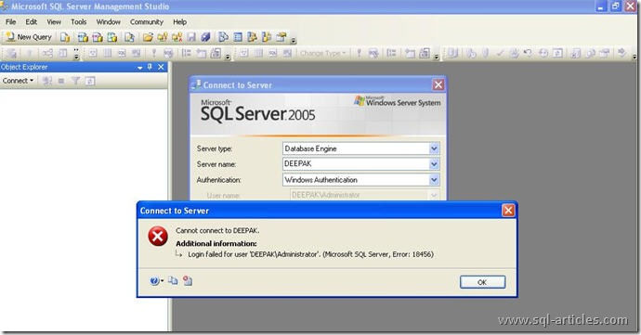
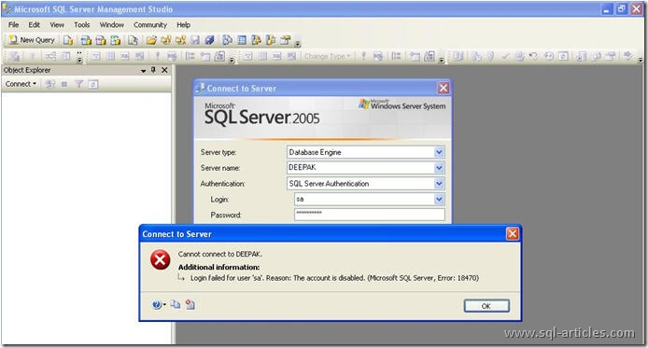
Refer the below screenshot which shows the members of windows administrator group,
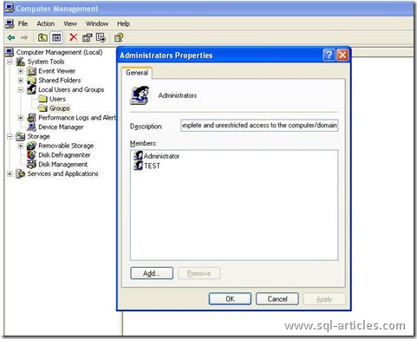
I perform the following steps ,
1. Login with the ID Test @OS Level
2. Stop SQL Server 2005 using the command, NET STOP MSSQLSERVER *
3. Start SQL Server 2005 in Single-User mode using the command, NET START MSSQLSERVER /m *
4. Login into SQL Server 2005 using the ID Test as shown in the below screenshot,
*Note: MSSQLSERVER is for default instance, if you are proceeding in a named instance then use MSSQL$Instancename instead of MSSQLSERVER.
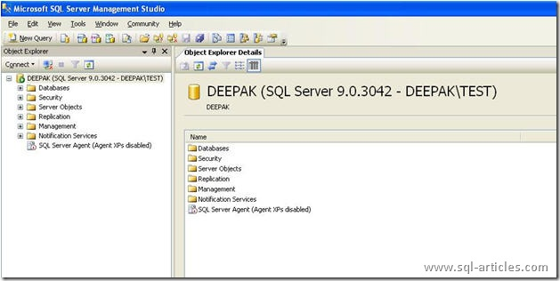
5. Since SQL Server is started in Single-User mode it will allow only one connection and hence you will get the following error if you click the New Query
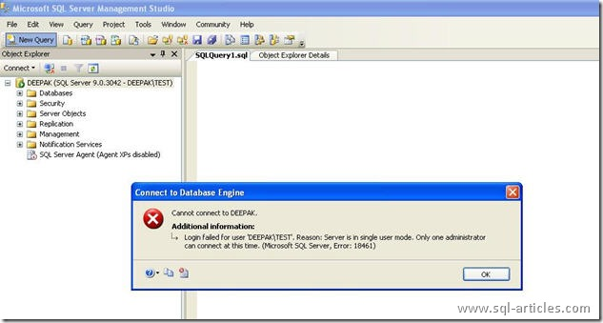
6. Disconnect and close the Object Explorer and then connect using New Query you will be able to connect as shown below, and then enable SA login using the command
1 | ALTER Login SA enable
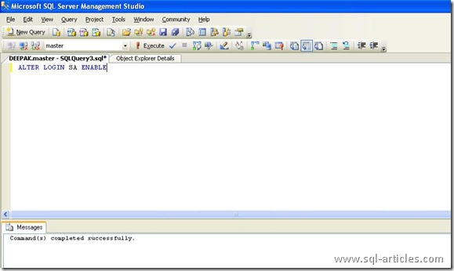
7. If you want to create a new SQL Level login with sysadmin privilege , you can perform as shown in the below screenshot
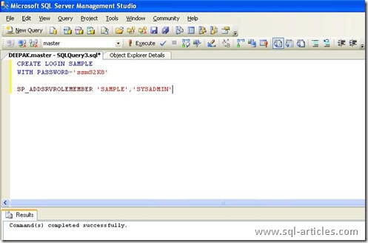
8. Now you need to Stop SQL Server and start it normally using the command, NET START MSSQLSERVER * and connect using SA or the new login you created and proceed as shown below,
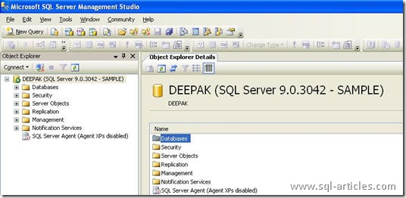
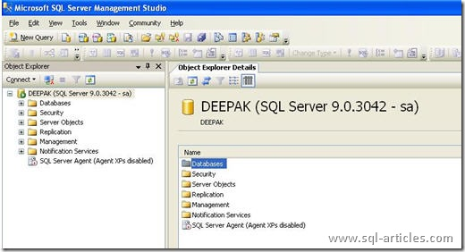
Read more: http://sql-articles.com/articles/troubleshooting/how-to-recover-sa-password-when-you-forget-it-sql-2005/#ixzz2BQWgGdXw

Backup Error
You might be wondering what is happening in your SQL Server when you see the error message given below. It's all simple, you need not panic.
Error Number: 18272
Error Message: I/O error on backup or restore restart-checkpoint file ‘%1′. Operating system error %2. The statement is proceeding but is non-restartable.
This happens when SQL server is not able to find the default backup directory. SQL Server needs to create a checkpoint file when a BACKUP or RESTORE operation happens. This happens when the RESTART option is specified. WITH RESTART tells SQL Server to start from the point where the operation was last aborted. When SQL Server searches for the file and it's not available then this error is thrown.
How to avoid this error:
- Check the default backup directory for the SQL Server and see if exists, if not create it.
- Verify if the backup directory has enough space in it.
- Verify if SQL Server service account has permissions to read and write into that directory

------------------------------------------------------------------------------------------------------

FIX: Error message in the Errorlog file of SQL Server 2005 or of SQL Server 2008 after the SQL Server service stops responding: "Timeout occurred while waiting for latch"
Article ID: 974205 - View products that this article applies to.
Microsoft distributes Microsoft SQL Server 2005 fixes as one downloadable file. Because the fixes are cumulative, each new release contains all the hotfixes and all the security fixes that were included with the previous SQL Server 2005 fix release.Microsoft distributes Microsoft SQL Server 2008 fixes as one downloadable file. Because the fixes are cumulative, each new release contains all the hotfixes and all the security fixes that were included with the previous SQL Server 2008 fix release.
Expand all | Collapse all

On This Page

SYMPTOMS
In Microsoft SQL Server 2005, you may encounter one of the following problems.

Problem 1
The SQL Server service stops responding, and a memory dump file is generated in the SQL Server 2005 log folder. Additionally, the following error message is logged in the SQL Server 2005 Errorlog file:
Date Time SPID Timeout occurred while waiting for latch: class 'QUERY_OPTIMIZER_ID_MANAGER', id 000000008031A7E0, type 4, Task 0x0000000000DAFAC8 : 0, waittime 300, flags 0x1a, owning task 0x0000000005454718. Continuing to wait.
Date Time SPID Timeout occurred while waiting for latch: class 'QUERY_OPTIMIZER_ID_MANAGER', id 000000008031A7E0, type 4, Task 0x000000000771A328 : 0, waittime 300, flags 0x1a, owning task 0x0000000005454718. Continuing to wait.
Date Time SPID Using 'dbghelp.dll' version '4.0.5'
Date Time SPID **Dump thread - spid = 148, PSS = 0x0000000126F4FBF0, EC = 0x0000000126F4FC00
Date Time SPID ***Stack Dump being sent to C:\Program Files\Microsoft SQL Server\MSSQL.1\MSSQL\LOG\SQLDump0021.txt
Date Time SPID * *******************************************************************************
Date Time SPID *
Date Time SPID * BEGIN STACK DUMP:
Date Time SPID * Date Time SPID
Date Time SPID *
Date Time SPID * Latch timeout
Date Time SPID *
Date Time SPID * Input Buffer 168 bytes -
Date Time SPID * SELECT backup_set_id FROM msdb..backupset WITH (NOLOCK) WHERE media_set_
Date Time SPID * id = 226059
Date Time SPID *
Date Time SPID * *******************************************************************************
Date Time SPID * -------------------------------------------------------------------------------
Date Time SPID * Short Stack Dump
Date Time SPID Stack Signature for the dump is 0x00000001212FF0DE
Date Time SPID Timeout occurred while waiting for latch: class 'QUERY_OPTIMIZER_ID_MANAGER', id 000000008031A7E0, type 4, Task 0x0000000007F31D68 : 0, waittime 300, flags 0x1a, owning task 0x0000000005454718. Continuing to wait.
When this problem occurs, the server does not respond to any attempted operations. The only way to make SQL Server functional again is to restart the SQL Server service.
Note Any system or user-level query can encounter this issue.

Problem 2
When the query optimizer of SQL Server 2005 generates a query plan, the query optimizer may wait for a spinlock to be released. The spinlock is used to access internal structure to record information about the missing indexes for the query plan. While the query optimizer is waiting for the spinlock, the query optimizer does not release the scheduler.In rare conditions the query optimizer does not obtain the spinlock and keeps holding the scheduler. This causes a "non-yielding scheduler" error and some other errors to be logged in the SQL Server Errorlog file. Additionally, SQL Server creates a memory dump in the SQL Server log folder. The memory dump records the context of the problem that the query optimizer does not release the scheduler.
If the query optimizer optimizes multiple queries on multiple schedulers, this problem may generate one or more "non-yielding scheduler" errors in the SQL Server Errorlog file.
The following are the sample errors that are logged in the SQL Server Errorlog file when this problem occurs.
Note There is more than one cause of the "non-yielding schedulers" error. You must analyze the memory dump to determine whether the context of "non-yielding scheduler" error matches the problem context that is described in this article.

Error 1
**Dump thread - spid = 0, PSS = 0x0000000000000000, EC = 0x0000000000000000
***Stack Dump being sent to D:\Microsoft Sql Server\MSSQL.1\MSSQL\LOG\SQLDump0001.txt
* *******************************************************************************
*
* BEGIN STACK DUMP:
* 10/22/09 11:01:13 spid 0
*
* Deadlocked Schedulers
*
* *******************************************************************************
* -------------------------------------------------------------------------------
* Short Stack Dump
Stack Signature for the dump is 0x00000000000000D7
External dump process return code 0x20000001.

Error 2
* *******************************************************************************
*
* BEGIN STACK DUMP:
* 10/22/09 11:01:23 spid 0
*
* Non-yielding Scheduler
*
* *******************************************************************************
Stack Signature for the dump is 0x00000000000000D7

Error 3
<Date><Time> Server New queries assigned to process on Node 0 have not been picked up by a worker thread in the last 60 seconds. Blocking or long-running queries can contribute to this condition, and may degrade client response time. Use the "max worker threads" configuration option to increase number of allowable threads, or optimize current running queries. SQL Process Utilization: 0%. System Idle: 99%.

Error 4
Note The Process ID, the Worker ID, the Scheduler ID and the time may change for your scenario.
Process 103:0:0 (0x4e0) Worker 0x0000000090A1A1C0 appears to be non-yielding on Scheduler 1. Thread creation time: 12900592800518. Approx Thread CPU Used: kernel 0 ms, user 0 ms. Process Utilization 0%. System Idle 98%. Interval: 74595 ms.
Process 101:0:0 (0x15f0) Worker 0x00000000908A01C0 appears to be non-yielding on Scheduler 2. Thread creation time: 12900652201513. Approx Thread CPU Used: kernel 0 ms, user 0 ms. Process Utilization 0%. System Idle 98%. Interval: 76376 ms.
Process 61:0:0 (0x144) Worker 0x00000000FB4141C0 appears to be non-yielding on Scheduler 0. Thread creation time: 12900697200999. Approx Thread CPU Used: kernel 0 ms, user 0 ms. Process Utilization 0%. System Idle 98%. Interval: 76376 ms.
Process 67:0:0 (0x1778) Worker 0x00000000902081C0 appears to be non-yielding on Scheduler 3. Thread creation time: 12900129835565. Approx Thread CPU Used: kernel 0 ms, user 0 ms. Process Utilization 0%. System Idle 98%. Interval: 76376 ms.
Back to the top | Give Feedback

CAUSE
This issue occurs when SQL Server processes missing index information for a dynamic management view (DMV). No user intervention is required to cause this issue. This issue is a rare, timing-related issue.
------------------------------------------------------------

Recovering From Suspect Mode
Many DBAs would have seen the database marked as suspect. If a database is marked suspect it cannot be accessed and hence nothing can be performed in the database. In this article I am going to explain how to overcome this and bring the database back to normalcy. There are three possible Workarounds to bring the database online and to retrieve the data. First try the Workaround 1 and if it fails go to Workaround 2 if that doesn’t yield the desired result try the Workaround 3.
WORKAROUND 1:
Step 1 : If your database is marked suspect execute the below query,
1  2  3 | USE Master  GO  Sp_resetstatus 'Database Name'
The above command will reset the status flag of the suspect database.
Step 2: Once the command is executed you need to restart the SQL services and check the status of the database.
Step 3: Execute the below query to check the integrity of the database
1 | DBCC Checkdb('Database Name')
WORKAROUND 2:
Step 1: But if you want to avoid any data loss you can bring the suspect database into emergency mode as follows,
1  2 | ALTER DATABASE DATABASE dbName  SET EMERGENCY
This will bring the Database into emergency mode so that you can Export the data using SSIS to another Test server.
Step 2: One you exported you can drop the suspect database and restore it from the latest available backup. Those objects Exported to Test server could be scripted and rerun in the source database after restoring from the backup so that we can minimize the data loss if

