

Webpage Project

KiranKC | GigaByte | initial: 7/12/2021

# Date : 2021/07/11

Idea and reference

The project assigned is about electronic device.

* To make a webpage of a company that manufactures electronic products.eg laptop , TV mobiles etc.
* reference for this webpage comes from Samsung official website.
* Black and white are the main color to be used in this page.
* website named Gigabyte which
* idea is to create options to buy TV , mobiles , laptops

Date : 2021/07/12

Starting Project

- created a navigation bar.

-Added quick links for Home , News, Products and signup option

-Added actual sign up section which contains input field for typing first name, last name , email ,password and finally button for submitting.

Nav bar



Signup section

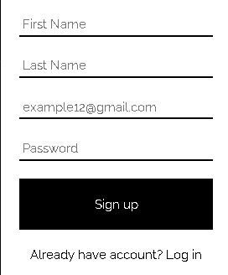

Date : 2021/07/13

Progress

* Created toggle sign up button
* Created intro page
* Collected images for products thumbnail
* Created page for products
* plus additional design ideas

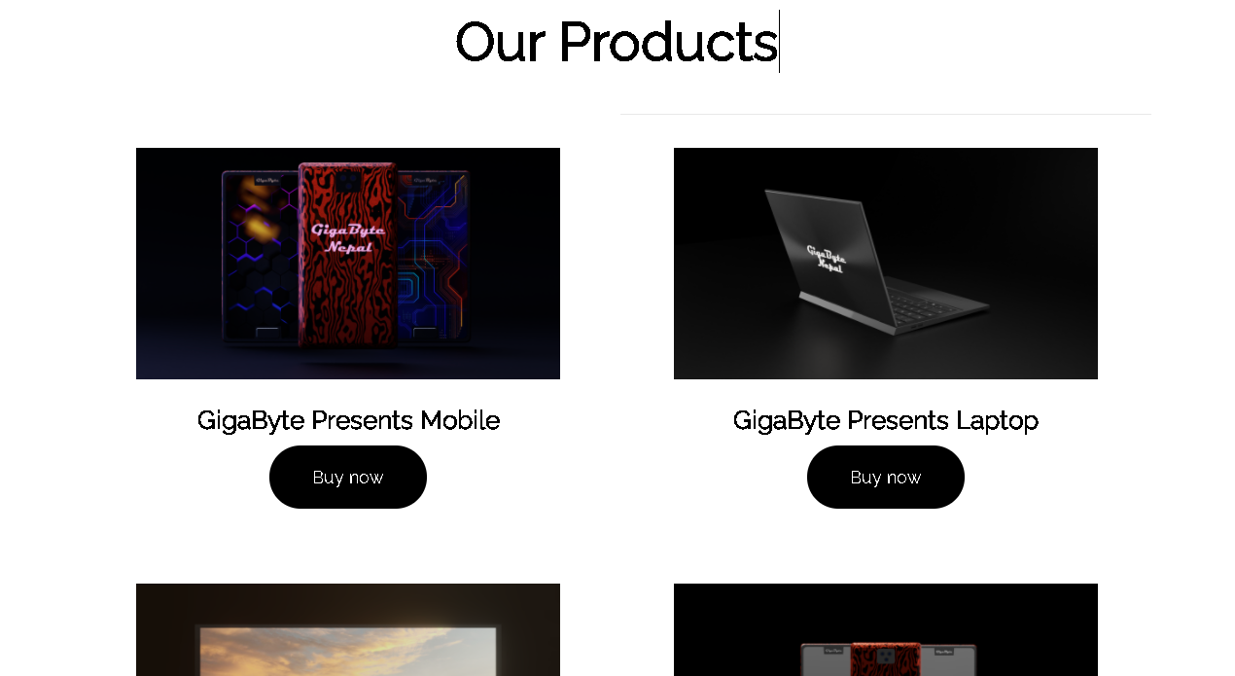

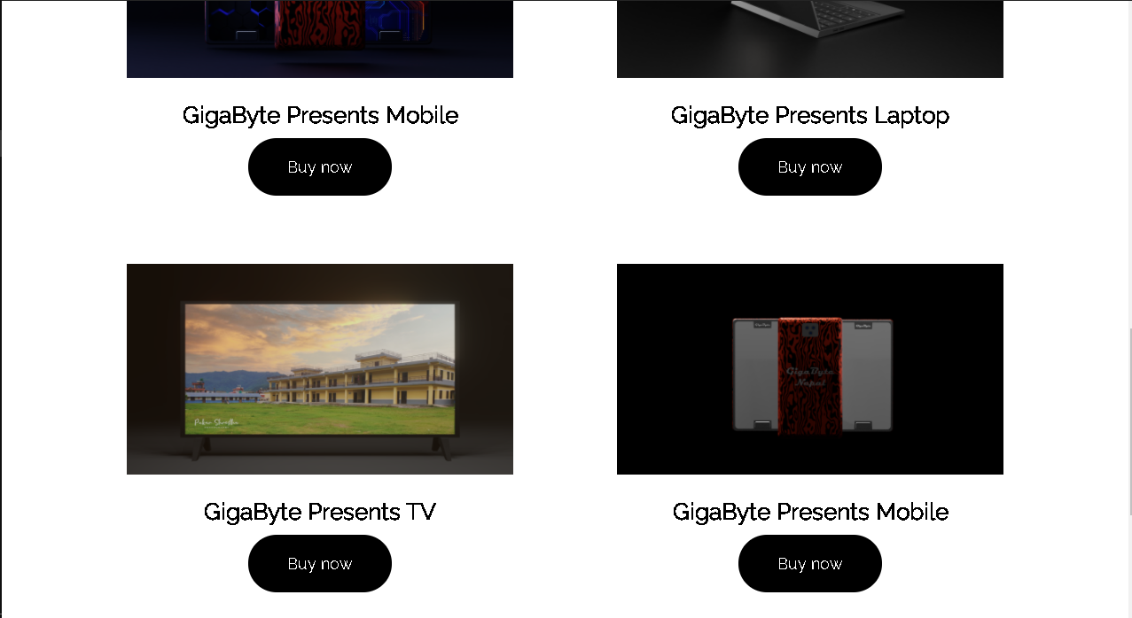

Date : 2021/07/14

Things added

- footer which contains about section, Contact section for social media links , Section for company and finally section for entering the email to receive all the news.

- Small section added for alerting about the cookies

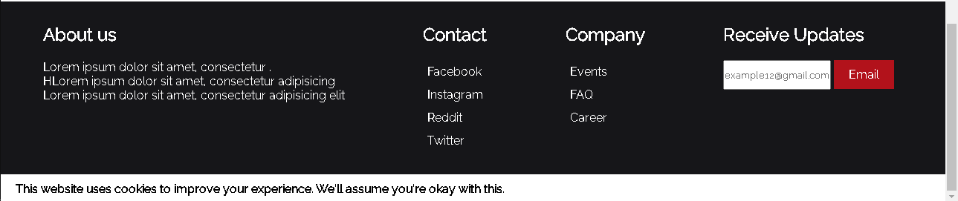

Date : 2021/07/15

Content Added :

* product purchasing page

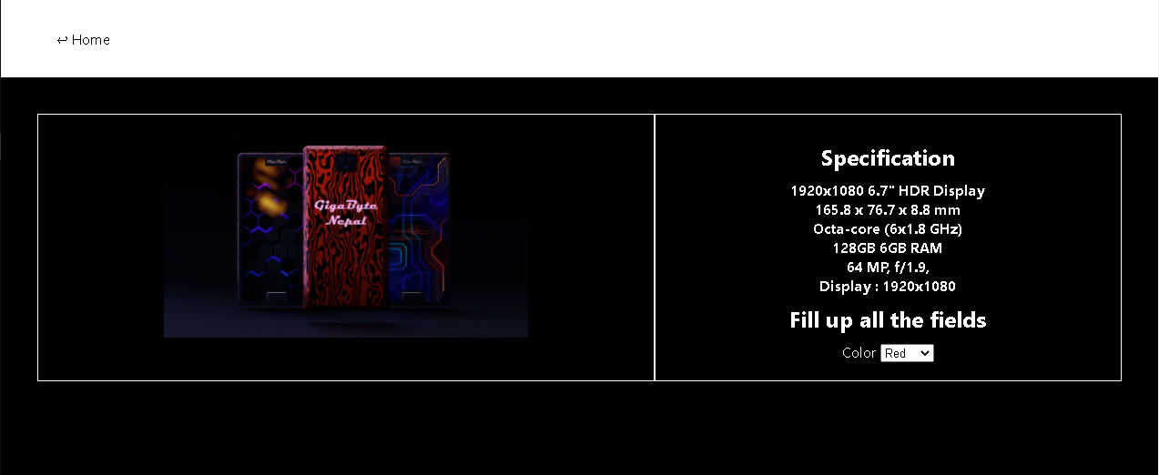

Date : 2021/07/16

Progress:

* Intro page background image toggle button.
* More ideas and reference collected.
* New images created using photoshop.

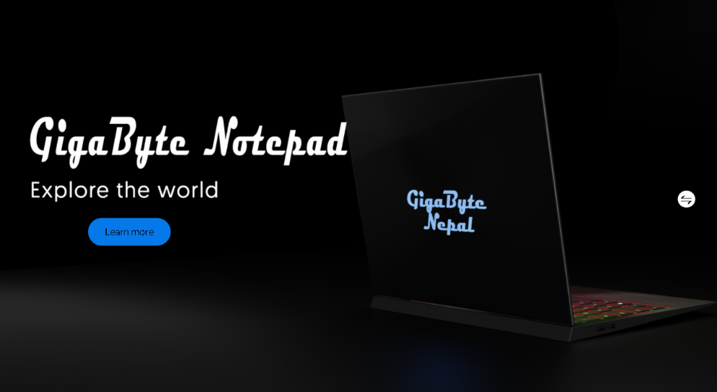

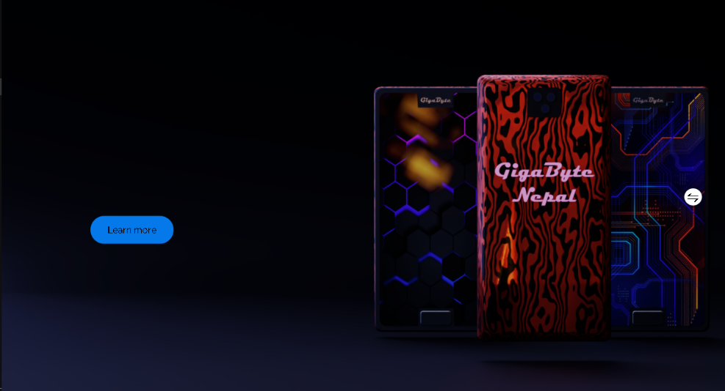

Date : 2021/07/17

Things added :

* functional signup and login section.
* 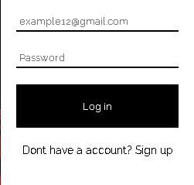
* updated product purchasing section.
* 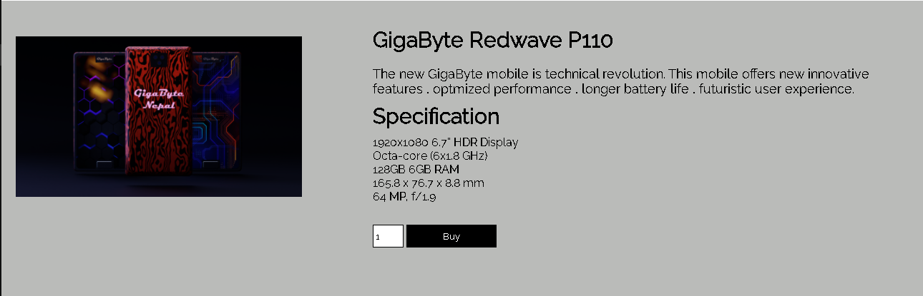

Date : 2021/07/18

Things Added:

* saving name , email , password functionality.
* promo banner added in home page
* 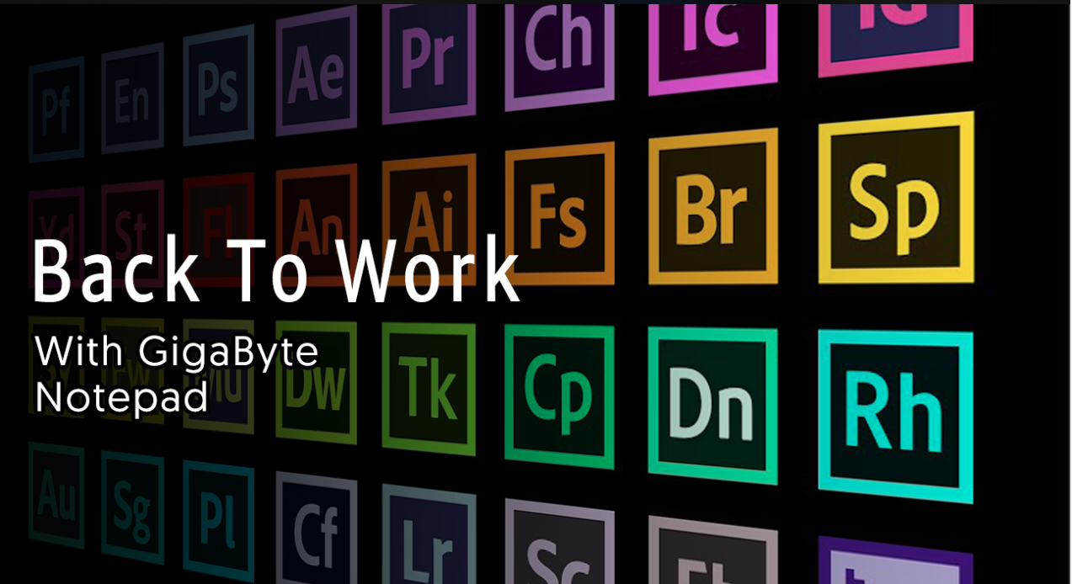

Date : 2021/07/20

Things added:

* purchase page updated.

