Book Management System - Project Report

Team Members:  
- Yangfan Li  
- Xiao Kuang

---

## A.1 OVERVIEW

This Book Management System is a PHP + MySQL based web application that allows users to manage a library of books efficiently. The main functionality revolves around CRUD operations (Create, Read, Update, Delete) for books, authors, and categories. The system features a user-friendly web interface powered by Bootstrap and stores data in a relational MySQL database.

## A.2 FEATURES

Guest Capabilities:  
- View all books (title, author, category, publication year)

Admin/User Capabilities:  
- Add new books with associated authors and categories  
- Edit existing book information  
- Delete books from the list  
- View all books in a table layout

## A.3 FUNCTIONALITY EXPLANATION

1. Book List Page (list.php):  
 - Displays all books in a formatted table  
 - Includes Edit/Delete action buttons for each book  
  
2. Add Book Page (create.php):  
 - Form to enter a new book's title, author, category, and publication year  
 - Pulls authors/categories from database dynamically  
  
3. Edit Book Page (edit.php):  
 - Pre-fills form fields with selected book's current data  
 - Allows editing and saving updates  
  
4. Delete Book Feature (delete.php):  
 - Deletes a book by ID and redirects to book list  
  
5. Database Tables:  
 - books: Contains book information  
 - authors: List of all authors  
 - categories: List of all book categories

## A.4 TECHNOLOGIES USED

- Frontend: HTML5, CSS3, Bootstrap 5  
- Backend: PHP 7+  
- Database: MySQL (via XAMPP)  
- Tools: phpMyAdmin for database management

## A.5 SAMPLE SCREENSHOTS

*(Add the screenshots from your create.php, list.php, and edit.php pages here)*

## A.6 DEPLOYMENT INSTRUCTION

1. Place project folder in htdocs of XAMPP  
2. Start Apache & MySQL in XAMPP  
3. Import book_db.sql into phpMyAdmin  
4. Access system at http://localhost/book-management/books/list.php

## A.7 CONCLUSION

This Book Management System offers a foundational CRUD interface for managing library data. It ensures usability through form validation and user-friendly design, while providing extendability for future features like login systems or book lending modules.

---

End of Report

## A.5 SAMPLE SCREENSHOTS

Screenshot: Add Book Page

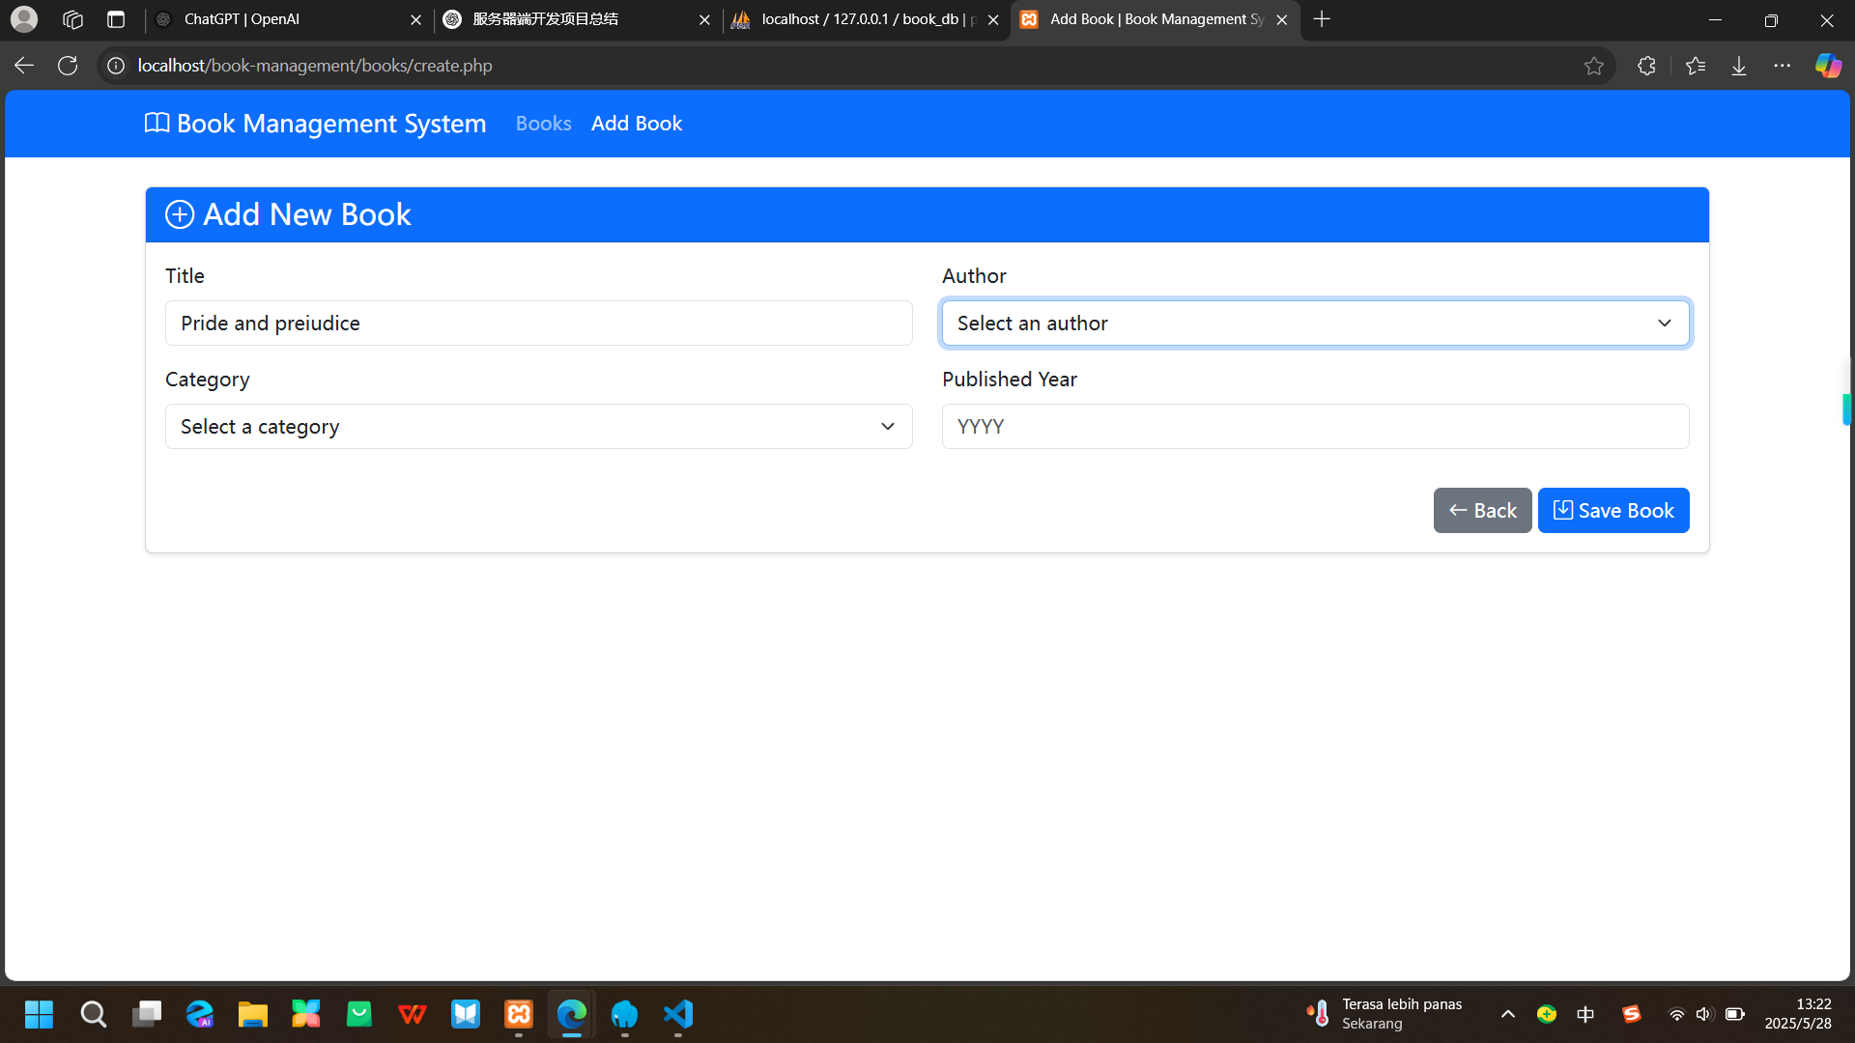

Screenshot: Book List Page

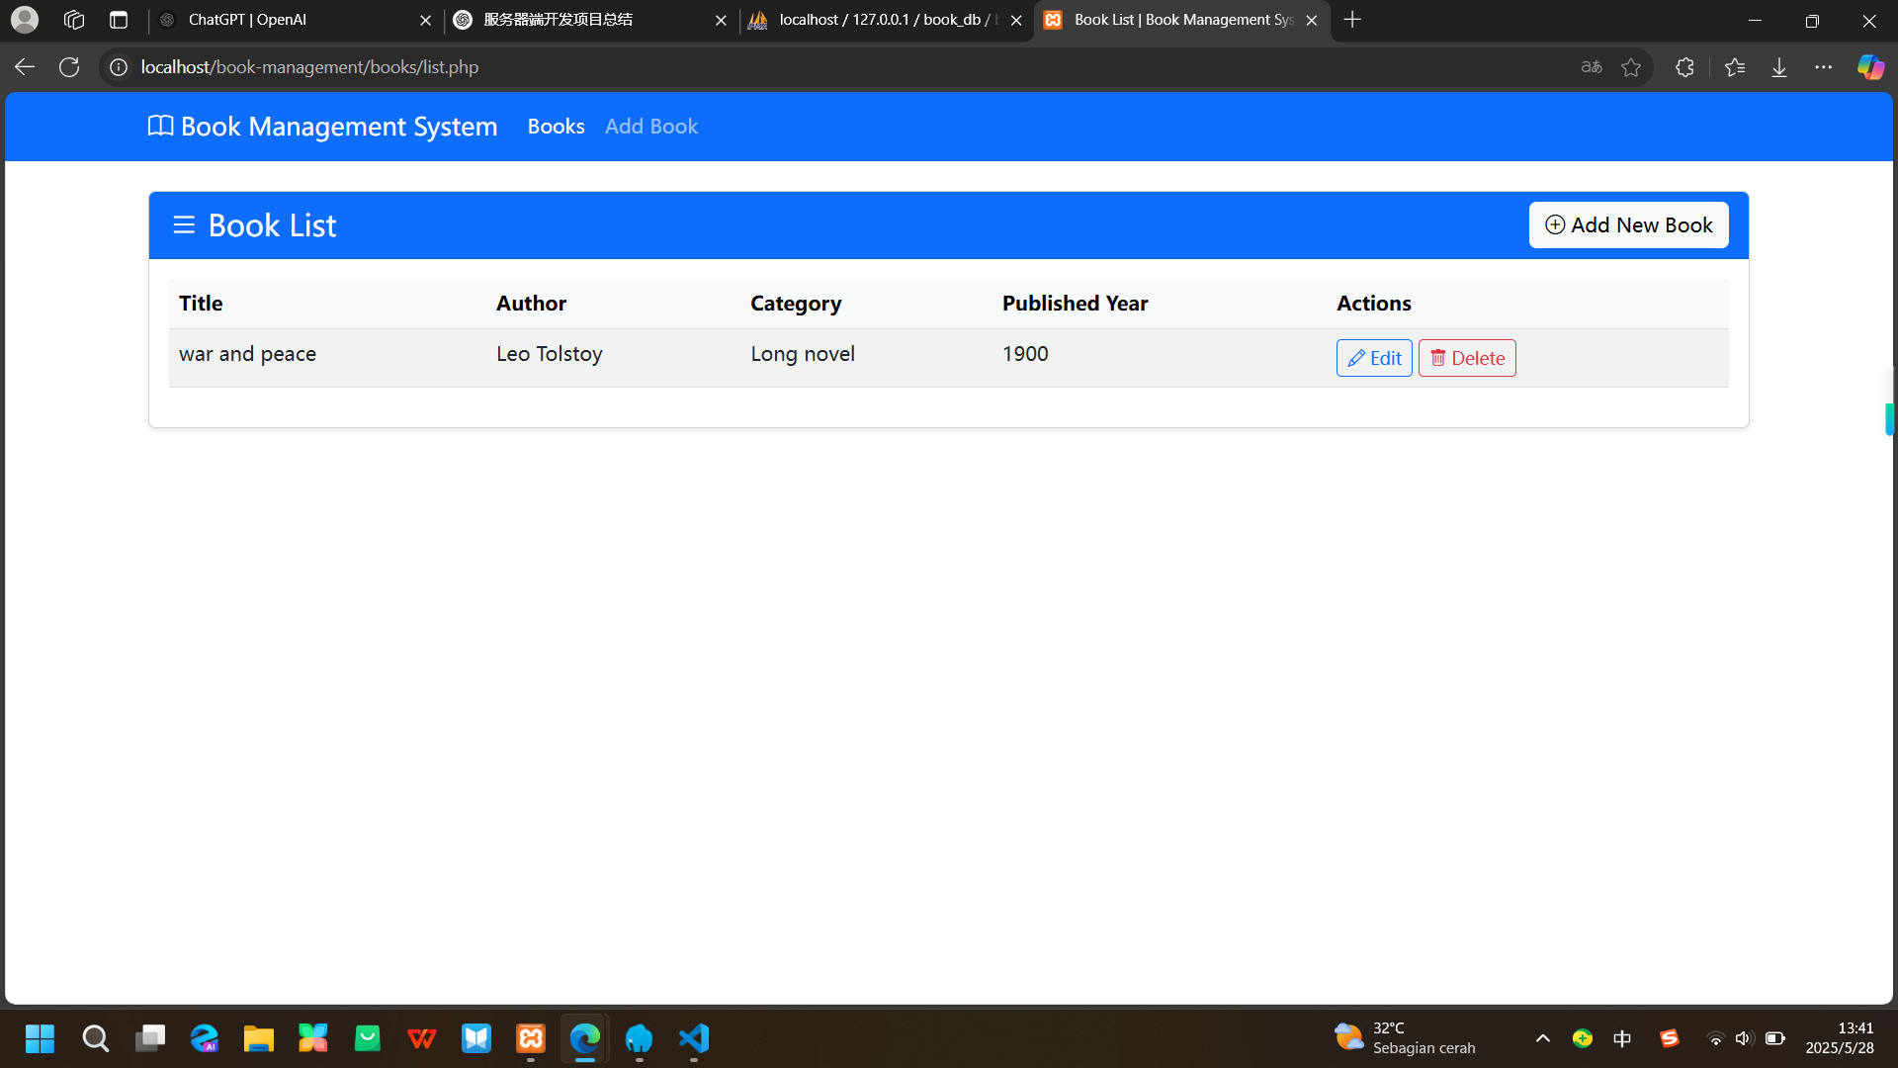

Screenshot: Edit Book Page

