**‘LOCAL THEATRE COMPANY’: WEBSITE DESIGN**

Kyle Christie

[20245231]

Written 24/11/20

Finalised 18/01/21

Lecturer: Angeline Nesbitt, Karen Sturgeon

Class: Multiplatform Websites



# Website Goal

I will be developing a website for ‘Local Theatre Company’ which will allow the client to make announcements to their followers, allow access to user submitted reviews of films/performances and provide customers with relevant information.

# Functional Requirements

*Users*

Users should be able to submit reviews

Users can leave comments on the feedback page

*System*

*User password strength should be checked before they can successfully register*

System should remember the username if a user was logged in within the last 24 hours

Users should be able to register an account with a username, password and email

Articles should be able to be edited/deleted

Article deletes should also delete all related content (comments)

*Admins*

Admins should be able to create a new blog article

Admins should be able to remove inappropriate content

Admins should be able to de-activate user accounts

# Non-Functional Requirements

Website should be highly accessible from different devices with a responsive design

Website design should be lightweight and complement companies branding

# Site Users

Due to the responsive design, the site is inclusive for young people who use mobile phones, tablets and similar devices. Anyone who enjoys film and theatre would be most likely to use this website in order to access the reviews and similar information the client would make available. People who follow the company (actors, audience) would also use this site to stay aware of announcements and read articles which are relevant to them. Theatre Staff/Admins would use the site to moderate user submitted content/approve user reviews and to write articles/announcements to be displayed on the website.

# Data Model

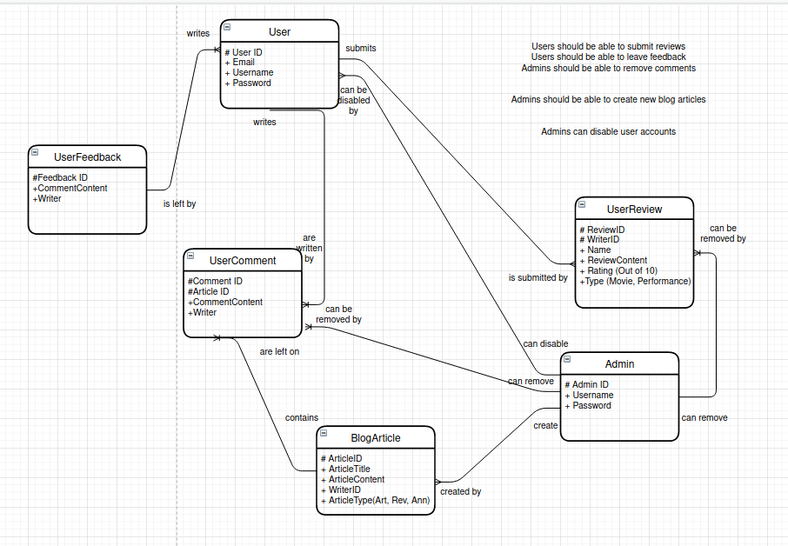

# Overview of main site functions

Register Users

Add Staff Articles

Manage User accounts

Remove User content

Submit Review

Add Comment

Check User Password (when registering)

Edit Articles

Delete Articles (and their related content)

Remember User where valid

# Site Map Diagram

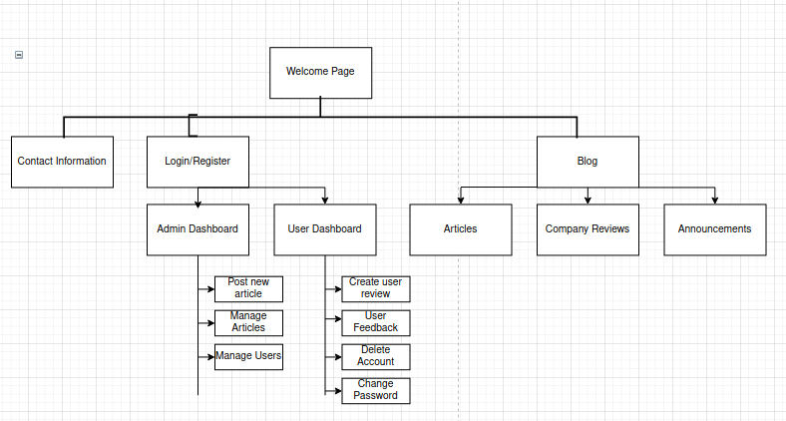NOTE: Company Reviews will hold a tab where user reviews can be accessed, possibility that user reviews can be used alongside the company review to provide an overall summary of reviews.

# Storyboard Designs

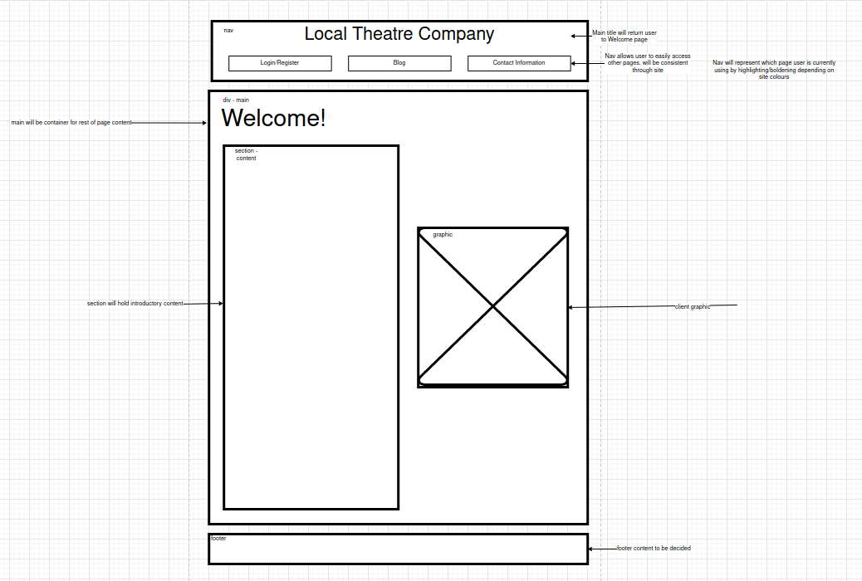

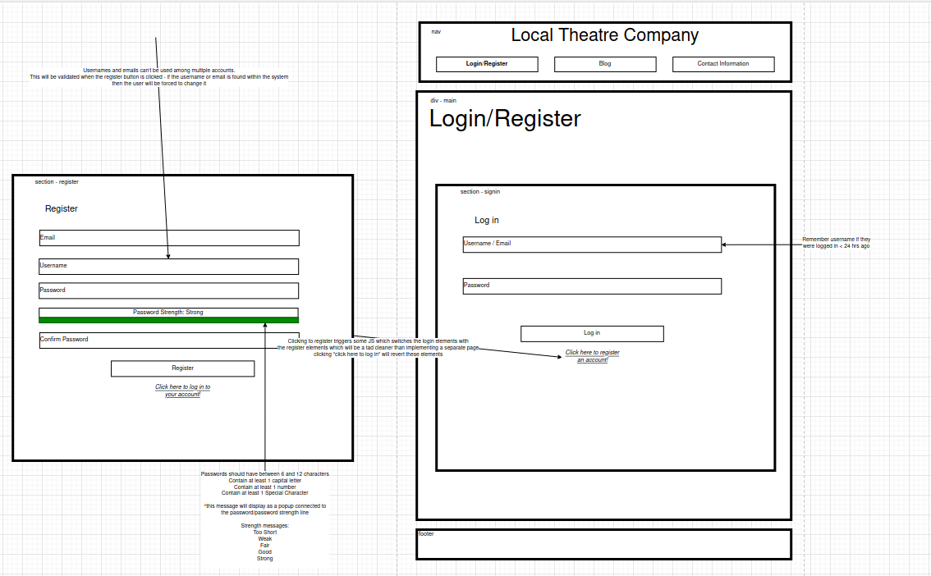

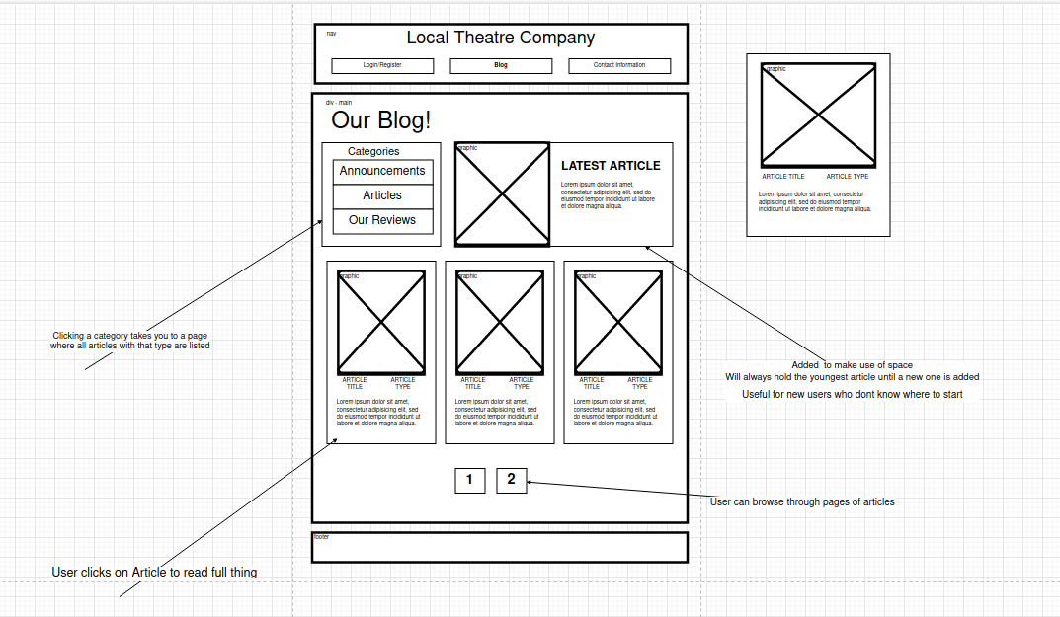

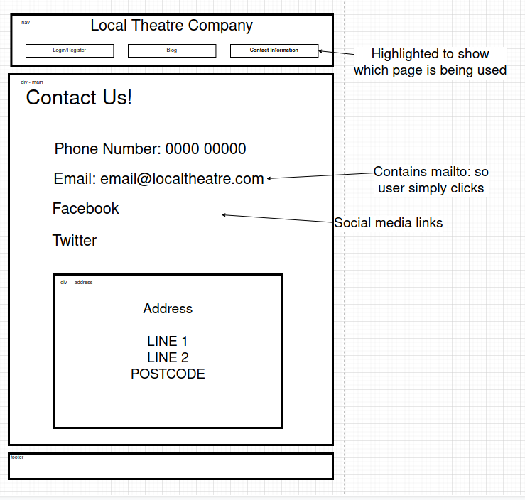

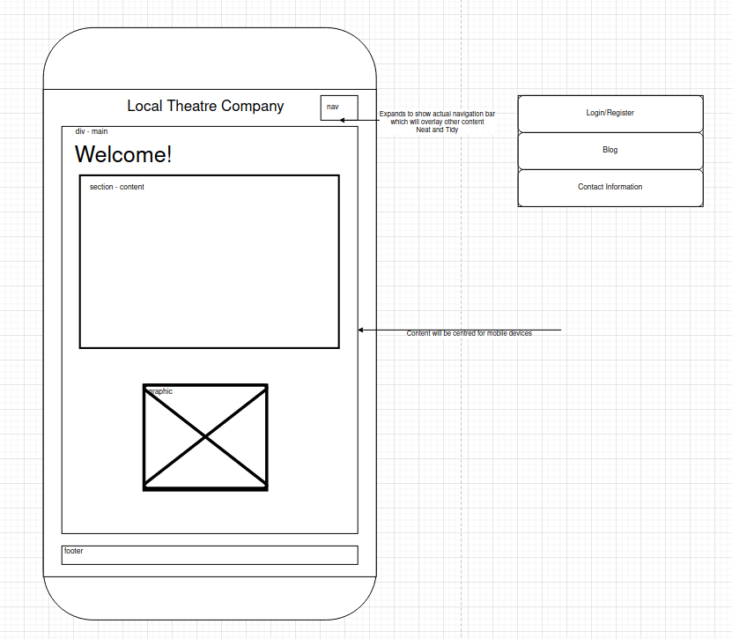

# Project Schedule

|  |  |  |  |  |  |  |
| --- | --- | --- | --- | --- | --- | --- |
| Schedule | TASK | DURATION | MATERIALS USED | PLANNED COMPLETION DATE | ACTUAL COMPLETION  DATE | STATUS |
| Analysis |  |  |  |  |  |  |
|  | - Identify site requirements based on brief | 3 days | LibreOffice Writer | (14/11/20) | (15/11/20) | COMPLETE |
|  | - Identify site goals and user base | 2 days | LibreOffice Writer | (17/11/20) | (17/11/20) | COMPLETE |
|  | - Analyse site functions | 1 days | LibreOffice Writer | (19/11/20) | (20/11/20) | COMPLETE |
| Design |  |  |  |  |  |  |
|  | - Develop Site Map | 3 days | Draw.io | (22/11/20) | (22/11/20) | COMPLETE |
|  | - Develop story board designs | 5 days | Draw.io | (27/11/20) | (30/11/20) | COMPLETE |
|  | - Develop data model | 2 days | Draw.io | (2/12/20) | (2/12/20) | COMPLETE |
| Implementation |  |  |  |  |  |  |
|  | - Create HTML for front end | 2 days | Visual Studio Code | 28/1/20 | -- | COMPLETE |
|  | - Create CSS stylesheet for site | 2 days | Visual Studio Code | 1/2/20 | -- | COMPLETE |
|  | - Create database and DB management code | 4 days | Visual Studio Code, MongoDB | 5/2/20 | -- | COMPLETE |
| Testing |  |  |  |  |  |  |
|  | - Test site links | 2 days | Browser | 7/2/20 | -- | COMPLETE |
|  | - Test JS/Database code | 3 days | Browser | 10/2/20 | -- | COMPLETE |
|  | - Test CSS across browsers | 3 days | Browser(s) | 13/2/20 | -- | COMPLETE |
|  | - Test site on mobile devices | 2 days | Browser, Mobile Phone | 15/2/20 | -- | COMPLETE |

# Functional Testing

|  |  |  |  |  |
| --- | --- | --- | --- | --- |
| **Test case** | **Test data** | **Expected result** | **Actual result** | **Action taken** |
| User can change password |  | Password is changed |  |  |
| User can log in to their account |  | User logged in |  |  |
| New accounts are registered to Database |  | Accounts successfully saved |  |  |
| User can leave feedback |  | Feedback successfully saved |  |  |
| Admins can deactivate users |  | User account disabled |  |  |
| Admins can post new articles |  | New article is created |  |  |
| Admins can edit current articles |  | Article is modified |  |  |

# Browser Testing [Firefox 89]

|  |  |  |  |  |
| --- | --- | --- | --- | --- |
|  | **Home page** | **About page** | **Contact Us** | **Welcome** |
| Links functional |  |  |  |  |
| Images display correctly |  |  |  |  |
| CSS successfully applied |  |  |  |  |
| Forms successfully submit |  |  |  |  |
| JavaScript functional |  |  |  |  |

# Browser Testing [Chromium v91 (based on Google Chrome) ]

|  |  |  |  |  |
| --- | --- | --- | --- | --- |
|  | **Home page** | **About page** | **Contact Us** | **Welcome** |
| Links functional |  |  |  |  |
| Images display correctly |  |  |  |  |
| CSS successfully applied |  |  |  |  |
| Forms successfully submit |  |  |  |  |
| JavaScript functional |  |  |  |  |