

**Project Management:**

**Developing Device Drivers in Rust**

Kyle Christie

B00415210

School of Computing, Engineering

and Physical Sciences

BSc (Honours) Computing Science

University of the West of Scotland

Supervisor: Paul Keir

Moderator: Stephen Devine

**Table of Contents**

Abstract 4

1. Trello 5

2. GitHub 7

2.1 Git 7

2.2 ‘Research-Improving-Device-Drivers’ 7

2.3 ‘Hons-Rust-DeviceDriver’ 8

3. Obsidian 9

3.1 Diaries 9

4. Formal Meetings 10

References 11

Formal Meeting Forms 12

Table of Figures

Figure 1: Research-Improving-Device-Drivers Trello Board (5/8/22) 6

Figure 2: Research-Improving-Device-Drivers Trello Board (28/3/22) 7

Figure 3: kc101010/Research-Improving-Device-Drivers repository main page 8

Figure 4: Pull Request #884 "add support for USB device drivers" (Rust for Linux, 2023) 9

Figure 5: Research notes on Memory Safe Languages in Android 13 10

# Abstract

Project management is a crucial aspect of any project and there are several tools available to assist users. In this report, the tools used to manage “Developing Device Drivers in Rust” are discussed. From GitHub repositories to note-taking, diaries, formal meetings to task visualisation, many tools were used to track progress and effectively manage the project.

# 1. Trello

Trello is a visual project and task management tool (Trello, 2023) which uses a format of lists, boards and cards to facilitate project management for users. Trello typically makes use of a ‘kanban’ style layout where a given board categorises tasks into distinct lists (or columns). Such lists commonly encompass three main types of task:

1. Tasks to be started or are not yet in progress.
2. Tasks that are in progress or have been undertaken.
3. Tasks that have been completed.

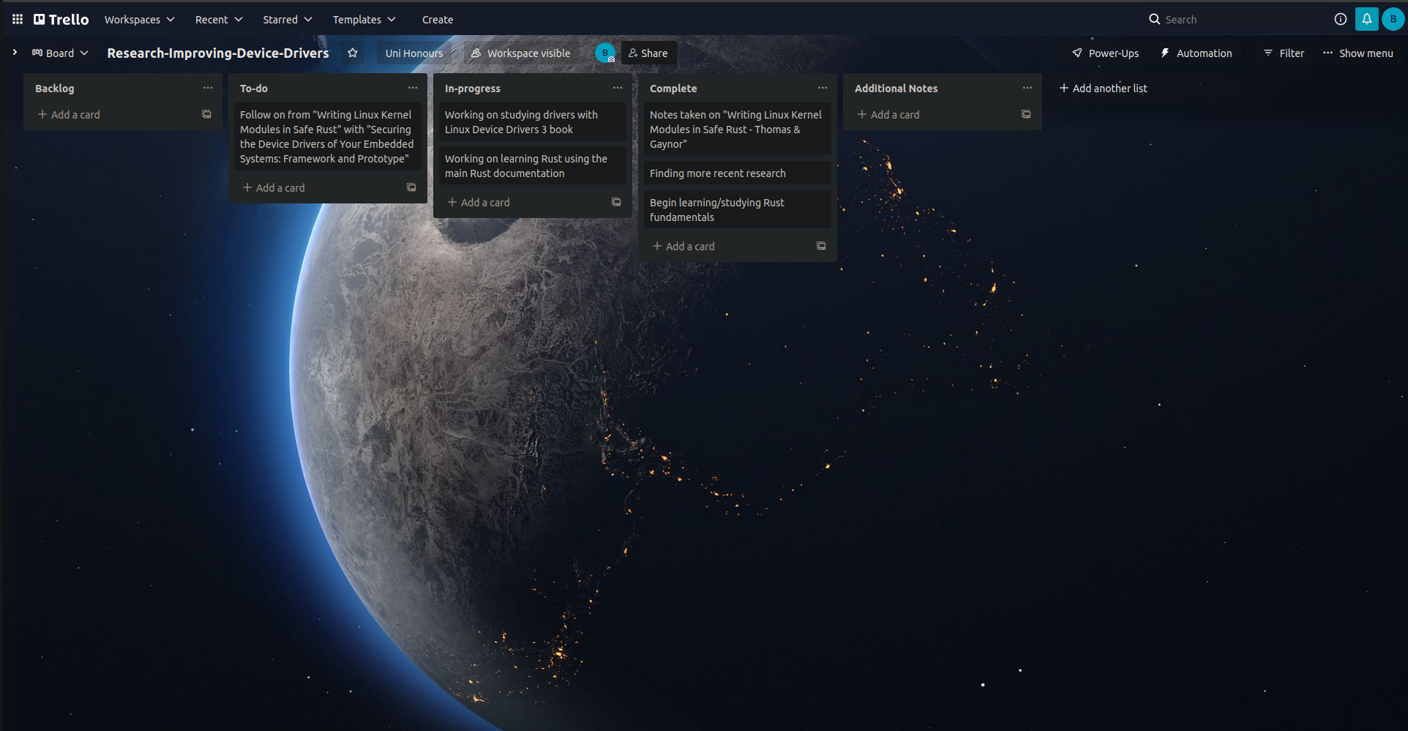Figure 1: Research-Improving-Device-Drivers Trello Board (5/8/22)

Kanban is a lean workflow management method which helps to “visualize work, maximize efficiency, and improve continuously” (Kanbanize, 2023). It originated within the manufacturing field, specifically from the Toyota Production System, eventually being adopted within Agile software development.

Throughout the project, Trello was used to track all tasks and key submission dates as well as serving to hold notes on submissions as necessary. The board ‘Research-Improving-Device-Drivers’ (found in figures 1 and 2) was split into nine lists as follows:

* ‘Backlog’
* ‘To-do’ [sic]
* ‘URGENT’ [sic]
* ‘In-progress’
* ‘Complete’
* ‘Submissions / Key dates’ [sic]
* ‘Additional Notes’
* ‘Binned/No longer relevant’ [sic]
* ‘Milestones’

Within this board, present tasks are represented within ‘To-do’, ‘URGENT’, ‘In-progress’ and Complete with ‘URGENT’ being an additional list (when compared to common kanban boards) to highlight critical or time-sensitive tasks. ‘Backlog’ is used to hold tasks that are no longer relevant but may eventually see completion. ‘Submissions / Key Dates’ holds a list of core submissions to be made with some cards holding information regarding the specific date in question. ‘Additional Notes’ contains various necessary information placed within cards alongside short, simple reminders. ‘Binned/No longer relevant’ represents tasks will not be completed. The ‘Milestones’ list contains various notable milestones achieved throughout the duration of the project.

The previously mentioned Trello board was used to track various aspects of the project from achievements to task statuses and more. Within some cards, commits from related GitHub repositories were written as comments in order to directly link and categorise work.

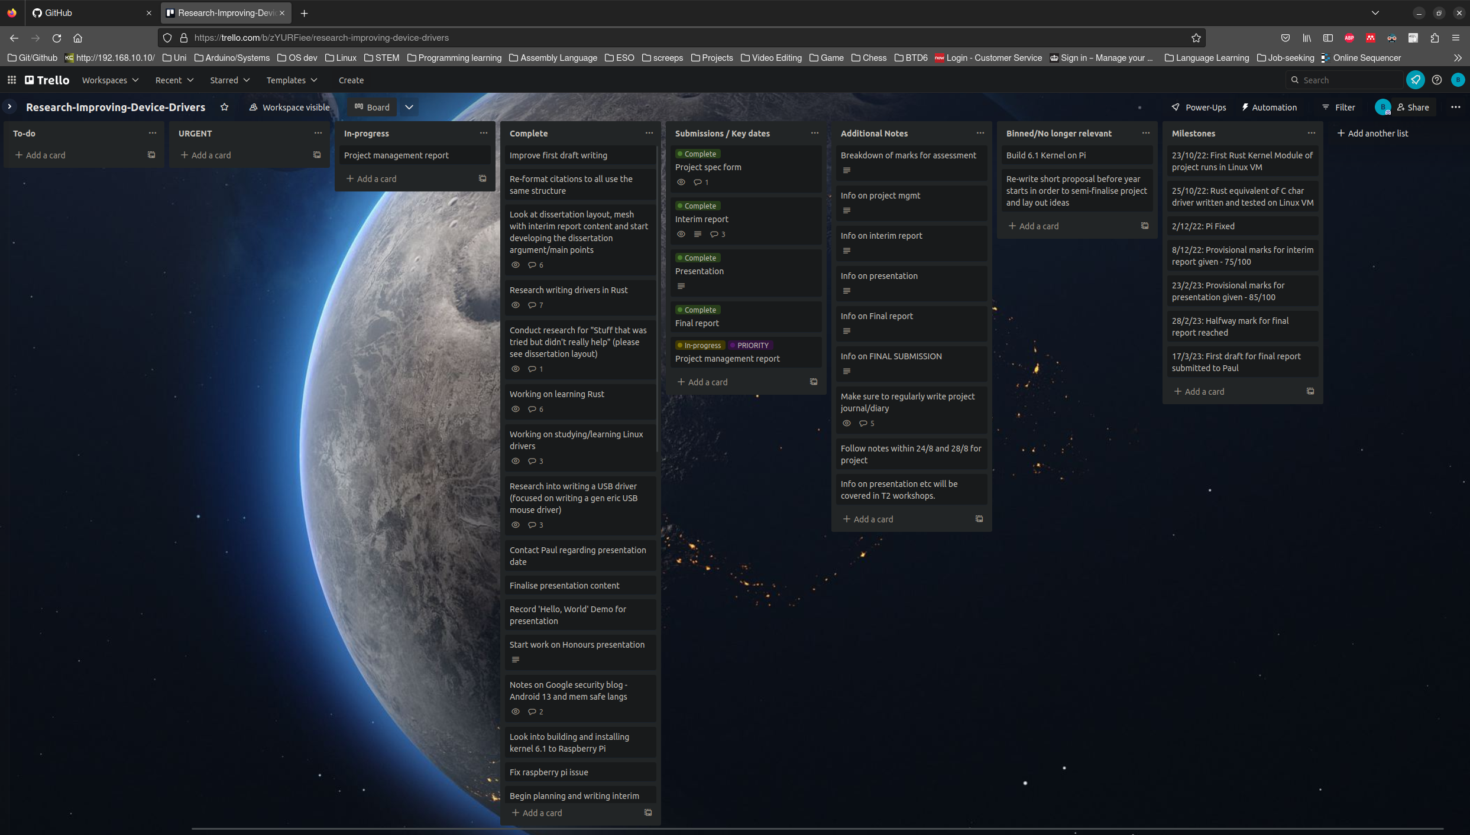Figure 2: Research-Improving-Device-Drivers Trello Board (28/3/22)

# 2. GitHub

GitHub is a common tool used in Software development and engineering which is used to store project source code and track the history of all changes to such code (Lutkevich and Courtemanche, 2023). Alongside this, GitHub also acts as a means for development teams to communicate and collaborate with each other via Pull Requests and Commits (as showcased in Figure 4) which contain facilities for users to discuss and review a given contribution. GitHub is often used to host open source software development projects where all interested users are encouraged to contribute where possible. Several projects and tools used within this project are hosted on GitHub including Rust-for-Linux, Rust, the Linux kernel and more.

## 2.1 Git

GitHub relies on ‘Git’, a source code management tool created by Linus Torvalds (Lutkevich and Courtemanche, 2023). Git effectively provides the core features of GitHub (in source code storage and tracking) and is commonly used to manage projects where multiple developers may introduce conflicts with their changes.

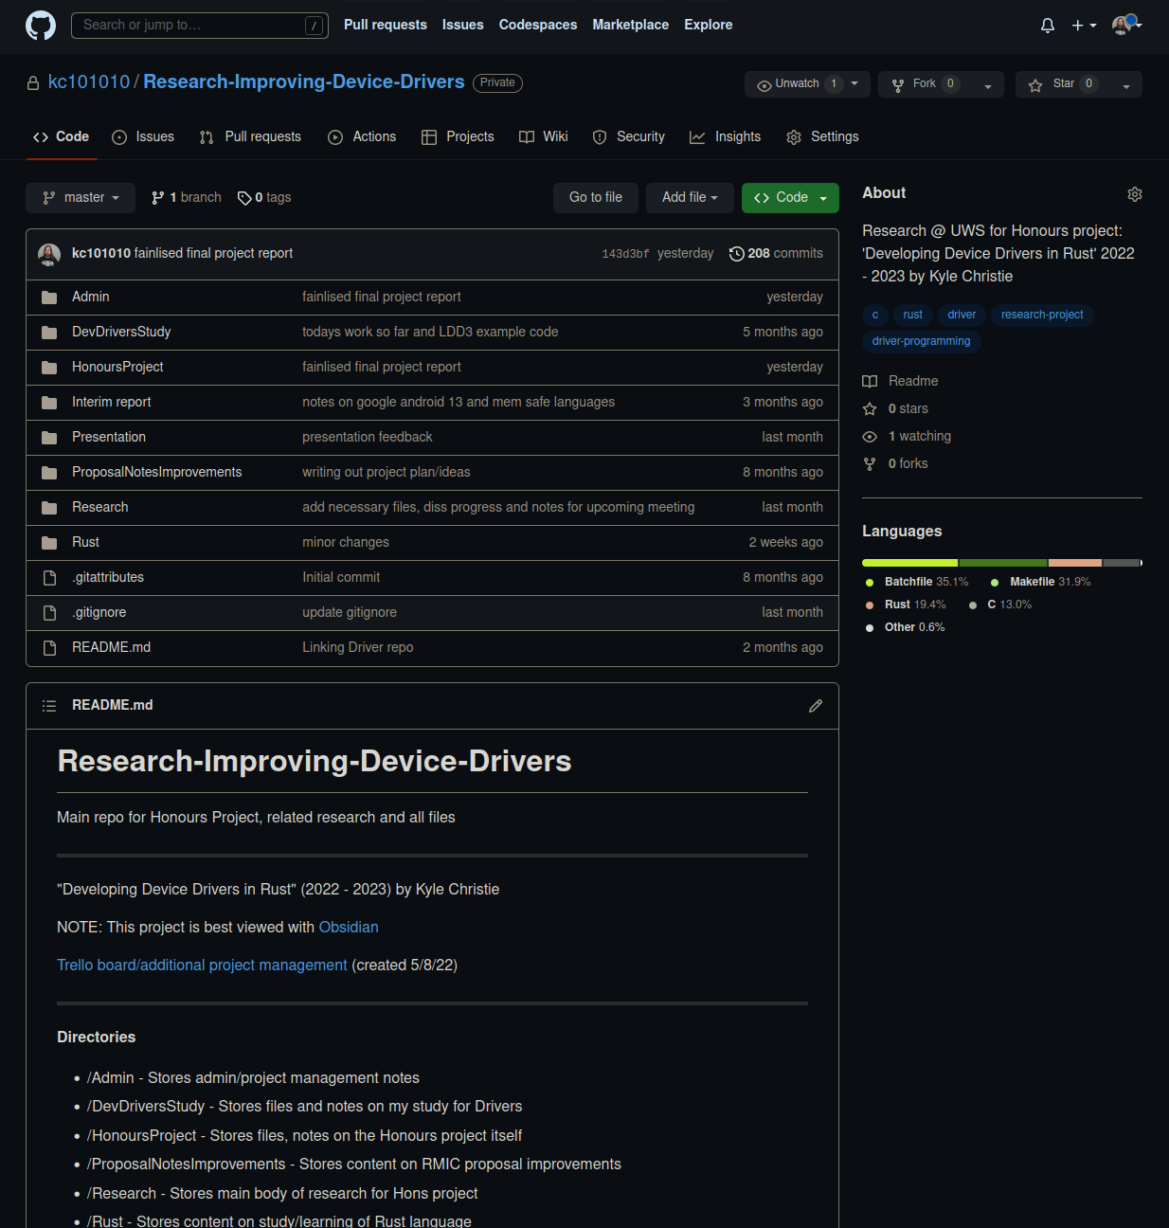Figure 3: kc101010/Research-Improving-Device-Drivers repository main page

## 2.2 ‘Research-Improving-Device-Drivers’

With over 200 commits, created at the very start of the project (around July 2022). This repository (found above in Figure 3) served to store all main research and development undertaken during the project as well as several project components such as the Interim report and Presentation. The repository was generally split into several folders including ‘Admin’, ‘Research’, ‘Rust’, ‘Presentation’ and so on which categorised screenshots, research notes, research papers, source code and more. As well as acting as remote storage that facilitated easy access across several machines, the repository served as a full backup which could be easily re-stored in the case of machine failure, data loss or similar issues.

## 2.3 ‘Hons-Rust-DeviceDriver’

This repository was created in January with the intent of storing source code for the ‘USB Mouse’ Rust driver. As the planned driver was not implemented (as discussed in the final report), the repository instead stores a ‘Hello, World’ driver. Alongside the source code, the projects makefile can be found. This repository was also used as a backup and to allow for access outwith the virtual machine in which the driver was written.

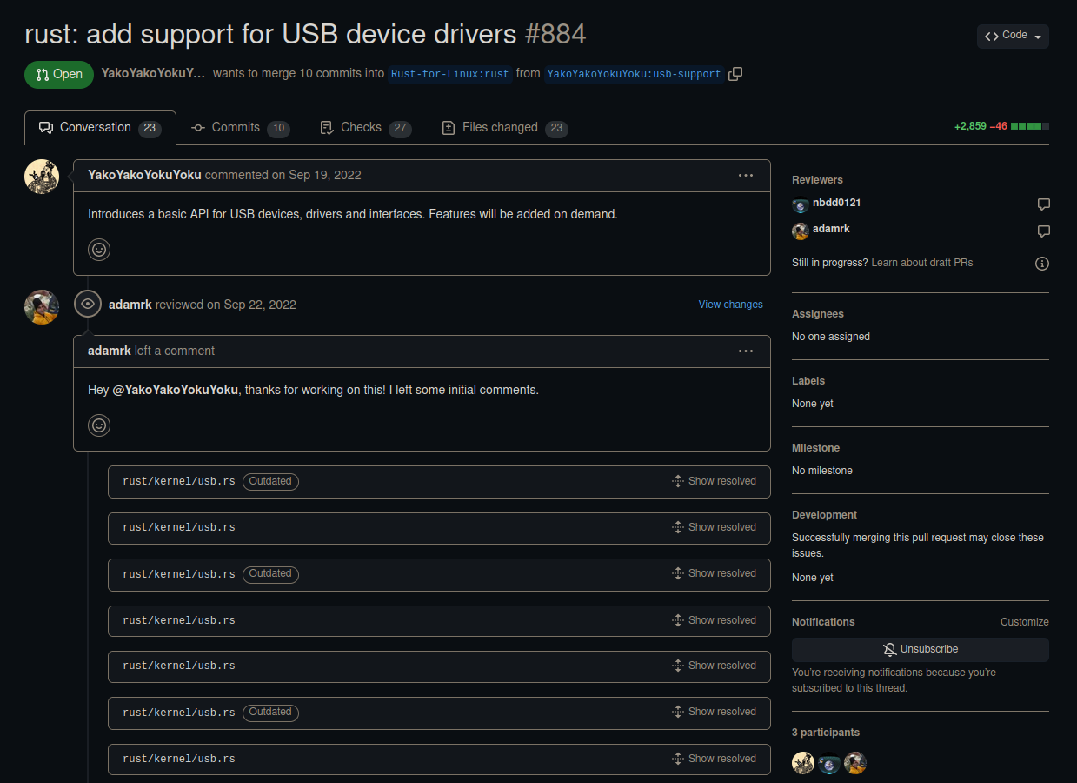Figure 4: Pull Request #884 "add support for USB device drivers" (Rust for Linux, 2023)

# 3. Obsidian

Obsidian is a knowledge base and note-taking application (Obsidian, 2023) which was heavily used throughout the duration of the project. Its main use was holding research notes and holding early drafts of writing. Obsidian uses ‘markdown’ files allowing users to utilise markdown formatting within notes which is formatted and rendered in real time. Alongside the inclusion of markdown is the potential to link notes which can then be represented as a connected graph. Its design is such that users can “structure their thoughts and knowledge in a flexible, non-linear way” (Wikipedia, 2023). It is also possible to customise Obsidian via its ‘plugin’ functionality where plugins are created by both the Obsidian team and the community.

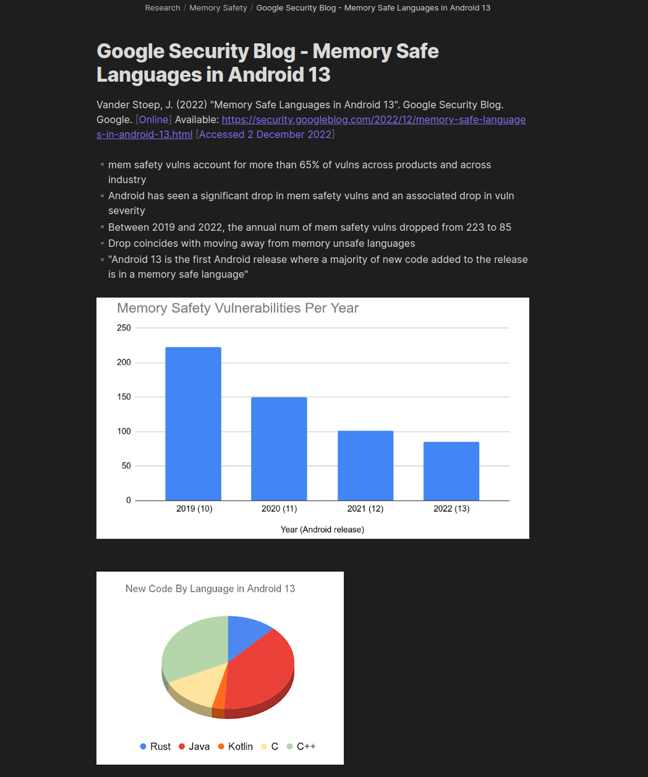Figure 5: Research notes on Memory Safe Languages in Android 13

## 3.1 Diaries

Alongside research and so on, Obsidian was also used to keep regular diaries which were intended to track work and progress, contribute to project management and note thoughts while undertaking the work. Diaries were kept between August 2022 and March 2023, providing deeper insight into specific issues, thoughts and processes throughout the projects.

# 4. Formal Meetings

Several formal ‘feedback and management’ meetings took place with the project supervisor where insight was given into progress of the project as well as discussions on arising problems, current work, future tasks and so on. Alongside the provided formal forms intended to document these meetings, informal meeting minutes were taken in Obsidian with the intention of holding more in-depth, specific notes and important details that were to be kept.

# References

Lutkevich, B. Courtemanche, M. (2023) “Definition: GitHub”. TechTarget. [Online] Available: <https://www.techtarget.com/searchitoperations/definition/GitHub> [Accessed 28 March 2023]

Kanbanize (2023) “What is Kanban? Explained for Beginners.” [Online] Available: <https://kanbanize.com/kanban-resources/getting-started/what-is-kanban> [Accessed 28 March 2023]

Obsidian (2023) “About Obsidian” [Online] Available: <https://obsidian.md/about> [Accessed 28 March 2023]

Rust for Linux (2023) “Rust-for-Linux/linux: Pull Request 884”. [Online] Available: <https://github.com/Rust-for-Linux/linux/pull/884> [Accessed 28 March 2023]

Trello (2023) “What is Trello: Learn Features, Uses & More.” [Online] Available: <https://trello.com/tour> [Accessed 28 March 2023]

Wikipedia (2023) “Obsidian (software)”. [Online] Available: <https://en.wikipedia.org/wiki/Obsidian_(software)> [Accessed 28 March 2023]

# Formal Meeting Forms

**FORM A**

**COMPUTING HONOURS PROJECT (COMP10034)**

**PROGRESS AND FEEDBACK MEETING AGENDA**

*(To be completed* ***before*** *the scheduled meeting)*

**Student: Kyle Christie Supervisor: Paul Keir**

**Meeting Number: 1 (Formal for Week 2/3) Date/Time: 3/10/22 @ 1400**

**PROGRESS**

Over the last month, the following tasks have been completed:

* I’ve worked on solidifying exact project, title, research questions.
* I’ve worked on research relating to OS driver differences, frameworks, how these relate to the project.
* I’ve worked on learning Rust specifically for Systems programming, have spent time studying how Rust manages memory. I have a diary with a short comparison between the same program in C and Rust.
* I’ve obtained a Raspberry Pi 400 and have configured/tested it for Linux driver development, I plan on using it for the final development task.
* I’ve found and taken notes on various articles that relate to drivers, rust and recent significant work/developments.

The following tasks identified last month have not been completed or problems/issues have emerged that require attention:

* None

**AGENDA**

1. **Provide summary of work/tasks undertaken since last meeting (12/9/22) [X]**
2. **Discussion regarding project specification form and final project plan [X]**
3. **Discussion on next major milestones/submission (interim report?)**
4. **Discussion on tasks to be carried out in meantime [X]**
5. **Any other business**
6. **Decide next meeting date**

**FORM B**

**COMPUTING HONOURS PROJECT (COMP10034)**

**PROGRESS AND FEEDBACK MEETING MINUTES AND PLAN**

*(To be completed* ***after*** *the scheduled meeting)*

**Student: Kyle Christie Supervisor: Paul Keir**

**Meeting Number: 1 (Formal Week 2/3) Date/Time: 3/10/22 @ 1400**

**MINUTES**

The following tasks and issues were discussed and specific actions agreed:

1. Provided a summary of work/tasks undertaken since last meeting/recently.
2. Discussion regarding project specification form and final project plan
3. Discussed project deliverable and related points
4. Discussed use of short articles within project
5. Short discussion on next major milestones
6. Decided next meeting date
7. Discussed other business

**PLAN**

The following tasks and timelines have been agreed both for the next month and beyond:

For the next month:

* Finish project specification.
* Begin research into how drivers are written in Rust.
* Continue work, focusing on literature review.
* ..

Beyond the next month

* ..
* ..
* ..
* ..

**FORM A**

**COMPUTING HONOURS PROJECT (COMP10034)**

**PROGRESS AND FEEDBACK MEETING AGENDA**

*(To be completed* ***before*** *the scheduled meeting)*

**Student: Kyle Christie Supervisor: Paul Keir**

**Meeting Number: 2 (Week 6/7) Date/Time: 26/10/22 @ 1300**

**PROGRESS**

Over the last month, the following tasks have been completed:

* The Honours project specification form has been submitted, signed by both Supervisor and Moderator.
* The interim report has been started, Overview section complete with Literature Review in progress. On track for successful submission.
* I have successfully set up a QEMU VM with the latest Linux kernel with Rust features. I have tested this machine and its configuration.
* I have written an equivalent of the C char driver but in Rust on Linux-Rust VM, I have tested it and it runs without issue.
* I am starting to conduct research into writing a Generic USB mouse driver as a C driver, intending to use those resources to write a mouse driver in Rust.

The following tasks identified last month have not been completed or problems/issues have emerged that require attention:

* None

**AGENDA**

1. Summary/Showcase of work undertaken since last meeting (3/10/22) [X]
2. Discussion regarding end project deliverable – a Mouse driver. Is this suitable? Recommended backup? [X]
3. Discussion on next major milestones – Completing interim report and setting up Linux Kernel 6.1 and necessary tools on Raspberry Pi.
4. Discussion on tasks to be carried out in the meantime.
5. Any other business.
6. Decide next meeting date.

**FORM B**

**COMPUTING HONOURS PROJECT (COMP10034)**

**PROGRESS AND FEEDBACK MEETING MINUTES AND PLAN**

*(To be completed* ***after*** *the scheduled meeting)*

**Student: Kyle Christie Supervisor: Paul Keir**

**Meeting Number: 2 (Week 6/7) Date/Time: 26/10/22 @ 1300**

**MINUTES**

The following tasks and issues were discussed and specific actions agreed:

1. Discussed current work/progress, showcased current work.
2. Discussed end project deliverable – decided on a Generic USB Mouse Driver with the LDD3 Scull Driver chosen as backup.
3. Discussed interim report layout and word count target.
4. Decided next meeting as Wednesday 9th November at 1300.

**PLAN**

The following tasks and timelines have been agreed both for the next month and beyond:

For the next month:

* Acquire additional storage for Pi, Configure Raspberry Pi with Rust for Linux Kernel 6 in order to start developing the mouse driver. Also install related tools for Rust kernel modules.
* Continue with and complete Interim report.
* Continue Research into writing a USB Linux Kernel Module.

Beyond the next month

**FORM A**

**COMPUTING HONOURS PROJECT (COMP10034)**

**PROGRESS AND FEEDBACK MEETING AGENDA**

*(To be completed* ***before*** *the scheduled meeting)*

**Student: Kyle Christie Supervisor: Paul Keir**

**Meeting Number: 3 Date/Time: 11/11/22 @ 1000**

**PROGRESS**

Over the last month, the following tasks have been completed:

* Interim report first draft has been submitted.
* Linux Kernel 6.1-rc3 has been successfully built in a test environment.
* Additional storage has been acquired and installed to Pi workstation.
* Additional reading material is being obtained in Linux Device Driver Dev Cookbook as well as a physical copy of Linux Device Drivers 3.

The following tasks identified last month have not been completed or problems/issues have emerged that require attention:

* In the test environment, an issue has arised with rust-analyzer which prevents Rust drivers from building. This has been noted in diaries and a successful solution has yet to be applied.
* The above issue has also froze research on Linux USB devices.

**AGENDA FOR FORMAL MEETING (Example)**

1. Summary/Showcase of work undertaken since last meeting (26/10/22) [X]
2. Discussion regarding main present issue i.e. Linux 6.1-rc3 and rust-analyzer [X]
3. Discussion on next major milestones – Building Kernel 6.1, related tools on the Pi and testing Rust driver on hardware, Start development on Rust module project deliverable. [X]
4. Discussion on tasks to be carried out in meantime, looking into the internals of Rust Linux. [X]
5. Any other business.
6. Decide/Discuss next meeting date.

**FORM B**

**COMPUTING HONOURS PROJECT (COMP10034)**

**PROGRESS AND FEEDBACK MEETING MINUTES AND PLAN**

*(To be completed* ***after*** *the scheduled meeting)*

**Student: Kyle Christie Supervisor: Paul Keir**

**Meeting Number: 3 Date/Time: 11/11/22 @ 1000**

**MINUTES**

The following tasks and issues were discussed and specific actions agreed:

1. Short summary of work undertaken since last meeting
2. Feedback on interim report
3. Discussion and insight into Rust-analyzer problem
4. Quick discussion on next milestones, tasks to work on in meantime
5. Will email to arrange next meeting (post interim report)
6. ..

**PLAN**

The following tasks and timelines have been agreed both for the next month and beyond:

For the next month:

* I have decided to restart the VirtualBox test and start fresh as there are a lot of issues with the current VMs. I aim to be more careful with the new tests.
* Submit a second draft of the interim report with recommended fixes/changes to Paul
* Continue Research as necessary (USB capabilities of Linux kernel etc)
* Formally submit final version of interim report.

Beyond the next month

* Workstation pending, start development on Rust ‘production’ driver
* ..
* ..
* ..

**FORM A**

**COMPUTING HONOURS PROJECT (COMP10034)**

**PROGRESS AND FEEDBACK MEETING AGENDA**

*(To be completed* ***before*** *the scheduled meeting)*

**Student: Kyle Christie Supervisor: Paul Keir**

**Meeting Number: 4 Date/Time: 2/2/23 @ 1100**

**PROGRESS**

Over the last month, the following tasks have been completed:

* Improving writing between interim report and dissertation.
* More industry figures have been contacted.
* More content written into dissertation.
* An attempt made to start development.

The following tasks identified last month have not been completed or problems/issues have emerged that require attention:

* Starting driver development – Rust USB library is not officially integrated and the integration in my own kernel does not seem to work.
* ..

**AGENDA**

1. Showcase of work undertaken since last meeting (11/11/22). [X]
2. Discussion of issue – Issues with Rust USB library and direction of final project deliverable. (there is more work from RustForLinux project on USB) [X]
3. Discussion on next major milestones – Creating and presenting project presentation, Working through dissertation writing. These will essentially make up the core tasks until end of project. [X]
4. Any other business.
5. Discuss next meeting date.

**FORM B**

**COMPUTING HONOURS PROJECT (COMP10034)**

**PROGRESS AND FEEDBACK MEETING MINUTES AND PLAN**

*(To be completed* ***after*** *the scheduled meeting)*

**Student: Kyle Christie Supervisor: Paul Keir**

**Meeting Number: 4 Date/Time: 2/2/23 @ 1100**

**MINUTES**

The following tasks and issues were discussed and specific actions agreed:

1. Regarding the USB library issue: Use the USB contributors full repository. Continue to try working on this component, try communicating with the contributor to find help in solving any problems.
2. Discussion on dissertation writing, highlighting new sections and their placement within the report.
3. Discussion of new content that could be added to report to enrich existing sections.
4. Brief discussion on expectations of presentation.

**PLAN**

The following tasks and timelines have been agreed both for the next month and beyond:

For the next month:

* Presentation writing.
* Continuing work and investigation into the Rust for Linux USB contributions.

Beyond the next month

* Continue work on writing for dissertation/final report.

**FORM A**

**COMPUTING HONOURS PROJECT (COMP10034)**

**PROGRESS AND FEEDBACK MEETING AGENDA**

*(To be completed* ***before*** *the scheduled meeting)*

**Student: Kyle Christie Supervisor: Paul Keir**

**Meeting Number: 5 Date/Time: 3/3/23 @ 1400**

**PROGRESS**

Over the last month, the following tasks have been completed:

* Project presentation
* Continuing of dissertation writing

The following tasks identified last month have not been completed or problems/issues have emerged that require attention:

* N/A

**AGENDA FOR FORMAL MEETING (Example)**

1. Discussion of presentation, marking & feedback (22/2/23) [X]
2. Showcase of work undertaken since last meeting (2/2/23) – Effectively rounding out Lit. review, added in summary to bring points together [X]
3. Discussion on next major milestones – Completing final project report, carrying out any further research as required. (Was noted through presentation that development is effectively complete and that final report now takes precedence) [X]
4. Any further business. [X]
5. Discuss next meeting date. [X]

**FORM B**

**COMPUTING HONOURS PROJECT (COMP10034)**

**PROGRESS AND FEEDBACK MEETING MINUTES AND PLAN**

*(To be completed* ***after*** *the scheduled meeting)*

**Student: Kyle Christie Supervisor: Paul Keir**

**Meeting Number: 5 Date/Time: 3/3/23 @ 1400**

**MINUTES**

The following tasks and issues were discussed and specific actions agreed:

1. Discussion of work undertaken since last meeting (2/2/23)
   * Next meeting will be after first draft submission, with focus on discussing said draft
2. Discussion of approaching development section in report
3. Discussion on approaching acknowledgements section
4. Discussion on job applications/aspirations

**PLAN**

The following tasks and timelines have been agreed both for the next month and beyond:

For the next month:

* Completing final report and related work as necessary

Beyond the next month

* N/A