CS1501 Recitation #1

# Introduction

Welcome to CS1501 recitation! Here’s some basic contact info for the term:

TA: Karin Cox

Email: [kmc51@pitt.edu](mailto:kmc51@pitt.edu)

Github repository for recitation materials:

<https://github.com/kc13/CS1501>

Office: 6150 Sennott Square

Office hours (starting next week):

Thursdays, 2:15 - 5:15 pm

Fridays, 1:00 - 4:00 pm

This handout is for informational purposes only. There is no formal assignment.

# Survey

An optional survey has been created in Google Forms (access this document on Github for a clickable link): <https://goo.gl/forms/YLV507ofCtUhOyK32>

# Recitation objective: Walk through the steps for homework submission

This course uses Github for the assignment submission process. This handout assumes that you have created a Github account, and will primarily emphasize interaction with the website and the Github Desktop application (available for Mac and Windows). The instructions here are based on the Windows 8.1 implementation. Git commands will be discussed briefly in the final section; for more information, please see the slides posted to the course website: <http://people.cs.pitt.edu/~nlf4/cs1501/slides/git_crash_course.pdf>.

## Download Github Desktop

The Github Desktop application is available here: <https://desktop.github.com/>.

## Create a test repository

When a new assignment is released, a new repository will appear in your Github account. You will need to clone this repository to your computer. If you’d like to practice cloning a Github repository, you might want to first create a test repository through the Github web interface:

* Sign in to Github, and click the drop-down menu beside the “+” symbol in the top right corner of the screen.
* Choose “New Repository”

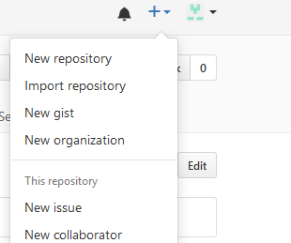

* Enter a repository name (for example, “TestRepository”), check “Initialize this repository with a README,”, and click Create Repository.
* You’ll be directed to the newly created repository, which includes a single readme file (“README.md”).

## Clone the test repository with Github Desktop

*Note: The following instructions are based on Windows 8.1.*

Once you’ve installed Github Desktop, go ahead and open the Github application on your computer (the icon looks like the Github octocat logo):

Screen Clipping

Note that this application can sometimes take a long time to load.

Once Github Desktop appears, you can clone your repository. In the top left corner, choose the drop down menu beside the “+” sign: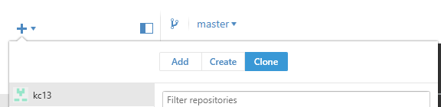

Click on “Clone” to highlight it. This brings up a list of repositories, which should include the test repository that you created earlier. Once you highlight its name, you should see an option that lets you clone it. You’ll be prompted to select the folder on your computer in which you wish to clone the repository’s contents.

When you receive a programming assignment for this class, you can clone the assignment repository using the same general procedure. The repository may include a few files that you need to get started (for example, the assignment instructions).

## Add files to the cloned repository on your computer

To practice the assignment submission process, try creating one or more new files within the repository’s clone on your computer (for this practice, a simple text file is sufficient; for submission, the new files will consist of your source code).

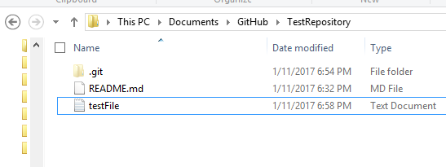

Adding this file to your cloned repository will not affect the online version of the repository.

## Use Github Desktop to commit the changes and sync with the online repository:

After you add the new file(s) to the test repository folder, you should be able to detect this modification in Github Desktop. Make sure that the test repository’s name is highlighted on the left side of the screen. At the top of the screen, make sure that you have highlighted “Changes”:

Screen Clipping

Your additions to the folder should appear in the section below:

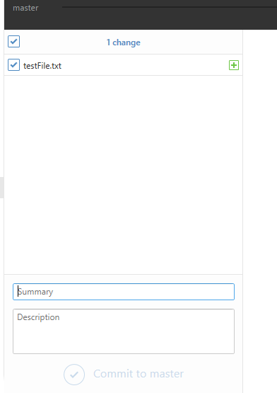

When you’re ready to submit the final source code for an assignment – or if you just want to create an online backup of a working version -- you’ll need to go through two steps in the Github Desktop: commit and sync. These steps can be practiced with your test repository. Make sure that all the new files are checked (as in the example above), and enter a summary of the modifications that you made (“Description” is an optional field). Then click “Commit to master.”

This step committed your changes within the cloned repository folder, but did not synchronize your cloned folder’s contents with your online repository. To perform the synchronization, click “Sync” in the top right corner:

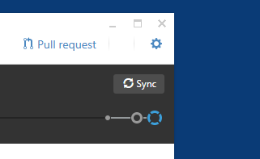

During the syncing process, the sync button will display “syncing”. It is finished when the text turns to “sync” again. Please note that the syncing process make take a short while.

Once syncing is complete, you should be able to verify that the new file(s) appear in your online repository. When you submit an actual assignment, this verification can be your final step. Your submitted assignment will consist of the files that are present in your online Github repository at the deadline.

A few additional notes:

* As discussed in lecture, the assignment deadlines are strict. Therefore, you are strongly encouraged to leave an ample buffer of time to allow for any unexpected slow-downs in the syncing process.
* Github’s online interface also allows you to upload files directly to a repository. This is not necessarily the recommended approach, but it can be useful in a pinch.

# Alternative approach: command line

This section will walk through a similar sequence as above by using git commands. It will be assumed that you have already installed git on your computer. For example, if you downloaded the Github Desktop, you should also have available the Git shell.

To clone the test repository that you created through Github’s web interface, type **git clone <repository URL>**. For example, for a username of kc13 and a repository name of TestRepository, the command would be **git clone https://github.com/kc13/TestRepository**.

When you wish to add a new or updated file to the cloned repository, you first use the git add command. For example, we can create a new file “testFile.txt” as before, and prepare it for a commit by typing

**git add testFile.txt**

This step is followed by the commit of the added file:

**git commit -m “added testFile.txt”**

where the -m flag precedes a similar summary statement as is requested in Github Desktop.

When you’re ready to synchronize with the online repository, type:

**git push origin master**

Again, it’s a good idea to confirm that the expected changes appear in the web version.