Exploring TCP Port Vulnerabilities in Metasploitable2 Using Kali Linux

Created by Kishan Chauhan Intern id – 2031

- Installing the Metasploitable 2
Steps to Install Metasploitable 2 in VirtualBox and Link with Kali Linux Prerequisites
Before starting, make sure the following are already installed on your system:
- Kali Linux Virtual Machine
Metasploitable 2 will be attacked from Kali Linux, so both must be available.
Step 1: Download Metasploitable 2
- Open a web browser.
- Go to Google and search for Metasploitable 2.
- Open the SourceForge link https://sourceforge.net/projects/metasploitable/files/Metasploitable2/
- Click on Download Latest Version.
- Wait for the download to complete.
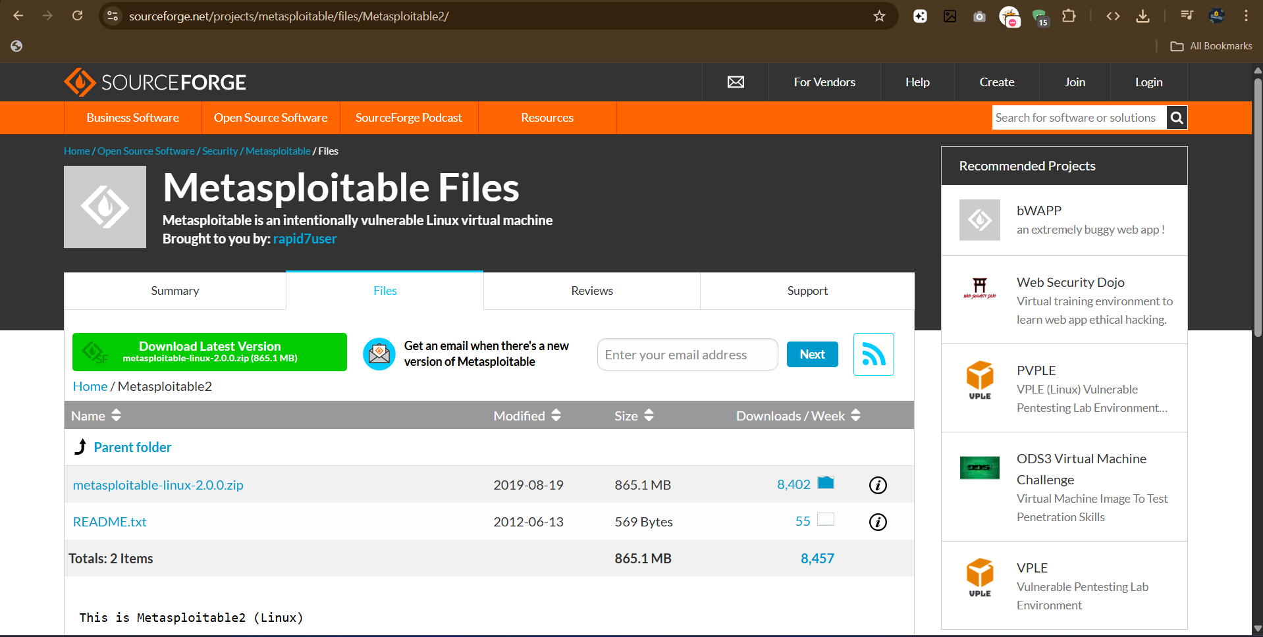

Step 2: Extract the Metasploitable 2 File
1. Open the Downloads folder.
2. Right-click on the downloaded Metasploitable 2 file.
3. Click Extract All.
4. A folder named Metasploitable-Linux-2.0 will be extracted.
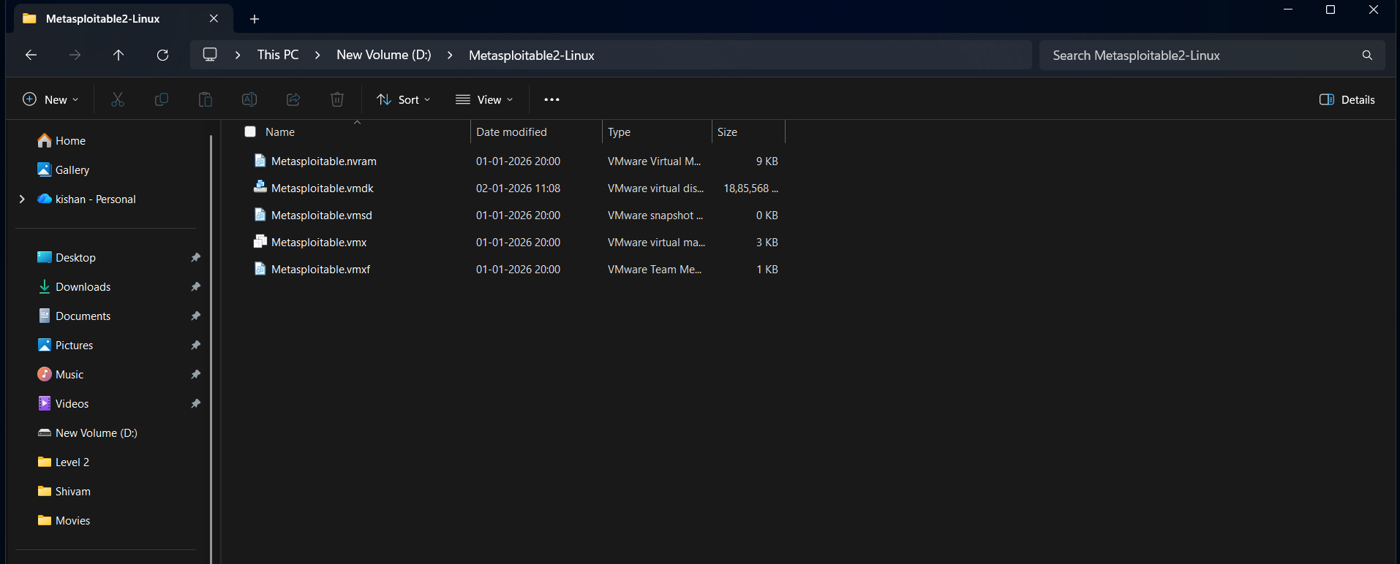

- Completing the Setup of Metasploitable 2 Using Bridged Adapter
Objective
Configure Metasploitable 2 and Kali Linux in VirtualBox so both machines are on the same network using a Bridged Adapter, allowing direct communication for testing.

Step 1: Create the Metasploitable 2 Virtual Machine
- Open Oracle VM VirtualBox
- Click New
- Enter:
  - Name: Metasploitable 2
  - Type: Linux
  - Version: Other Linux (64-bit)
- Click Next

Step 2: Configure Hardware
- Keep default values:
  - RAM: 512 MB
  - CPU: 1
- Click Next

Step 3: Attach Existing Virtual Disk
- Select Use an existing virtual hard disk file
- Click the folder icon → Add
- Browse to Metasploitable-Linux-2.0
- Select the .vmdk file
- Click Open → Choose
- Click Finish

Step 4: Configure Bridged Adapter (Network Setup)
Bridged networking connects VMs directly to your physical network.
Configure Metasploitable 2
- Select Metasploitable 2 VM
- Click Settings → Network
- Set:
  - Attached to: Bridged Adapter
  - Name: Your active network adapter
    - Wi-Fi → Wireless adapter
    - Ethernet → Ethernet adapter
- Click OK

Step 5: Connect Kali Linux to the Same Bridged Network
- Select Kali Linux VM
- Click Settings → Network
- Set:
  - Attached to: Bridged Adapter
  - Name: Same adapter used for Metasploitable 2
- Click OK
✔ Both machines are now on the same bridged network.

Step 6: Start Both Virtual Machines
- Start Metasploitable 2
- Start Kali Linux
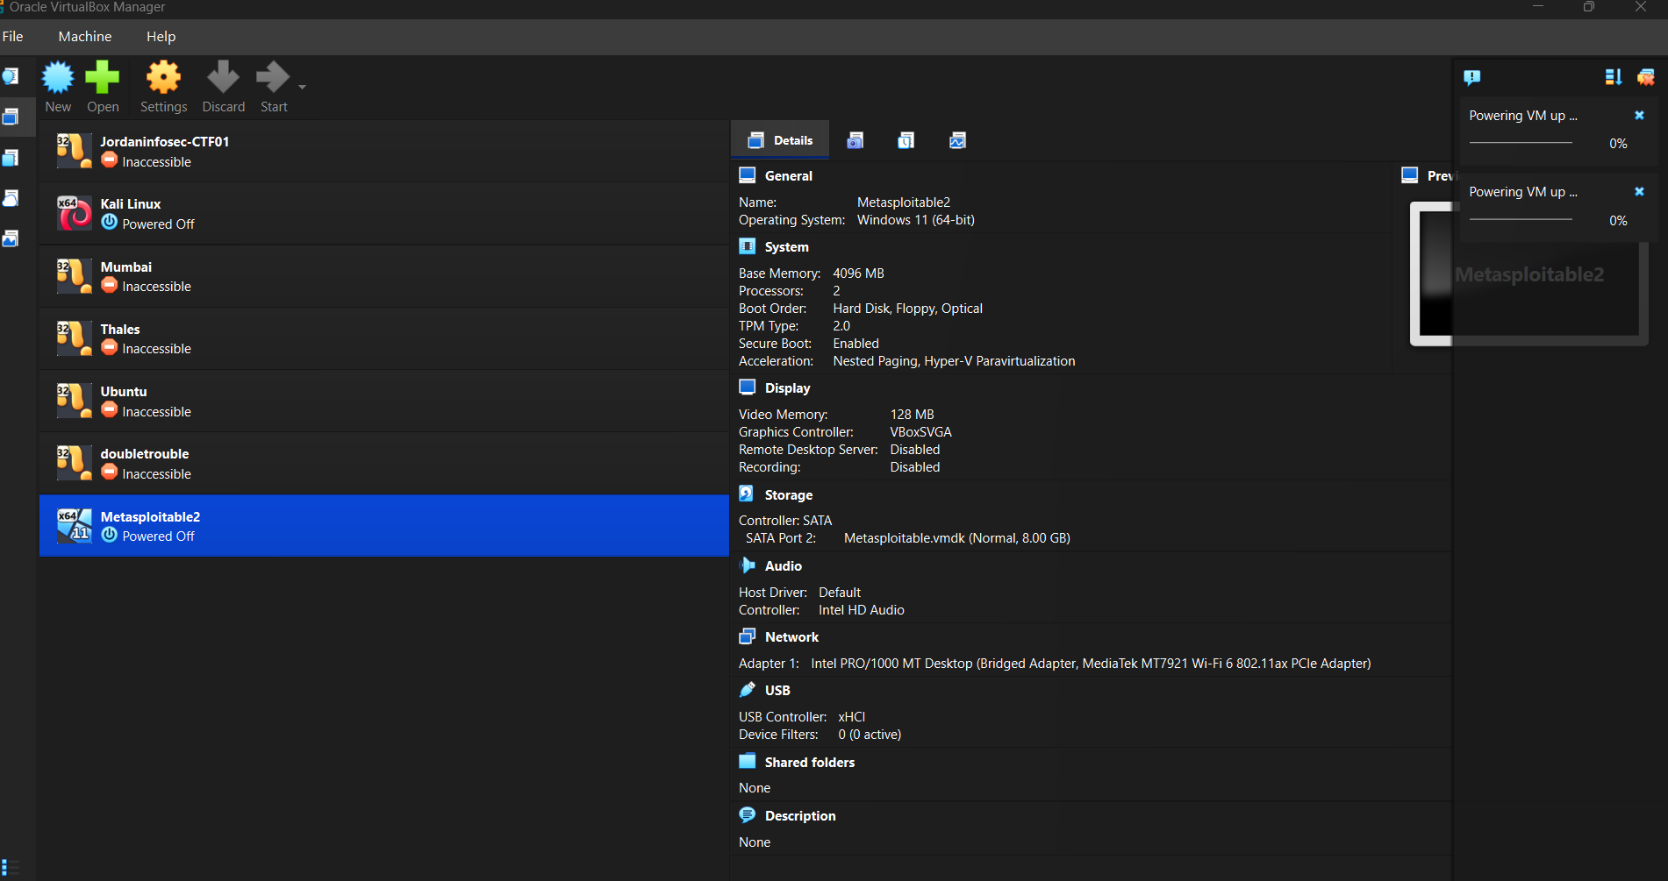
3. Performing Exploitation on Vulnerabilities of the Metasploitable 2 Machine

Verify Connectivity from Kali Linux (Using netdiscover)
This step helps you discover Metasploitable 2 on the network and confirm that Kali Linux is properly connected via the Bridged Adapter.

Step 1: Start Kali Linux
Boot your Kali Linux virtual machine and log in normally.

Step 2: Open the Terminal
You can open the terminal by:
- Clicking the Terminal icon, or
- Pressing Ctrl + Alt + T

- Tool: netdiscover
Description
netdiscover is a network reconnaissance tool used to discover live hosts on a local network using ARP requests. It is commonly used in penetration testing to identify active systems (such as Metasploitable 2) before scanning or exploitation.

Command
sudo netdiscover -r 192.168.0.0/24
Command explanation:
- sudo – Required for ARP scanning
- netdiscover – Network discovery tool
- -r – Specifies the IP range
- 192.168.0.0/24 – Scans all hosts in the subnet

Impact
- Reveals active devices on the network
- Exposes IP addresses, MAC addresses, and vendors
- Helps attackers identify potential targets
- First step in reconnaissance and attack planning

Severity
Low to Medium
- Low by itself (only information gathering)
- Becomes medium when combined with scanning and exploitation
- Critical in the attack lifecycle (Reconnaissance phase)

CVE-ID
N/A (Not Applicable)
- netdiscover is not a vulnerability
- It is a legitimate reconnaissance tool
- No CVE is assigned to tools; CVEs apply to vulnerabilities

Remedial / Mitigation Reference
To prevent or limit netdiscover-style reconnaissance:
- Disable unused network services
- Use network segmentation (VLANs)
- Enable ARP monitoring & detection
- Configure firewalls to block ARP scanning
- Use IDS/IPS tools (Snort, Suricata)
- Restrict unknown devices on LAN

MITRE ATT&CK Mapping
- Tactic: Discovery
- Technique: Network Service Discovery (T1046)
PUC:-
In the terminal, type:
sudo netdiscover -r 192.168.0.0/24
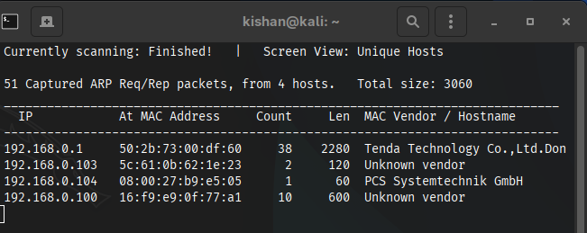

- Technique: Port Scan
Description
A port scan is a reconnaissance technique used to identify open ports and running services on a target system. Attackers use port scanning to understand which services are accessible and to find potential vulnerabilities for exploitation.
In ethical hacking labs, Nmap is the most commonly used port-scanning tool.

Command (Using Nmap)
nmap 192.168.0.12
Common Advanced Port Scan Command:
nmap -sS -sV -O 192.168.0.12
Command explanation:
- nmap – Network scanning tool
- -sS – TCP SYN (stealth) scan
- -sV – Service version detection
- -O – Operating system detection
- 192.168.0.12 – Target IP address

Impact
- Reveals open, closed, and filtered ports
- Identifies running services and versions
- Helps attackers choose specific exploits
- Enables target profiling and attack planning

Severity
Medium
- Alone: Medium risk (information disclosure)
- Combined with vulnerabilities: High to Critical
- Essential step before exploitation

CVE-ID
N/A (Not Applicable)
- Port scanning itself is not a vulnerability
- It is a reconnaissance technique
- CVE IDs apply to services discovered, not the scan

Remedial / Mitigation Reference
To protect systems from port scanning:
- Close unused ports
- Disable unnecessary services
- Configure firewall rules (iptables / ufw)
- Use IDS/IPS systems (Snort, Suricata)
- Enable port-knocking
- Use network segmentation
- Log and monitor scan attempts

MITRE ATT&CK Mapping
- Tactic: Discovery
- Technique: Network Service Discovery (T1046)
PUC:-
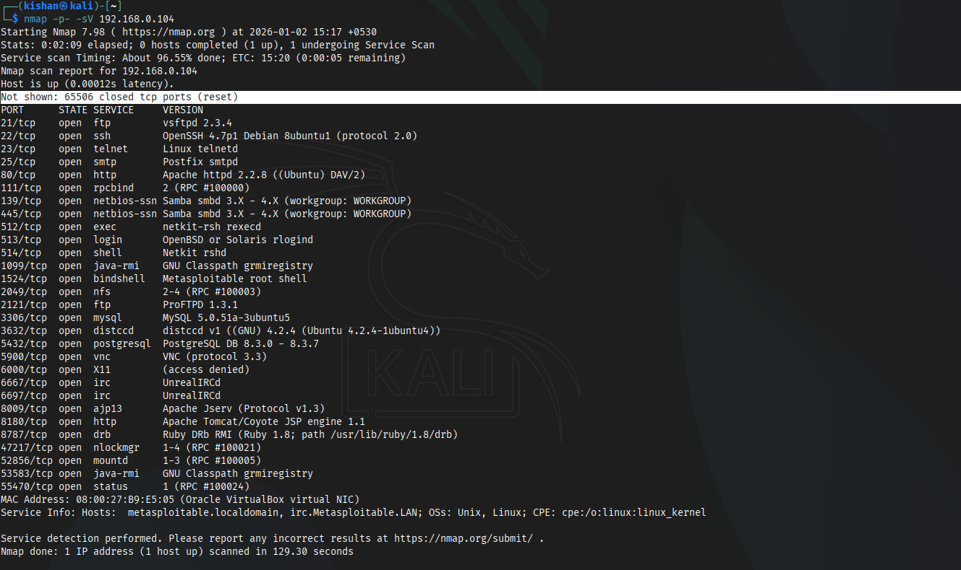
Port 21 – FTP
Service
File Transfer Protocol (FTP)

Description
FTP is a standard protocol used for transferring files between a client and a server. It transmits credentials and data in cleartext, making it vulnerable to interception and abuse. In vulnerable systems like Metasploitable 2, FTP is often misconfigured or runs a backdoored version.

Possible Attack Methods
- Anonymous login abuse
- Weak or default credential brute-force
- Misconfigured read/write permissions
- Exploitation of vulnerable FTP services (e.g., vsftpd backdoor)

Tools Used
- Nmap – Service detection and script scanning
- FTP Client – Manual login and file access
- Metasploit Framework – Automated exploitation using FTP modules

Impact
- Credential disclosure
- Unauthorized file access
- Remote command execution
- Full system compromise

Severity
Critical

CVE-ID
- CVE-2011-2523
  - Affects vsftpd 2.3.4
  - Introduces a malicious backdoor
  - Allows unauthenticated remote shell access
  - Commonly found in Metasploitable 2

CVSS Score
10.0 – Critical
Justification:
- Network exploitable
- No authentication required
- Remote code execution
- Complete compromise of confidentiality, integrity, and availability

Remediation
- Disable FTP service if not required
- Replace FTP with SFTP or FTPS
- Remove anonymous access
- Enforce strong authentication policies
- Keep FTP software up to date
- Restrict access using firewall rules

References
- GoLinuxCloud – Metasploitable 2 Lab
- CISA – Secure FTP Configuration

Proof of Concept:-
