

**REPUBLIC OF CAMEROON**

**PEACE – WORK – FATHERLAND**

**MINISTRY OF HIGHER EDUCATION**

**UNIVERSITY OF BUEA**

**REPUBLIQUE DU CAMEROUN**

**PAIX – TRAVAIL – PATRIE**

**MINISTERE DE L’ENSEIGNEMENT SUPERIEURE**

**UNIVERSITE DE BUEA**

**FACULTY OF ENGINEERING AND TECHNOLOGY**

**PO BOX 63**

**BUEA, SOUTH WEST REGION**

**DEPARTMENT OF COMPUTER ENGINEERING**

COURSE CODE: CEF440

COURSE TITLE: INTERNET PROGRAMMING AND MOBILE DEVELOPMENT

COURSE INSTRUCTOR: Dr. NKEMENI VALERY

**TASK 1 REPORT**

Presented by:

|  |  |
| --- | --- |
| NAMES | MATRICLE |
| 1. **MEKOLLE ASHLEY ARREYMANYOR** | **FE22A247** |
| 1. **AKO RUTH ACHERE** | **FE22A144** |
| 1. **NGUIMENANG ZEUFACK KEREINE** | **FE22A266** |
| 1. **TUMUTOH LYDIE-KASEY BIHNUI** | **FE22A321** |
| 1. **TIWA DELAN NDIKA** | **FE22A319** |

**MARCH 2025**

Table of Contents

1. Types of Mobile Applications 4

1.1. Native Apps 4

1.2. Web Apps 5

1.3. Hybrid Apps 6

2. Mobile App Development Frameworks: In-Depth Comparison 7

2.1. Framework Comparison 7

2.1.1. React Native 7

2.1.2. Flutter 8

2.1.3. Xamarin 9

2.1.4. Ionic 10

2.2. Key Metrics Comparison 11

2.2.1. Performance Benchmark 11

2.2.2. Time-to-Market 11

2.2.3. Community & Ecosystem 12

2.3. Comparing Performance 12

2.4. Recommendations by Use Case 13

2.5. Some FAQs for Mobile App Development Frameworks 14

3. Mobile App Architecture and Design Patterns 15

3.1. Architectural Foundations 15

3.1.1. Core Architectural Objectives 15

3.1.2. Key Architectural Considerations 15

3.2. Architectural Patterns 15

3.2.1. Model-View-Controller (MVC) 15

3.2.2. Model-View-View-Model (MVVM) 16

3.2.3. Clean Architecture 17

3.3. Design Patterns 18

3.3.1. Creational Patterns 18

3.3.2. Structural Patterns 19

3.3.3. Behavioral Patterns 19

3.4. Choosing the Right Architecture 19

3.5. Best Practices 19

4. Mobile App Requirements: How to Gather & analyse iOS, Android, or Native Requirements 20

4.1. What Are Mobile App Requirements? 20

4.2. How to Gather an App Requirements for Project Success 20

4.2.1. Mobile App Requirements Types 20

4.2.2. Requirements Gathering Process 21

Step 1: Define Your App Idea and Purpose 21

Step 2: Gather and Align the App and Business Objectives or Goals 22

Step 3: Run a Market Analysis and Competitor Analysis 22

Step 4: Determine Scenarios and a User Persona 24

Step 5: Gather and Prioritize Functional and Non-Functional Requirements 25

4.2.3. Requirements Analysis Process 26

4.3. CASE STUDY : How to Design a Use Case for App Requirements Documents 27

Write an App Requirements Document 27

5. Estimating Mobile App Development Costs 30

5.1. Importance of Cost Estimation in Mobile App Development 30

5.2. Factors Influencing Mobile App Development Costs 30

5.3. Steps to Estimate Mobile App Development Costs 31

5.4. Cost Estimation Models 33

5.5. Mobile App Development Cost Estimation Formula 33

5.6. Cost Estimation Tools & Methods 34

5.7. Tactics for Reducing Mobile App Development Costs 34

6. Conclusion 34

7. References 35

# Mobile App Development

Mobile app development is the process of creating software applications specifically designed to run on mobile devices such as smartphones and tablets. These apps are developed to provide users with various functionalities and serve different purposes, ranging from entertainment and social networking to productivity and e-commerce.

## Types of Mobile Applications

There are three kinds of mobile applications. They are;

* Native apps.
* Web apps.
* Hybrid apps.

### Native Apps

Native app development serves a single operating system or platform. And they use a programming language that’s specific to that platform or operating system. This is usually a choice of iOS, Android, or Windows Phone.

Native apps run straight from devices. As a result, they can support strong performance, high levels of security, and advanced features ‘native’ to the specific operating system. Some of the common programming languages seen across the three operating systems for different types of mobile apps include the following;

* **iOS:** Programming languages include **Swift, Python, and Objective-C**
* **Android**: Programming languages include **Kotlin and Java**
* **Windows Phone:** Programming languages include **C# and .NET**

#### Native subcategories: cross-platform development

The single biggest challenge of the native approach is **unreusable code**. Developers need to create another set of code to fit another operating system, to replicate the app. However, there is a way around this, and it supports different types of mobile apps, in the form of **cross-platform development**: *the process of creating software applications that can run on multiple operating systems (like iOS and Android) using a single codebase*. And one of the more popular cross-platform-based frameworks is React Native, which is an open-source UI framework that offers a high level of flexibility. React Native uses a JavaScript library. And, it sits alongside other cross-platform frameworks such as Flutter, Ionic, and Xamarin as a native app-building alternative that enables cross-platform development. In practice, code used to develop an app for a specific OS, for example, Android, becomes reusable for iOS and Windows Phone.

#### Examples and Use Cases of Native Apps

Some popular exemplifications of native mobile apps include Spotify, Telegram, WhatsApp, Snapchat, etc. Native apps are ideal for operations that bear high performance, access to device features, and platform-specific stoner gests. These can include gaming apps, social networking platforms, and productivity tools.

#### Advantages of Native Apps

* Access to device-specific features
* No internet connection needed
* Impressive users experience on Android or IOS

#### Disadvantages of Native Apps

* Multiple code bases
* Higher budget costs
* Longer build times
* Maintenance can be complicated
* Native apps tend to be less discoverable than hybrid or web apps

### Web Apps

Web apps are types of mobile apps that draw from web-based technologies. They do not require installation, making them accessible to anyone with a web browser. However, they may lack some of the native functionality and offline capabilities found in native apps. However, their internet-enabled nature gives them added flexibility and a more responsive design that can work on any mobile device or operating system.

Web apps run off a single codebase and use languages such as **HTML5, CSS, Javascript, and Ruby**. They also use server-side languages or web application frameworks of the developer’s choice such as PHP, Rails or Python.

#### Web app subcategory: Progressive Web Apps

PWAs are web apps that provide a native app like experience. These are designed and developed similar to web apps. These apps take support of services workers. These are published on play store or app store.

Some super examples of revolutionary internet apps consist of Pinterest, Starbucks, Adidas, Tinder, Trivago etc.

#### Examples and Use Cases of Web Apps

Some famous examples of web-based cellular apps are; Amazon, Canva, Netflix, Walmart etc. Web apps are appropriate for conditions the place cross-platform compatibility and convenient accessibility are important, such as information portals, on-line buying platforms, and content-based applications.

#### Advantages of Web Apps

* Easy discoverability
* Faster development time than Native
* Simple to Maintain
* Lower development costs
* They work on all Platforms
* Updates made to the application are immediately available

#### Disadvantages of Web Apps

* Slower performance than native
* Unable to work offline
* Cannot access platform features
* Unable to access UI and match style like native apps

### Hybrid Apps

Of all the different types of mobile apps, a hybrid app is a combination of a native app and a web app. In practice, it’s developed as a web app in a native app container. By leveraging certain native platform features and device hardware, hybrid apps offer the benefits of a native experience while flexing to non-native environments. But to drive this type of cross-platform functionality, hybrid apps make use of front-end development technologies like JavaScript, HTML5, Ionic, Cordova and CSS.

#### Examples and Use Cases

Popular examples of hybrid apps encompass Facebook, Gmail, Instagram, LinkedIn, Twitter, Slack, and Evernote. Hybrid apps are appropriate for initiatives that require a quicker improvement cycle and want to attain a wider target audience throughout specialplatforms. They are frequently used for content-centric applications, commercial enterprise tools, and utility apps.

#### Advantages of Hybrid Apps

* Less expensive to sell in app store
* simple to maintain
* Lower development costs
* Targets multiple platforms
* Allows apps to match look of native application and take advantage of the platform's UI style

#### Disadvantages of Hybrid Apps

* Slower performance than native
* Can't access platform features dues to WebView restrictions

# **Mobile App Development Frameworks: In-Depth Comparison**

Mobile app frameworks streamline cross-platform development, balancing performance, cost, and time. This report elaborates on React Native, Flutte-, Xamarin, and Ionic, comparing their key features and suitability for different use cases. Diagrams are included to visualize critical comparisons.

## **Framework Comparison**

### **React Native**

React Native is one of the most recommended Mobile App Frameworks in the development industry. The framework, created by Facebook, is an open-source framework that offers you to develop mobile applications for Android & iOS platforms. The React Native framework is based on React and JavaScript that aims to develop native applications over hybrid applications that run on a web view. Moreover, it is a cross-platform development framework that uses a single code base for both Android & iOS applications

**Language: JavaScript/TypeScript**

Architecture:

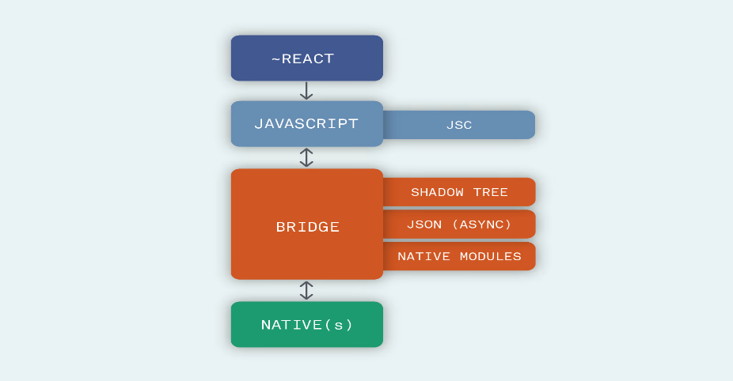

* **Performance:** Near-native but relies on a bridge for native module communication. Delays possible in heavy animations.
* **Cost & Time:** Open-source with reusable components. Ideal for startups due to rapid MVP development.
* **UX/UI:** Uses native components (e.g., <View>, <Text>). Platform-specific tweaks may be needed.
* **Complexity:** Moderate (familiar to web developers but requires native module integration for advanced features).
* **Community:** Massive support (GitHub: 115k+ stars).

**Diagram:** React Native Workflow

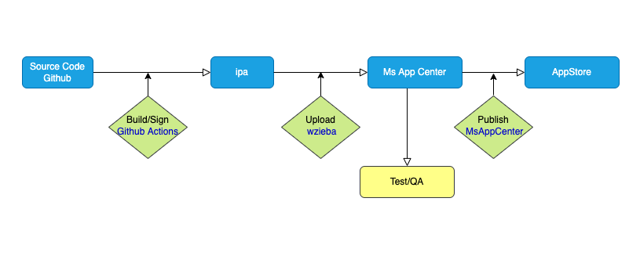

### **Flutter**

Flutter, developed by Google, is a UI toolkit to build native applications for mobile apps, desktop and web platforms. Flutter is a cross-platform mobile app development framework that works on one code base to develop Android as well as iOS applications. The framework provides a large range of fully customizable widgets that helps to build native applications in a shorter span.

**Language: Dart**

Architecture:

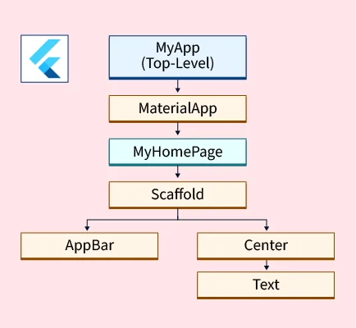

* **Performance:** Compiled to ARM code; no bridge needed. Best for 60fps animations (e.g., gaming apps).
* **Cost & Time:** Fast UI prototyping with customizable widgets (e.g., Material/Cupertino).
* **UX/UI:** Pixel-perfect control but requires manual platform adjustments (no native components).
* **Complexity:** Steeper learning curve (Dart + widget tree).
* **Community:** Growing rapidly (GitHub: 160k+ stars).

**Diagram:** Flutter Overview

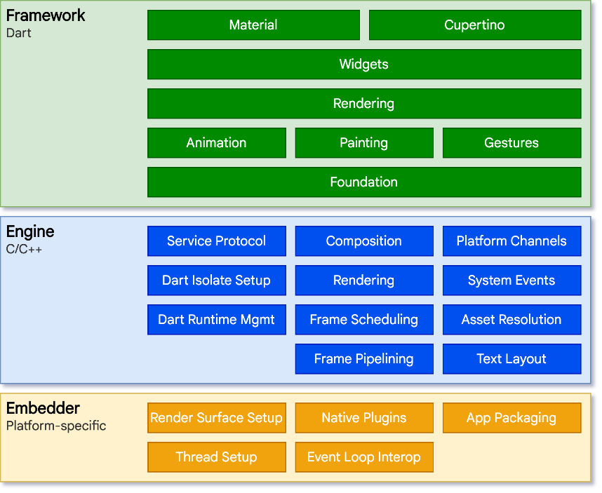

### **Xamarin**

Xamarin is also one of the most popular open-source frameworks used to develop mobile applications. The framework, acquired by **Microsoft**, is based on **.Net** and allows you to build native applications for Android, iOS, and Windows platforms. Xamarin comes with almost every required tool and library needed to build native applications and offers you to create rich experiences using native UI elements. Moreover, Xamarin also supports the feature of sharing the common codebase to make the development process more efficient and cost-effective.

**Language: C#**

Architecture:

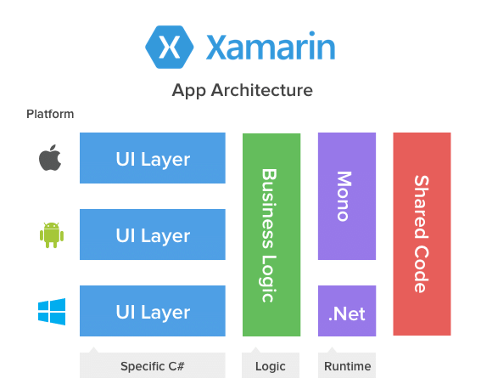

* **Performance:** Near-native via Ahead-of-Time (AOT) compilation.
* **Cost & Time:** Free, but enterprise tools (Visual Studio) may add costs.
* **UX/UI:** Native components via Xamarin.Forms or platform-specific UIs with Xamarin.Native.
* **Complexity:** High for non-C# developers; integrates with Azure/.NET.
* **Community:** Smaller but strong enterprise backing (GitHub: 8k+ stars).

### **Ionic**

Ionic, developed in 2013, is an open-source framework that allows you to build cross-platform for mobile apps using web technologies like HTML, CSS & JavaScript. The application built through the Ionic framework can work on Android, iOS & Windows platforms. The framework offers numerous default UI components such as forms, action sheets, filters, navigation menus, and many more for attractive and worthwhile design. Moreover, Ionic has its own command-line interface and various other in-built features such as Ionic Native, Cordova-Based App packages, etc.

**Language: HTML/CSS/JavaScript**

Architecture:

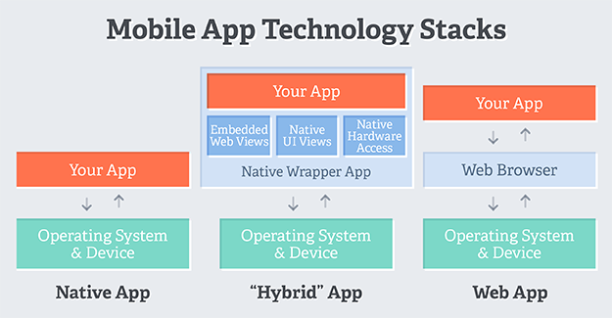

* **Performance:** WebView-based; slower for complex interactions.
* **Cost & Time:** Fast for web developers. Free but plugins may require paid tiers.
* **UX/UI:** Web-like feel; lacks native polish.
* **Complexity:** Low for web developers.
* **Community:** Active but smaller (GitHub: 49k+ stars).

## **Key Metrics Comparison**

### **Performance Benchmark**

|  |  |  |  |
| --- | --- | --- | --- |
| **Framework** | **UI Rendering** | **Animation** | **Native Access** |
| React Native | ⭐⭐⭐⭐ | ⭐⭐⭐ | ⭐⭐⭐⭐ |
| Flutter | ⭐⭐⭐⭐⭐ | ⭐⭐⭐⭐⭐ | ⭐⭐⭐ |
| Xamarin | ⭐⭐⭐⭐ | ⭐⭐⭐ | ⭐⭐⭐⭐⭐ |
| Ionic | ⭐⭐ | ⭐⭐ | ⭐⭐ |

### **Time-to-Market**

Flutter ────────────────▮▮▮▮▮ (Fastest)

React Native ───────────▮▮▮▮

Xamarin ────────────────▮▮▮

Ionic ──────────────────▮▮▮▮▮ (Fastest for web devs)

### **Community & Ecosystem**

**GitHub Stars (2023):**

* Flutter: 160k
* React Native: 115k
* Ionic: 49k
* Xamarin: 8k

## **Comparing Performance**

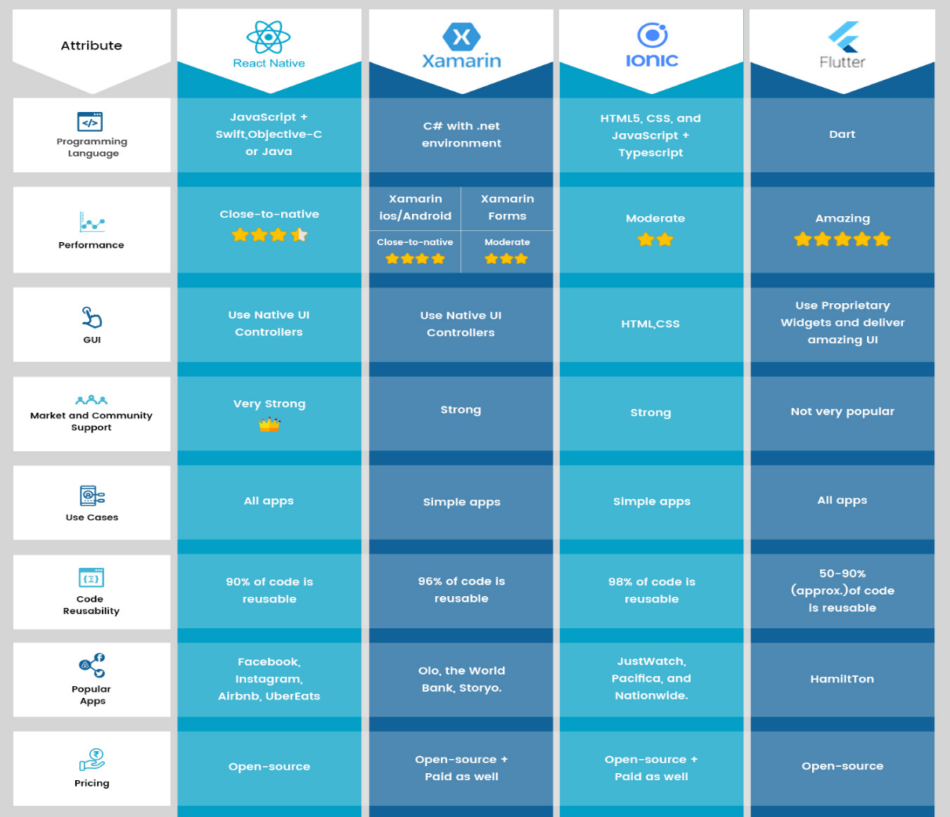

## **Recommendations by Use Case**

|  |  |  |
| --- | --- | --- |
| **Use Case** | **Best Framework** | **Why?** |
| MVP for Startups | React Native | Fast, JS ecosystem, native-like |
| Gaming/Media Apps | Flutter | 60fps animations, custom widgets |
| Enterprise Integration | Xamarin | .NET compatibility, AOT compilation |
| Simple PWA | Ionic | Web skills reuse, low cost |

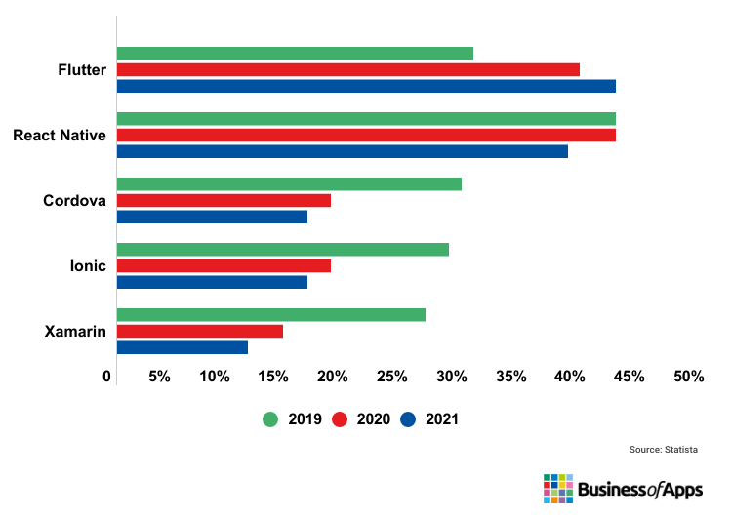

*Fig: Chart showing the percentage of use of the most popular frameworks*

## Some FAQs for Mobile App Development Frameworks

1***. Which mobile app development framework should I learn in 2025?***

All the above-mentioned mobile applications frameworks (React Native, Flutter, Ionic, Xamarin, Apache Cordova, including Swiftic, and jQuery Mobile) are essential for any mobile app developer to learn.

***2. Which are the easy-to-use mobile app development frameworks?***

jQuery Mobile is simple to understand and also uses an open-source framework. It enables programmers to create native-looking Android, iOS, and desktop applications utilizing popular online standards like HTML5, JavaScript, or CSS3.

***3. Which mobile app development frameworks can be used for cross-platform app development?***

React Native, Ionic Framework, Xamarin, NativeScript, Adobe PhoneGap, and Flutter are the best mobile app development frameworks for cross-platform app development.

***4. Which frameworks are the best for native app development?***

Native Script is an accessible framework that uses Angular, Typescript, JavaScript, and CSS to develop native mobile applications. React Native is the finest JavaScript framework for creating native apps for any platform and operating system. Xamarin is among the most used mobile app development frameworks. Microsoft launched this native framework.

***5. Which is the best mobile app development framework?***

* Flutter is the most popular Android framework out there. It has speedily scaled the list of dominant positions after being recognized as the most-used framework second by React Native.
* React Native is among the most commonly utilized mobile applications frameworks, with 42% of programmers globally using it. It was created by Facebook and is built on JavaScript. Using Android and iOS platforms, React Native programmers can quickly construct a smartphone application with a native appearance and touch.

# Mobile App Architecture and Design Patterns

Mobile application architecture is a critical aspect of software development that defines the structural organization of mobile applications.

## 3.1. Architectural Foundations

### 3.1.1. Core Architectural Objectives

* Ensure application scalability
* Maximize code reusability
* Optimize performance
* Simplify maintenance
* Enhance testability
* Support future expansion

### 3.1.2. Key Architectural Considerations

* Platform-specific constraints
* Performance limitations
* Memory management
* User experience requirements
* Security considerations
* Data persistence strategies

## 3.2. Architectural Patterns

### 3.2.1. Model-View-Controller (MVC)

**Core Components:**

* **Model**: Manages the data and business logic
* **View**: Handles user interface and presentation
* **Controller**: Connects data and UI

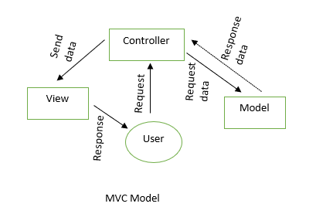

**Characteristics:**

* Separates application logic into distinct components
* Provides clear separation of concerns
* Widely used in early mobile application development

**Advantages:**

* Simple implementation
* Easy to understand
* Quick initial development

**Limitations:**

* Challenges with complex applications
* Potential for massive controller classes
* Limited flexibility for large-scale projects

### 3.2.2. Model-View-View-Model (MVVM)

**Core Components:**

* **Model**: Data and business logic
* **View**: User interface elements
* **View-Model**: Connects the Model and View, handles presentation logic

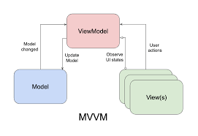

**Key Features:**

* Improved separation of concerns
* Enhanced testability
* Support for data binding
* Reduced coupling between components

**Implementation Strategies:**

* Reactive programming support
* Passing required tools to classes
* State management
* Event-driven architecture

### 3.2.3. Clean Architecture

**Architectural Layers:**

1. Presentation Layer
2. Domain Layer
3. Data Layer

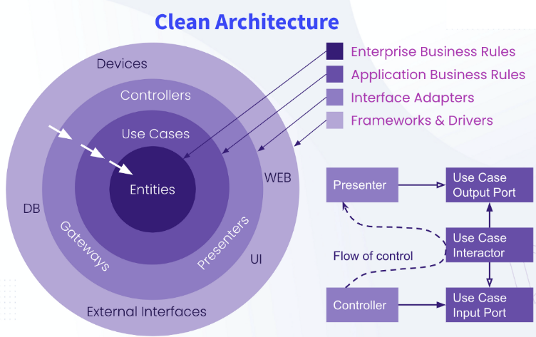

**Fundamental Principles:**

* Independent layer design
* Dependency rule enforcement
* Separation of concerns
* Minimized external dependencies

**Benefits:**

* High maintainability
* Framework independence
* Simplified testing
* Long-term scalability

## 3.3. Design Patterns

### 3.3.1. Creational Patterns

* **Singleton**: Ensures single instance management
* **Factory Method**: Flexible object creation
* **Builder**: Complex object construction
* **Prototype**: Object cloning and initialization

### 3.3.2. Structural Patterns

* **Adapter**: Interface compatibility
* **Decorator**: Dynamic functionality extension
* **Composite**: Hierarchical object composition
* **Proxy**: Access control and lazy loading

### 3.3.3. Behavioral Patterns

* **Observer**: Event handling and notifications
* **Strategy**: Algorithm interchangeability
* **Command**: Action encapsulation
* **State**: Dynamic behavior modification

## **3.4. Choosing the Right Architecture**

| **App Size** | **Recommended Architecture** | **Best For** |
| --- | --- | --- |
| Small | MVC | Simple apps |
| Medium | MVVM | Team projects |
| Large | Clean Architecture / VIPER | Enterprise apps |

## 3.5. Best Practices

1. **Modular Design**
   * Create independent, reusable modules
   * Minimize interdependencies
   * Support easy maintenance and updates
2. **Dependency Management**
   * Implement dependency injection
   * Use inversion of control principles
   * Minimize tight coupling
3. **Testing Strategies**
   * Unit testing
   * Integration testing
   * Performance testing
   * Continuous integration approaches
4. **Optimize performance** by reducing UI lag, optimizing database queries, and minimizing network calls.
5. **Implement caching mechanisms** for better offline support.
6. **Use Tools for handling app data** (e.g., Redux for React Native, Jetpack View-Model for Android).
7. **Follow solid principles** for better code organization.

# Mobile App Requirements: How to Gather & analyse iOS, Android, or Native Requirements

## 4.1. What Are Mobile App Requirements?

Mobile app requirements document the business logic, technical specifications, and development guidelines for mobile app developers to design the application of your business dreams.

It includes the key app’s features, app user personas, and business goals to ensure that multiple team members are on the same page before the software development process commences.

## 4.2. How to Gather an App Requirements for Project Success

### 4.2.1. Mobile App Requirements Types

Mobile apps have different requirement types to collect, including:

* **Business requirements** are high-level requirements that ensure the app will align with business objectives, and the project’s scope, and identify the key stakeholders.
* **User requirements** are valuable insights into what your target audience needs and wants, how you can solve their problems, and what the audience experiences from your prototyping app.
* **Product or system requirements** are non-functional requirements and functional requirements that include technical requirements and technical specifications for the engineering team.

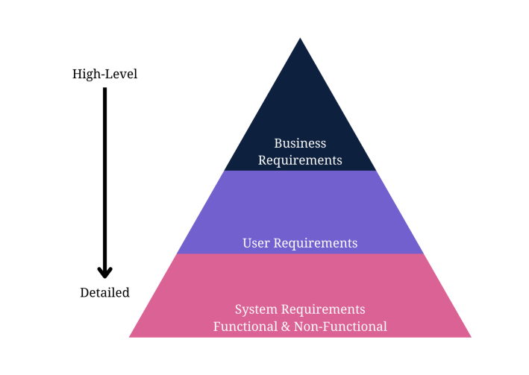

A functional specification document will outline the product’s features and how users interact with the app. On the other hand, non-functional requirements include the technical specification for the app’s quality attributes. For example, a functional requirement refers to the sign-up button users click on before using your services. However, non-functional requirements refer to how fast the system responds to the user clicking on that button and how the system protects their data while clicking the button.

Next, let’s show the steps to gather requirements for a mobile application to ensure you meet the business requirements and key features necessary to develop a profitable product. Some steps will involve sub-steps that will help developers gather the right information and requirements for documents.

### 4.2.2. Requirements Gathering Process

### **Step 1: Define Your App Idea and Purpose**

* Mobile development requirements-gathering starts with a business idea. The first information you need is the idea or purpose of the mobile app.
* What purpose will it serve? Does it offer a solution to a potential problem?
* You need to identify a problem the app will solve to recognize the idea or purpose behind it.

[Requirements gathering and management for mobile apps](https://www.requiment.com/requirements-gathering-and-management-for-mobile-apps/) require some effort with massive results.

### **Step 2: Gather and Align the App and Business Objectives or Goals**

An app idea is fruitless without understanding business needs, business goals, and business rules.

This step encourages to gather business requirements to understand how the enterprise aligns with the idea from the first step.

Gathering business requirements to document involves these steps:

1. Identify the stakeholders for the right mobile application software development based on the business idea.
2. Define clear and concise business goals and objectives to understand the project’s scope.
3. Elicit stakeholder requirements and user requirements with elicitation techniques.
4. Document the requirements in a **business requirements document.**
5. Validate your requirements with stakeholders for a further transparent and opportunistic process.

So, what requirements-gathering elicitation techniques are used to gather stakeholder requirements for the business requirements document?

Elicitation techniques work for any requirements-gathering type.

Here are some popular and successful techniques to use:

* Analyze similar documents
* Analyze similar external and internal interfaces
* Brainstorm use cases and user stories
* Create user stories and use cases
* Hold stakeholder focus groups
* Host requirements workshops
* Interview all the relevant stakeholders
* Observe documents and case studies
* Prototype visual examples for feedback
* Reverse engineer the processes
* Use online surveys/questionnaires
* Validate ideas with stakeholders

### **Step 3: Run a Market Analysis and Competitor Analysis**

Conduct a market or competitor analysis to truly understand the user’s perspective and design the appropriate user personas.

It also helps the team gather more user requirements for the development company.

The following steps explain the process of gathering user and competitor requirements:

1. Identify the direct, indirect, secondary, and substitute competitors for the mobile app. Remember to recognize any businesses offering similar mobile app services or products and those offering different products in a broader niche umbrella.
2. Gather competitor information, including products, descriptions, pricing structures, geographic reach, engaging promotions, target market positioning, business reputation, user profiles, and key partnerships to understand what your product needs to compete against.
3. Use a SWOT analysis to determine your competitor’s strengths, weaknesses, opportunities, and threats. We could learn from another app’s mistakes to improve our requirements and identify possibly unique features other apps don’t provide.

The SWOT analysis in a table will help to see what the new product needs to do to compete better with the top market competitors.

Rank each competitor from 1-10 on each key element.

Then, rank what your mobile app aims to have in the requirements, looking for opportunities to improve the numbers.

| **Attribute** | **Competitor 1** | **Competitor 2** | **Competitor 3** | **Your Product** | **Action Needed** |
| --- | --- | --- | --- | --- | --- |
| Quality | 7 | 6 | 5 | **9** | Maintain leadership |
| Pricing | 6 | 8 | 4 | 7 | Match Competitor 2's value |
| Place | 5 | 7 | 3 | 6 | Expand distribution channels |
| Promotion | 4 | **9** | 6 | 5 | Boost marketing campaigns |
| Unique Features | 5 | 6 | 2 | **7** | Highlight differentiators |
| Positioning | 6 | **8** | 5 | 7 | Refine brand messaging |
| People | 7 | 5 | 4 | **8** | Enhance customer support |
| Reputation | 6 | 7 | 5 | **8** | Leverage positive testimonials |
| Partnerships | 3 | **5** | 2 | 4 | Build strategic alliances |

Next, determine what competitive advantage your product holds over other apps. For example, the sample analysis shows that your product quality is far superior to others. The pricing is also better than competitors. Choose at least three elements in which you wish to compete with other apps.

***Fun fact: [Requirements gathering is the most undertaught area in software development](https://www.requiment.com/requirements-gathering-is-the-most-undertaught-area-in-software-development/).***

### **Step 4: Determine Scenarios and a User Persona**

The next major step in mobile app requirements-gathering is to design user personas and scenarios to guide the requirements.

A user persona fictionalizes the target users for the mobile app.

It should describe the ideal person who uses the app, with some flexible aspects for alternate users.

The ultimate user person could include the following details about target users:

* Age (also, typical generational qualities)
* Behavioural considerations
* Gender (including non-binary if relevant to the product)
* Geographic location
* Goal or problem the app addresses or solves
* Goal quotes or principles
* Goal-related frustrations
* Motivation to use the app
* Range of hobbies and daily activities
* Typical occupation range

**How to transform user personas into scenarios?**

Create a persona scenario or storyboard by focusing on the goals, how their typical behaviours affect them, and how the persona’s background motivates them to respond differently.

Write the scenario as a short paragraph for starters, as you’ll design user stories later. Meanwhile, *[identifying stakeholders for requirements gathering](https://www.requiment.com/identifying-stakeholders-for-requirements-gathering/)* means creating personas.

### **Step 5: Gather and Prioritize Functional and Non-Functional Requirements**

Your user and business requirements are shaped through the initial steps of app requirements gathering.

You still need to document them, but you’ll do that soon enough.

Meanwhile, start prioritizing the functional and non-functional requirements for the technical details, which also design use cases.

First, determine which functional app requirements the project needs.

Here are some examples of functional mobile requirements:

* A complete description of a feature the app offers or software interfaces.
* How the app allows users to sign up, verify accounts, or subscribe to a newsletter.
* Buttons and dashboards users interact with to complete a specified task.
* External and internal interfaces users interact with on the app.
* The necessary administrative functions for different user classes.
* Transaction adjustment, correction, and cancellation functions.

Secondly, determine the non-functional requirements necessary to run your app.

Here are some examples of non-functional requirements in mobile development:

* How fast the app responds to user input.
* How the app protects user and business data.
* Whether the app can work on multiple platforms.
* How much data does the app store and is it scalable?
* How reliable and maintainable the app remains.
* Does the app comply with local laws and regulations?

Next, you’ll prioritize the non-functional requirements (NFRs) and functional requirements for an app.

Priorities determine the tech stack and importance of each function.

The **MoSCoW Prioritization** technique helps with any requirements prioritization before documenting the requirements.

The technique requires you to put every technical requirement into one of four categories:

* **Must Have** – The highest-level requirements are critical to the requirements document to ensure the project’s success.
* **Should Have** – The second highest-level specifications are necessary for the project but won’t delay the progress of development or success.
* **Could Have** – The medium-level specifications could enhance user experience but aren’t dealbreakers if you don’t develop them right away.
* **Won’t Have** – The low-level requirements aren’t important to stakeholders at the time of requirements documentation and won’t affect the development process.

Include requirements for user experience (UX) and user interface (UI) with your functional and non-functional requirements.

It helps to have these requirements in place before designing use cases and documenting a key user experience and user flow requirement for app development.

***[Requirements prioritization](https://www.requiment.com/requirements-prioritisation-making-informed-decisions/) simplifies decision-making for your app.***

### 4.2.3. Requirements Analysis Process

The next step is the requirement analysis, fun intended. Some techniques also help managers represent the requirements to stakeholders. The following requirements analysis techniques are commonly used for the actual analysis process:

#### Common Requirement Analysis Techniques

**1. Gap Analysis:** A gap analysis identifies performance gaps in a software application to determine whether the business requirements are met. The gap analysis depicts the difference between the present state and the target state of a software application.

**2. Gantt Charts:** Gantt charts outline the schedule of tasks and timelines in which developers must perform them. The Gantt charts show a project team the complete timeline with tasks.

**3. Integrated Definition of Function Modeling (IDEF):** The integrated definition of function modeling (IDEF) method in requirement analysis techniques represents process functions and the integrated set of relationships between parent and child systems.

**4. Role-Activity Diagrams (RAD):** This method offers a high-level view of diagrams that capture role structure and dynamics within an enterprise. Roles are used to group responsibilities and activities into units in project planning and systems engineering.

**5. Data Flow Diagrams:** A data flow diagram lets project managers represent complex processes that would otherwise be challenging to visualize from the text. Also, a data flow diagram shows analysts possible gaps.

**6. The Flowchart Technique:** A flowchart technique outlines the sequential flow of information and the control logic of an activity set. The flowchart technique uses different formats, including top-down, cross-functional, and linear graphs.

**7. Unified Modeling Language (UML):** The unified modeling language (UML) method uses an integrated set of diagrams to specify, construct, and document software system artifacts. Graphical notations also present the software project for systems engineering.

**8. Business Process Modeling Notation (BPMN):** The business process model technique uses process flowcharts with unique elements and symbols to depict the business process in graphs. Business process modeling is a process improvement method in the software industry.

## **4.3. CASE STUDY :** How to Design a Use Case for App Requirements Documents

A use case diagram lets everyone at the development company visualize an overview of how users will interact with the app.

It’s an overview that includes actors, how actors interact with the app, and the sequence of interactions actors will deploy.

Here’s a simple example of a use-case diagram that shows an overview of how actors interact with functional features while non-functional features interact with the app from the back-end stack: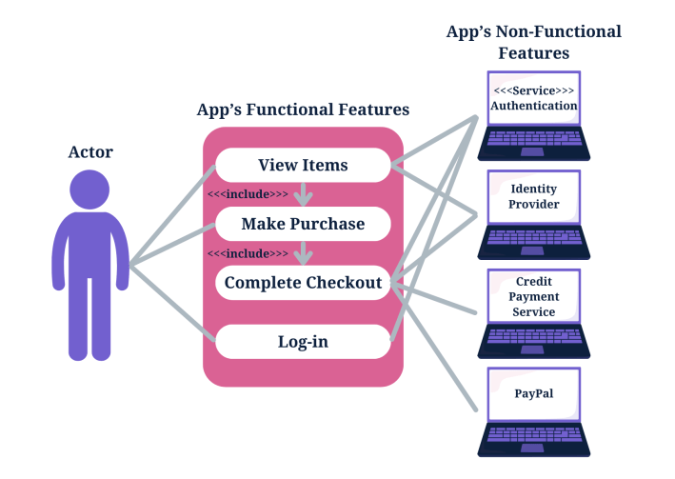

### Write an App Requirements Document

Delivering a proper app requirements document means you need to know how to write a mobile app requirements document.

Mobile application development relies on the requirements document to design proper flow or the best app features and hit the right target audience.

#### Formulate the App’s Idea Statement

Every app requirements document should include an idea statement that lets every stakeholder and software developer understand the document before diving into the details.

Start your app requirements document with a simple single-sentence statement that aligns with the app’s idea.

#### Document All Relevant App Details

A detailed description of development plans in the requirements document is instrumental to completing the documentation.

A successful mobile app requirements document includes more than the details of an application and its functions for the development team.

##### **Descriptions to Include in a Mobile Requirements Document**

A mobile application requirements document should include a detailed description of functional and technical requirements and the app’s functionality to properly capture and represent the project’s scope.

* Business requirements
* User requirements
* Software requirements specification
* Technical specifications
* Functional specifications
* Non-functional requirements
* Hardware interfaces
* A list of must-have features
* Unique app features
* Internal and external interfaces
* Non-functional key metrics
* User stories
* Acceptance criteria

#### Prepare a Navigation Sequence

The development team requires a simple navigation sequence they can follow during software development.

The mobile app requirements document outlines the sequence in which the software development process flows.

#### Add Requirements Formats for Visuals

Add your user stories from a user’s perspective and the use case overviews you designed to the app requirements document to help stakeholders and the development team understand every aspect of the app requirements document.

Successful software development means knowing the intended users.

#### Add Cost Optimization Details

The development team, stakeholders, and the client will appreciate a cost-benefit analysis to ensure cost optimization throughout the software development process. Business analysts also insist on adding a cost-benefit analysis to an app requirements document to meet the business needs and have a greater chance of success against competing apps.

#### Add Communication Protocols

Add communication methods for a collaborative process. Collaboration relies on dependable communication. The [importance of effective communication in requirements gathering](https://www.requiment.com/the-importance-of-effective-communication-in-requirements-gathering/) outlines why you need it.

#### Deploy Prototyping and Wireframing

Prototyping and wireframing let you design the user flow of user interfaces and basic app functions.

It also lets you test and validate layouts and transitions between app pages.

Here are the steps to wireframe your requirements for an app, which you will then validate in the next step:

1. Map the target user flow.
2. Sketch the flow’s core part.
3. Set a mobile wireframe.
4. Determine the layout with boxes.
5. Use design patterns.
6. Add intended copy.
7. Connect the app’s pages to design a flow.
8. Design a prototype.
9. Release the initial design to gather feedback.

#### Validate the App Requirements

Validation is a quality control process you use before launching the final product based on your requirements.

The prototype app collects feedback from stakeholders, and you can invite stakeholders to verify that the app meets the documented requirements. Use the feedback for the final step.

#### Apply Agile Methodology

Agile methodology in requirements-gathering means you’ll always adapt the requirements document as per the feedback from stakeholders, testing, and initial product releases.

Agile methodology focuses on user experience and constant testing and validation to further improve your application.

# **5. Estimating Mobile App Development Costs**

Building a mobile app is a significant investment, but when executed correctly, it can yield substantial rewards. Accurately estimating development costs is crucial for budgeting and ensuring project success. This guide explores the factors influencing costs, different estimation methods, and strategies to reduce expenses while maintaining quality.

## Importance of Cost Estimation in Mobile App Development

Estimating app development costs allows businesses to set realistic budgets, allocate resources efficiently, and prevent unexpected financial overruns. A well-structured cost estimation process ensures that stakeholders understand the financial implications and can plan accordingly.

## Factors Influencing Mobile App Development Costs

Estimating app development costs is not a one-size-fits-all process. Several key factors affect the final cost:

#### Complexity and Size of the App

Simple apps with basic functionality cost less than complex apps with advanced features like real-time synchronization, user authentication, and extensive backend infrastructure. The number of screens/pages in an app affects design, development, and testing efforts.

#### Platform Choice (iOS, Android, or Both)

Developing for a single platform (iOS or Android) is less expensive than creating a cross-platform app.

Target audience and market demand play a role in determining platform selection.

#### User Interface (UI) and User Experience (UX) Design

Custom graphics, animations, and interactive designs increase costs.

Simpler designs are more budget-friendly but may not be as competitive in the market.

#### Backend Development and API Integrations

Apps requiring server-side functionalities, cloud storage, and API interactions will have higher development costs.

Secure data handling and performance optimization add to development complexity.

#### Location and Structure of the Development Team

Developers in North America and Western Europe charge higher rates than those in Asia and Eastern Europe.

A specialized team (UI/UX designers, front-end and back-end developers, testers) ensures quality but increases costs.

#### Maintenance and Updates

Post-launch costs include bug fixes, security patches, and feature enhancements.

Regular updates ensure compatibility with new OS versions and user expectations.

## Steps to Estimate Mobile App Development Costs

Estimating mobile app development costs involves several key steps to ensure an accurate budget while avoiding unexpected expenses.

#### Define Objectives & Features

Clearly outline the app’s purpose, target audience, and core features to avoid unnecessary costs.

#### Choose the Platform

Decide between iOS, Android, or cross-platform development based on audience preferences and functionality needs.

#### Evaluate Design Complexity

A simple UI is more cost-effective, while a custom design with animations and unique elements increases costs.

#### Estimate Development Hours

Break down the project into stages and allocate hours to set a realistic timeline and budget.

#### Research Development Rates

Developer costs vary by location, ranging from $20-$200 per hour, depending on expertise and region.

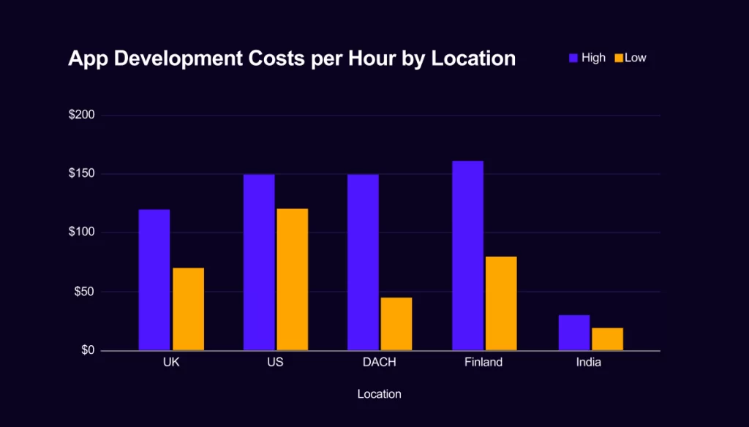

#### Consider Additional Expenses

Budget for app design, testing, third-party integrations, cloud hosting, marketing, and post-launch maintenance.

By following these steps, businesses can create a well-planned budget and avoid unforeseen financial challenges during app development.

## 5.4. Cost Estimation Models

#### **a. Fixed Price Model**

Suitable for small projects with well-defined requirements.

#### **b. Hourly Rate Model**

Best for flexible and evolving projects.

#### **c. Cost Based on Development Stages**

* Planning & Research – 10% of the budget
* Design & Prototyping – 15%
* Development & Testing – 50%
* Deployment & Maintenance – 25%

## Mobile App Development Cost Estimation Formula

In the realm of mobile app development, precision is paramount, especially when it comes to estimating costs. One of the most straightforward and widely utilized methods for calculating the average cost of app development is through a simple formula:

**App Development Cost = Total Development Time x Hourly Rate**

This formula serves as a foundational pillar in cost estimation, offering a clear and concise way to determine the financial requirements for your app project. Let’s break it down:

* **Total Development Time**: This component represents the cumulative hours required for the app’s development. It encompasses every development phase, including planning, design, coding, quality assurance, and deployment. Understanding your project’s scope and complexity is essential to ascertain this value.
* **Hourly Rate:** The hourly rate is the cost per hour of development work. Factors such as location, development team expertise, and specific services rendered can significantly affect the cost.

This formula is the cornerstone of financial planning for many companies as they embark on app development endeavors. It enables a precise projection of the budget required, allowing businesses to make informed decisions before initiating the development process

## Cost Estimation Tools & Methods

**Online Cost Calculators** (e.g., Estimate My App, Clutch)

**Agile Development** (flexible budgeting and iterative progress)

**Prototyping** (reduces risk and rework)

## Tactics for Reducing Mobile App Development Costs

To reduce mobile app development costs without compromising quality, businesses should adopt strategic approaches:

* **Effective Planning & Requirement Analysis** – Clearly define the app’s purpose and core functionalities to avoid unnecessary revisions and cost overruns.
* **Prioritizing Features (MVP Approach)** – Focus on essential features first, launching a Minimum Viable Product (MVP) to gather user feedback before investing in advanced features.
* **Outsourcing vs. In-House Development** – Outsourcing to a reliable development team can be more cost-effective than hiring an in-house team for short-term needs.
* **Using Cross-Platform Development Tools** – Frameworks like Flutter or React Native enable code reuse across iOS and Android, reducing development time and costs.

By carefully planning, prioritizing features, outsourcing wisely, and leveraging cross-platform tools, businesses can develop high-quality mobile apps within budget while ensuring a strong return on investment.

# Conclusion

Mobile app development is a rapidly evolving field that involves creating native, web, and hybrid applications tailored for different platforms. The choice of development approach depends on factors like performance, cost, and accessibility.

Cross-platform frameworks such as React Native, Flutter, Xamarin, and Ionic streamline development, enabling faster deployment and broader reach. Effective mobile app architecture, including MVC, MVVM, and Clean Architecture, ensures scalability, maintainability, and performance.

Cost estimation is crucial for budgeting, as factors like app complexity, platform choice, and development frameworks influence expenses. By selecting the right technologies and design patterns, businesses can optimize costs while delivering high-quality applications.

As mobile technology advances, developers must stay adaptable, leveraging modern frameworks and best practices to build efficient, scalable, and user-friendly applications.

## References

1. Types Of Mobile Applications:

<https://www.businessofapps.com/app-developers/research/types-of-mobile-apps/>

<https://www.geeksforgeeks.org/types-of-mobile-application-appium/>

<https://medium.com/@olivereric075/what-are-the-types-of-mobile-apps-d625b01e7fb0>

1. Mobile Application Frameworks:

<https://www.geeksforgeeks.org/top-mobile-app-development-frameworks/>

<https://technostacks.com/blog/mobile-app-development-frameworks/>

1. Estimating Mobile App Development Costs

[Estimating Mobile App Development Costs: A Comprehensive Guide - itCraft blog](https://itcraftapps.com/blog/estimating-mobile-app-development-costs-a-comprehensive-guide/)

[How to Estimate Mobile App Development Cost [Free Calculator Template]](https://www.choicely.com/blog/how-to-estimate-mobile-app-development-cost-free-calculator-template)

[A Guide to Mobile App Development Cost Estimates](https://appwrk.com/mobile-app-development-cost-estimate)

[How to Calculate the Cost of Developing a Mobile App](https://thinkupsoft.com/blog/how-to-calculate-the-cost-of-developing-a-mobile-app/" \l ":~:text=One of the most straightforward and widely utilized,Cost = Total Development Time x Hourly Rate)