**Mobile App Architecture and Design Patterns**

**1. Introduction**

Mobile application architecture is a critical aspect of software development that defines the structural organization of mobile applications.

**2. Architectural Foundations**

**2.1 Core Architectural Objectives**

* Ensure application scalability
* Maximize code reusability
* Optimize performance
* Simplify maintenance
* Enhance testability
* Support future expansion

**2.2 Key Architectural Considerations**

* Platform-specific constraints
* Performance limitations
* Memory management
* User experience requirements
* Security considerations
* Data persistence strategies

**3. Architectural Patterns**

**3.1 Model-View-Controller (MVC)**

**Core Components:**

* **Model**: Manages the data and business logic
* **View**: Handles user interface and presentation
* **Controller**: Connects data and UI

Response

Send data

Response data

Model

Request data

Request

Controller

View

User

MVC Model

**Characteristics:**

* Separates application logic into distinct components
* Provides clear separation of concerns
* Widely used in early mobile application development

**Advantages:**

* Simple implementation
* Easy to understand
* Quick initial development

**Limitations:**

* Challenges with complex applications
* Potential for massive controller classes
* Limited flexibility for large-scale projects

**3.2 Model-View-ViewModel (MVVM)**

**Core Components:**

* **Model**: Data and business logic
* **View**: User interface elements
* **ViewModel**: Connects the Model and View, handles presentation logic

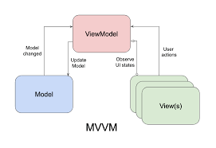

**Key Features:**

* Improved separation of concerns
* Enhanced testability
* Support for data binding
* Reduced coupling between components

**Implementation Strategies:**

* Reactive programming support
* Passing required tools to classes
* State management
* Event-driven architecture

**3.3 Clean Architecture**

**Architectural Layers:**

1. Presentation Layer
2. Domain Layer
3. Data Layer

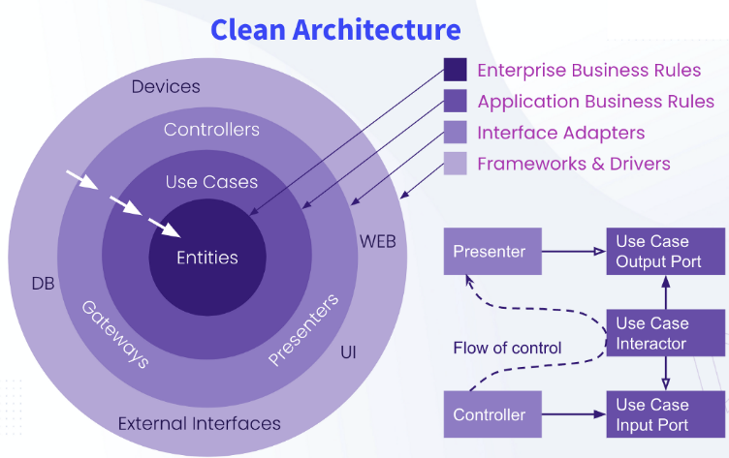

**Fundamental Principles:**

* Independent layer design
* Dependency rule enforcement
* Separation of concerns
* Minimized external dependencies

**Benefits:**

* High maintainability
* Framework independence
* Simplified testing
* Long-term scalability

**4. Design Patterns**

**4.1 Creational Patterns**

* **Singleton**: Ensures single instance management
* **Factory Method**: Flexible object creation
* **Builder**: Complex object construction
* **Prototype**: Object cloning and initialization

**4.2 Structural Patterns**

* **Adapter**: Interface compatibility
* **Decorator**: Dynamic functionality extension
* **Composite**: Hierarchical object composition
* **Proxy**: Access control and lazy loading

**4.3 Behavioral Patterns**

* **Observer**: Event handling and notifications
* **Strategy**: Algorithm interchangeability
* **Command**: Action encapsulation
* **State**: Dynamic behavior modification

## ****5. Choosing the Right Architecture****

| **App Size** | **Recommended Architecture** | **Best For** |
| --- | --- | --- |
| Small | MVC | Simple apps |
| Medium | MVVM | Team projects |
| Large | Clean Architecture / VIPER | Enterprise apps |

**6. Best Practices**

1. **Modular Design**
   * Create independent, reusable modules
   * Minimize interdependencies
   * Support easy maintenance and updates
2. **Dependency Management**
   * Implement dependency injection
   * Use inversion of control principles
   * Minimize tight coupling
3. **Testing Strategies**
   * Unit testing
   * Integration testing
   * Performance testing
   * Continuous integration approaches
4. **Optimize performance** by reducing UI lag, optimizing database queries, and minimizing network calls.
5. **Implement caching mechanisms** for better offline support.
6. **Use Tools for handling app data** (e.g., Redux for React Native, Jetpack ViewModel for Android).
7. **Follow solid principles** for better code organization.

**7. Conclusion**

Selecting an appropriate mobile app architecture requires careful consideration of project requirements, team expertise, and long-term objectives. Continuous learning and adaptation are crucial in the rapidly evolving mobile development landscape.