# **Mobile App Development Frameworks: In-Depth Comparison**

## **1. Introduction**

Mobile app frameworks streamline cross-platform development, balancing performance, cost, and time. This report elaborates on React Native, Flutter, Xamarin, and Ionic, comparing their key features and suitability for different use cases. Diagrams are included to visualize critical comparisons.

## **2. Framework Comparison**

### **2.1 React Native**

**Language: JavaScript/TypeScript**

Architecture:

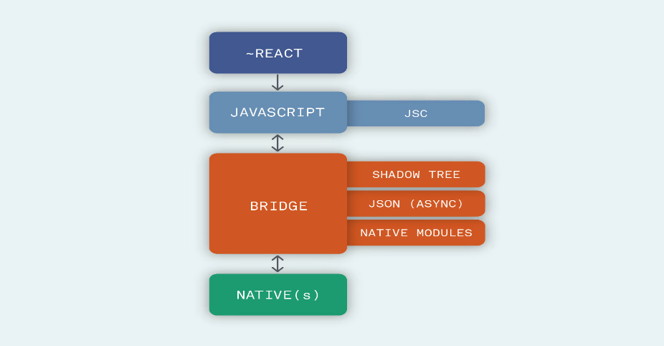

* **Performance:** Near-native but relies on a bridge for native module communication. Delays possible in heavy animations.
* **Cost & Time:** Open-source with reusable components. Ideal for startups due to rapid MVP development.
* **UX/UI:** Uses native components (e.g., <View>, <Text>). Platform-specific tweaks may be needed.
* **Complexity:** Moderate (familiar to web developers but requires native module integration for advanced features).
* **Community:** Massive support (GitHub: 115k+ stars).

**Diagram:** React Native Workflow

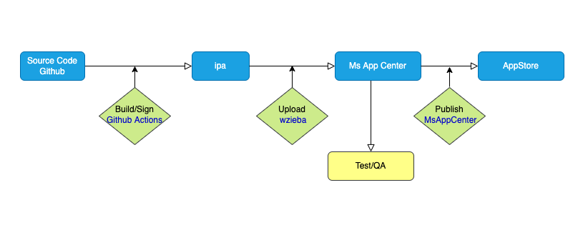

### **2.2 Flutter**

**Language: Dart**

Architecture:

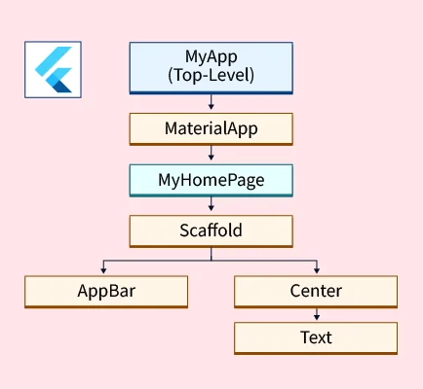

* **Performance:** Compiled to ARM code; no bridge needed. Best for 60fps animations (e.g., gaming apps).
* **Cost & Time:** Fast UI prototyping with customizable widgets (e.g., Material/Cupertino).
* **UX/UI:** Pixel-perfect control but requires manual platform adjustments (no native components).
* **Complexity:** Steeper learning curve (Dart + widget tree).
* **Community:** Growing rapidly (GitHub: 160k+ stars).

**Diagram:** Flutter Overview

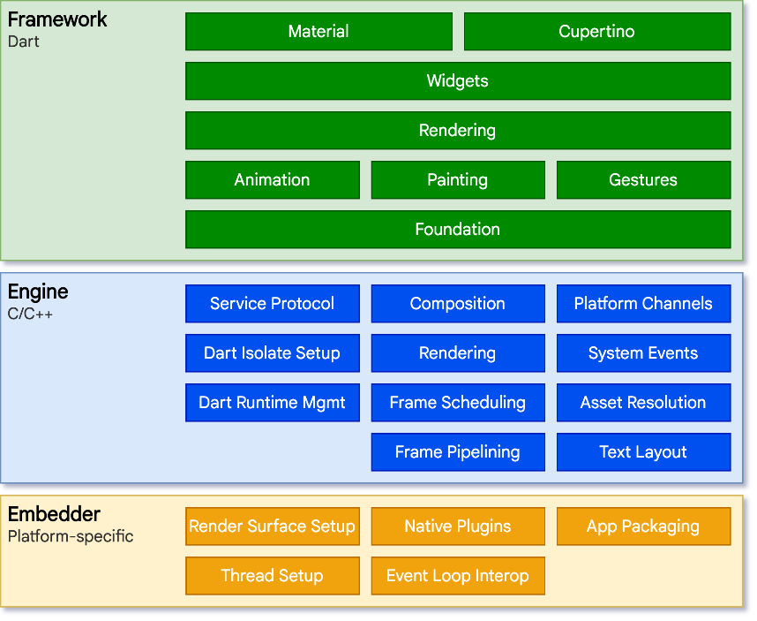

### **2.3 Xamarin**

**Language: C#**

Architecture:

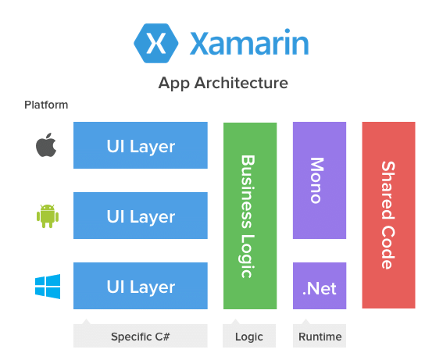

* **Performance:** Near-native via Ahead-of-Time (AOT) compilation.
* **Cost & Time:** Free, but enterprise tools (Visual Studio) may add costs.
* **UX/UI:** Native components via Xamarin.Forms or platform-specific UIs with Xamarin.Native.
* **Complexity:** High for non-C# developers; integrates with Azure/.NET.
* **Community:** Smaller but strong enterprise backing (GitHub: 8k+ stars).

### **2.4 Ionic**

**Language: HTML/CSS/JavaScript**

Architecture:

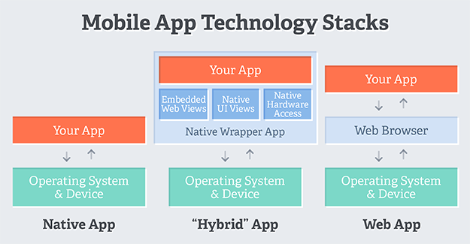

* **Performance:** WebView-based; slower for complex interactions.
* **Cost & Time:** Fast for web developers. Free but plugins may require paid tiers.
* **UX/UI:** Web-like feel; lacks native polish.
* **Complexity:** Low for web developers.
* **Community:** Active but smaller (GitHub: 49k+ stars).

## **3. Key Metrics Comparison**

### **3.1 Performance Benchmark**

|  |  |  |  |
| --- | --- | --- | --- |
| **Framework** | **UI Rendering** | **Animation** | **Native Access** |
| React Native | ⭐⭐⭐⭐ | ⭐⭐⭐ | ⭐⭐⭐⭐ |
| Flutter | ⭐⭐⭐⭐⭐ | ⭐⭐⭐⭐⭐ | ⭐⭐⭐ |
| Xamarin | ⭐⭐⭐⭐ | ⭐⭐⭐ | ⭐⭐⭐⭐⭐ |
| Ionic | ⭐⭐ | ⭐⭐ | ⭐⭐ |

### **3.2 Time-to-Market**

Flutter ────────────────▮▮▮▮▮ (Fastest)

React Native ───────────▮▮▮▮

Xamarin ────────────────▮▮▮

Ionic ──────────────────▮▮▮▮▮ (Fastest for web devs)

### **3.3 Community & Ecosystem**

**GitHub Stars (2023):**

Flutter: 160k

React Native: 115k

Ionic: 49k

Xamarin: 8k

## **4. Comparing Performance**

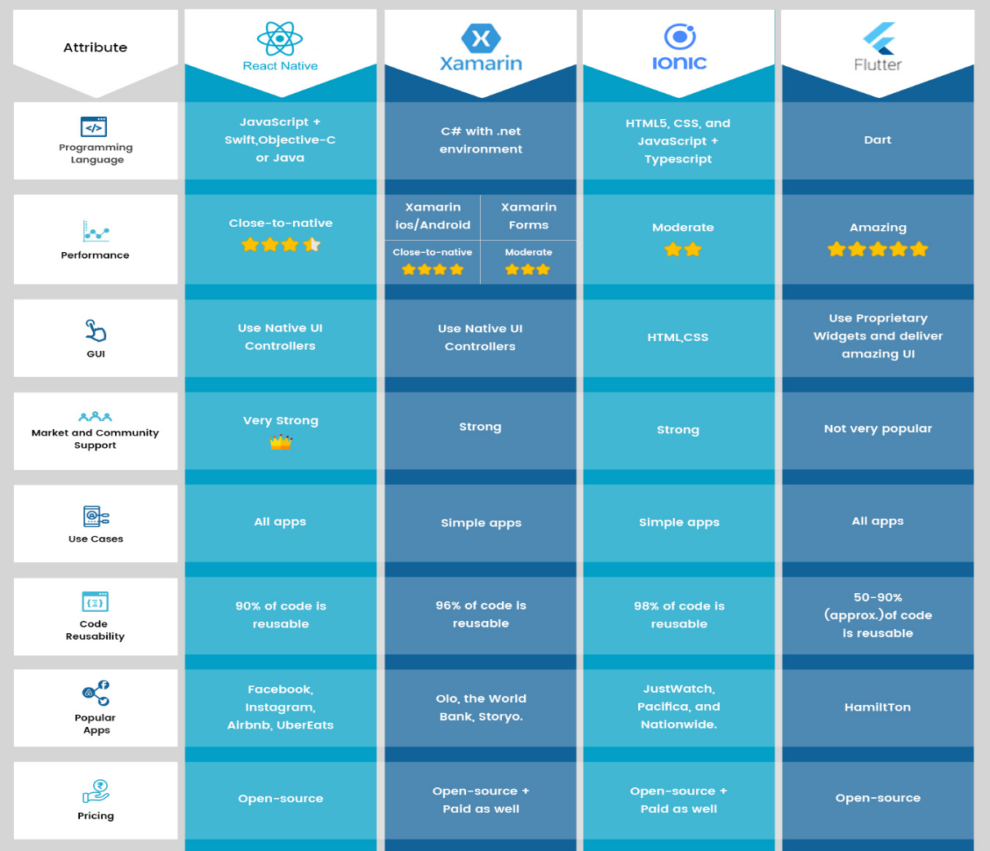

## **5. Recommendations by Use Case**

|  |  |  |
| --- | --- | --- |
| **Use Case** | **Best Framework** | **Why?** |
| MVP for Startups | React Native | Fast, JS ecosystem, native-like |
| Gaming/Media Apps | Flutter | 60fps animations, custom widgets |
| Enterprise Integration | Xamarin | .NET compatibility, AOT compilation |
| Simple PWA | Ionic | Web skills reuse, low cost |

## **6. Conclusion**

React Native and Flutter dominate general-purpose apps, while Xamarin and Ionic cater to niche needs. Using the diagrams and benchmarks we can align framework choice with project goals, team expertise, and budget.