
REPUBLIC OF CAMEROON

PEACE – WORK – FATHERLAND

MINISTRY OF HIGHER EDUCATION

UNIVERSITY OF BUEA
REPUBLIQUE DU CAMEROUN

PAIX – TRAVAIL – PATRIE

MINISTERE DE L’ENSEIGNEMENT SUPERIEURE

UNIVERSITE DE BUEA

FACULTY OF ENGINEERING AND TECHNOLOGY
PO BOX 63
BUEA, SOUTH WEST REGION

DEPARTMENT OF COMPUTER ENGINEERING
COURSE CODE: CEF440
COURSE TITLE: INTERNET PROGRAMMING AND MOBILE DEVELOPMENT
COURSE INSTRUCTOR: Dr. NKEMENI VALERY
TASK 6 REPORT: Database Design and Backend Implementation
Presented by:
NAMES | MATRICLE
- MEKOLLE ASHLEY ARREYMANYOR | FE22A247
- AKO RUTH ACHERE | FE22A144
- NGUIMENANG ZEUFACK KEREINE | FE22A266
- TUMUTOH LYDIE-KASEY BIHNUI | FE22A321
- TIWA DELAN NDIKA | FE22A319

JUNE 2025

Table of Contents
1. Introduction 4
1.1. Purpose 4
1.2. Importance of a Well-Structured & Scalable Design 4
1.3. Chosen Technology: Firebase Firestore 4
1.4. Database Support for SmartCheck’s Key Workflows 5
2. Data Elements 5
2.1. User 5
2.2. Course 8
2.3. Session 11
2.4. Geofencing Data Elements 13
2.5. Facial Recognition Data Elements 13
2.6. Attendance 14
2.7. Dispute / Leave Request 15
3. Conceptual Design 18
3.1. Overview of the Data Model Structure 18
3.2. Entity-Relationship (ER) Diagram 19
3.3. Major Entities in the ER Diagram 20
3.4. Relationships Between Major Entities 20
4. Relational Database Schema 21
4.1. User Management Tables 21
4.2. Course and Session Management Tables 23
4.3. Attendance and Verification Tables 26
4.4. Leave and Dispute Management Tables 28
4.5. System Support and Administration Tables 31
4.6. Data Types and Constraints 32
4.7. Normalization 32
4.8. Impact of NoSQL on Design Logic 32
5. Database Implementation 34
5.1. Core Collections and Document Structure 34
5.2. Storing Geolocation and Facial Recognition Data 37
5.3. Document Validation and Schema Integrity 38
5.4. Indexing Strategies 38
5.5. Security Rules (Firestore Specific) 38
6. Backend Implementation 39
6.1. Interaction Pattern 39
6.2. Service-Function Structure 39
7. Connecting Database to Backend 40
7.1. Firebase Setup 40
8. Conclusion 41

Introduction

Purpose
The database is the central information hub for SmartCheck, governing everything from user authentication data to fine-grained attendance logs. It must accurately persist:
- User profiles (students, lecturers, admins)
- Course definitions and enrolments
- Attendance sessions (time window, geofence, lecturer in charge)
- Biometric check-in records (face-match metadata, GPS coordinates)
- Disputes and leave requests
By storing this data in an organized, query-friendly structure, the database enables SmartCheck to deliver its core promise: instant, verifiable attendance without manual roll-calls or paper sheets.

Importance of a Well-Structured & Scalable Design
Because SmartCheck is expected to serve multiple faculties and potentially thousands of students per semester, the data layer must be both predictable and horizontally scalable. A poorly designed schema would lead to:
- Latency spikes during mass check-ins
- Synchronization conflicts between parallel sessions
- Complicated maintenance when new features (e.g., analytics, push notifications) are added
A thoughtfully modelled database avoids these pitfalls by clarifying entity relationships (users → courses → sessions → attendance) and by supporting fast, indexed look-ups for real-time screens such as dashboards and lecture-hall monitors.

Chosen Technology: Firebase Firestore
SmartCheck uses Firebase Firestore, Google’s cloud-hosted NoSQL document database. Firestore was selected because it offers:
- Real-time synchronization: attendance logs update instantly on every lecturer and student device.
- Automatic scaling: collection sharding keeps read/write latency low even during campus-wide exams.
- Granular security rules: access can be limited per document (e.g., a student may read only their own disputes).
- Native integration with Firebase Authentication: token claims (role: student | lecturer | admin) flow directly into Firestore rules without extra middleware.
- Serverless operation: no manual cluster management; ideal for academic deployments on limited DevOps budgets.

Database Support for SmartCheck’s Key Workflows
A robust Firestore schema underpins SmartCheck’s two signature technologies:
- Facial Recognition workflow
  - Stores reference face embeddings or image URLs under each user profile.
  - Logs confidence scores and timestamps with each check-in document for audit trails.
- Geofencing workflow
  - Saves latitude, longitude, and radius for every active session.
  - Compares incoming GPS coordinates inside Cloud Functions before writing an attendance record.
Because both workflows are mobile-first, Firestore’s offline persistence and batched writes guarantee that check-ins remain dependable even on unstable campus Wi-Fi. In sum, the database layer is not merely a data dump; it is an active enforcement engine that validates presence, preserves integrity, and feeds upstream features such as analytics and push notifications.

Data Elements
SmartCheck’s data layer revolves around six primary entities. Each entity is designed to be atomic, query-friendly, and easily extensible as new features (e.g., additional biometrics or analytics) are introduced.

User
Represents every authenticated person in the system—students, lecturers, and admins.
Core attributes include personal info (name, email, phone), institutional metadata (role, department), face-template reference, and FCM push-token.
Why it matters: establishes identity and role-based access for all downstream modules.

Common User Data
Field Name | Data Type | Constraints | Description | Example Values
userID | UUID | Primary Key, Not Null, Auto-generated | Unique identifier for each user | "550e8400-e29b-41d4-a716-446655440000"
passwordHash | VARCHAR(255) | Not Null, BCrypt encrypted | Encrypted password using BCrypt algorithm | "$2b$10$N9qo8..."
firstName | VARCHAR(100) | Not Null, 1-100 characters | User's first name, alphabetic characters only | "John", "Mary"
lastName | VARCHAR(100) | Not Null, 1-100 characters | User's last name, alphabetic characters only | "Doe", "Smith"
email | VARCHAR(255) | Unique, Not Null, Valid email format | User's email address for communication | "john.doe@university.edu"
role | ENUM | Not Null, Values: 'Student', 'Lecturer', 'Admin' | User role determining system access level | "Student", "Lecturer", "Admin"
phoneNumber | VARCHAR(20) | Optional, International format | Contact number with country code | "+237123456789", "+1-555-0123"
registrationDate | TIMESTAMP | Not Null, Auto-generated | Date and time when user registered | "2024-01-15 14:30:25"
profileImageURL | VARCHAR(500) | Optional | URL to user's profile image | "https://storage.../profile123.jpg"
passwordResetToken | VARCHAR(255) | Nullable | Token for password reset functionality | "abc123def456..."
tokenExpiryDate | TIMESTAMP | Nullable | Expiration date for reset token | "2024-06-06 12:00:00"

Student-Specific Data
Field Name | Data Type | Constraints | Description | Example Values
studentID | VARCHAR(20) | Primary Key, Not Null, Unique | Institution-assigned student identifier | "STU2024001", "20240001"
enrollmentNumber | VARCHAR(30) | Unique, Not Null | Official enrollment/matriculation number | "EN/2024/CSE/001"
department | VARCHAR(100) | Not Null | Student's academic department | "Computer Science", "Mechanical Engineering"
semester | INTEGER | Not Null, Range: 1-8 | Current semester number | 1, 2, 3, 4, 5, 6, 7, 8
yearOfStudy | INTEGER | Not Null, Range: 1-4 | Academic year level | 1, 2, 3, 4
program | VARCHAR(100) | Not Null | Degree program enrolled in | "Bachelor of Science", "Master of Engineering"
admissionYear | INTEGER | Not Null | Year of admission to institution | 2024, 2023, 2022
emergencyContact | VARCHAR(20) | Optional | Emergency contact number | "+237555123456"

Lecturer-Specific Data
Field Name | Data Type | Constraints | Description | Example Values
facultyID | VARCHAR(20) | Primary Key, Not Null, Unique | Unique faculty identifier | "FAC2024001", "LECT001"
department | VARCHAR(100) | Not Null | Lecturer's academic department | "Computer Science", "Mathematics"
designation | VARCHAR(100) | Not Null | Academic position/title | "Assistant Professor", "Senior Lecturer", "Professor"
specialization | VARCHAR(200) | Optional | Area of expertise/specialization | "Machine Learning", "Database Systems"
officeLocation | VARCHAR(100) | Optional | Physical office location | "Block A, Room 201", "Engineering Building 3F"
officeHours | VARCHAR(200) | Optional | Available consultation hours | "Mon-Wed 2:00-4:00 PM", "Tue/Thu 10:00-12:00"
qualifications | TEXT | Optional | Educational qualifications | "PhD Computer Science, MSc Software Engineering"
joinDate | DATE | Not Null | Date of joining institution | "2020-08-15"

Admin-Specific Data
Field Name | Data Type | Constraints | Description | Example Values
adminID | VARCHAR(20) | Primary Key, Not Null, Unique | Unique admin identifier | "ADM2024001", "ADMIN001"
permissions | JSON | Not Null | Specific admin permissions array | ["USER_MANAGEMENT", "SYSTEM_CONFIG"]
department | VARCHAR(100) | Optional | Admin's associated department | "IT Department", "Academic Affairs"
lastActivityDate | TIMESTAMP | Auto-updated | Last admin activity timestamp | "2024-06-05 15:30:00"

Course
Defines an academic course or class section. It stores the course code, title, semester, owning lecturer ID, and the list of enrolled student IDs.
Why it matters: serves as the anchor for grouping sessions, attendance records, and analytics.

Course Data
Field Name | Data Type | Constraints | Description | Example Values
courseID | UUID | Primary Key, Not Null, Auto-generated | Unique course identifier | "550e8400-e29b-41d4-a716-446655440001"
courseCode | VARCHAR(20) | Unique, Not Null, Uppercase | Institution course code | "CEF440", "CS101", "MATH205"
courseName | VARCHAR(200) | Not Null | Full descriptive course name | "Software Engineering", "Introduction to Programming"
courseDescription | TEXT | Optional | Detailed course description | "This course covers fundamental principles..."
credits | INTEGER | Not Null, Range: 1-6 | Course credit hours | 3, 4, 2, 6
semester | INTEGER | Not Null, Range: 1-8 | Course semester | 1, 2, 3, 4, 5, 6, 7, 8
academicYear | VARCHAR(9) | Not Null, Format: YYYY/YYYY | Academic year period | "2024/2025", "2023/2024"
lecturerID | VARCHAR(20) | Foreign Key, Not Null | Assigned lecturer identifier | "FAC2024001"
currentEnrollment | INTEGER | Not Null, Default: 0 | Current number of enrolled students | 45, 67, 123
enrollmentStatus | ENUM | Not Null, Values: 'OPEN', 'CLOSED', 'FULL' | Enrollment availability status | "OPEN", "CLOSED", "FULL"
courseType | ENUM | Not Null | Course delivery type | "LECTURE", "LAB", "HYBRID", "ONLINE"
schedule | JSON | Not Null | Weekly schedule information | {"Monday": "09:00-11:00", "Wednesday": "14:00-16:00"}
venue | VARCHAR(100) | Optional | Default classroom location | "Room 101, Engineering Block", "Lab 205"
createdDate | TIMESTAMP | Not Null, Auto-generated | Course creation timestamp | "2024-01-10 10:30:00"
isActive | BOOLEAN | Not Null, Default: true | Course active status | true, false

Course Enrollment Data
Field Name | Data Type | Constraints | Description | Example Values
enrollmentID | UUID | Primary Key, Not Null, Auto-generated | Unique enrollment identifier | "550e8400-e29b-41d4-a716-446655440002"
studentID | VARCHAR(20) | Foreign Key, Not Null | Enrolled student identifier | "STU2024001"
courseID | UUID | Foreign Key, Not Null | Course identifier | "550e8400-e29b-41d4-a716-446655440001"
enrollmentDate | TIMESTAMP | Not Null, Auto-generated | Date and time of enrollment | "2024-01-15 09:30:00"
enrollmentStatus | ENUM | Not Null | Current enrollment status | "ACTIVE", "INACTIVE", "WITHDRAWN", "COMPLETED"
attendancePercentage | DECIMAL(5,2) | Default: 0.00 | Overall attendance percentage | 85.50, 92.75, 67.25
withdrawalDate | TIMESTAMP | Optional | Date of course withdrawal | "2024-03-15 14:20:00"
withdrawalReason | TEXT | Optional | Reason for withdrawal | "Medical reasons", "Schedule conflict"

Class Schedule Data
Field Name | Data Type | Constraints | Description | Example Values
scheduleID | UUID | Primary Key, Not Null, Auto-generated | Unique schedule identifier | "550e8400-e29b-41d4-a716-446655440011"
courseID | UUID | Foreign Key, Not Null | Associated course identifier | "550e8400-e29b-41d4-a716-446655440001"
dayOfWeek | INTEGER | Not Null, Range: 1-7 | Day of week (1=Monday, 7=Sunday) | 1, 3, 5
startTime | TIME | Not Null | Scheduled start time | "09:00:00", "14:30:00"
endTime | TIME | Not Null | Scheduled end time | "11:00:00", "16:30:00"
geofenceID | UUID | Foreign Key, Not Null | Associated location geofence | "550e8400-e29b-41d4-a716-446655440004"
effectiveStartDate | DATE | Not Null | When schedule becomes active | "2024-01-15"
effectiveEndDate | DATE | Optional | When schedule expires | "2024-06-30"
sessionType | ENUM | Not Null | Type of scheduled session | "LECTURE", "LAB", "TUTORIAL", "EXAM"
createdBy | VARCHAR(20) | Foreign Key, Not Null | Lecturer who created schedule | "FAC2024001"
createdDate | TIMESTAMP | Not Null, Auto-generated | Schedule creation timestamp | "2024-01-10 08:00:00"

Session
A time-bound, geofenced attendance window created by a lecturer for a specific course. It records start/end timestamps, GPS centre point, radius, and session status (open, closed).
Why it matters: enforces location and time constraints for valid check-ins.

Course Session Data
Field Name | Data Type | Constraints | Description | Example Values
sessionID | UUID | Primary Key, Not Null, Auto-generated | Unique session identifier | "550e8400-e29b-41d4-a716-446655440003"
courseID | UUID | Foreign Key, Not Null | Associated course identifier | "550e8400-e29b-41d4-a716-446655440001"
sessionDate | DATE | Not Null | Date of session | "2024-06-05"
startTime | TIME | Not Null | Session start time | "09:00:00", "14:30:00"
endTime | TIME | Not Null | Session end time | "11:00:00", "16:30:00"
actualStartTime | TIMESTAMP | Optional | Actual session start timestamp | "2024-06-05 09:05:30"
actualEndTime | TIMESTAMP | Optional | Actual session end timestamp | "2024-06-05 10:58:15"
locationDescription | VARCHAR(200) | Not Null | Classroom/venue description | "Room 101, Main Building", "Computer Lab 3"
sessionStatus | ENUM | Not Null | Current session status | "SCHEDULED", "OPEN", "CLOSED", "CANCELLED", "COMPLETED"
attendanceCount | INTEGER | Default: 0 | Number of students who attended | 45, 32, 67
expectedAttendance | INTEGER | Not Null | Expected number of attendees | 50, 35, 70
createdBy | VARCHAR(20) | Foreign Key, Not Null | Lecturer who created session | "FAC2024001"
createdDate | TIMESTAMP | Not Null, Auto-generated | Session creation timestamp | "2024-06-01 08:30:00"
modifiedDate | TIMESTAMP | Auto-updated | Last modification timestamp | "2024-06-03 16:45:00"

Geofencing Data Elements

Geofence Location Data
Field Name | Data Type | Constraints | Description | Example Values
geofenceID | UUID | Primary Key, Not Null, Auto-generated | Unique geofence identifier | "550e8400-e29b-41d4-a716-446655440004"
centerLatitude | DECIMAL(10,8) | Not Null, Range: -90 to 90 | Center point latitude coordinate | 4.12345678, -23.87654321
centerLongitude | DECIMAL(11,8) | Not Null, Range: -180 to 180 | Center point longitude coordinate | 9.87654321, -120.12345678
radiusInMeters | INTEGER | Not Null, Range: 10-1000 | Geofence radius in meters | 50, 100, 200
venue | VARCHAR(200) | Not Null | Descriptive venue/classroom name | "Main Auditorium", "Computer Lab 1", "Library Study Hall"
isActive | BOOLEAN | Not Null, Default: true | Geofence operational status | true, false
createdDate | TIMESTAMP | Not Null, Auto-generated | Geofence creation timestamp | "2024-01-05 12:00:00"

Facial Recognition Data Elements

Facial Data
Field Name | Data Type | Constraints | Description | Example Values
facialDataID | UUID | Primary Key, Not Null, Auto-generated | Unique facial data identifier | "550e8400-e29b-41d4-a716-446655440005"
studentID | VARCHAR(20) | Foreign Key, Not Null, Unique | Associated student identifier | "STU2024001"
facialEmbedding | BLOB | Not Null, Encrypted | Biometric facial features/descriptors | [Encrypted binary data]
registrationDate | TIMESTAMP | Not Null, Auto-generated | Date facial data was registered | "2024-01-15 10:30:00"
isActive | BOOLEAN | Not Null, Default: true | Facial data operational status | true, false
confidenceThreshold | DECIMAL(4,3) | Not Null, Range: 0.500-0.999 | Minimum match confidence required | 0.850, 0.900, 0.750
imageQualityScore | DECIMAL(4,3) | Optional, Range: 0.000-1.000 | Quality score of registered images | 0.925, 0.875
lastSuccessfulMatch | TIMESTAMP | Optional | Last successful face recognition | "2024-06-05 09:15:30"

Attendance
A single check-in record linked to a student and a session. Stores the captured GPS coordinates, face-match confidence, timestamp, and final status (Present, Late, Rejected).
Why it matters: provides the immutable audit trail required for reporting and dispute resolution.

Attendance Record Data
Field Name | Data Type | Constraints | Description | Example Values
attendanceID | UUID | Primary Key, Not Null, Auto-generated | Unique attendance record identifier | "550e8400-e29b-41d4-a716-446655440006"
studentID | VARCHAR(20) | Foreign Key, Not Null | Student who checked in | "STU2024001"
sessionID | UUID | Foreign Key, Not Null | Associated session identifier | "550e8400-e29b-41d4-a716-446655440003"
courseID | UUID | Foreign Key, Not Null | Associated course identifier | "550e8400-e29b-41d4-a716-446655440001"
checkInTime | TIMESTAMP | Not Null, Auto-generated | Timestamp of check-in | "2024-06-05 09:05:30"
checkOutTime | TIMESTAMP | Optional | Timestamp of check-out | "2024-06-05 10:55:15"
attendanceStatus | ENUM | Not Null | Attendance status | "PRESENT", "ABSENT", "LATE", "EXCUSED", "PARTIAL"
verificationMethod | ENUM | Not Null | How attendance was verified | "SELF_CHECKIN", "LECTURER_ASSISTED", "MANUAL_ENTRY"
locationLatitude | DECIMAL(10,8) | Not Null | GPS latitude at check-in | 4.12345678
locationLongitude | DECIMAL(11,8) | Not Null | GPS longitude at check-in | 9.87654321
locationAccuracy | DECIMAL(8,2) | Not Null | GPS accuracy in meters | 3.50, 8.25, 15.75
distanceFromGeofence | DECIMAL(8,2) | Not Null | Distance from geofence center | 15.25, 35.80, 2.10
faceMatchScore | DECIMAL(4,3) | Optional, Range: 0.000-1.000 | Facial recognition confidence score | 0.925, 0.875, 0.800
ipAddress | VARCHAR(45) | Not Null | IP address of check-in device | "192.168.1.100", "2001:0db8:85a3::8a2e:0370:7334"
verificationDate | TIMESTAMP | Optional | Date of manual verification | "2024-06-05 11:30:00"
isDisputed | BOOLEAN | Default: false | Whether attendance is under dispute | true, false
lastModified | TIMESTAMP | Auto-updated | Last record modification | "2024-06-05 16:45:00"

Dispute / Leave Request
Submitted by students to contest an attendance record or request authorised absence. Contains references to the affected session, reason text, optional evidence URL, and resolution status (pending, approved, denied).
Why it matters: formalises exception handling and keeps an auditable history of decisions.

Leave Request Data
Field Name | Data Type | Constraints | Description | Example Values
leaveRequestID | UUID | Primary Key, Not Null, Auto-generated | Unique leave request identifier | "550e8400-e29b-41d4-a716-446655440007"
studentID | VARCHAR(20) | Foreign Key, Not Null | Student requesting leave | "STU2024001"
courseID | UUID | Foreign Key, Optional | Associated course identifier | "550e8400-e29b-41d4-a716-446655440001"
leaveType | ENUM | Not Null | Type of leave request | "MEDICAL", "PERSONAL", "EMERGENCY", "FAMILY", "ACADEMIC", "OTHER"
severity | ENUM | Default: 'NORMAL' | Leave request severity/priority | "LOW", "NORMAL", "HIGH", "CRITICAL"
startDate | DATE | Not Null | Leave start date | "2024-06-10"
endDate | DATE | Not Null | Leave end date | "2024-06-12"
totalDays | INTEGER | Computed, Range: 1-365 | Total number of leave days | 1, 3, 7, 14
reason | TEXT | Not Null, Max: 1000 chars | Detailed reason for leave | "Medical appointment with specialist"
supportingDocument | JSON | Optional | Attached files/documents | [{"filename": "medical_cert.pdf", "url": "..."}]
emergencyContact | VARCHAR(20) | Optional | Emergency contact during leave | "+237123456789"
requestDate | TIMESTAMP | Not Null, Auto-generated | Date request was submitted | "2024-06-08 14:30:00"
status | ENUM | Not Null, Default: 'PENDING' | Current request status | "PENDING", "APPROVED", "DENIED", "CANCELLED"
reviewedBy | VARCHAR(20) | Foreign Key, Optional | Lecturer/Admin who reviewed | "FAC2024001"
reviewDate | TIMESTAMP | Optional | Date of review | "2024-06-08 16:45:00"
reviewComments | TEXT | Optional | Reviewer's comments | "Approved due to medical emergency"
approvalDate | TIMESTAMP | Optional | Date of approval/denial | "2024-06-08 17:00:00"

Dispute Data
Field Name | Data Type | Constraints | Description | Example Values
disputeID | UUID | Primary Key, Not Null, Auto-generated | Unique dispute identifier | "550e8400-e29b-41d4-a716-446655440008"
studentID | VARCHAR(20) | Foreign Key, Not Null | Student raising dispute | "STU2024001"
sessionID | UUID | Foreign Key, Optional | Associated session identifier | "550e8400-e29b-41d4-a716-446655440003"
courseID | UUID | Foreign Key, Not Null | Associated course identifier | "550e8400-e29b-41d4-a716-446655440001"
attendanceRecordID | UUID | Foreign Key, Optional | Related attendance record | "550e8400-e29b-41d4-a716-446655440006"
disputeType | ENUM | Not Null | Type of dispute | "ATTENDANCE_ERROR", "TECHNICAL_ISSUE", "GEOFENCE_ERROR", "FACE_RECOGNITION_FAIL", "SYSTEM_MALFUNCTION", "OTHER"
disputeCategory | ENUM | Not Null | Dispute category | "TECHNICAL", "PROCEDURAL", "ADMINISTRATIVE", "APPEAL"
severity | ENUM | Default: 'MEDIUM' | Dispute severity level | "LOW", "MEDIUM", "HIGH", "CRITICAL"
description | TEXT | Not Null, Max: 2000 chars | Detailed description | "I was present in class but face recognition..."
evidenceFile | JSON | Optional | Supporting evidence/screenshots | [{"filename": "evidence.jpg", "url": "..."}]
locationDuringIncident | JSON | Optional | Location during the incident | {"lat": 4.12345, "lng": 9.87654}
submissionDate | TIMESTAMP | Not Null, Auto-generated | Date dispute was submitted | "2024-06-05 15:30:00"
status | ENUM | Not Null, Default: 'PENDING' | Current dispute status | "PENDING", "UNDER_REVIEW", "RESOLVED", "REJECTED", "ESCALATED"
assignedTo | VARCHAR(20) | Foreign Key, Optional | Lecturer/Admin assigned to resolve | "FAC2024001"
assignmentDate | TIMESTAMP | Optional | Date dispute was assigned | "2024-06-05 16:00:00"
ResolutionDate | TIMESTAMP | Optional | Actual resolution timestamp | "2024-06-07 14:30:00"
resolutionTime | INTEGER | Computed | Resolution time in hours | 23, 48, 72
resolutionComments | TEXT | Optional | Detailed resolution explanation | "Attendance marked present after verification"

Conceptual Design
The conceptual design defines the high-level data model for the SmartCheck system. It focuses on the core entities, their relationships, and how these reflect the operational logic of the application. Since the system is implemented using Firebase Firestore (a NoSQL document-oriented database), the design approach differs from traditional relational models.

Overview of the Data Model Structure
SmartCheck uses a collection-document model, where each major entity (e.g., user, course, attendance session) is a top-level collection containing structured documents. Each document is self-contained, containing all relevant fields and references needed for that entity.
Instead of strict table relationships and joins (as in SQL), SmartCheck uses document references, nested fields, and indexed queries to model relationships. This approach supports high-speed reads and writes, real-time syncing, and offline-first access, which is essential for mobile-based systems.

Entity-Relationship (ER) Diagram
The ER Diagram serves as the blueprint for the database, visually representing the logical structure of the data. It helps in understanding the different pieces of information the system manages and how they interrelate.
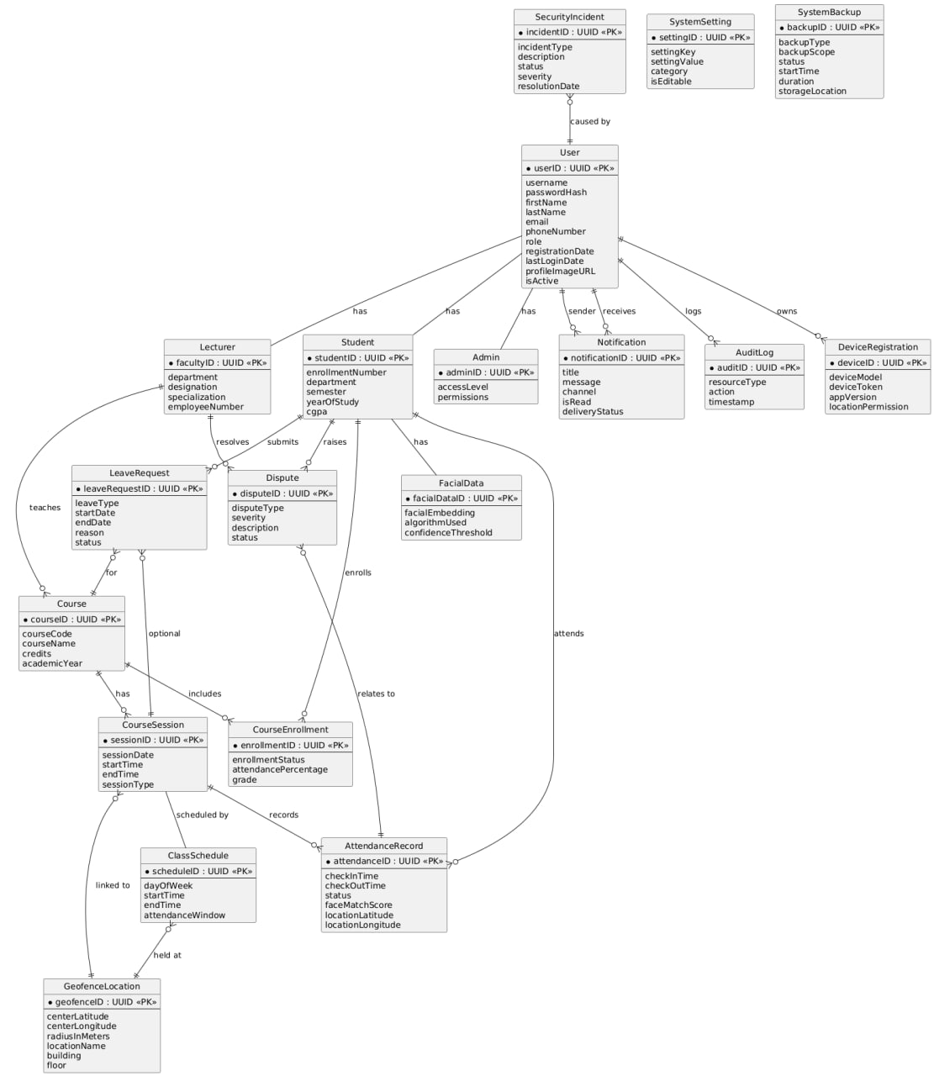
Entity-Relationship Diagram for the SmartCheck System

Major Entities in the ER Diagram
The SmartCheck system revolves around several core entities, each representing a distinct real-world object or concept:
- User: The central entity representing any individual interacting with the system.
  - Student, Lecturer, Admin (Specializations of User): Inherit from User and add role-specific attributes.
- Course: Represents academic courses.
- CourseEnrollment: Manages the many-to-many relationship between Students and Courses.
- CourseSession: Represents a specific instance of a class or lecture.
- ClassSchedule: Defines recurring patterns for course sessions.
- GeofenceLocation: Stores geographical zone definitions.
- FacialData: Contains biometric facial embeddings for students.
- AttendanceRecord: Logs student attendance for sessions.
- LeaveRequest: Manages student requests for absence.
- Dispute: Handles student-raised concerns or discrepancies.
- Notification: Manages system-generated alerts.
- SystemSetting: Stores configurable application parameters.
- AuditLog: Records user and system actions.
- DeviceRegistration: Manages mobile devices registered by users.
- SecurityIncident: Logs detected security-related events.
- SystemBackup: Tracks system backup information

Relationships Between Major Entities
- One-to-Many (Lecturer → Courses):
A lecturer can create and manage multiple courses. Each course document stores the lecturer’s user ID to establish ownership.
- One-to-Many (Course → Sessions):
Each course can have many attendance sessions. Sessions are stored in a separate collection with a reference to the courseId.
- One-to-Many (Session → Attendance Logs):
For each session, multiple students will check in. Each attendance record logs the sessionId and the student’s userId.
- Many-to-One (Attendance → User & Session):
Every attendance log references both the student and the session in which it occurred.
- One-to-Many (Student → Disputes):
Students can raise multiple disputes tied to different sessions. Each dispute links to a session and the student.
- One-to-Many (User → Devices):
Each user may have one or more registered devices with FCM tokens for push notifications.
This structure promotes flexibility and denormalization, ensuring that documents can be fetched quickly without requiring complex server-side joins.

Relational Database Schema
The ER Diagram is translated into a set of relational tables. The following SQL Data Definition Language (DDL) statements define the complete schema for the SmartCheck database, including tables, columns, data types, primary keys, foreign keys, unique constraints, not null constraints, default values, and check constraints as derived from the "Data Elements" document.

User Management Tables
CREATE TABLE Users (
userID UUID PRIMARY KEY,
username VARCHAR(50) UNIQUE NOT NULL CHECK (LENGTH(username) >= 3),
passwordHash VARCHAR(255) NOT NULL,
firstName VARCHAR(100) NOT NULL,
lastName VARCHAR(100) NOT NULL,
email VARCHAR(255) UNIQUE NOT NULL, -- Consider adding CHECK for email format
role ENUM('Student', 'Lecturer', 'Admin') NOT NULL,
phoneNumber VARCHAR(20),
registrationDate TIMESTAMP NOT NULL DEFAULT CURRENT_TIMESTAMP,
lastLoginDate TIMESTAMP,
isActive BOOLEAN NOT NULL DEFAULT TRUE,
profileImageURL VARCHAR(500),
twoFactorEnabled BOOLEAN NOT NULL DEFAULT FALSE,
accountLockoutCount INTEGER NOT NULL DEFAULT 0,
passwordResetToken VARCHAR(255),
tokenExpiryDate TIMESTAMP
);
CREATE TABLE Students (
studentID VARCHAR(20) PRIMARY KEY,
enrollmentNumber VARCHAR(30) UNIQUE NOT NULL,
department VARCHAR(100) NOT NULL,
semester INTEGER NOT NULL CHECK (semester BETWEEN 1 AND 8),
yearOfStudy INTEGER NOT NULL CHECK (yearOfStudy BETWEEN 1 AND 4),
program VARCHAR(100) NOT NULL,
admissionYear INTEGER NOT NULL,
cgpa DECIMAL(3,2) CHECK (cgpa IS NULL OR cgpa BETWEEN 0.00 AND 4.00),
guardianName VARCHAR(200),
guardianPhone VARCHAR(20),
emergencyContact VARCHAR(20),
FOREIGN KEY (studentID) REFERENCES Users(userID) ON DELETE CASCADE
);
CREATE TABLE Lecturers (
facultyID VARCHAR(20) PRIMARY KEY,
department VARCHAR(100) NOT NULL,
employeeNumber VARCHAR(30) UNIQUE NOT NULL,
designation VARCHAR(100) NOT NULL,
specialization VARCHAR(200),
officeLocation VARCHAR(100),
officeHours VARCHAR(200),
qualifications TEXT,
joinDate DATE NOT NULL,
canCreateCourses BOOLEAN NOT NULL DEFAULT TRUE,
FOREIGN KEY (facultyID) REFERENCES Users(userID) ON DELETE CASCADE
);
CREATE TABLE Admins (
adminID VARCHAR(20) PRIMARY KEY,
accessLevel INTEGER NOT NULL CHECK (accessLevel BETWEEN 1 AND 5),
permissions JSON NOT NULL,
department VARCHAR(100),
canManageUsers BOOLEAN NOT NULL DEFAULT FALSE,
canViewReports BOOLEAN NOT NULL DEFAULT TRUE,
canModifySettings BOOLEAN NOT NULL DEFAULT FALSE,
lastActivityDate TIMESTAMP DEFAULT CURRENT_TIMESTAMP,
FOREIGN KEY (adminID) REFERENCES Users(userID) ON DELETE CASCADE
);

Course and Session Management Tables
CREATE TABLE Courses (
courseID UUID PRIMARY KEY,
courseCode VARCHAR(20) UNIQUE NOT NULL,
courseName VARCHAR(200) NOT NULL,
courseDescription TEXT,
credits INTEGER NOT NULL CHECK (credits BETWEEN 1 AND 6),
semester INTEGER NOT NULL CHECK (semester BETWEEN 1 AND 8),
academicYear VARCHAR(9) NOT NULL, -- Consider CHECK for YYYY/YYYY format
lecturerID VARCHAR(20) NOT NULL,
maxStudents INTEGER NOT NULL CHECK (maxStudents BETWEEN 1 AND 500),
currentEnrollment INTEGER NOT NULL DEFAULT 0,
enrollmentStatus ENUM('OPEN', 'CLOSED', 'FULL') NOT NULL,
courseType ENUM('LECTURE', 'LAB', 'HYBRID', 'ONLINE', 'TUTORIAL', 'SEMINAR', 'EXAM') NOT NULL,
prerequisites JSON,
schedule JSON NOT NULL,
location VARCHAR(100),
createdDate TIMESTAMP NOT NULL DEFAULT CURRENT_TIMESTAMP,
isActive BOOLEAN NOT NULL DEFAULT TRUE,
FOREIGN KEY (lecturerID) REFERENCES Lecturers(facultyID) ON DELETE RESTRICT
);
CREATE TABLE CourseEnrollments (
enrollmentID UUID PRIMARY KEY,
studentID VARCHAR(20) NOT NULL,
courseID UUID NOT NULL,
enrollmentDate TIMESTAMP NOT NULL DEFAULT CURRENT_TIMESTAMP,
enrollmentStatus ENUM('ACTIVE', 'INACTIVE', 'WITHDRAWN', 'COMPLETED') NOT NULL,
grade VARCHAR(5),
attendancePercentage DECIMAL(5,2) DEFAULT 0.00,
UNIQUE (studentID, courseID),
FOREIGN KEY (studentID) REFERENCES Students(studentID) ON DELETE CASCADE,
FOREIGN KEY (courseID) REFERENCES Courses(courseID) ON DELETE CASCADE
);
CREATE TABLE GeofenceLocations (
geofenceID UUID PRIMARY KEY,
centerLatitude DECIMAL(10,8) NOT NULL CHECK (centerLatitude BETWEEN -90 AND 90),
centerLongitude DECIMAL(11,8) NOT NULL CHECK (centerLongitude BETWEEN -180 AND 180),
radiusInMeters INTEGER NOT NULL CHECK (radiusInMeters BETWEEN 10 AND 1000),
altitudeMin DECIMAL(8,2),
altitudeMax DECIMAL(8,2),
locationName VARCHAR(200) NOT NULL,
building VARCHAR(100) NOT NULL,
floor INTEGER CHECK (floor IS NULL OR floor BETWEEN -5 AND 50),
roomNumber VARCHAR(20),
capacity INTEGER,
facilities JSON,
accessRequirements JSON,
isActive BOOLEAN NOT NULL DEFAULT TRUE,
createdDate TIMESTAMP NOT NULL DEFAULT CURRENT_TIMESTAMP,
lastCalibrated TIMESTAMP,
accuracyLevel ENUM('HIGH', 'MEDIUM', 'LOW') NOT NULL DEFAULT 'MEDIUM'
);
CREATE TABLE ClassSchedules (
scheduleID UUID PRIMARY KEY,
courseID UUID NOT NULL,
dayOfWeek INTEGER NOT NULL CHECK (dayOfWeek BETWEEN 1 AND 7),
startTime TIME NOT NULL,
endTime TIME NOT NULL,
geofenceID UUID NOT NULL,
isRecurring BOOLEAN NOT NULL DEFAULT TRUE,
effectiveStartDate DATE NOT NULL,
effectiveEndDate DATE,
sessionType ENUM('LECTURE', 'LAB', 'TUTORIAL', 'EXAM', 'SEMINAR', 'ONLINE') NOT NULL,
attendanceWindow INTEGER NOT NULL CHECK (attendanceWindow BETWEEN 5 AND 60),
lateThreshold INTEGER NOT NULL CHECK (lateThreshold BETWEEN 1 AND 30),
autoCloseAfter INTEGER NOT NULL CHECK (autoCloseAfter BETWEEN 60 AND 300),
reminderBefore INTEGER NOT NULL CHECK (reminderBefore BETWEEN 5 AND 60),
isActive BOOLEAN NOT NULL DEFAULT TRUE,
createdBy VARCHAR(20) NOT NULL,
createdDate TIMESTAMP NOT NULL DEFAULT CURRENT_TIMESTAMP,
lastModified TIMESTAMP DEFAULT CURRENT_TIMESTAMP,
FOREIGN KEY (courseID) REFERENCES Courses(courseID) ON DELETE CASCADE,
FOREIGN KEY (geofenceID) REFERENCES GeofenceLocations(geofenceID) ON DELETE RESTRICT,
FOREIGN KEY (createdBy) REFERENCES Lecturers(facultyID) ON DELETE SET NULL
);

CREATE TABLE CourseSessions (
sessionID UUID PRIMARY KEY,
courseID UUID NOT NULL,
sessionDate DATE NOT NULL,
startTime TIME NOT NULL,
endTime TIME NOT NULL,
actualStartTime TIMESTAMP,
actualEndTime TIMESTAMP,
sessionType ENUM('LECTURE', 'LAB', 'TUTORIAL', 'SEMINAR', 'EXAM', 'ONLINE') NOT NULL,
locationDescription VARCHAR(200) NOT NULL,
sessionStatus ENUM('SCHEDULED', 'OPEN', 'CLOSED', 'CANCELLED', 'COMPLETED') NOT NULL,
attendanceCount INTEGER DEFAULT 0,
expectedAttendance INTEGER NOT NULL,
sessionNotes TEXT,
recordingURL VARCHAR(500),
materials JSON,
createdBy VARCHAR(20) NOT NULL,
createdDate TIMESTAMP NOT NULL DEFAULT CURRENT_TIMESTAMP,
modifiedDate TIMESTAMP DEFAULT CURRENT_TIMESTAMP,
isRecurring BOOLEAN DEFAULT FALSE,
recurringPattern JSON,
FOREIGN KEY (courseID) REFERENCES Courses(courseID) ON DELETE CASCADE,
FOREIGN KEY (createdBy) REFERENCES Lecturers(facultyID) ON DELETE SET NULL
);

Attendance and Verification Tables
CREATE TABLE FacialData (
facialDataID UUID PRIMARY KEY,
studentID VARCHAR(20) UNIQUE NOT NULL,
facialEmbedding BLOB NOT NULL,
encodingVersion VARCHAR(10) NOT NULL,
algorithmUsed VARCHAR(50) NOT NULL,
registrationDate TIMESTAMP NOT NULL DEFAULT CURRENT_TIMESTAMP,
lastUpdated TIMESTAMP DEFAULT CURRENT_TIMESTAMP,
updateReason VARCHAR(100),
isActive BOOLEAN NOT NULL DEFAULT TRUE,
confidenceThreshold DECIMAL(4,3) NOT NULL CHECK (confidenceThreshold BETWEEN 0.500 AND 0.999),
trainingImages INTEGER NOT NULL CHECK (trainingImages BETWEEN 1 AND 10),
imageQualityScore DECIMAL(4,3) CHECK (imageQualityScore IS NULL OR imageQualityScore BETWEEN 0.000 AND 1.000),
lastSuccessfulMatch TIMESTAMP,
failedMatchCount INTEGER DEFAULT 0,
needsRetraining BOOLEAN DEFAULT FALSE,
FOREIGN KEY (studentID) REFERENCES Students(studentID) ON DELETE CASCADE
);
CREATE TABLE AttendanceRecords (
attendanceID UUID PRIMARY KEY,
studentID VARCHAR(20) NOT NULL,
sessionID UUID NOT NULL,
courseID UUID NOT NULL,
checkInTime TIMESTAMP NOT NULL DEFAULT CURRENT_TIMESTAMP,
checkOutTime TIMESTAMP,
attendanceStatus ENUM('PRESENT', 'ABSENT', 'LATE', 'EXCUSED', 'PARTIAL') NOT NULL,
arrivalStatus ENUM('ON_TIME', 'LATE', 'VERY_LATE'),
lateMinutes INTEGER CHECK (lateMinutes IS NULL OR lateMinutes BETWEEN 0 AND 120),
verificationMethod ENUM('SELF_CHECKIN', 'LECTURER_ASSISTED', 'MANUAL_ENTRY') NOT NULL,
locationLatitude DECIMAL(10,8) NOT NULL,
locationLongitude DECIMAL(11,8) NOT NULL,
locationAccuracy DECIMAL(8,2) NOT NULL,
distanceFromGeofence DECIMAL(8,2) NOT NULL,
faceMatchScore DECIMAL(4,3) CHECK (faceMatchScore IS NULL OR faceMatchScore BETWEEN 0.000 AND 1.000),
faceMatchAttempts INTEGER DEFAULT 1,
deviceInfo JSON NOT NULL,
ipAddress VARCHAR(45) NOT NULL,
userAgent VARCHAR(500),
batteryLevel INTEGER CHECK (batteryLevel IS NULL OR batteryLevel BETWEEN 0 AND 100),
networkType VARCHAR(20),
isVerified BOOLEAN NOT NULL DEFAULT FALSE,
verifiedBy VARCHAR(20),
verificationDate TIMESTAMP,
notes TEXT,
photoURL VARCHAR(500),
isDisputed BOOLEAN DEFAULT FALSE,
lastModified TIMESTAMP DEFAULT CURRENT_TIMESTAMP,
FOREIGN KEY (studentID) REFERENCES Students(studentID) ON DELETE CASCADE,
FOREIGN KEY (sessionID) REFERENCES CourseSessions(sessionID) ON DELETE CASCADE,
FOREIGN KEY (courseID) REFERENCES Courses(courseID) ON DELETE CASCADE,
FOREIGN KEY (verifiedBy) REFERENCES Users(userID) ON DELETE SET NULL
);

Leave and Dispute Management Tables
CREATE TABLE LeaveRequests (
leaveRequestID UUID PRIMARY KEY,
studentID VARCHAR(20) NOT NULL,
courseID UUID,
sessionID UUID,
leaveType ENUM('MEDICAL', 'PERSONAL', 'EMERGENCY', 'FAMILY', 'ACADEMIC', 'OTHER') NOT NULL,
severity ENUM('LOW', 'NORMAL', 'HIGH', 'CRITICAL') NOT NULL DEFAULT 'NORMAL',
startDate DATE NOT NULL,
endDate DATE NOT NULL,
totalDays INTEGER,
halfDay BOOLEAN DEFAULT FALSE,
timeSlot ENUM('MORNING', 'AFTERNOON'),
reason TEXT NOT NULL CHECK(LENGTH(reason) <= 1000),
supportingDocument JSON,
doctorNote BOOLEAN DEFAULT FALSE,
emergencyContact VARCHAR(20),
alternateContact VARCHAR(20),
requestDate TIMESTAMP NOT NULL DEFAULT CURRENT_TIMESTAMP,
status ENUM('PENDING', 'APPROVED', 'DENIED', 'CANCELLED') NOT NULL DEFAULT 'PENDING',
urgency ENUM('LOW', 'NORMAL', 'HIGH', 'URGENT') NOT NULL DEFAULT 'NORMAL',
autoApproval BOOLEAN DEFAULT FALSE,
reviewedBy VARCHAR(20),
reviewDate TIMESTAMP,
reviewComments TEXT,
approvalDate TIMESTAMP,
notificationSent BOOLEAN DEFAULT FALSE,
followUpRequired BOOLEAN DEFAULT FALSE,
followUpDate DATE,
FOREIGN KEY (studentID) REFERENCES Students(studentID) ON DELETE CASCADE,
FOREIGN KEY (courseID) REFERENCES Courses(courseID) ON DELETE SET NULL,
FOREIGN KEY (sessionID) REFERENCES CourseSessions(sessionID) ON DELETE SET NULL,
FOREIGN KEY (reviewedBy) REFERENCES Users(userID) ON DELETE SET NULL,
CHECK (endDate >= startDate)
);

CREATE TABLE Disputes (
disputeID UUID PRIMARY KEY,
studentID VARCHAR(20) NOT NULL,
sessionID UUID,
courseID UUID NOT NULL,
attendanceRecordID UUID,
disputeType ENUM('ATTENDANCE_ERROR', 'TECHNICAL_ISSUE', 'GEOFENCE_ERROR', 'FACE_RECOGNITION_FAIL', 'SYSTEM_MALFUNCTION', 'OTHER', 'LEAVE_RELATED') NOT NULL,
disputeCategory ENUM('TECHNICAL', 'PROCEDURAL', 'ADMINISTRATIVE', 'APPEAL') NOT NULL,
severity ENUM('LOW', 'MEDIUM', 'HIGH', 'CRITICAL') NOT NULL DEFAULT 'MEDIUM',
disputeReason VARCHAR(500) NOT NULL,
description TEXT NOT NULL CHECK (LENGTH(description) <= 2000),
expectedResolution TEXT,
evidenceFile JSON,
witnessInfo TEXT,
timeOfIncident TIMESTAMP,
deviceUsed JSON,
locationDuringIncident JSON,
submissionDate TIMESTAMP NOT NULL DEFAULT CURRENT_TIMESTAMP,
status ENUM('PENDING', 'UNDER_REVIEW', 'RESOLVED', 'REJECTED', 'ESCALATED') NOT NULL DEFAULT 'PENDING',
priority ENUM('LOW', 'MEDIUM', 'HIGH', 'URGENT') NOT NULL DEFAULT 'MEDIUM',
escalationLevel INTEGER DEFAULT 0 CHECK (escalationLevel BETWEEN 0 AND 3),
assignedTo VARCHAR(20),
assignmentDate TIMESTAMP,
estimatedResolutionDate DATE,
actualResolutionDate TIMESTAMP,
resolutionTime INTEGER,
resolutionComments TEXT,
finalAction ENUM('ATTENDANCE_CORRECTED', 'REQUEST_DENIED', 'TECHNICAL_FIX', 'POLICY_EXCEPTION', 'NO_ACTION'),
studentSatisfaction INTEGER CHECK (studentSatisfaction IS NULL OR studentSatisfaction BETWEEN 1 AND 5),
followUpRequired BOOLEAN DEFAULT FALSE,
relatedDisputes JSON,
FOREIGN KEY (studentID) REFERENCES Students(studentID) ON DELETE CASCADE,
FOREIGN KEY (sessionID) REFERENCES CourseSessions(sessionID) ON DELETE SET NULL,
FOREIGN KEY (courseID) REFERENCES Courses(courseID) ON DELETE CASCADE,
FOREIGN KEY (attendanceRecordID) REFERENCES AttendanceRecords(attendanceID) ON DELETE SET NULL,
FOREIGN KEY (assignedTo) REFERENCES Users(userID) ON DELETE SET NULL
);

System Support and Administration Tables
CREATE TABLE Notifications (
notificationID UUID PRIMARY KEY,
recipientID VARCHAR(20) NOT NULL,
senderID VARCHAR(20),
notificationType ENUM('SESSION_ALERT', 'DISPUTE_UPDATE', 'LEAVE_STATUS', 'SYSTEM_ALERT', 'REMINDER', 'ANNOUNCEMENT', 'GENERAL') NOT NULL,
category ENUM('ATTENDANCE', 'ACADEMIC', 'SYSTEM', 'PERSONAL', 'EMERGENCY') NOT NULL,
channel ENUM('PUSH', 'EMAIL', 'SMS', 'IN_APP') NOT NULL,
title VARCHAR(200) NOT NULL,
message TEXT NOT NULL CHECK (LENGTH(message) <= 1000),
richContent JSON,
priority ENUM('LOW', 'MEDIUM', 'HIGH', 'URGENT') NOT NULL DEFAULT 'MEDIUM',
isRead BOOLEAN NOT NULL DEFAULT FALSE,
readDate TIMESTAMP,
scheduledTime TIMESTAMP,
sentTime TIMESTAMP,
deliveryStatus ENUM('PENDING', 'SENT', 'DELIVERED', 'FAILED') NOT NULL DEFAULT 'PENDING',
deliveryAttempt INTEGER DEFAULT 0,
expiryTime TIMESTAMP,
actionURL VARCHAR(500),
metadata JSON,
groupID VARCHAR(50),
batchID VARCHAR(50),
deviceToken VARCHAR(255),
createdDate TIMESTAMP NOT NULL DEFAULT CURRENT_TIMESTAMP,
lastModified TIMESTAMP DEFAULT CURRENT_TIMESTAMP,
FOREIGN KEY (recipientID) REFERENCES Users(userID) ON DELETE CASCADE,
FOREIGN KEY (senderID) REFERENCES Users(userID) ON DELETE SET NULL
);

Data Types and Constraints
The schema utilizes appropriate SQL data types (UUID, VARCHAR, TEXT, INTEGER, DECIMAL, BOOLEAN, TIMESTAMP, DATE, TIME, ENUM, JSON, BLOB) as per the "Data Elements" document. Key constraints include:
- PRIMARY KEY: Uniquely identifies each row in a table.
- FOREIGN KEY: Enforces referential integrity between tables. ON DELETE clauses define behavior on deletion of referenced records.
- UNIQUE: Ensures values in a column or set of columns are unique.
- NOT NULL: Ensures a column cannot have a NULL value.
- DEFAULT: Specifies a default value if none is provided during insertion.
- CHECK: Enforces specific conditions on data values (e.g., ranges, formats).

Normalization
The schema aims for Third Normal Form (3NF) to reduce data redundancy and improve data integrity. This is achieved by ensuring atomic values, full dependency on primary keys, and minimizing transitive dependencies. Associative tables like CourseEnrollments resolve many-to-many relationships.

Impact of NoSQL on Design Logic
Because Firestore is a NoSQL system:
- Redundancy is acceptable for performance (e.g., course name may be duplicated in session records).
- Denormalization allows fast access with fewer reads, which is important for mobile apps.
- Collections are flat, not nested—subcollections are only used when necessary.
- Relationships are maintained through ID references, not enforced with foreign key constraints like in SQL.
In addition to indexes automatically created for PRIMARY KEY and UNIQUE constraints, the following performance-enhancing secondary indexes are defined:
CREATE INDEX idx_attendance_student_date ON AttendanceRecords(studentID, checkInTime);
CREATE INDEX idx_attendance_session ON AttendanceRecords(sessionID);
CREATE INDEX idx_attendance_course_date ON AttendanceRecords(courseID, checkInTime);
CREATE INDEX idx_sessions_course_date ON CourseSessions(courseID, sessionDate);
CREATE INDEX idx_enrollments_student ON CourseEnrollments(studentID);
CREATE INDEX idx_enrollments_course ON CourseEnrollments(courseID);
CREATE INDEX idx_notifications_recipient_read ON Notifications(recipientID, isRead);
CREATE INDEX idx_disputes_status_submission ON Disputes(status, submissionDate);
CREATE INDEX idx_disputes_student ON Disputes(studentID);
CREATE INDEX idx_disputes_assigned_to ON Disputes(assignedTo);
CREATE INDEX idx_audit_logs_user_date ON AuditLogs(userID, timestamp);
CREATE INDEX idx_audit_logs_resource ON AuditLogs(resourceType, resourceID);
CREATE INDEX idx_facial_data_student_active ON FacialData(studentID, isActive);
CREATE INDEX idx_leave_requests_student_status ON LeaveRequests(studentID, status);
CREATE INDEX idx_leave_requests_reviewed_by ON LeaveRequests(reviewedBy);
CREATE INDEX idx_device_registrations_user ON DeviceRegistrations(userID);
This design philosophy makes the system scalable, fast, and real-time capable, with the trade-off being a need for thoughtful indexing and validation.

Database Implementation
This section explains how the conceptual model is realized in Firebase Firestore. Each major entity from the conceptual design becomes a Firestore collection, and fields are designed to optimize read performance and security.

Core Collections and Document Structure
Below is an overview of how the key entities are implemented in Firestore:

Users collection
Stores each user’s metadata (name, email, role, department, etc.), plus profile image URL and facial data reference. Users are distinguished by a role field (e.g., student, lecturer, admin).
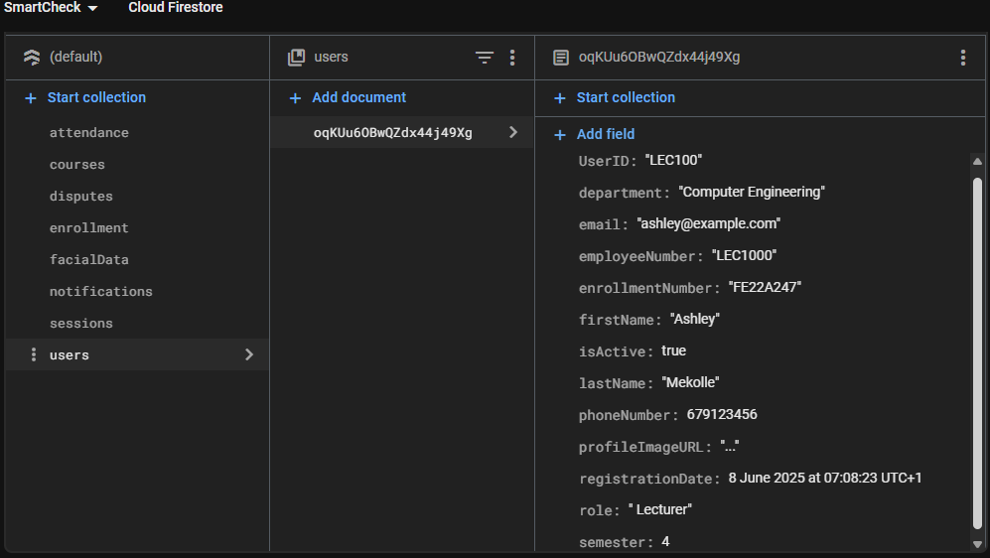

courses collection
Contains documents for each course. Fields include course code, title, lecturer ID, enrolled students (as an array of user IDs or references), and optional tags like semester or department.
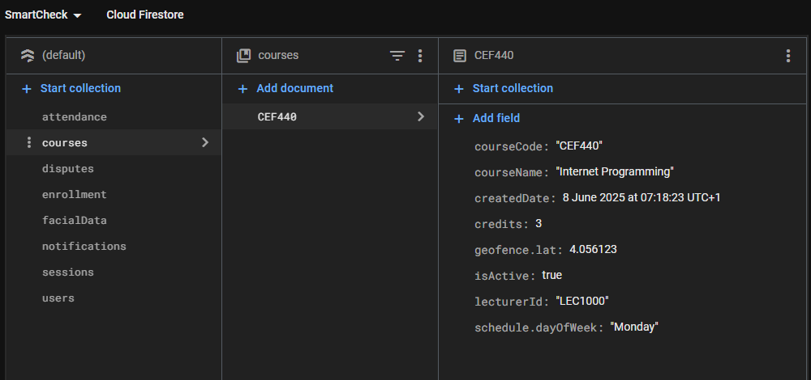

sessions collection
Each document represents a single attendance session. Fields include course ID, lecturer ID, geofence coordinates, radius, start/end time, and status (open, closed). Sessions may also store summary fields (like total check-ins) to improve performance.
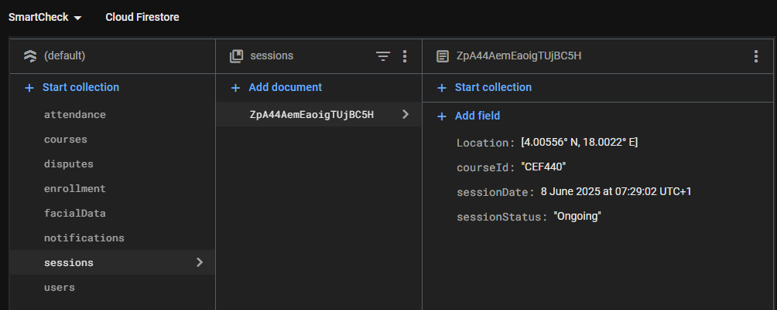

attendance collection
Logs individual check-ins. Each record includes the student’s ID, session ID, timestamp, GPS location, face match score, and result status (e.g., Present, Late, Rejected).
Attendance records are immutable after creation, except when manually edited by lecturers.
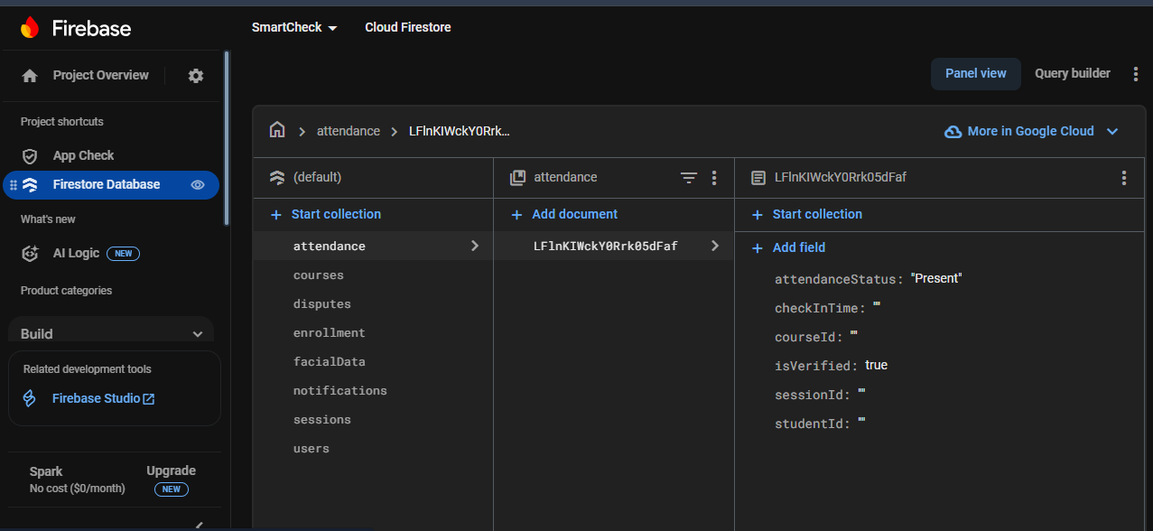

disputes collection
Stores student-raised issues or leave requests. Each document contains the session ID, student ID, reason, optional proof document (URL), status (pending, approved, denied), and timestamps.
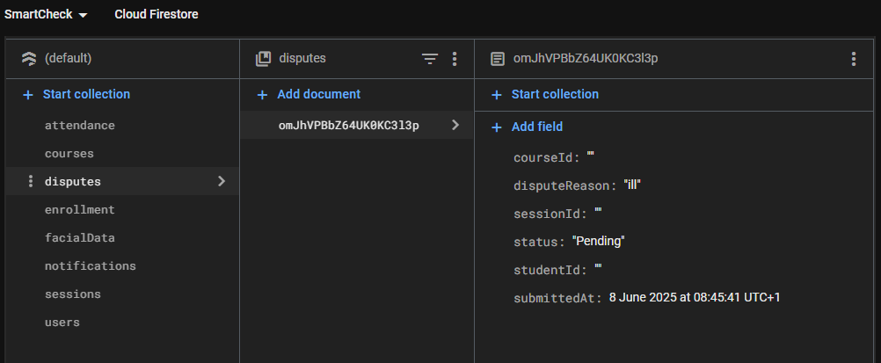

notifications collection
Stores FCM tokens and user/device associations for push notifications.
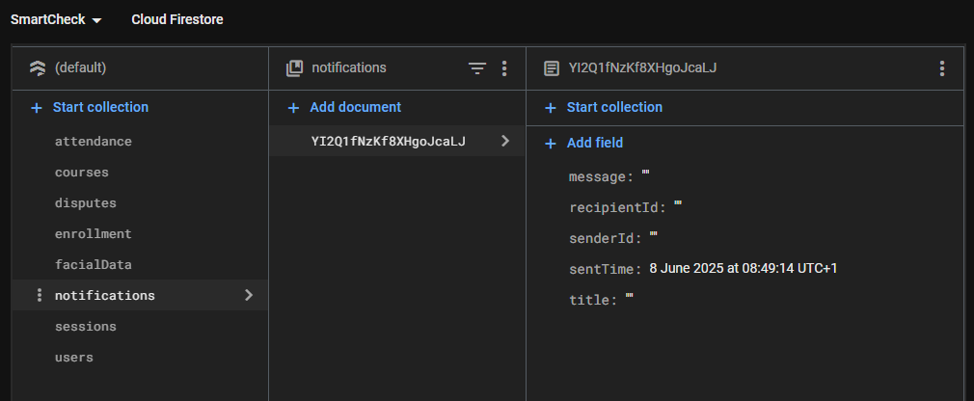
Each collection is implemented as a top-level collection, with document IDs generated automatically or using custom formats (e.g., course codes).

Storing Geolocation and Facial Recognition Data
- Geolocation:
Each session document includes fields like latitude, longitude, and radius to define the geofence. During check-in, the system compares the device’s coordinates with these to determine validity.
- Facial Recognition:
Facial reference data may be stored as:
  - A URL to a secure Firebase Storage image (if image-based recognition is used), or
  - A face embedding vector (numerical features extracted from face) stored as a string or array in the users collection.
Each attendance record stores the face match confidence score from the recognition process.
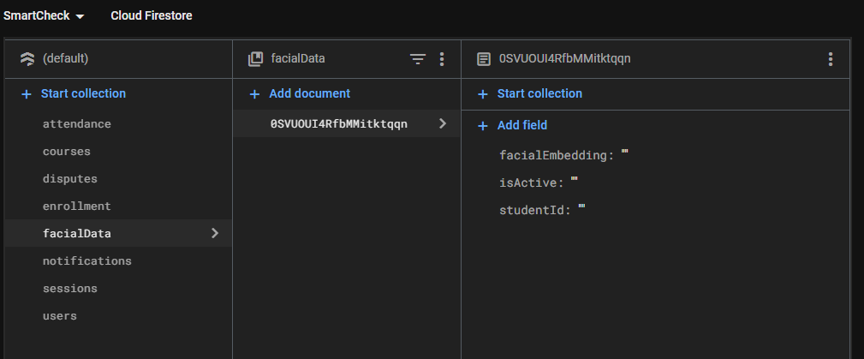

Document Validation and Schema Integrity
Firestore is schema-less by nature, but developers can enforce consistency by:
- Using server-side validation in the backend (e.g., via Express controllers).
- Implementing Firebase Security Rules to restrict what fields can be written by whom.
- Optionally using tools like Firestore schema validators or TypeScript interfaces in the backend logic.

Indexing Strategies
To support high-performance queries:
- Firestore automatically indexes most fields.
- Compound indexes are manually created to support filters (e.g., query sessions by course and status).
- Attendance history queries are indexed by userId and timestamp to support pagination in student dashboards.

Security Rules (Firestore Specific)
Security rules are written to:
- Allow users to read/write only their own data.
- Allow lecturers to modify only their course and session records.
- Restrict sensitive collections like attendance and disputes from being edited after finalization (unless by admin).
- Enforce role-based permissions using Firebase Authentication claims.

Backend Implementation
The SmartCheck backend is built with Node.js + Express and leverages the Firebase Admin SDK to perform all database operations securely. The Express application acts as a middle layer between the React Native frontend and Firestore, exposing RESTful endpoints that map directly to service-level functions.

Interaction Pattern
Each incoming request passes through authentication middleware, which verifies the Firebase ID-token and enriches req.user with role claims (student, lecturer, admin). Controller methods then delegate to service functions that encapsulate Firestore logic, ensuring a clean separation of concerns:

Service-Function Structure
- UserService – createUser, getUserById, updateUser, deleteUser
- CourseService – createCourse, enrollStudent, listCoursesByUser
- SessionService – startSession, closeSession, getSessionsByCourse
- AttendanceService – logAttendance, batchAssistedCheckIn, getHistoryByUser
- DisputeService – raiseDispute, resolveDispute, listDisputes
Each service function performs:
- Input validation (checking required fields, data types, latitude/longitude bounds).
- Role enforcement (e.g., only lecturers can startSession).
- Firestore transaction or batched write to guarantee atomicity for multi-document updates (e.g., logging attendance and incrementing session counters in the same commit).

Connecting Database to Backend

Firebase Setup
The backend initializes Firebase by importing a service-account key and calling admin.initializeApp. The key file path and other environment-specific variables (e.g., storage bucket) are referenced through environment variables loaded by dotenv, keeping secrets out of source control.
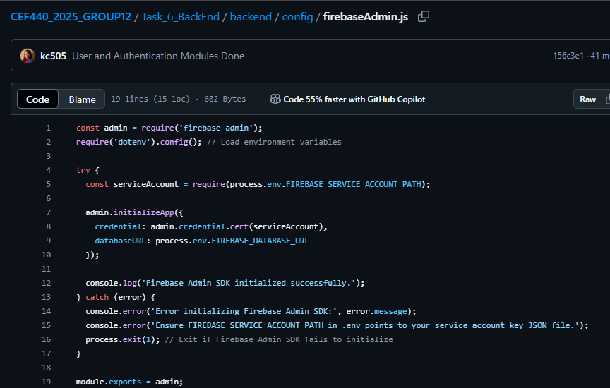

Conclusion
The database design and implementation for the SmartCheck system provides a strong, scalable, and secure foundation for managing attendance in a mobile-first environment. By leveraging Firebase Firestore, the system ensures real-time data synchronization, efficient storage of biometric and geolocation data, and seamless integration with authentication and cloud services.
Through a carefully structured conceptual model and clearly defined data entities—such as users, courses, sessions, and attendance logs—SmartCheck achieves both operational efficiency and data integrity. The backend, powered by Node.js and the Firebase Admin SDK, adds essential layers of logic, validation, and role-based access control, ensuring that all interactions with the database are secure, consistent, and traceable.
Together, these components enable SmartCheck to deliver a modern attendance solution that is intuitive for users, robust for administrators, and adaptable for future growth.

