https://holisticvetdirectory.com/vet/aqua-animal-care-center/
Sequence | iPhone Screenshot
Step 1 – Select “View Details” for “Aqua Animal Care Center” | 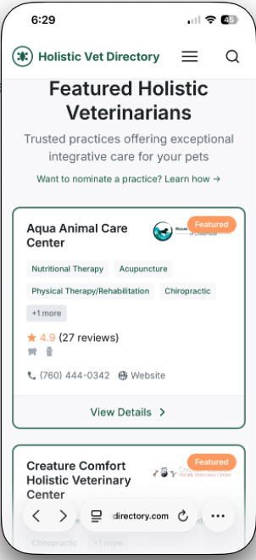
2 – Land at top of Details | 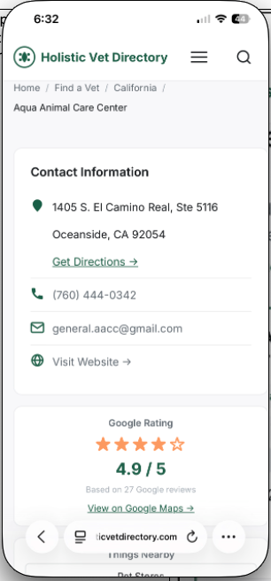
3 – Scroll down to Google maps. Just below the map is blank space area | 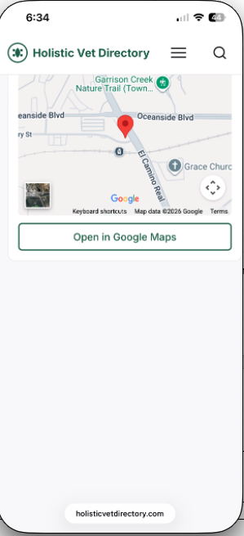
4 – Scroll down further and you will find the ad placeholder | 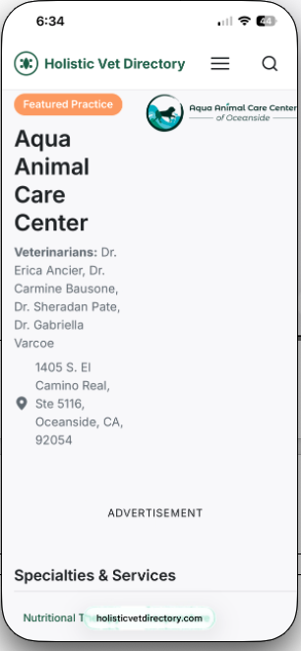
5 – Just below the advertisement is the Vet Description | 