Name: **Krishna Chaitanya**

Introduction to R data.table

# Introduction

For this assignment our aim is to describe the data set using R commands.

Below are the different types of functions that are applied on the baseball dataset, click here for each function.

Download the baseball data set from website.

Loading data from CSV and converting to data.table

Running Summary Functions on data set

Running Chaining Functions on Data set

Running subset functions on Dataset

# Downloading Data set

Downloading comma delimited version data set from below URL:

http://www.seanlahman.com/baseball-archive/statistics/

Once file is downloaded, unzip it to a directory and copy the salaries.csv file to the present working directory.

# Loading Data into R

Load the dataset into R & verify data

Command to Execute:

salaries<-read.csv("Salaries.csv") #Read the data as csv and store into salaries dataframe.

str(salaries) #This command will compactly display the internal structure of the data set

summary(salaries) #This command with output the summary of the data frame.

head(salaries) #This command will give you first 5 lines of the dataframe.

Below are the screen shots for the same.

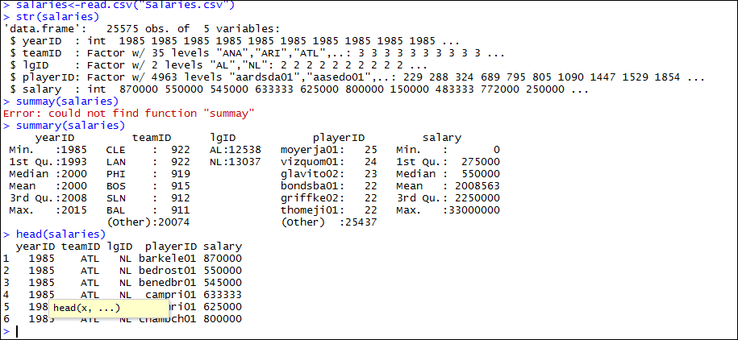

Converting data.frame to data.table.

install.packages('data.table') #Installing data.table package

library('data.table') #using data.table library

dtSal <- as.data.table(salaries) #converts dataframe to data.table

print(dtSal) # allows you to view the first & last few lines

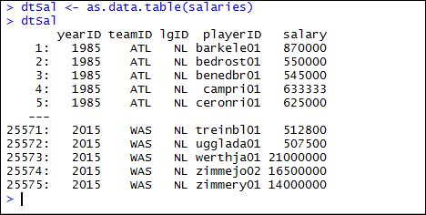

BACK TO MENU

# Summary Functions

Finding mean of all the salaries of all the player’s in each year

dtSal[,mean(salary),by="yearID"] #finding mean of salaries in each year

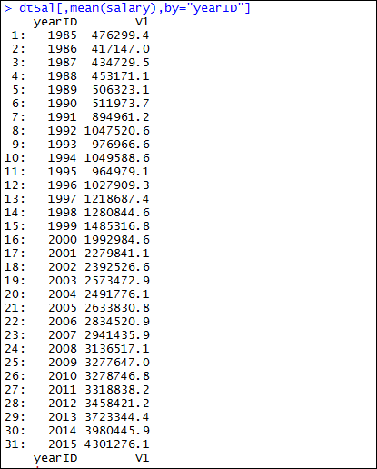

Group by yearID and lgID and compute means on salary

dtSal[,mean(salary),by="yearID,lgID"] #compute mean w.r.t yearID and lgID

Below is the screen shot

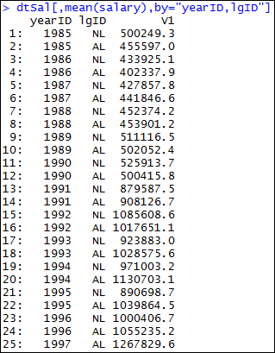

Compute No Of Players in each league ID.

dtSal[,(NoOfPlayers=.N),by="lgID"] #.N represents the count in data.table for each lgID

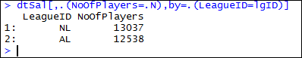

BACK TO MENU

# Chaining Functions

Average Salary of each Team in descending order.

dtSal[,list(noOfPlayer=.N,averageSal=mean(salary)),by=.(teamID=teamID)][order(-averageSal)] #This will output the average salaries for each teamID and order by averageSal in descending order

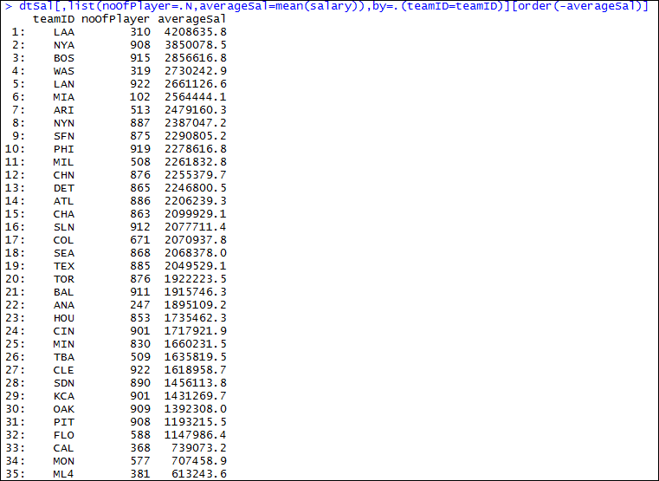

Average Salary of each Team in ascending order.

dtSal[,list(noOfPlayer=.N,averageSal=mean(salary)),by=.(teamID=teamID)][order(averageSal)] #This will output the average salaries for each teamID and order by averageSal in ascending order

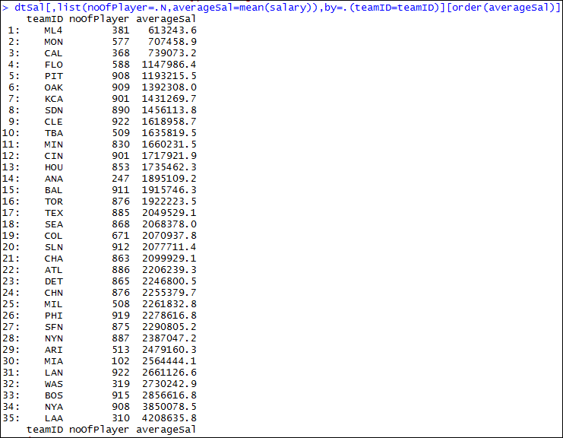

BACK TO MENU

# Subset Functions

Now let us prepare the dataset salaries for each teamID to compute subset functions.

avg.team.sal=dtSal[,list(salary), by="teamID"]

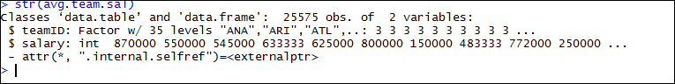

Now let us apply lapply function to get the max salary for the team.

avg.team.sal[,lapply(.SD,max),by="teamID"]

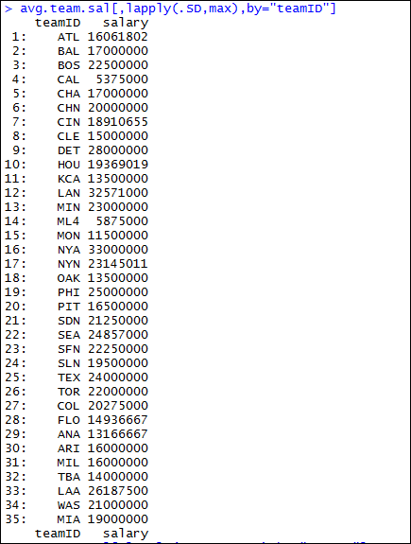

Now let us get the Average salary for each teamID using lapply.

avg.team.sal[,lapply(.SD,mean),by="teamID"]

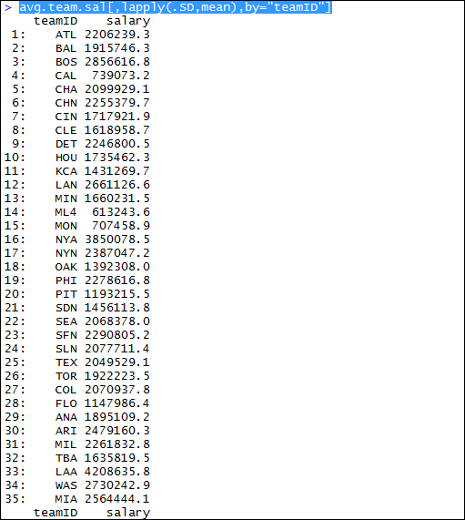

BACK TO MENU