ITP4506 Human Computer Interaction & GUI Programming

Assignment

Web design analysis and user analysis

|  |
| --- |
| Team Member |
| CHEUNG Pui Lam |
| LAM Ho Yin |

# User Analysis

|  |
| --- |
| Target Users |
| Tertiary students in Hong Kong |

## User Characteristics

1. Learning style

* Do-then-read

The user group are willing to take the risk, they prefer using a system without reading the user guild.

1. Tool preferences

* Mouse or keyboard

The user group has much experience in using mouse and keyboard.

1. Physical differences

* Good visual abilities

The user group are the young adult, the number of users has visual difficulties are expected to be must lower compare with the elderly.

1. Cultural differences

* High education background

Tertiary students in Hong Kong study in different university and institution learning professional knowledge.

* Can read Chinese and English

Tertiary students in Hong Kong included locals and non-locals, most of them can read English.

1. Knowledge of job

* Use computer and smartphone daily
* For different reasons, mainly for information and entertainment

1. Application familiarity

* A computer expert

## Techniques for observing and listening to users

* Role playing

The developer is one of the target users, they can play the role of a user in this situation.

## Environment Analysis

* On computer

The target users can easily access to PC or laptop.

## Recruiting Users

* Test with real current users (Employee, Customers)

## Task Analysis (HTA)

Main Task

* Register
* Login
* Search Product
* View Cart
* Make Payment
* Register

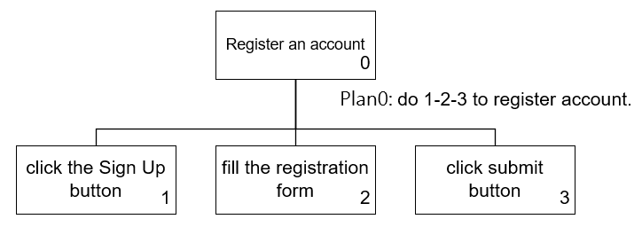

* Login

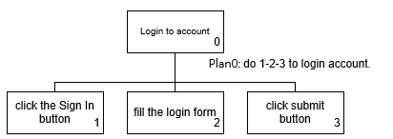

* Search Product

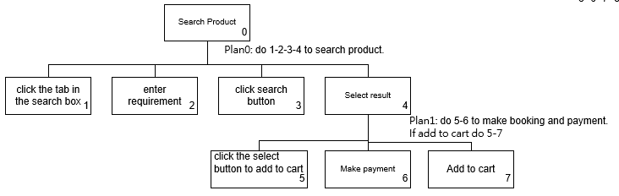

* Make Payment

