Kyle Carlson
SDEV-200
Final Project

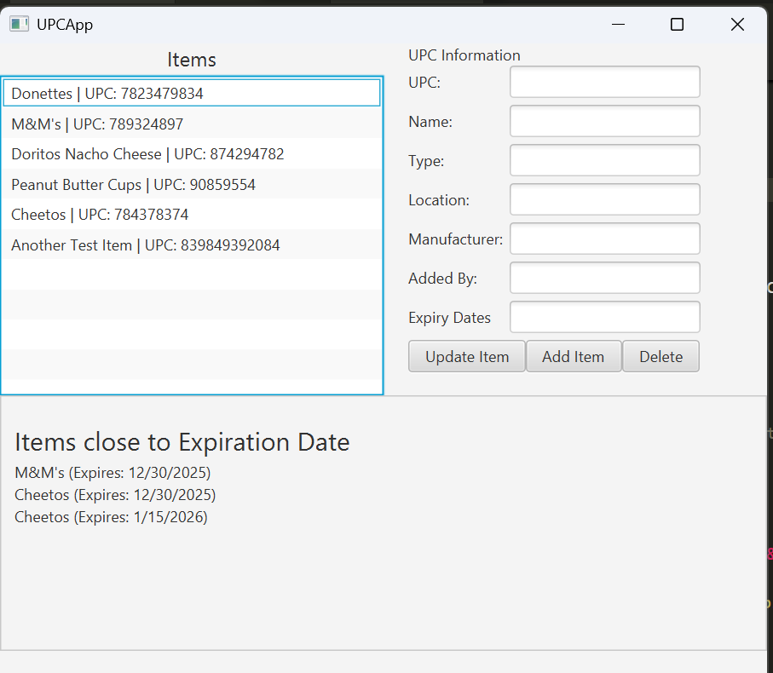
Here is the screen the user is greeted with when first opening the app. The top left shows a list of all items in the database. The bottom shows items that are close to expiring and require attention. The top right shows any currently selected item’s information. (No item is currently selected)
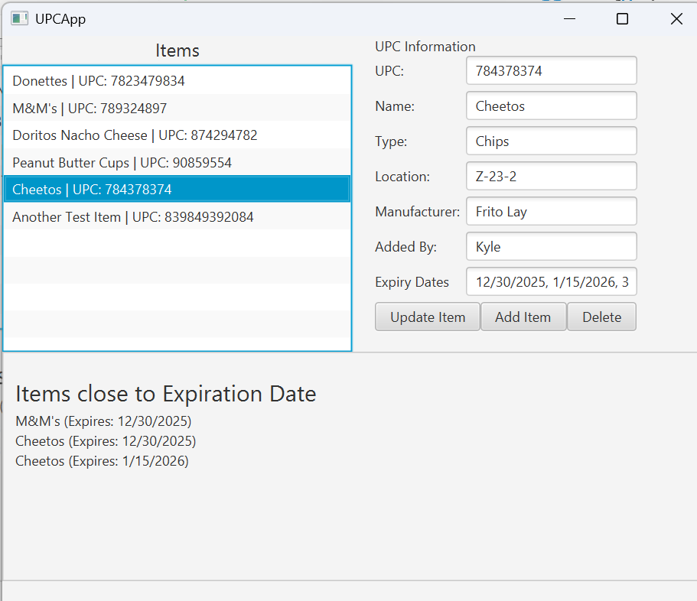
The item cheetos was selected, and the info fills the top right.
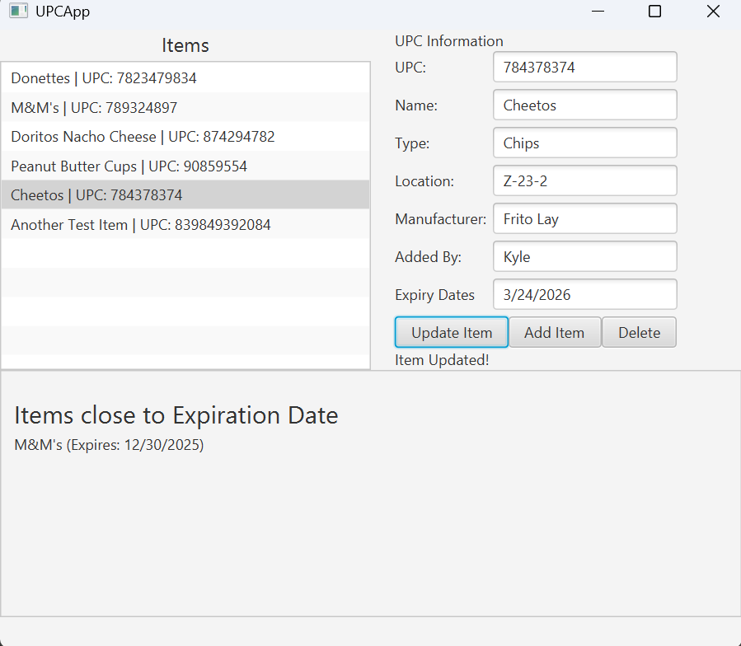
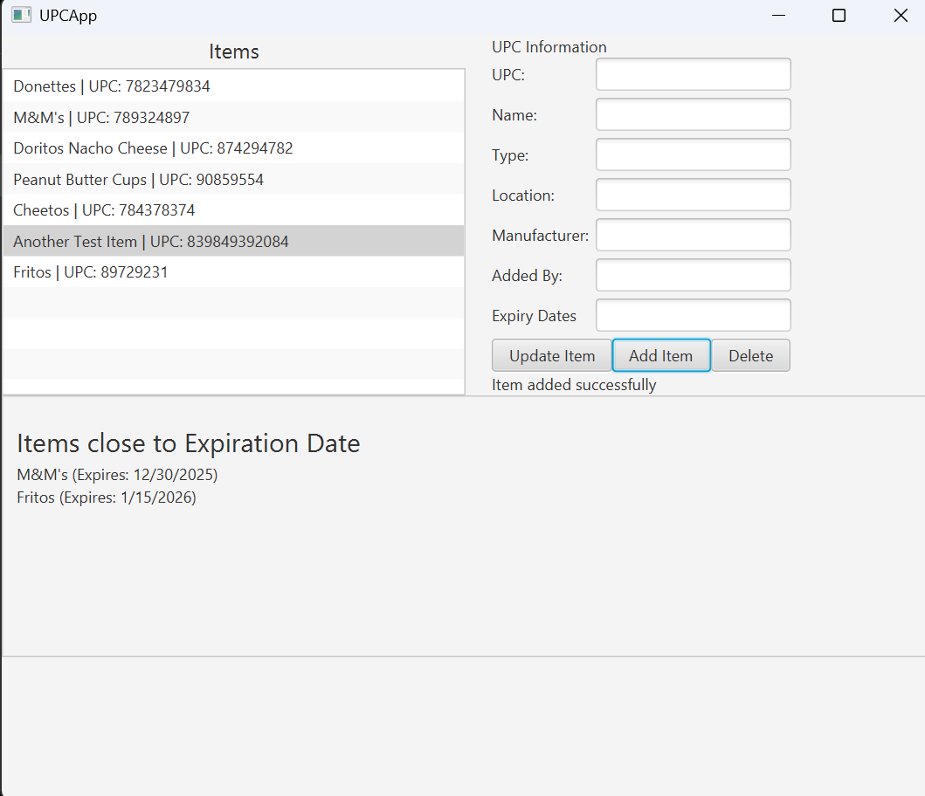
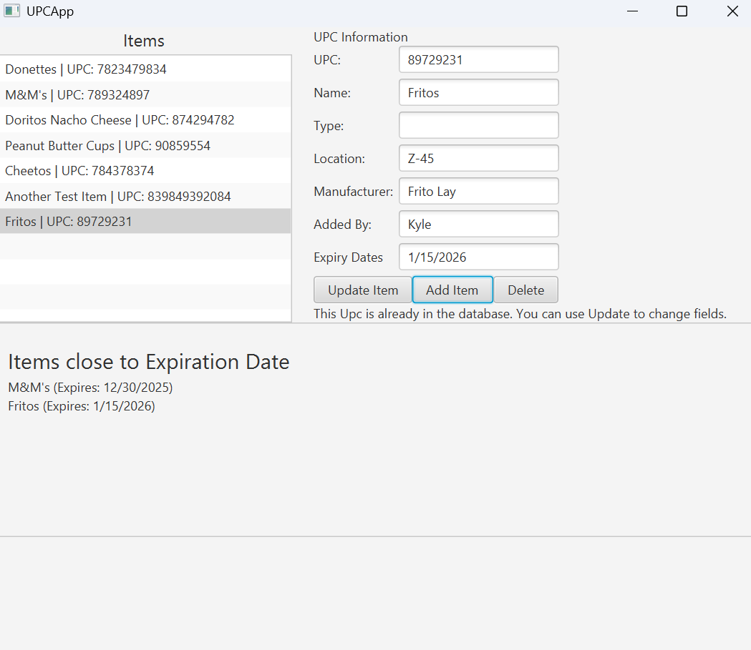
Two dates are removed, and the update item button is pressed. This refreshes the bottom to reflect these removed dates, and the item is updated in the database. The information for a new item, Fritos, is entered and added. The item is added to the list on the left and the bottom shows an expiry date that is approaching. Fritos is clicked on to show the info, and then add item button is pressed. Since the item is already in the system, and the upc (main key) must be unique, it is rejected.
The delete item button is pressed, which shows a popup warning the user that this action isn’t cant be undone.

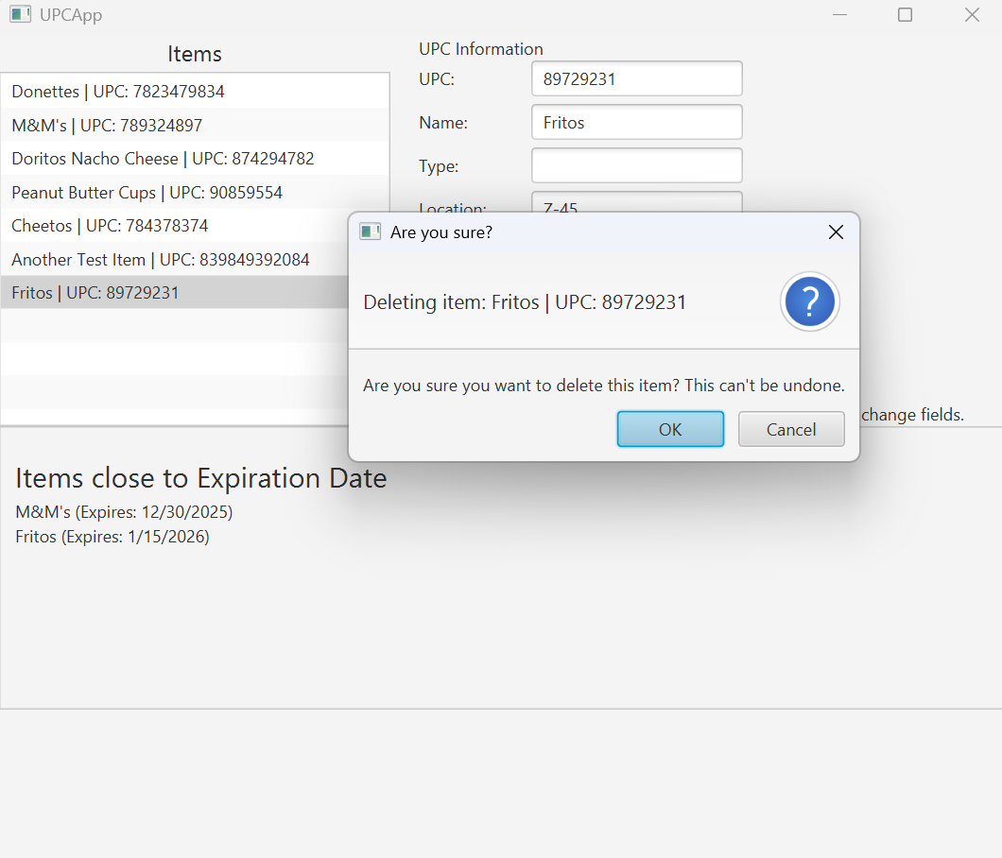
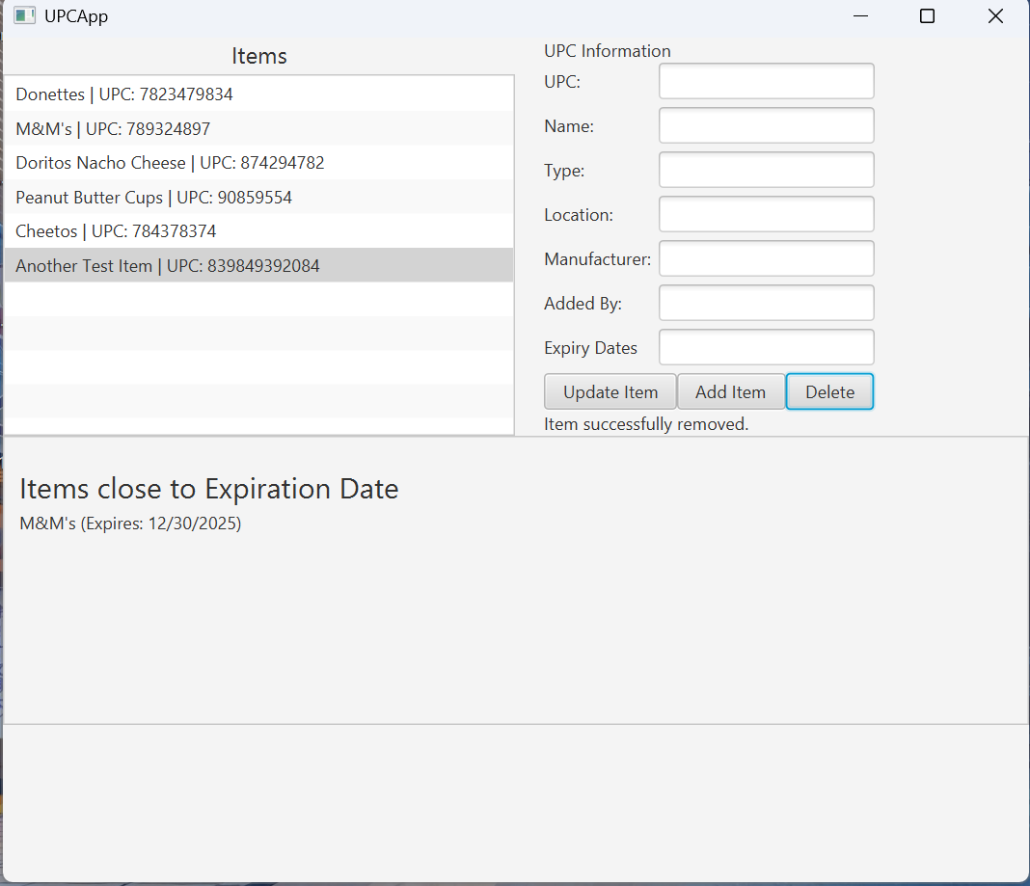
Finally, the item is deleted, which updates the left and bottom side of the program.

I used a library called Jackson to save and load information in and out of the database using a JSON file and format. I have used JSON in the past and felt this would be an easy way of debugging any issues.
Here is the UML for the project.
