Software Requirements Specification

for

Rev-Logger
Version 1.1a approved
Prepared by Kenneth R. Cechura, KC9UMR
Texas A&M University
24 March 2026

Table of Contents
Table of Contents ii
Revision History v
1. Introduction 1
1.1 Purpose 1
1.2 Document Conventions 1
1.3 Project Scope 1
1.4 References 2
2. Overall Description 3
2.1 Product Perspective 3
2.2 User Classes and Characteristics 3
2.3 Operating Environment 3
2.4 Design and Implementation Constraints 3
2.5 Assumptions and Dependencies 4
3. System Features 5
3.1 Amateur Radio Logging 5
3.1.1 Description 5
3.1.2 Logging Stimulus/Response Sequences 5
3.1.3 Logging Functional Requirements 5
3.2 Log File Export 5
3.2.1 Description 5
3.2.2 Stimulus/Response Sequences 5
3.2.3 Functional Requirements 6
3.3 Speech-to-Text (STT) 6
3.3.1 Description 6
3.3.2 Stimulus/Response Sequences 6
3.3.3 Functional Requirements 6
3.4 Callsign Identification 7
3.4.1 Description 7
3.4.2 Stimulus/Response Sequences 7
3.4.3 Functional Requirements 7
3.5 NWS Tag 8
3.5.1 Description 8
3.5.2 Stimulus/Response Sequences 8
3.5.3 Functional Requirements 8
3.6 Compact Mode 8
3.6.1 Description 8
3.6.2 Stimulus/Response Sequences 8
3.6.3 Functional Requirements 8
3.7 Spoken Script File Integration 9
3.7.1 Description 9
3.7.2 Stimulus/Response Sequences 9
3.7.3 Functional Requirements 9
3.8 Theme Control 9
3.8.1 Description 9
3.8.2 Stimulus/Response Sequences 10
3.8.3 Functional Requirements 10
3.9 NWS Watch & Warning Display 10
3.9.1 Description 10
3.9.2 Stimulus/Response Sequences 10
3.9.3 Functional Requirements 10
4. Data Requirements 12
4.1 Logical Data Model 12
4.2 Data Dictionary 13
4.3 Input Files 14
4.3.1 Script File 14
4.3.2 Event Keyphrase File 14
4.4 Reports 15
4.4.1 ICS-214 15
4.5 Data Acquisition, Integrity, Retention, and Disposal 15
5. External Interface Requirements 16
5.1 User Interfaces 16
5.1.1 Command Bar 16
5.1.2 Operator Information and Event Detail Panel 16
5.1.3 Script Display Buttons 17
5.1.4 Modal “Script” Display Pane 17
5.1.5 Data Entry Panel 17
5.1.6 STT Placeholder 18
5.1.7 STT Transcript 18
5.1.8 Copy/Paste Functionality 18
5.1.9 Keyword Highlighting Panel 18
5.1.10 Event Log 18
5.1.11 Theme Behavior 19
5.2 Software Interfaces 20
5.2.1 Frontend Logic Layer 20
5.2.2 Python 21
📁 Folder structure 21
5.3 Hardware Interfaces 23
5.4 Communications Interfaces 23
6. Quality Attributes 24
6.1 Usability 24
6.1.1 Tab order 24
6.2 Performance 24
6.3 Security 24
6.4 Safety 25
7. Internationalization and Localization Requirements 25
8. Other Requirements 25
Appendix A: Glossary 26
Appendix B: Supported Phonetic Alphabets 2
Appendix C: Successful Proof-of-Concept Code Excerpts 3
9. Appendix D: Current Architecture and Runtime File Set 7
9.1 D.1 Required Runtime Files 7
9.2 D.2 Current System Architecture 8
9.3 D.3 Primary Runtime Sequence 9
9.4 D.4 V23 Interface Characteristics Reflected by this Appendix 10
9.5 D.5 Required Startup Sequence 10

Revision History
Name | Date | Reason For Changes | Version
K. R. Cechura |  | Original Release for Coding | Original

Introduction
<The introduction presents an overview to help the reader understand how the SRS is organized and how to use it.>
This document is based upon the 2013 SRS template by Karl Wiegers and Seilevel. The original template included the statement “Permission is granted to use and modify this document.”

Purpose
This Software Requirements Specification (SRS) defines the requirements and expectations for the initial release of Rev-Logger. This SRS will be used to define the detailed operational requirements, inputs, and outputs of the software, and will be uploaded into an AI engine to auto-generate the files required for Rev-Logger to meet its intended purpose.

Document Conventions
<Describe any standards or typographical conventions used, including the meaning of specific text styles, highlighting, or notations. If you are manually labeling unique requirement identifiers, you might specify the format here for anyone who needs to add one later.>

Project Scope
The project scope is defined in Table I. To control potential scope creep during development, there are several parameters included that have been defined as out-of-scope, which are also shown in Table I.

Table I: Project Scope
In-Scope | Out-of-Scope
Capture of ICS-214 header information | Control interface for radio hardware.
Export of ICS-214 or similar log file | Logging functions for other amateur radio operations (e.g., contests)
Minimum logging fields for Callsign & message traffic | Text-to-speech or AI generated transmit capabilities
Automatic date & time stamp | Modification of AI models to reduce code size
AI Speech decoding (i.e., speech to text).
Listing of detected callsigns, given phonetically or directly
Displayed log of all messages
Locally stored temporary file for log data
Software written in HTML and JavaScript
Python script to locally “host” the webpage as necessary.
Code size kept to less than 2 MB

References
Table II: References
Document | Revision | Title
NIMS ICS-214 |  | Activity Log

Overall Description
<This section presents a high-level overview of the product and the environment in which it will be used, the anticipated users, and known constraints, assumptions, and dependencies.>

Product Perspective
Rev-Logger is an amateur radio logging program, intended for simple capture of event data during a public service or public safety event, such as a SKYWARN based weather net. This software is intended to replace paper logging, and potentially replace tools such as “NetLogger” which require installation.

User Classes and Characteristics
The primary users of this software are amateur radio operators involved in “Skywarn” type efforts, during which amateur radio is used to communicate weather conditions, both from the national weather service to the amateurs, and from the amateur community back to the NWS. This radio traffic aids in radar indications, as radar cannot definitively show all weather phenomenon like tornadic activity and the size of any hail. Additionally, amateur radio is used to assess damage during and after an event, which is the prime indicator for determining the severity of a weather event, like a tornado.

Operating Environment
Rev-Logger is intended to be a platform agnostic application. By being an HTML and JavaScript based application, there is no need for installation of additional operating environments beyond the operating system and the web browser.

Design and Implementation Constraints
It is intended that Rev-Logger operate using standard user privileges on the computer hosting its operation.
Rev-Logger must operate without limitations on computer hardware at least one generation behind current hardware. As of 2025, this means hardware that is not optimized for AI operation. This also would refer to equivalent equipment to that optimized for Windows 10.
As previously stated, Rev-Logger is expected to be an HTML-based application. Python may also be used, if it is determined htat HTML and JavaScript have limitations.
In order to control costs for the end users and reduce the potential for those costs being a reason behind resistance to adoption, freely available APIs and libraries are planned for use.
Rev-Logger prototype (version 1) shall operate fully offline as a standalone HTML/JavaScript application without network dependency. This means that the Speech to Text application and AI/ML models will need to be downloadable, and useable on the hosting computer in an offline manner.

Assumptions and Dependencies
The following assumptions have been made for this software operation:
- users will be operating Microsoft Windows, Linux, or MacOS.
- users either DO or CAN run a chromium based browser (e.g., Google Chrome)
- Users have the ability to install the Whisper Small AI model
- Users will read and operate in the English language
The following dependencies exist for this software operation:
- For full software operation, the Whisper Small AI model will be required
- A chromium-based browser (such as Google Chrome) will be required to allow operation of the speech-to-text functionality.
- An internet connection may be required for some functions.

System Features

Amateur Radio Logging

Description
The Software shall have the ability to log amateur radio contacts in the form of a public event log.

Logging Stimulus/Response Sequences
The user shall have the ability to enter a contact callsign and relevant data provided by that individual.
The enter key shall log the current data set whether fields are completed or not.
The tab key shall allow movement between the callsign entry window, data entry window, and “log this contact” button.
The “log this contact” button shall have the same functionality as hitting the enter key.

Logging Functional Requirements
The software shall, for each data entry, log the following items:
Contact Data. This shall be automatically captured when the data save routine is initiated.
Contact Time. This shall be automatically captured when the data save routine is initiated.
Contact Callsign (“calling station”). This is input by the user.
Data input by the user. This may be messages from the calling station, notes about the conditions, or information sent to the user. This shall be a free-form text entry box.
All new log entries shall appear at the top of the event log table (reverse-chronological order).
The event log table shall automatically refresh after each entry.

Log File Export

Description
The Software shall have the ability to export the log file containing all data captured during operation.

Stimulus/Response Sequences
The software shall have a button to trigger a file export.

Functional Requirements
The software shall, when triggered by the user, export the logged data to a common filetype, which may be stored for later use or sent to emergency management leadership.
This filetype shall be .PDF
Filetypes MAY also support generation of .DOC or .DOCX.
The file shall match the format of a NIMS ICS-214 form. Data will be formatted to fit the ICS-214 format, as well.
Refer to Paragraph 4.3, herein.
The data shall be listed in chronological order.

Speech-to-Text (STT)

Description
The Software shall have the ability to transcribe radio traffic using the computer’s soundcard.

Stimulus/Response Sequences
When the selected STT engine detects audio at the microphone input, it will convert that audio to written text to be displayed on the front panel. The text will also be parsed for key terms and callsigns as described elsewhere in this document.

Functional Requirements
The software shall include the ability to interface with the computer’s soundcard input.
The software shall, when initiated, transcribe, with diarization, received radio traffic, and display it on the software front panel.
STT functionality shall not be limited to short durations or the need to repeatedly grant access during system operation.
STT functionality shall include the ability to operate in less-than-perfect audio conditions, such as noisy FM radio channels. Note: This software is intended for FM or digital radio use only, therefore, the capture effect is assumed to be present, and therefore, the need to discern interfering signals or heterodyned noise is eliminated.
Because there are limitations on the built in browser STT engines, the whisper speech to text (https://openai.com/index/whisper/) is a good candidate for the required functionality, which will also provide improved noise rejection. In order to maintain flexibility as to whi

Callsign Identification

Description
When amateur radio formatted callsigns are detected, they shall be listed in an input window on the user interface.

Stimulus/Response Sequences
The STT application will parse incoming speech and annotate any callsigns observed in the text. These shall be listed in a separate input window. When the user clicks on a callsign in that window, it will be highlighted (selected in a scrolling window). If the user double clicks on a callsign, the callsign entry field will be cleared, and the selected callsign shall be put into that field.
The callsigns shall be listed with the most recently received callsign at the top of the list, and the list shall automatically scroll to the top.

Functional Requirements
Callsigns shall be detected when in the following formats (where “x” represents a single number from 0 – 9, and the numbers represent the number of letters in that position, e.g., 2x3 would represent a callsign with 2 letters, a number, and three more letters, such as “KC9UMR”).
- 1x2
- 2x1
- 1x2
- 2x2
- 1x3
- 2x3
Callsigns may be given directly (i.e., the letters simply spoken, such as “kay cee nine you em are”), or phonetically (e.g., “kilo Charlie nine uniform Mexico radio”)
The NATO, APCO, and “Able-Baker” phonetic alphabets shall be supported. These are listed in Appendix B. Intermixing of the different alphabets shall be supported.
Non-standardized Phonetic alphabets will not be supported.
Because some words may be spelled out during an event (such as non-common street names, or in high-noise environments), and the words in the phonetic alphabets may be used in their normal context (e.g., “My name is Mike”), partial callsigns shall not be listed in the callsign window.

NWS Tag

Description
The Software should have the ability to track which stations have identified themselves as a NWS station during the event. This helps to track the sources of information after an event is over and after-action reports are being generated.

Stimulus/Response Sequences
The software shall have a checkbox to track NWS stations on-frequency during the event.

Functional Requirements
The software user interface shall include a checkbox entry on the front panel with the heading “NWS”.
If the callsign entry field is blank, the NWS checkbox shall be disabled.
Once a callsign is entered, the NWS checkbox shall be enabled.
If the NWS checkbox is checked, then all entries for the input callsign shall be noted with “[NWS]” in the output log file.
If the callsign is changed after the NWS field is selected, the NWS field shall automatically be cleared, unless the user re-enables it.
Any time a callsign is entered in the callsign entry field that has, during its last entry (during the current event) been annotated as a NWS callsign, the NWS checkbox shall automatically be checked, unless the user unchecks the checkbox.

Compact Mode

Description
Compact Mode reduces UI padding and spacing for small-screen or high-density operating environments.

Stimulus/Response Sequences
Clicking the button in the command bar will enable/disable compact mode display

Functional Requirements
A “Compact Mode” toggle button shall be located in the command bar.
When enabled, panels, inputs, and buttons shall reduce padding and margins.
Compact Mode shall not hide any functionality or fields.

Spoken Script File Integration

Description
The Software should have the ability to import a file ahead of time, which will contain one or more script files for the operator to read on the air as necessary.

Stimulus/Response Sequences
The software shall have a button to initiate a file import. The software will then have one or more buttons corresponding to the number of script files and display a pop-up window with the selected script file text. When the user “clicks off” of the pop-up, it will automatically close with no other impact to log operation.

Functional Requirements
The UI shall include a button to initiate a script file import. See 4.3.1 for a detailed description of the script input file.
The UI shall have a pane available to display a series of dynamically created buttons. A button shall be created for each script, up to 10 individual scripts.
When a script button is clicked, the UI shall display the selected script in a modal popup window. The window shall stay on the screen until the user “clicks off” of the window or clicks a “close” button at the bottom of the pop-up window.
The window shall appear like a windows dialog box, using a blue gradient title bar and white body.
The input file format shall support “\n” and “<br>” to represent new lines or line breaks within the text for end user readability.
The pop-up window shall support scrolling if the script text is long enough to necessitate it.

Theme Control

Description
The UI shall support user-selectable themes including Light, Dark, and Auto (system-controlled).

Stimulus/Response Sequences
When “light” or “dark” is selected, the corresponding UI theme shall be selected. When “Auto” is selected, the computer’s current theme shall be applied.

Functional Requirements
- A theme selector dropdown shall be located in the command bar.
- Theme changes shall immediately apply to all UI elements.
- Auto mode shall obey the device prefers-color-scheme media query.

NWS Watch & Warning Display

Description
The UI shall include a bar at the bottom indicating, using icons, active NWS watch and warning conditions. This shall also enable the display of the text of those watches and warnings. The command bar at the top of the window shall display the current location zip code, and allow for the user to enter a different region, and load that area’s watches and warnings.

Stimulus/Response Sequences
A panel at the bottom of the display will indicate NWS watch and warning types using icons. The icons shall include:
- Winter Weather / Cold Weather
- Fire Weather
- Fog / Wind // Severe Weather
- Marine
- Flooding
- Excessive Heat
- Tropical
There shall be two sets of icons; one for watches, and one for warnings. All icons, when not active, shall be greyed out.
When a watch or warning of any category is active, that icon shall be highlighted using bright colors.
When a highlighted icon is clicked, a modal dialog box shall be displayed, indicating any active watches and warnings for the users region.

Functional Requirements
- Upon launch, the webpage shall get the user’s location.
- Watches and warnings shall be provided by the API at api.weather.gov.
- Modal dialog shall close and disappear when the “X” button is clicked, or when the user clicks anywhere off of the modal dialog area.

Data Requirements

Logical Data Model
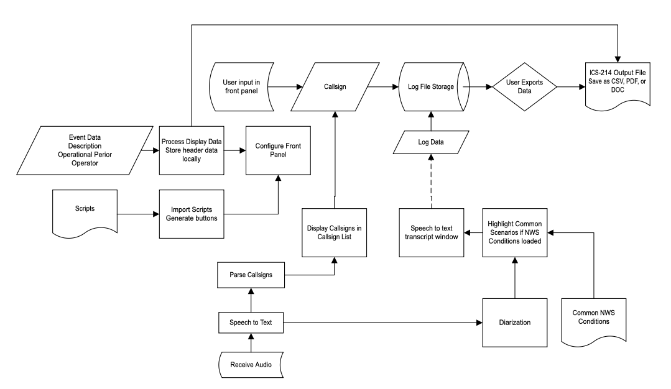
Figure 1: Data Model

Data Dictionary
Data Item | Data Type | Data length
Operational Period Date | Day
Operational Period Start Time | Time
Operational Period Stop Time | Time
Event Name | Text String | 100 characters
Operator ID | Text string | 20 characters
Number of scripts | integer | Single digit
Script | Text string | As required on import
Callsign | Text string | 10 characters
Call Data | Text String | 256 characters each
Callsign list | List of text strings | Expands as needed
Speech to text transcript | Text field | Expands as needed
Common NWS condition list | List of text strings | Expands as needed
NWS station identifier | boolean | 1 bit
Theme Mode | Enum | User interface theme selection (auto/light/dark)
Compact Mode Flag | Boolean | Indicates whether compact mode is active
Script Button Definitions | List | Dynamically created button titles + script text
Keyword Highlight Rules | List | List of keyed words/phrases and their colors
Event Log Table | Array | Client-side storage of log entries prior to export

Input Files

Script File
An optional script file will be a 2 column CSV. The CSV does not contain a header row. The table below illustrates the type of data contained in the script file. Note that <br> will display a carriage return in the pop-up window when the appropriate button is clicked.

Button Title | Text
Open | “Attention all Amateurs! This is (your callsign), interrupting regular traffic on this repeater to activate a Parker County Office of Emergency Management SKYWARN Weather Net, in response to a National Weather Service (warning type) which was issued at (time of warning) …  [truncated for the example]  …. This is (your callsign) standing by for any reports.”  <br>  “Is there a National Weather Service station currently monitoring?” (note the station in your log).  (over)  <br>
Periodic | “This is (your callsign) Net Control for the current Parker County OEM SKYWARN Weather Net.  The National Weather Service has issued a (warning type) at (start time of warning) until (end time of warning). Please come now with your Call Sign slowly and phonetically if you have a report.”
Pause | “The warning that caused the activation of this Parker County OEM SKYWARN net has been allowed to expire, however there is additional weather expected in (rough time estimate). At this time, I am pausing the SKYWARN Weather Net. Please limit traffic on the repeater as the SKYWARN Weather Net may resume unexpectedly. Thank you for your participation and reports! (your callsign) monitoring for Parker County OEM.”
Close | “This is (your callsign). At this time, the National Weather Service has allowed the last remaining warning to expire and there is no remaining significant weather in the Parker County area. I will be closing the SKYWARN Weather Net and returning this repeater back to normal amateur use. I will stay on this frequency for additional damage reports as available. Thank you very much for reporting ground truth and assisting the National Weather Service and SKYWARN operations. This is (your callsign) returning this repeater to normal traffic and monitoring.”

Event Keyphrase File
An optional script file will be a 1- or 2- column CSV. The CSV does not contain a header row. The first column (required) will be a list of the relevant weather events to listen for when performing speech-to-text processing, such as “rotation”, “wall cloud”, “hail”, “lowering” and “tornado”. The software will highlight these terms in the speech to text transcript window if they are detected. The software will highlight them yellow by default, but a second column can be included which will list a primary color to use for events, if desired.

Reports

ICS-214
The output file from the software shall be an ICS-214 form. An example is shown below.
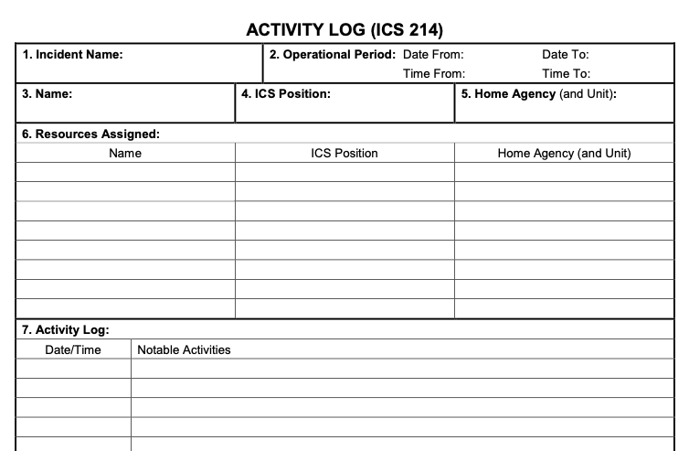
Figure 2: ICS-214 Form

Data Acquisition, Integrity, Retention, and Disposal
Data acquisition requirements are described in Section 3, herein.
Data Integrity and Retention shall be achieved by two different means:
First, the data shall be stored in a temp file while the software is in operation. This temp file will retain data so that, even in the case of a power failure or software failure, the log data is not lost. The software shall contain a means to import a temp log file. The temp log file shall contain all user and event details, as well as the logged data.
The temp log file may be a normal ASCII file, and may be saved in a user-queried location, in which case data retention will be handled by the user, and their storage of this temp file. Additionally, post-event, user control of the exported log file will serve as the means for data retention. Data disposal will be the user’s responsibility.

External Interface Requirements
<This section provides information to ensure that the system will communicate properly with users and with external hardware or software elements.>

User Interfaces
The user interface (UI) shall have several major “panels”, each containing groups of related items.
The UI shall be dynamically sized and shall be no more than 95% of the width of the browser window in which it is open.
The top of the UI shall contain three clearly labeled file import areas
- Import an incomplete temporary log file, should the event be resuming earlier operations (Section 4.5, herein)
- Import script button labels/scripts for display during the event (Section 3.6 and 4.3.1 herein)
- Import a list of event key terms or phrases to be highlighted in the speech to text transcript window (Section 4.3.2, herein)

Command Bar
The command bar shall be fixed at the top and remain visible during scrolling.
All import/export functions shall be accessed from this command bar.
The theme dropdown and compact mode toggle shall be right-aligned.

Operator Information and Event Detail Panel
The Operator and event detail panel will collect the operator callsign or name, the event description, and the start/stop date and time. This is not modified during the event, so it can be at the top of the window, and more compact than the other panes.
This panel shall contain two buttons on either the left or right edge of the panel; a “Start/Resume” (herein referred to simply as “start”) button and a “Pause/End” (herein referred to simply as “stop”) button. Upon program startup, the stop button will be disabled.
This panel will be no greater than half the width of the UI, and set to the left edge of the UI. The script selection/display entry buttons will be displayed in a panel that takes up the remaining 50% of the UI width, and on the right half of the UI.

Start/Resume Button
If no data has been logged, clicking the start button will enter the current date and time in the “Operational period start” field. The start button will then be disabled. A log entry will be made with only a timestamp and “message traffic” field stating “Event Initiated”.
If the event has been paused, the start button will be re-enabled. When the event has been paused and the start button is clicked, the “Operational period end” field will be cleared (if not already blank) and the Stop button will be enabled. A log entry will be made with only a timestamp and “message traffic” field stating “Logging Resumed”. Upon enabling the stop button, the start button will be disabled again.
If no data has been entered, but a temp log file is imported, the start date and time from that log shall be imported and entered into the event start time. If the log file contains an event stop time, that shall also be imported and entered into the event stop time. The resume button shall be enabled, and start button shall be disabled at this time.

Pause/End Button
If the event start time is blank, the stop button shall be disabled.
The stop button will be enabled any time data is entered and the start button is disabled.
When the stop button is clicked, the date and time stamp shall be recorded in the event stop field, and an indicator shall be put on the data entry field indicating the event is paused or stopped. A log entry will be made with only a timestamp and “message traffic” field stating “Event Halted”.

Script Display Buttons
As described in 5.1.1, The script display panel shall contain the script buttons described in 3.6, herein. The buttons will be dynamically created as described in 3.6, and dynamically sized to fit in the pane.

Modal “Script” Display Pane
Script modal shall appear centered and overlay the full screen.
Clicking outside the modal or the “×” shall close it.
Modal shall support scrolling for long scripts.

Data Entry Panel
The data entry panel will be the central focus for the operator during the event.
This panel shall contain a callsign entry field, and a message traffic entry field.
This panel shall contain the “callsigns heard” field will be included, which will be a listbox that is automatically updated with any callsigns detected as described in 3.4, herein.
The panel shall contain a “log data” button to enter the callsign, date and time, and message traffic into the event log. Additionally, hitting the “Enter” (“Return”) key when in the message traffic entry field will perform the same function as clicking the “log data” button.
As the central data entry portion of the logger, the Data Entry Panel shall be the center of the operator’s focal area, likely the vertical center of the UI.
The Data Entry Panel shall be 60% of the full width of the UI, and on the left side of the UI. The STT transcript (described in 5.1.3) shall be located in the remining 40% of the UI width, to the right of the Data Entry window.
The Callsigns Heard listbox shall be on the left hand side of the panel, next to the Callsign entry field. The Message traffic entry field shall be a multi-line text input box, and shall be to the right of the callsign entry field.

STT Placeholder
Until backend STT is implemented, the UI shall display a placeholder container and message: “STT output will appear here…”
The placeholder shall occupy the full size of the STT Transcript panel.
The STT container shall support dynamic insertion of styled transcript segments.

STT Transcript
The Transcript panel will contain the speech-to-text transcript.

Copy/Paste Functionality
The Transcript panel will contain a “copy” button. If text is selected, and the “copy” button is clicked, the selected text will automatically be copied and pasted into the “message traffic” field. The user may then edit the entry or chose to log it.

Keyword Highlighting Panel
Keywords imported via CSV shall be used to highlight matching words in the STT output pane. This is described in 4.3.2, herein.
Highlighting shall default to yellow unless the CSV specifies a color.

Event Log
Display of the full event log allows the user to review previous entries as needed.
The event log panel shall display the event log of all traffic entered during the event as a table. If the event log is larger than the allotted UI space for the panel, a vertical scrollbar shall be included. The event log panel shall be the full width of the UI, and shall be positioned at the bottom of the UI.
Within the event log, the same keywords highlighting rules in 4.3.2 herein shall apply throughout the duration of the event. Keywords shall not be highlighted in the output files.
An “export log” button shall be located below the event log table display. When clicked, this button shall allow the user to export the log file to a CSV, PDF, or DOC / DOCX file. Section 4.4.1 shows the ICS-214 form that is intended as the output format.

Theme Behavior
UI shall automatically apply correct color palettes per selected theme.
Inputs shall maintain sufficient contrast even in dark mode.
If input fields are white, then input text shall be black. If input fields are sufficiently dark, then input text shall be white. Under no circumstances shall white text be used on white input fields.

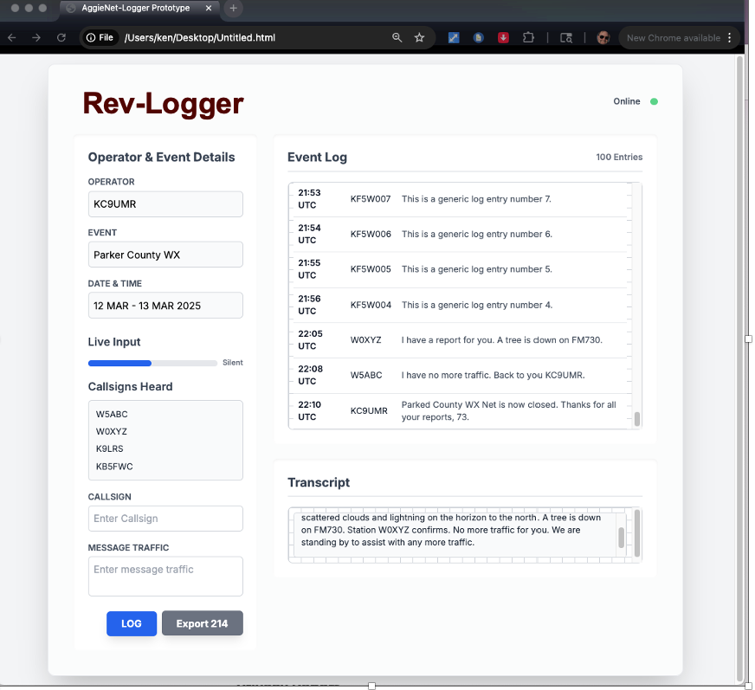

Software Interfaces
While HTML is the primary software protocol used, there are a number of other interfaces that will be required for full functionality as expected by this application.
- CSV export
- JavaScript-based log table
- JavaScript-based dynamic script buttons
- UI theme logic in JS

Frontend Logic Layer
The frontend shall perform client-side CSV generation for log export.
The frontend shall dynamically generate script buttons from CSV input.
The frontend shall perform client-side application of theme and compact mode.
The frontend shall manage UI state internally (no backend dependency required until STT).

Python
The use of python may be required for several key functions.

Device Access
In order to overcome repeated “access to hardware” requests from the chrome web browser, a python script to locally host the webpage may be required. This script will simply utilize python’s built in webserver. The block below is the explanation of this process provided by ChatGPT when performing initial proof-of-concept testing.
If you already have a folder with HTML/JS files:
cd your_web_app/
python3 -m http.server 8000
Visit:
http://localhost:8000
This serves the files without re-requesting mic permissions each reload.
However:
❗This provides no API routes.
❗Just static files — but often enough for a STT page.

ChatGPT goes on to recommend a more complex method (A Flask Server with Audio API) when building this functionality in from the initial phases of the project. This discussion is described in the field below.
Better Option — Flask Server With an Audio API
This example hosts your webpage and provides backend routes, if needed for STT engines or audio processing.

📁 Folder structure
my_audio_app/
├── app.py
├── static/
│ └── index.html
└── templates/
└── main.html

🎯 Flask Server (app.py)
from flask import Flask, send_from_directory, render_template, request, jsonify

app = Flask(__name__)

@app.route("/")
def index():
return render_template("main.html")

# If you want to serve JS/CSS:
@app.route('/static/<path:path>')
def send_static(path):
return send_from_directory('static', path)

# Example endpoint to receive audio blobs (optional)
@app.route("/upload_audio", methods=["POST"])
def upload_audio():
audio = request.files['audio']
# Process or save here...
return jsonify({"status": "ok"})

if __name__ == "__main__":
app.run(host="0.0.0.0", port=5000, debug=True)

🎨 Example frontend request + mic access (main.html)
This shows how to request audio only once and send chunks to Python if needed:
<!DOCTYPE html>
<html>
<head>
<title>Audio Test</title>
</head>
<body>
<h1>Microphone Test</h1>
<button id="start">Start Recording</button>

<script>
document.getElementById("start").onclick = async () => {
const stream = await navigator.mediaDevices.getUserMedia({ audio: true });

const recorder = new MediaRecorder(stream);
recorder.ondataavailable = (e) => {
const data = new FormData();
data.append("audio", e.data, "chunk.webm");
fetch("/upload_audio", { method: "POST", body: data });
};

recorder.start(1000); // send 1-second chunks
};
</script>
</body>
</html>

Audio Routing (future revisions)
<this is reserved for a future revision which will allow text to speech and user microphone input to be routed to the radio>

Hardware Interfaces
Rev-Logger does not require any unique hardware interfaces at this time. Rev-Logger will operate using a standard computer sound card. Preliminary testing has shown that built-in interfaces between HTML, JavaScript, and Python and built-in sound cards, docking station sound cards, and plug-and-play USB sound cards all work with no issues.
A future revision may incorporate python-based sound routing between a USB headset and the radio input/output ports. This functionality is not described at length at this time, and therefore will not be incorporated in the software.

Communications Interfaces
<State the requirements for any communication functions the product will use, including e-mail, Web browser, network protocols, and electronic forms. Define any pertinent message formatting. Specify communication security or encryption issues, data transfer rates, handshaking, and synchronization mechanisms. State any constraints around these interfaces, such as whether e-mail attachments are acceptable or not.>

Quality Attributes

Usability
Rev-Logger is intended to improve operator efficiency for public service and public safety related event logging. Ergonomics and effective data capture even in adverse conditions are crucial. For this reason, logged data is stored in temporary log files while the software is operating. This will allow files to be recovered by the software or the user in the event of a power failure or computer failure.

Tab order
Upon startup, the focus shall be in the “operator” field. The tab order shall then be:
- Operator
- Event
- Date & Time
- Callsign
- Message Traffic
- “Log” button (if activated, focus then moves back to the callsign field)
- “Export 214” button.
- (return to Callsign)

Performance
<State specific performance requirements for various system operations. If different functional requirements or features have different performance requirements, it's appropriate to specify those performance goals right with the corresponding functional requirements, rather than collecting them in this section.>

Security
<Specify any requirements regarding security or privacy issues that restrict access to or use of the product. These could refer to physical, data, or software security. Security requirements often originate in business rules, so identify any security or privacy policies or regulations to which the product must conform. If these are documented in a business rules repository, just refer to them.>

Safety
<Specify requirements that are concerned with possible loss, damage, or harm that could result from use of the product. Define any safeguards or actions that must be taken, as well as potentially dangerous actions that must be prevented. Identify any safety certifications, policies, or regulations to which the product must conform.>

Internationalization and Localization Requirements
There are no internationalization or localization requirements for Rev-Logger. Rev-Logger is based on the NIMS operation model, and NIMS ICS forms, which are intended for use by US emergency services personnel, therefore Rev-Logger intended for use by US based amateur radio operators.

Other Requirements
<Examples are: legal, regulatory or financial compliance, and standards requirements; requirements for product installation, configuration, startup, and shutdown; and logging, monitoring and audit trail requirements. Instead of just combining these all under "Other," add any new sections to the template that are pertinent to your project. Omit this section if all your requirements are accommodated in other sections. >

Appendix A: Glossary
Acronymns and Abbreviations

Acronym | Definition
AI | Artificial Intelligence
APCO | Association of Public-Safety Communications Officials (APCO)
API | Application Programming Interface
ASCII | American Standard Code for Information Interchange
FM | Frequency Modulation
ICS | Incident Command System
IEEE | Institute of Electrical and Electronics Engineers
HTML | Hypertext Markup Language
NATO | North Atlantic Treaty Organization
NIMS | National Incident Management System
NWS | National Weather Service
STT | Speech To Text
SRS | Software Requirements Specification
UI | User Interface
URL | Uniform Resources Locator
USB | Universal Serial Port
UTC | Coordinated Universal Time

Appendix B: Supported Phonetic Alphabets
Letter | APCO | NATO | Able-Baker
A | Adam | Alpha | Able
B | Boy | Bravo | Baker
C | Charles | Charlie | Charlie
D | David | Delta | Dog
E | Edward | Echo | Easy
F | Frank | Foxtrot | Fox
G | George | Golf | George
H | Henry | Hotel | How
I | Ida | India | Item
J | John | Juliet | Jig
K | King | Kilo (or Kilowatt) | King
L | Lincoln | Lima | Love
M | Mike | Mike | Mike
N | Nora | November | Nan
O | Ocean | Oscar | Oboe
P | Paul | Papa | Peter
Q | Queen | Quebec | Queen
R | Robert | Romeo | Roger
S | Sam | Sierra | Sugar
T | Tom | Tango | Tare
U | Union | Uniform | Uncle
V | Victor | Victor | Victor
W | William | Whiskey | William
X | X-ray | X-Ray | X-ray
Y | Young | Yankee | Yoke
Z | Zebra | Zulu | Zebra

Note: The “Able-Baker” Phonetic Alphabet is the original NATO alphabet. It is included here, as many older amateurs still utilize it, and some of the words are found intermixed with the NATO alphabet by amateurs (such as “Fox” and “Sugar”). The APCO alphabet is included, as it is utilized by many public safety organizations, and is occasionally heard on the amateur bands, as well.

Appendix C: Successful Proof-of-Concept Code Excerpts
Net Scripts
<!DOCTYPE html>
<html lang="en">
<head>
<meta charset="UTF-8">
<title>CSV Button Modal Demo (Windows Style)</title>
<script src="https://cdn.jsdelivr.net/npm/papaparse@5.4.1/papaparse.min.js"></script>
<style>
body {
font-family: "Segoe UI", Tahoma, Geneva, Verdana, sans-serif;
padding: 20px;
background: #eaeaea;
}

h2 {
margin-bottom: 10px;
}

#buttons {
margin-top: 20px;
}

button {
margin: 8px;
padding: 10px 22px;
font-size: 1rem;
border: 1px solid #0078d7;
border-radius: 6px;
background-color: #0078d7;
color: white;
cursor: pointer;
transition: background-color 0.2s;
}

button:hover {
background-color: #005fa3;
}

#status {
margin-top: 10px;
font-size: 0.9em;
color: #333;
}

/* Modal backdrop */
.modal {
display: none;
position: fixed;
z-index: 1000;
left: 0; top: 0;
width: 100%; height: 100%;
background-color: rgba(0,0,0,0.4);
}

/* Modal box styled like Windows dialog */
.modal-content {
background-color: #f9f9f9;
margin: 10% auto;
padding: 0;
border-radius: 8px;
width: 80%;
max-width: 900px; /* Wider for easier reading */
box-shadow: 0 6px 20px rgba(0,0,0,0.4);
overflow: hidden;
}

/* Title bar like Windows dialog */
.modal-header {
background: linear-gradient(to bottom, #0078d7, #005fa3);
color: white;
padding: 10px 15px;
font-size: 1.1em;
display: flex;
justify-content: space-between;
align-items: center;
}

.modal-body {
padding: 20px;
max-height: 70vh;
overflow-y: auto;
background: white;
font-size: 0.95em;
white-space: pre-wrap; /* preserves newlines */
}

.close {
font-size: 22px;
cursor: pointer;
padding: 0 8px;
border-radius: 3px;
}

.close:hover {
background-color: rgba(255,255,255,0.3);
}
</style>
</head>
<body>
<h2>Import CSV File and Create Buttons</h2>
<input type="file" id="fileInput" accept=".csv" />
<div id="status">Please choose a CSV file with two columns (item, description).</div>
<div id="buttons"></div>

<!-- Modal -->
<div id="infoModal" class="modal">
<div class="modal-content">
<div class="modal-header">
<span id="modalTitle">Item Info</span>
<span id="closeModal" class="close">&times;</span>
</div>
<div id="modalText" class="modal-body"></div>
</div>
</div>

<script>
const fileInput = document.getElementById('fileInput');
const buttonsDiv = document.getElementById('buttons');
const modal = document.getElementById('infoModal');
const modalTitle = document.getElementById('modalTitle');
const modalText = document.getElementById('modalText');
const closeModal = document.getElementById('closeModal');
const status = document.getElementById('status');
let dataMap = {};

fileInput.addEventListener('change', handleFile);

function handleFile(event) {
const file = event.target.files[0];
if (!file) {
status.textContent = "No file selected.";
return;
}

status.textContent = "Reading file...";

Papa.parse(file, {
complete: function(results) {
const rows = results.data.filter(r => r.length >= 2 && r[0].trim() !== "");
if (!rows.length) {
status.textContent = "⚠️ No valid data found (need at least 2 columns).";
return;
}

dataMap = {};
buttonsDiv.innerHTML = "";

rows.forEach(row => {
const key = row[0].trim();
const value = row[1].trim();
dataMap[key] = value;
const btn = document.createElement('button');
btn.textContent = key;
btn.addEventListener('click', () => showModal(key));
buttonsDiv.appendChild(btn);
});

status.textContent = `✅ Loaded ${rows.length} item(s).`;
},
error: function(err) {
console.error(err);
status.textContent = "❌ Failed to parse CSV.";
},
skipEmptyLines: true
});
}

function showModal(key) {
modalTitle.textContent = key;
const rawText = dataMap[key] || "(No text found)";

const formatted = rawText
.replace(/\\n/g, '\n') // interpret \n literally
.replace(/\r/g, ''); // remove carriage returns

modalText.innerHTML = formatted;
modal.style.display = "block";
}

closeModal.onclick = () => modal.style.display = "none";
window.onclick = (event) => {
if (event.target === modal) modal.style.display = "none";
};
</script>
</body>
</html>

Appendix D: Current Architecture and Runtime File Set
Purpose. This appendix updates the SRS to reflect the functional Rev-Logger V23 implementation. It documents the current system architecture, the primary runtime sequence, and the files required to deploy and use the application in its present form.

D.1 Required Runtime Files
The current working Rev-Logger package requires the files in Table D-1. These files shall be stored in the same local project folder so that the User Manual can be opened from the Help menu and the local backend can be started against the matching frontend build.

File | Required | Purpose | Notes
RevLog_xxxxx.html | Yes | Primary frontend application | Current working UI build with Import / Export / Help dropdowns, top-row WX badges, STT controls, and help integration.
server_patched_stable.py | Yes | Local FastAPI STT backend | Receives WAV audio chunks from the browser and returns transcript text using faster-whisper.
requirements_patched.txt | Yes | Python dependency list | Used to install FastAPI, Uvicorn, python-multipart, and faster-whisper dependencies into the virtual environment.
revlogger_user_manual.html | Yes | Help system document | Opened by the Help dropdown in a new browser tab. Must remain in the same folder as the V23 HTML file.
revlogger_operator_cheat_sheet.html | No | Standalone reference copy | Optional because the operator cheat sheet is embedded into the application modal in V23, but this standalone file remains useful for printing or external reference.
Table D-1. Runtime files required for the current Rev-Logger implementation.

D.2 Current System Architecture
The current architecture is a local-first browser application. The frontend operates in Chrome and uses the Web Audio API to capture microphone audio. Short WAV chunks are sent to a local FastAPI backend, which runs faster-whisper (small.en, CPU int8) and returns JSON transcript text. Weather and alert data are retrieved from api.weather.gov as needed for the weather panel and top-row WX indicators.
+--------------------+ user input / display +-------------------------------+
| Operator / Browser | ----------------------------> | Rev-Logger Frontend |
| Chrome UI | | HTML + JavaScript (V23) |
+--------------------+ +-------------------------------+
| |
| mic access / downloads | POST /transcribe (WAV)
v v
+---------------------------+ +------------------------------+
| Browser Services | | Local STT Backend |
| Microphone permission | | FastAPI + faster-whisper |
| Web Audio API | | small.en (CPU int8) |
| Local storage / downloads | +------------------------------+
+---------------------------+ |
| transcript JSON
v
+------------------------------+
| Local Runtime Files |
| • RevLog_..._v23....html |
| • server_patched_stable.py |
| • requirements_patched.txt |
| • revlogger_user_manual.html|
+------------------------------+
|
| HTTPS GET / JSON
v
+------------------------------+
| api.weather.gov |
| NWS forecast / alerts |
+------------------------------+
Figure D-1. Current Rev-Logger system architecture, including required local files and the NWS API dependency.

D.3 Primary Runtime Sequence
The runtime sequence in Figure D-2 shows the normal operating path for speech-to-text and logging. The operator opens the frontend, starts STT, reviews transcript text, converts meaningful content into log entries, and uses the weather services to maintain awareness of active alerts. This sequence reflects the current functional V23 workflow.
Operator Browser UI FastAPI Backend faster-whisper NWS API
| | | | |
1. | Open app | | | |
|--------------->| | | |
2. | Start STT | | | |
|--------------->| | | |
3. | | Capture audio -> 16 kHz WAV chunks | |
| |------------------->| | |
4. | | | Decode / transcribe| |
| | |------------------->| |
5. | | | Transcript text | |
| | |<-------------------| |
6. | | Append transcript, deduplicate edges | |
| |<-------------------| | |
7. | Review text / edit message | | |
|--------------->| | | |
8. | | Save log entry to local event log | |
| |---------------------------------------->| (internal state)|
9. | | Fetch alerts / forecast by ZIP or loc | |
| |--------------------------------------------------------->|
10.| | Alert JSON / active warnings & watches | |
| |<---------------------------------------------------------|
11.| View WX badges, tooltips, transcript, and updated log | |
|<---------------| | | |
Figure D-2. Primary runtime sequence for STT capture, logging, and weather refresh.

D.4 V23 Interface Characteristics Reflected by this Appendix
• The command bar is organized into Import, Export, and Help dropdown menus instead of individual top-level import buttons.
• The WX label and active watch / warning badges are located on the top row of the navigation bar and are right-aligned on the same row as the dropdown menus.
• Weather alert items are color-coded by type, with warning items shown in a red-coded style and watch items shown in a yellow-coded style.
• Hover tooltips are provided for weather alert indicators to display alert type, severity, urgency, expiration, and affected areas.
• The Help system includes a scrollable in-application Operator Cheat Sheet modal and a User Manual that opens in a new tab.
• Speech-to-text uses a local backend architecture rather than a browser-native STT placeholder. The browser sends WAV chunks to the backend for transcription.

D.5 Required Startup Sequence
1. Place the required runtime files in the same project folder.
2. Create and activate a Python virtual environment.
3. Install dependencies from requirements_patched.txt.
4. Start the backend with: uvicorn server_patched_stable:app --reload
5. Open RevLog_Alpha_01_ui_panels_synced_v23_wx_really_top_row.html in Chrome.
6. Allow microphone access, load weather context as needed, and begin logging.

