Whats the Goal of a Browser?
To hit a specific browser, fetch HTML/CSS/JS and render it on the screen.

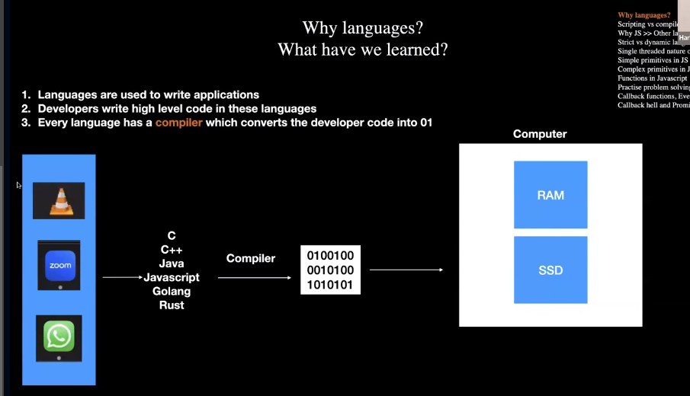

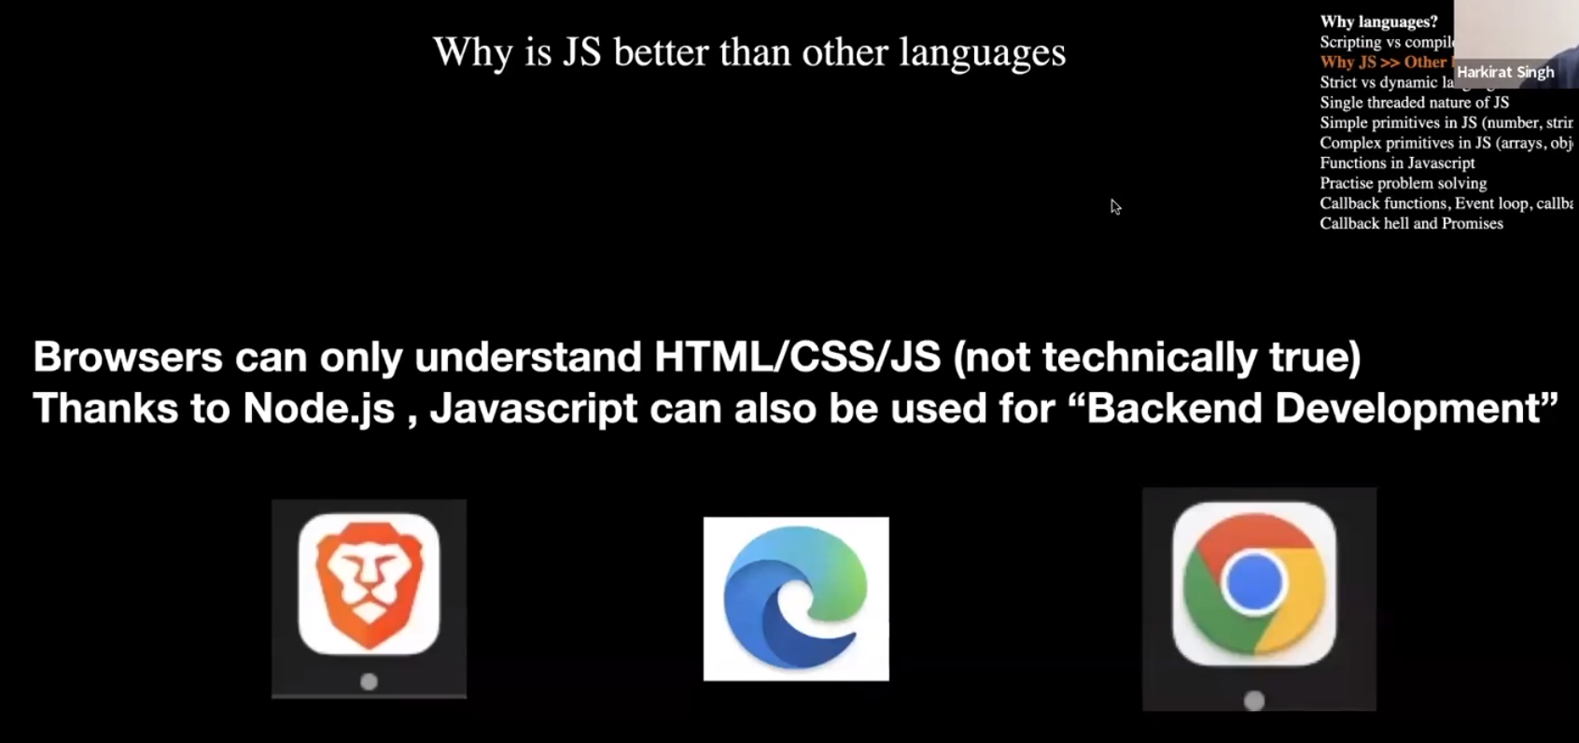
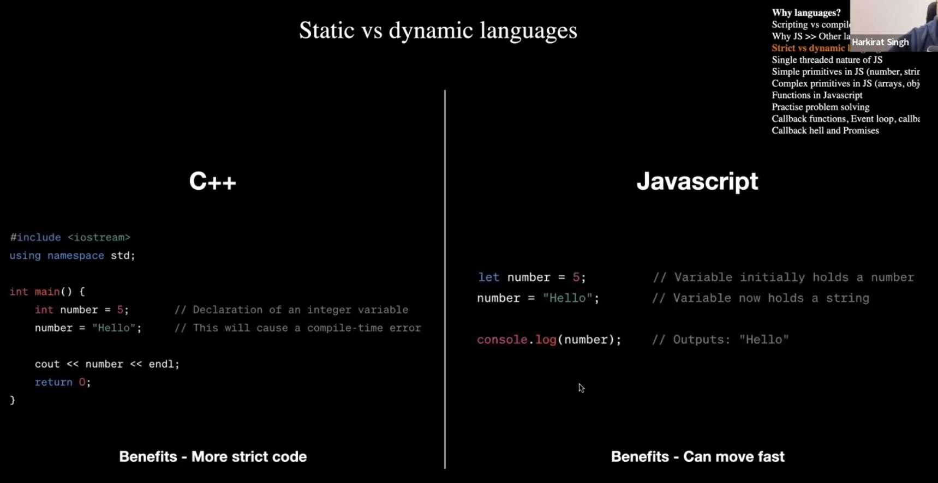

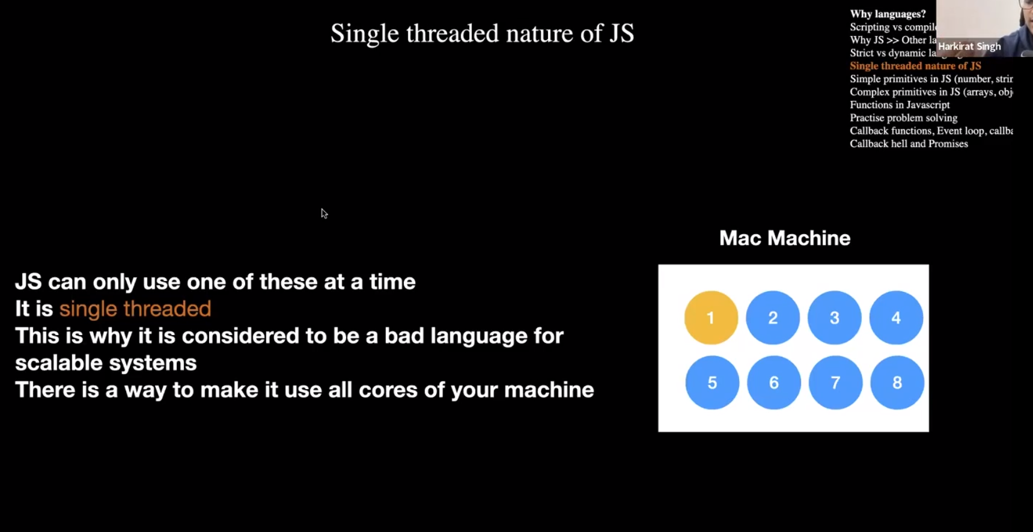
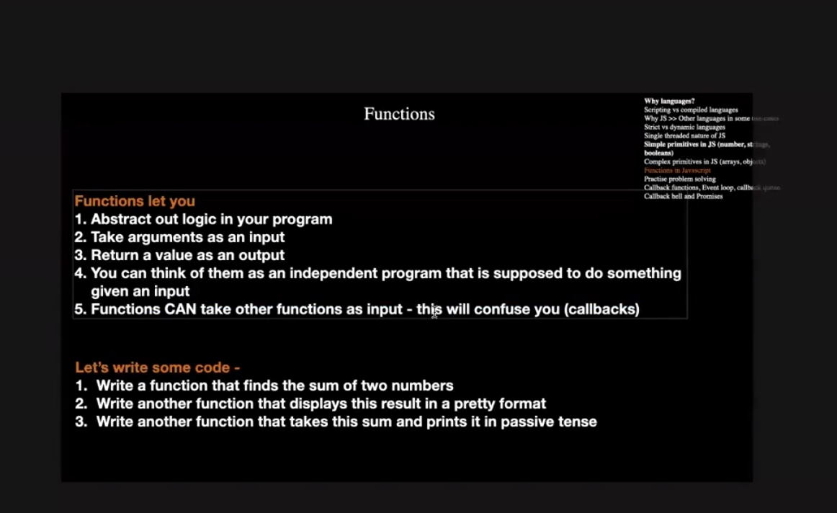

CALLBACK FUNCTION

We can call function inside another function . For Example:

function sum(num1,num2,fnToCall){
let result = num1 + num2;
fnToCall(result);
}

function displayResult(data){
console.log("Result of the sum is "+ data );
}
function displayResultPassive(data){
console.log("The Sum is : "+data);
}

sum(1,2,displayResultPassive);//Callback, passing function as an argument

SYNCHRONOUS VS ASYNCHRONOUS FUNCTIONS



