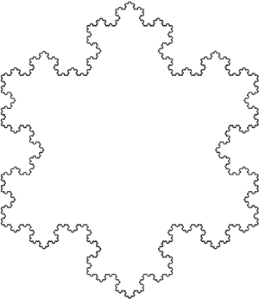**Business Math I – MTH 148**

**Cleveland State University | Math Learning Center**

|  |  |  |  |  |
| --- | --- | --- | --- | --- |
| **Factoring** | **Linear Cost Functions**    *m* = marginal (or per-item) cost, *b* = fixed cost    *p* = price per unit when *q* units **supplied**    *p* = price per unit when q units **demanded**    **equilibrium price** and **equilibrium quantity** occur that this *q* value | | **Matrices**  *Elementary Operations*   * Interchange any two equations * Multiply both sizes by a constant * Replace any equations by a sum of itself and a multiple of another   *Sum, Difference, Product*   * Sum of any two  matrices is every corresponding element added * Difference of any two  matrices is every corresponding element subtracted * Product of scalar *k* and matrix *M* is the matrix *kM*, with every element *k* times the corresponding element | |
| **Radicals** |
| **Quadratics** | **Graphing Polynomial Functions**    **parabola**, vertex *(h,k)*, axis of symmetry *x=h*, open upward if *a>0*, downward if *a<0*    **parabola**, vertex at | |
| **Matrix Operations** | |
| **Exponents** |
| **Graphing Rational Functions**  *x = c* is a *vertical asymptote*  if a number *c* makes the denominator 0, but a non-zero numerator  *y = k* is a *horizontal asymptote*  if as *x* increases, the values of *y* approach, but do not equal, *k*  *x-axis* is a *vertical asymptote*  if the numerator is a smaller degree than the denominator  Given the function  is a horizontal asymptote | |
| **Financial Math Variables**  r = annual interest rate  m = number of periods per year  i = interest rate per period,  t = number of years  n = number of periods,  P = principle, or present value  A = future value of lump sum  S = future value of annuity  R = periodic payment on annuity | |
| **Slope and Equations of a Line**    slope m, y-intercept b  slope m, point (x1,y1)  x-intercept c/a, y-intercept c/b  vertical line, x-intercept k  horizontal line, y-intercept k |
| **Interest *Simple* *Compound***  *Interest:*  *Future value:*  *Present value:*  *Effective rate:* | | | **Exponential Growth**  or  Such that  is the amount at time ,  is the amount at time , and  and  are constants. |
| **Logarithms** |
| **Continuous Interest**  *Future:*  *Present:* | **Annuities**  Ordinary future value  Ordinary present value  Annuity due future value | | |

© 2014 Kevin A. Candow, k.candow@csuohio.edu