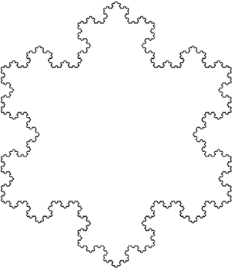**Business Math II – MTH 149**

**Cleveland State University | Math Learning Center**

|  |  |  |
| --- | --- | --- |
| **Sets**  *Element of*  4 is an element of the set {3,4,5}  *Not element of*  8 is not an element of the set {3,4,5}  *Set-builder*  The set of all elements *x* with property *P*  *Subset*  every element of A is an element in B  *Proper Subset*  A is a subset of B with least 1 more element  *Complement*  All the elements not in the set A  *Intersection*  Set of all elements in both A and B  *Union*  Set of all elements in either A or B or both | **Binomial Experiments**    n = number of trials  p = probability of success  x = number of successes    Expected value | **Applications of the Derivative**  Increasing function  Decreasing function  Constant function  Location of local extrema  Concave up  Concave down  Inflection point  If and , local min  If and , local max |
| **Limits**  **Macintosh HD:Users:kcandow:Downloads:Capture.PNG** |
| **Probability**    The odds in favor of event E    Complement Rule    Probability of a union    Conditional probability    Product Rule of probability | **Rate of Change**    Average rate of change    Instantaneous rate of change | **Multivariable**  : plane  : surface  : paraboloid  **Partial derivative of $f\left(x,y\right)$ with respect to $x$**  is the derivative of $f$ treating *x* as a variable and *y* as a constant  **A critical point** exists if either of the following is true: $$f_{x}(a,b)=f_{y}\left(a,b\right)=0$$ $f_{x}=DNE$ or $f_{y}=DNE$ at $\left(a,b\right)$ Let $M\left(x,y\right)=f_{xx}f_{yy}-{f_{xy}}^{2}$ If $M>0$ and $f_{xx}\left(a,b\right)<0$, local max  If $M>0$ and $f_{xx}\left(a,b\right)>0$, local min  If $M<0$, then $f$ has a saddle point  If $M=0$, then the test is inconclusive |
| **Notations for the Derivative** |
| **Factorial and Permutations**      Permutation: order matters  Ex. arrangement, schedule  Combination:  Ex. group, set, sample | **Rules of a Derivative** |
| **Integration**  If, then |
| **Expected Value**    Where xi is value, and pi is probability |

© 2014 Kevin A. Candow, k.candow@csuohio.edu