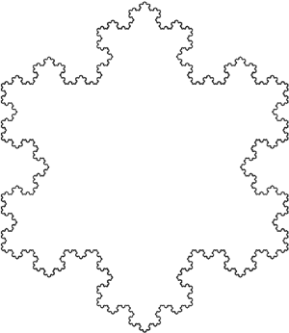**Calculus II – MTH 182 – Part 2**

© 2014 Kevin A. Candow, k.candow@csuohio.edu

**Cleveland State University | Math Learning Center**

|  |  |  |
| --- | --- | --- |
| **Integral Test** | $$\sum_{n=1}^{∞}{a_{n}}→\int_{1}^{∞}{f\left(x\right)dx}$$ | If integral diverges, summation diverges  If integral converges, summation converges |
| **Comparison Test** | $$0≤a_{n}≤b_{n}$$ | If $\sum{b_{n}}$ converges, $\sum{a_{n}}$ converges  If $\sum{a_{n}}$ diverges, $\sum{b_{n}}$ diverges |
| **Limit Comparison Test** | $$L=\lim_{n→∞}{\frac{a_{n}}{b_{n}}}$$ | If $L>0$, $\sum{a_{n}}$ converges iff $\sum{b_{n}}$ converges  If $L=∞$ and $\sum{a_{n}}$ converges, $\sum{b_{n}}$ converges  If $L=0$ and $\sum{b_{n}}$ converges, $\sum{a_{n}}$ converges |
| **Divergence Test** | $$L=\lim_{n→∞}{a_{n}}$$ | If $L≠0$, $\sum{a_{n}}$ diverges |
| **Ratio Test** |  | If $ρ<1$, $\sum{a_{n}}$ converges absolutely  If $ρ>1$, $\sum{a_{n}}$ diverges  If $ρ=1$, inconclusive |
| **Root Test** |  | If $L<1$, $\sum{a_{n}}$ converges absolutely  If $L>1$, $\sum{a_{n}}$ diverges  If $L=1$, inconclusive |
| **p-series** | $$\sum_{n=1}^{∞}{\frac{1}{n^{p}}}$$ | If $p>1$, $\sum{\frac{1}{n^{p}}}$ converges  If $p≤1$, $\sum{\frac{1}{n^{p}}}$ diverges |
| **Absolute Convergence** | $$\sum{a_{n}}$$ | If converges, then $\sum{a_{n}}$ converges absolutely |
| **Conditional Convergence** | $$\sum{a_{n}}$$ | If $\sum{a_{n}}$ converges, but diverges, then $\sum{a_{n}}$ converges conditionally |
| **Leibniz Test** | $$a_{1}>a_{2}>a_{3}>…>0$$ $\lim_{n→∞}{a_{n}}=0$ | $$S=\sum_{n=1}^{∞}{{(-1)}^{n-1}a_{n}}=a_{1}-a_{2}+a_{3}-a_{4}+…$$ $0<S<a_{1}$ and $S_{2N}<S<S_{2N+1} N≥1$ |
| **Geometric Series** | $$\sum_{n=M}^{∞}{cr^{n}}$$ | If the series converges to $\frac{cr^{M}}{1-r}$ otherwise it diverges. |