Lab 4
Theory:
In mathematics (in particular, functional analysis), convolution is a mathematical operation on two functions (f and g) that produces a third function(f*g) that expresses how the shape of one is modified by the other. The term convolution refers to both the result function and to the process of computing it. It is defined as the integral of the product of the two functions after one is reflected about the y-axis and shifted. The choice of which function is reflected and shifted before the integral does not change the integral result (see commutativity). The integral is evaluated for all values of shift, producing the convolution function.
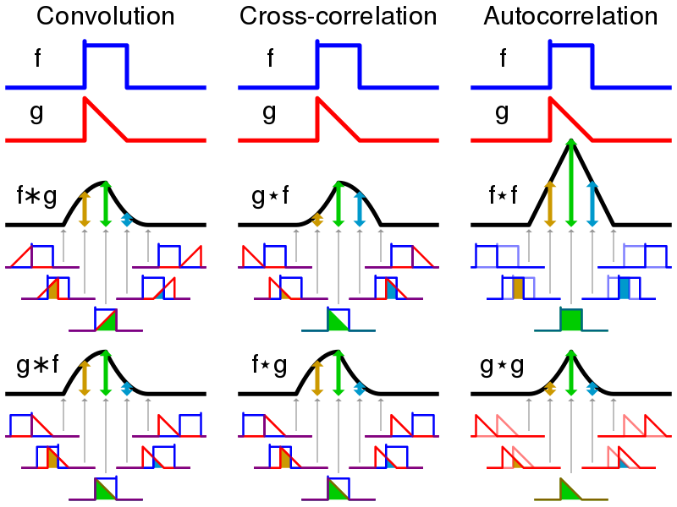
The convolution of f and g is written f∗g, denoting the operator with the symbol ∗.It is defined as the integral of the product of the two functions after one is reflected about the y-axis and shifted. As such, it is a particular kind of integral transform:
(f * g)(x) = ∫[−∞ to +∞] f(t) * g(x - t) dt

Code:
% Linear Convolution
% x(n)=(1,2,1,2)
% h(K)=(1,1,1)

x=[1 2 1 2];
h=[1 1 1];
a=length(x);
b=length(h);
n=a+b-1;
y=zeros(1,n);
t=0:n-1;
for i=0:n
for j=0:n
if((i-j+1)>0 && (i-j+1)<=b && (j+1)<=a)
y(i+1)=y(i+1)+x(j+1).*(i-j+1);
end
end
end
subplot(2,1,1);
stem(t,y);
title('ANJAN KC')
%BY Built in Function
z=conv(x,h);
subplot(2,1,2);
stem(t,z);

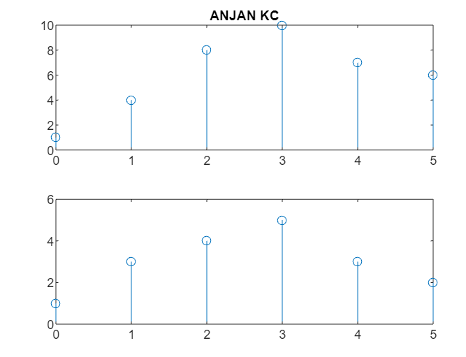

%x=a^n
% y=u(t)
n1=0:1:10;
y1=0.8.^n1;
h1(n1>=0)=1;
subplot(3,1,1); % a<1
stem(n1,y1);
title('ANJAN KC')
subplot(3,1,2);
stem(n1,h1);
x=conv(n1,h1);
n2=0:length(x)-1;
subplot(3,1,3);
stem(n2,x);
