Supplementary Material

rachel Robertson and Kelly Cao

2024-05-03

The supplementary materials include tables and figures from the exploratory analysis and data analysis that were unused in the final manuscript.

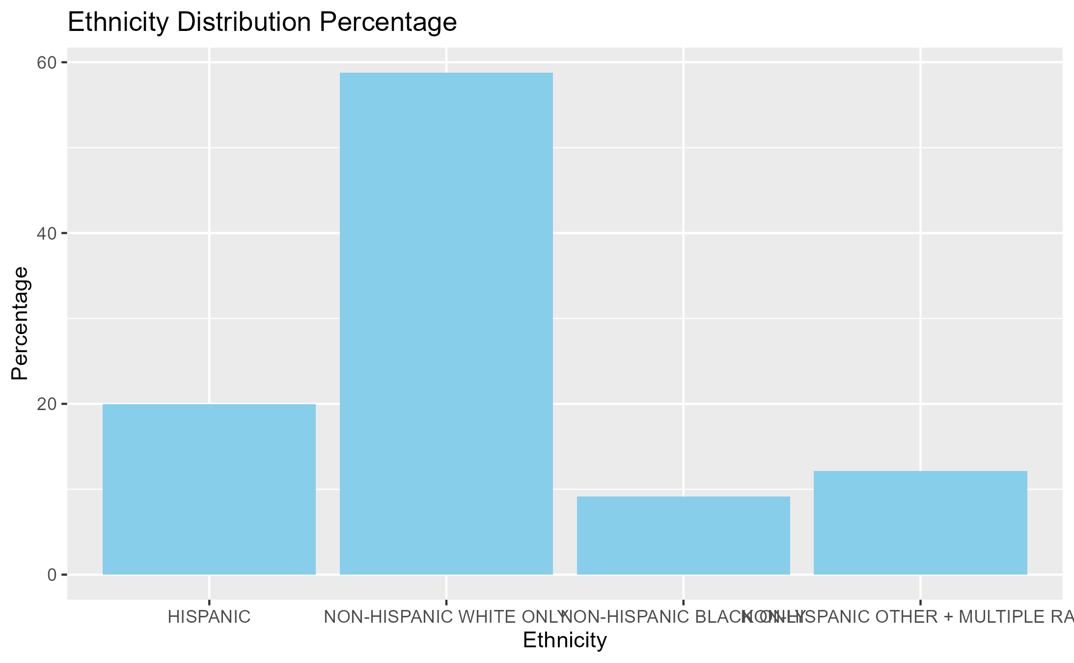

S.1. Distribution of ethnicity and race in sample populaiton of U.S. teens.

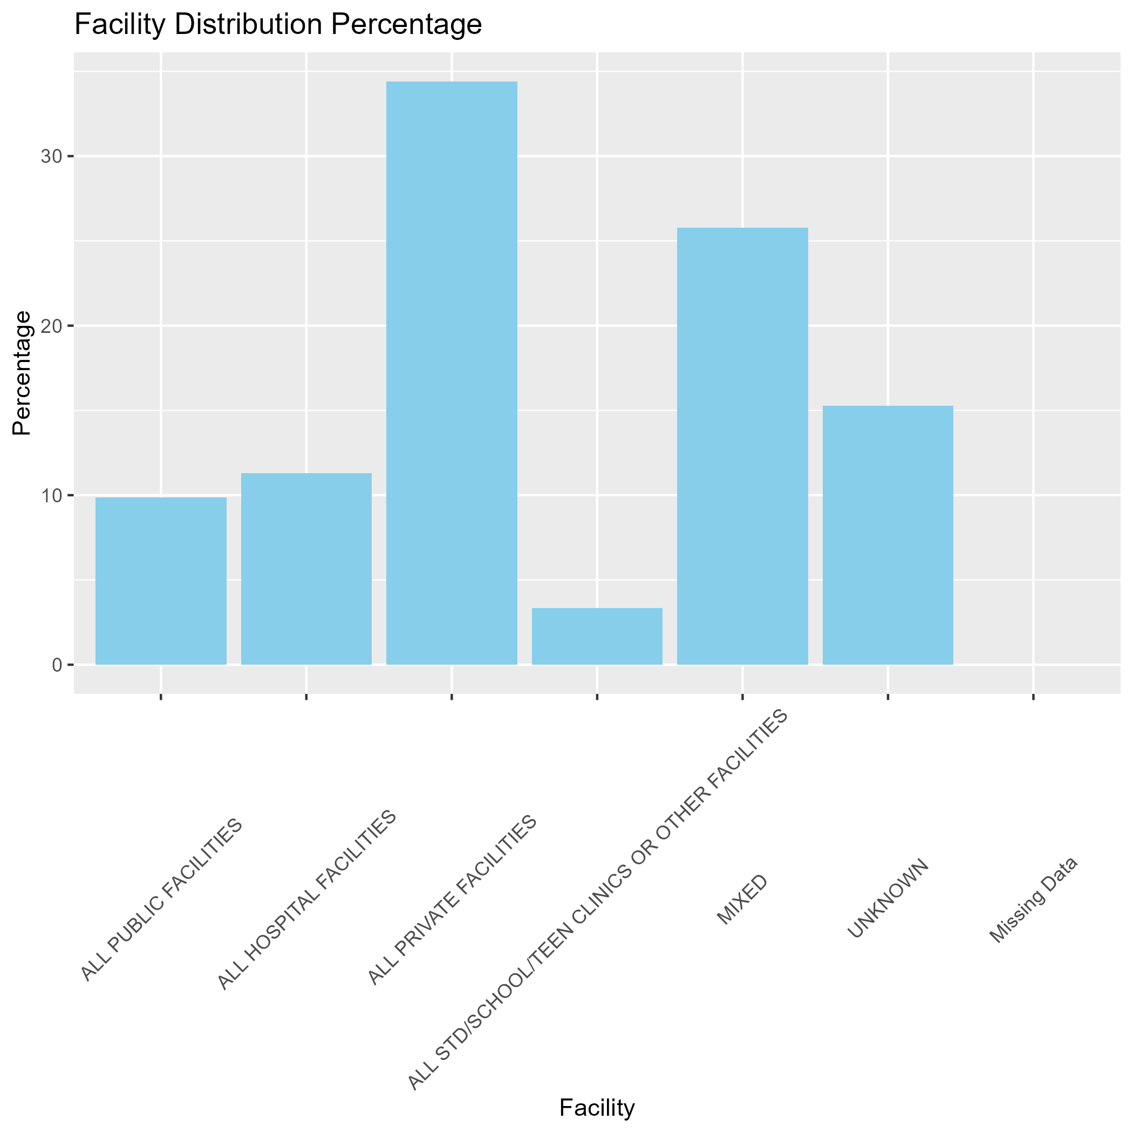 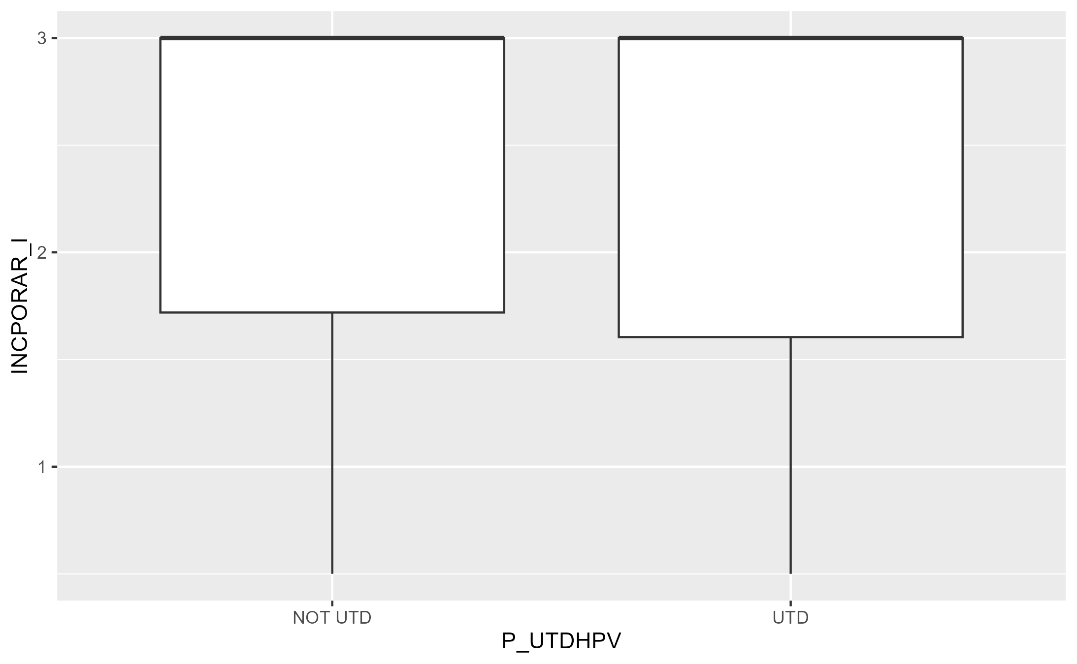

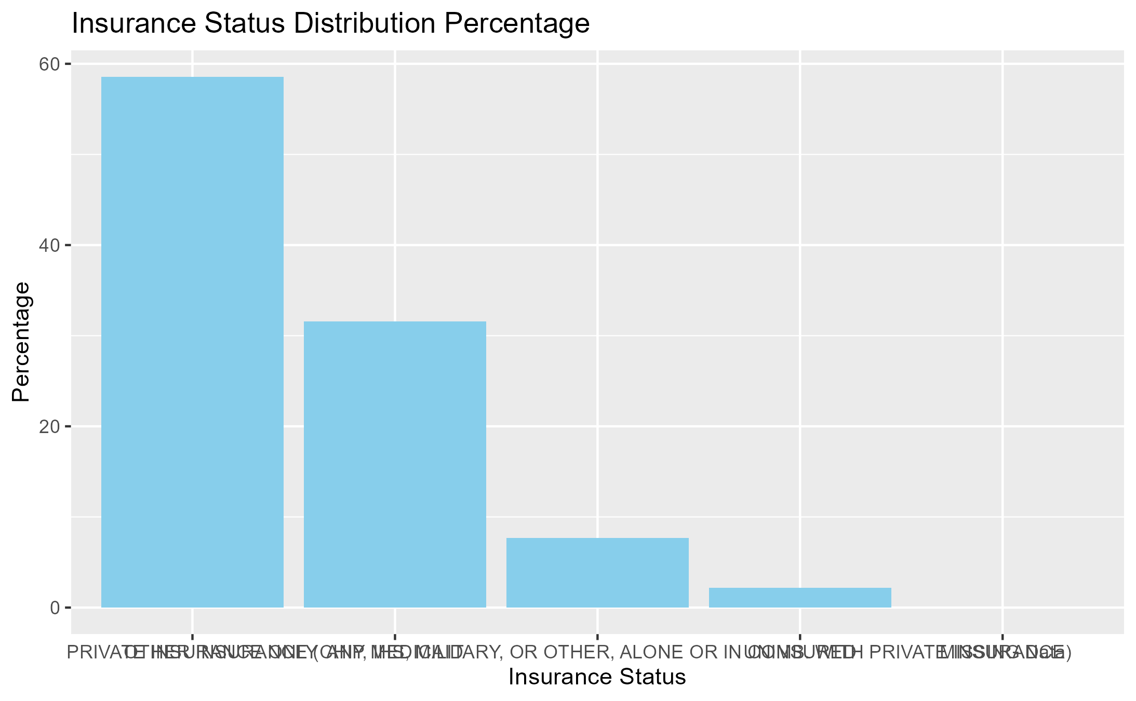 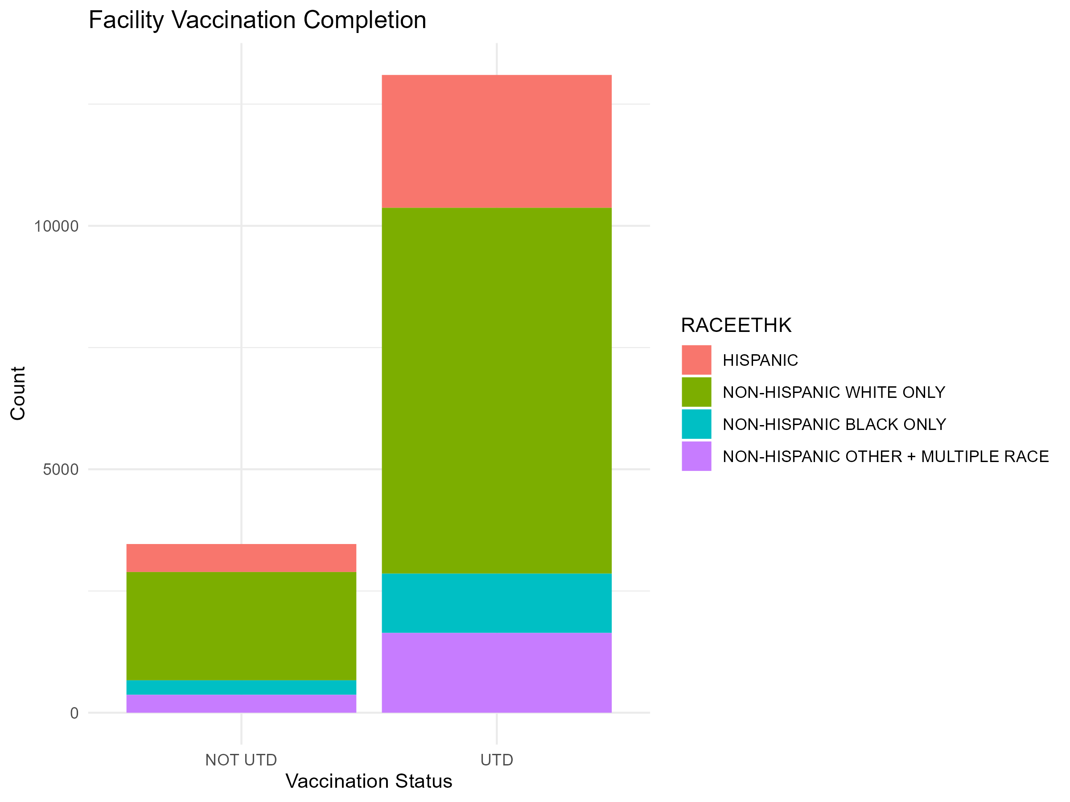 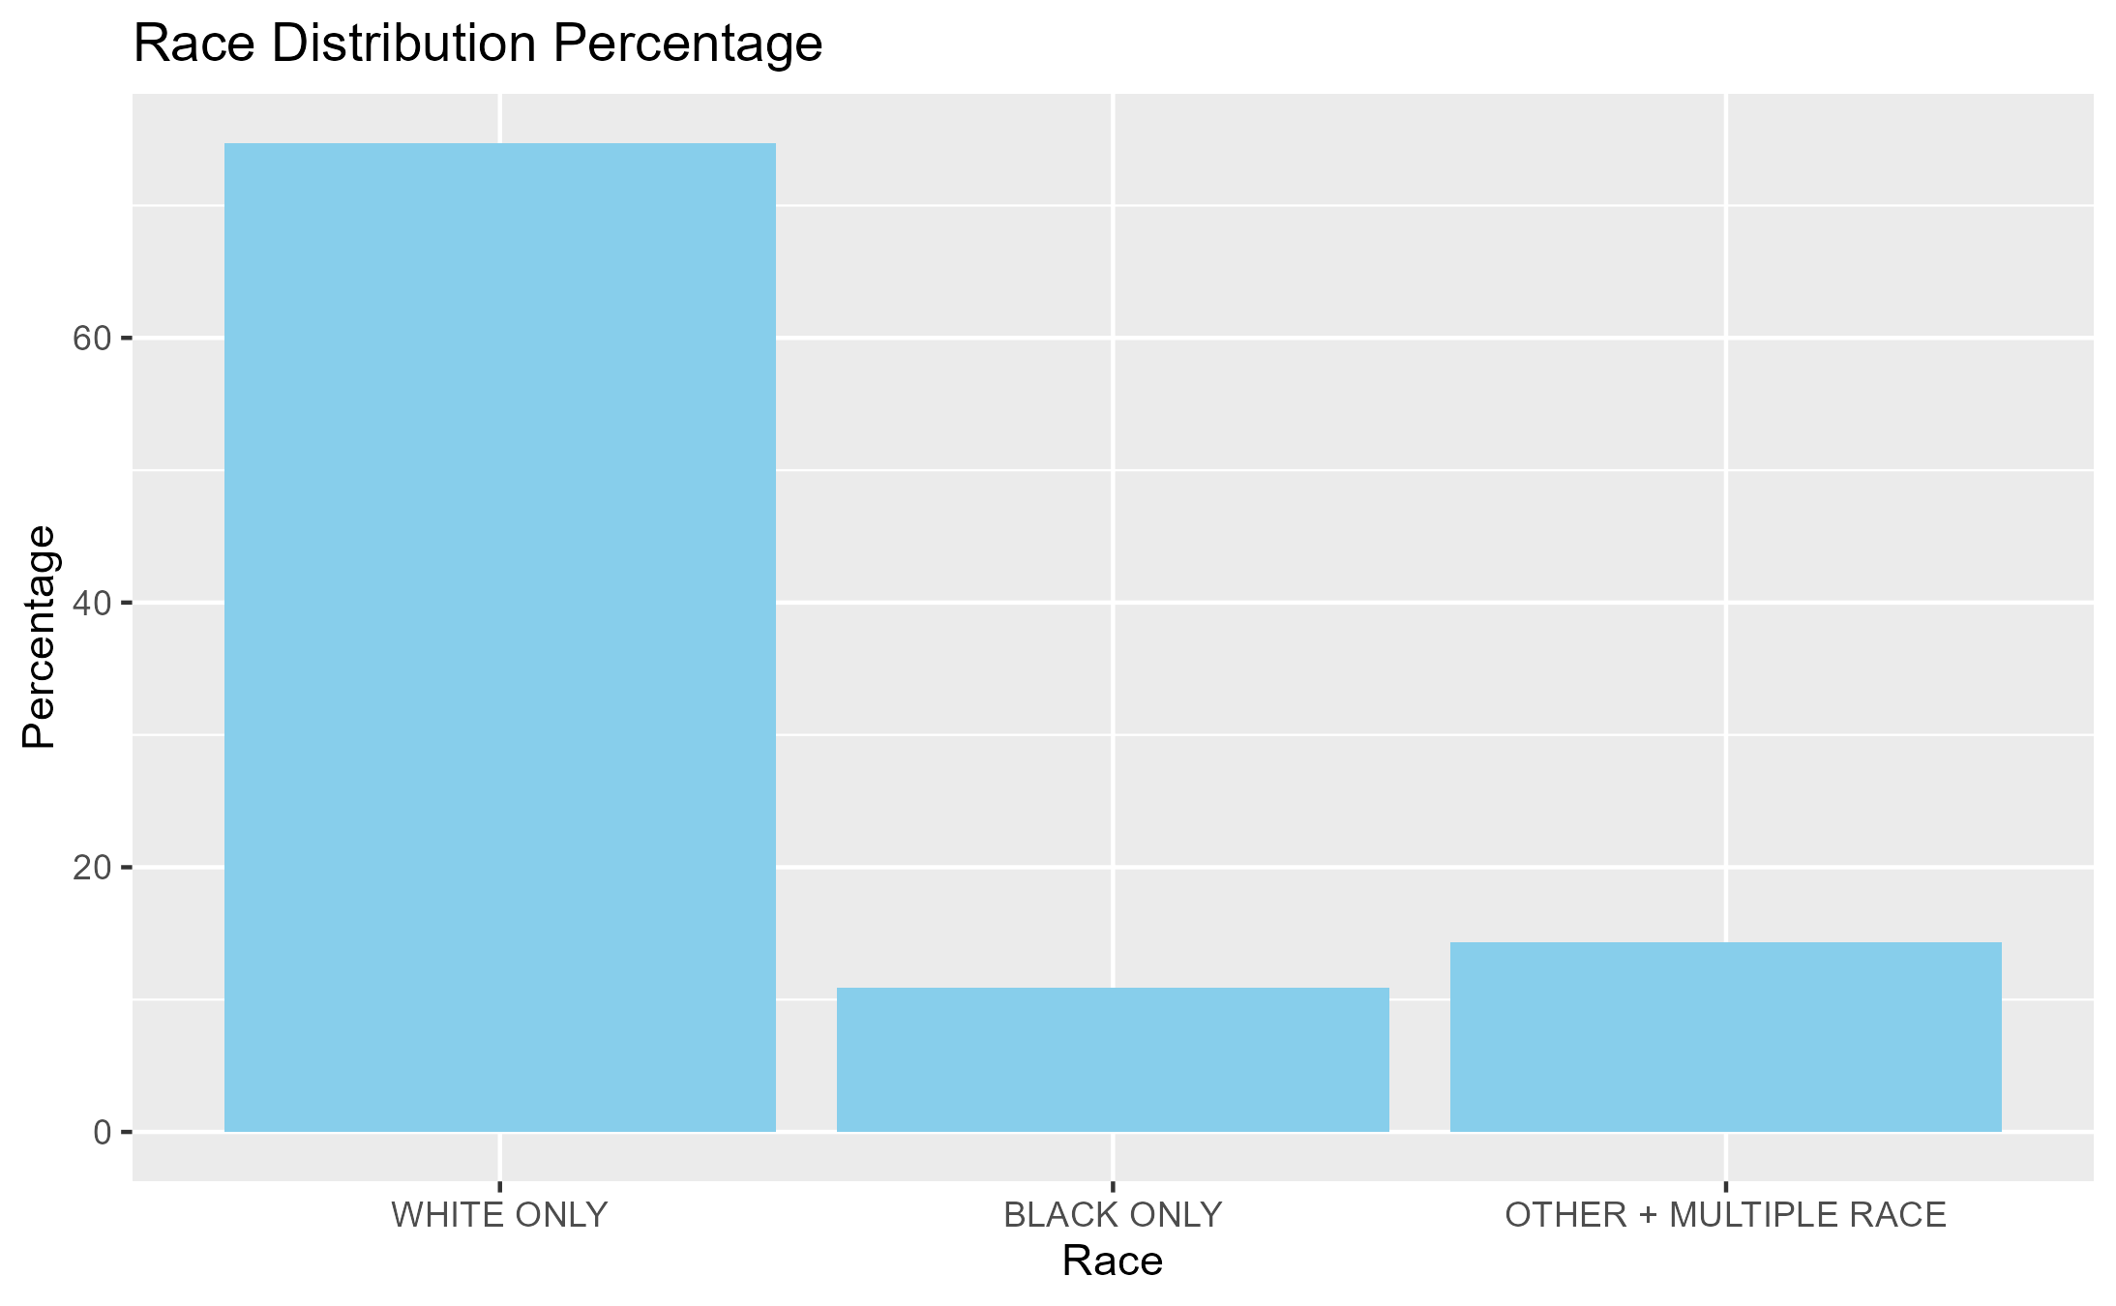

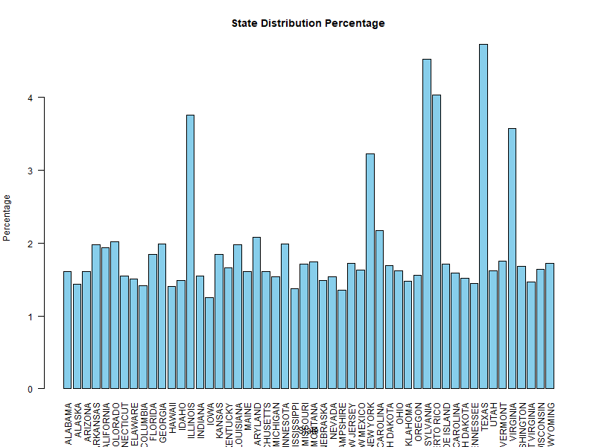

S.7. The percentage of surveys submitted for each state in the U.S. study.

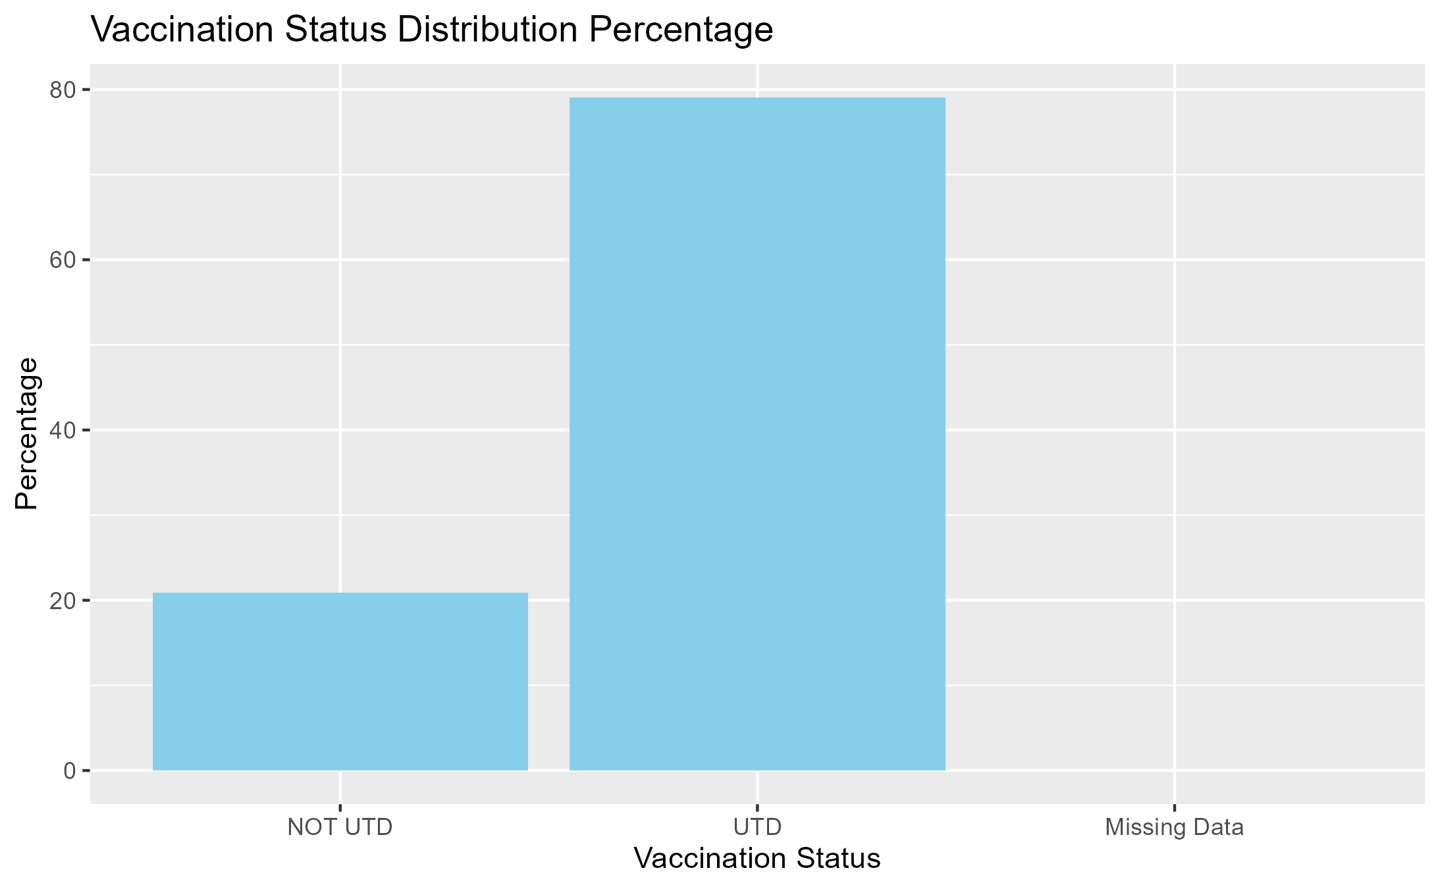

S.8. The distribution of HPV vaccination status in the overall study population of U.S. teens.



S.9. The distribution of race/ ethnicity in U.S. teens in the study population, stratified by HPV vaccination status.

S.10. Percentage of up-to-date HPV vaccination status for each state from study sample.

| STATE | percentage_UTD |
| --- | --- |
| ALABAMA | 73.68421 |
| ALASKA | 75.21008 |
| ARIZONA | 76.02996 |
| ARKANSAS | 73.47561 |
| CALIFORNIA | 74.37500 |
| COLORADO | 81.49254 |
| CONNECTICUT | 79.29688 |
| DELAWARE | 84.80000 |
| DISTRICT OF COLUMBIA | 86.38298 |
| FLORIDA | 74.42623 |
| GEORGIA | 71.51515 |
| HAWAII | 87.98283 |
| IDAHO | 77.73279 |
| ILLINOIS | 82.82504 |
| INDIANA | 77.34375 |
| IOWA | 87.92271 |
| KANSAS | 73.85621 |
| KENTUCKY | 68.72727 |
| LOUISIANA | 79.87805 |
| MAINE | 78.65169 |
| MARYLAND | 85.21739 |
| MASSACHUSETTS | 86.51685 |
| MICHIGAN | 76.37795 |
| MINNESOTA | 85.45455 |
| MISSISSIPPI | 56.14035 |
| MISSOURI | 74.29577 |
| MONTANA | 82.35294 |
| NEBRASKA | 83.73984 |
| NEVADA | 73.72549 |
| NEW HAMPSHIRE | 85.71429 |
| NEW JERSEY | 72.98246 |
| NEW MEXICO | 81.85185 |
| NEW YORK | 81.46067 |
| NORTH CAROLINA | 75.27778 |
| NORTH DAKOTA | 85.35714 |
| OHIO | 78.81041 |
| OKLAHOMA | 70.61224 |
| OREGON | 81.39535 |
| PENNSYLVANIA | 83.06667 |
| PUERTO RICO | 86.52695 |
| RHODE ISLAND | 94.71831 |
| SOUTH CAROLINA | 75.37879 |
| SOUTH DAKOTA | 81.27490 |
| TENNESSEE | 71.12971 |
| TEXAS | 73.59694 |
| UTAH | 76.86567 |
| VERMONT | 87.93103 |
| VIRGINIA | 80.06757 |
| WASHINGTON | 81.00358 |
| WEST VIRGINIA | 70.78189 |
| WISCONSIN | 82.35294 |
| WYOMING | 69.47368 |

S.11. Percentage and Count of up-to-date HPV vaccination status according to racial and ethnic group.

| RACEETHK | total_count | UTD_count | percentage_UTD |
| --- | --- | --- | --- |
| HISPANIC | 3303 | 2728 | 82.59158 |
| NON-HISPANIC WHITE ONLY | 9738 | 7514 | 77.16163 |
| NON-HISPANIC BLACK ONLY | 1516 | 1218 | 80.34301 |
| NON-HISPANIC OTHER + MULTIPLE RACE | 2007 | 1639 | 81.66418 |