**Task 3a (optional) – Using Eclipse and Git / GitHub Desktop for Configuration Management.**

While performing this task, I learned how to configure the Git configuration management system and reviewed concepts on how it works. GitHub is a platform to manage version control and allows users to collaborate remotely. The tutorial described repositories, branches, commits, push requests and pull requests. I created an account on GitHub.com. I then created a ‘hello-world’ repository to become familiar with GitHub. Repositories can store many types of files, but to keep it simple I just created a readme file in my ‘hello-world’ repository. I then started a new branch in the repository and learned that a branch allows you to work on different versions of a repository simultaneously. There is a master branch, which is the main branch. Additional branches are used to examine other solutions and edits before merging with the master branch. A branch is a snapshot of the master at a point in time. Changes made to the master can be pulled into a branch. I made changes to the readme file and pushed the changes to GitHub as commits. A commit is a saved change that has a message describing the justification for the change. This allows others to understand the history of changes made to a repository. I reviewed how pull requests are used to collaborate with other developers to propose changes, conduct code reviews, and merge changes into another branch. I then merged my edits to the readme-edits branch into the master branch. After confirming the merge, I deleted the branch since changes are now incorporated into the main branch and the readme-edits branch is no longer valid.

I completed all 4 units of the Learn Git course at <https://www.codecademy.com/>. The completion certificate is included below:

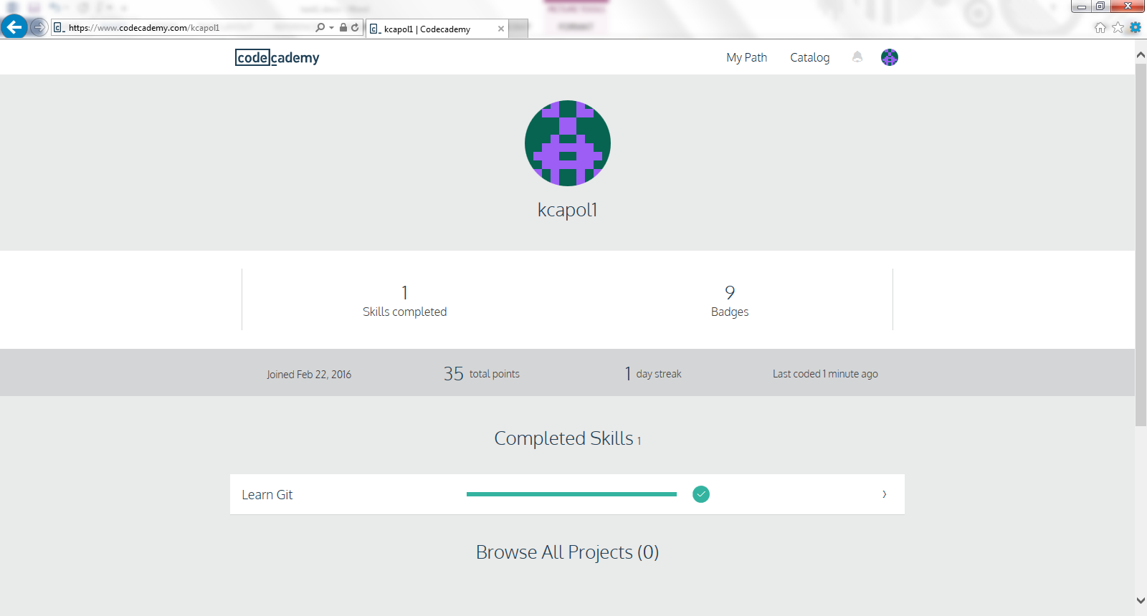

This course did well as a primer for understanding the basic concepts of Git, but it used the command line only. I had some difficulty in understanding how to use the EGit plug-in in the Eclipse IDE. I spent some time searching and review content on the Internet. I found the following tutorial on You Tube which provides a good description on how to configure and use the EGit plug-in for Eclipse:

[**https://www.youtube.com/watch?v=r5C6yXNaSGo**](https://www.youtube.com/watch?v=r5C6yXNaSGo)