**Malformation Nation**

Home About Malformations Background Species Identification Report Data Explore Data Educational Resources

[Placeholder for photo slide-show banner.]

**Have you found a frog, toad or salamander that has extra or missing legs, missing eye or jaw, or looks otherwise deformed, “mutated”, or abnormal?**

If so, we encourage you to report your sightings using the online reporting forms on our [“Malformation Nation” FieldScope](http://narcam.fieldscope.org/) page, sponsored by the National Geographic Society. See the Report Data tab for data collection forms and instructions.

There, you can also get information on the extent of malformation reports received to date, including geographic distribution, information on the types of malformations found and species affected in each area.

[Placeholder for “What’s with the frogs?” video.]

**Amphibian Malformations**

Recent reports of amphibian declines and frog malformations have caused great concern among the public and scientific communties. Multiple limbs, missing limbs, and facial abnormalities are striking hallmarks of the developmental malformations seen in these frogs (see [*Malformation Gallery*](Deformed_Amphibian_Images.pdf)). Although amphibian abnormalities have been addressed in the scientific literature for some time, it was not until 1996—when a group of Minnesota middle school students visited a local pond during a field trip and discovered large numbers of abnormal frogs—that the general public and Congress began to take notice. Soon thereafter, reports began surfacing from other areas of North America that frogs with similar malformations were present. This issue is still very much alive, and new malformations sites continue to be discovered each year. To date, malformations have now been documented in XX species of frogs and XX species of toads from XX states in the USA, with occurrences as high as XX percent in some local populations (citation).

In cooperation with the greater scientific community, the “Malformation Nation” website serves as a resource for people to learn about the amphibian malformation phenomena in North America and for concerned citizens to report on the health of local amphibian populations. The growing increase of citizen science as a tool for ecological research and public engagement provides an indispensable means of continental-scale monitoring of the temporal and spatial changes in malformed amphibian occurrence and severity, information that is vital to amphibian conservation efforts.

**GOT A QUESTION?**

Email us at: [malformation.nation@gmail.com](mailto:malformation.nation@gmail.com)

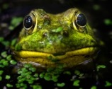

**Malformation Nation**

Home About Malformations Background Species Identification Report Data Explore Data Educational Resources

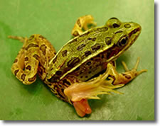

Malformations, along with the apparent decline of many amphibian species around the globe, are raising concerns about the world’s ecological health. Concern over possible associated threats to human health has prompted intensive research by a variety of academic and government organizations. William Souder's book, *A Plague of Frogs* (Hyperion Press, 2000) present s a detailed history of the early investigation into this issue and some of the ensuing controversies (see [*Malformation Gallery*](Deformed_Amphibian_Images.pdf)for an illustration of the major types of amphibian malformations).

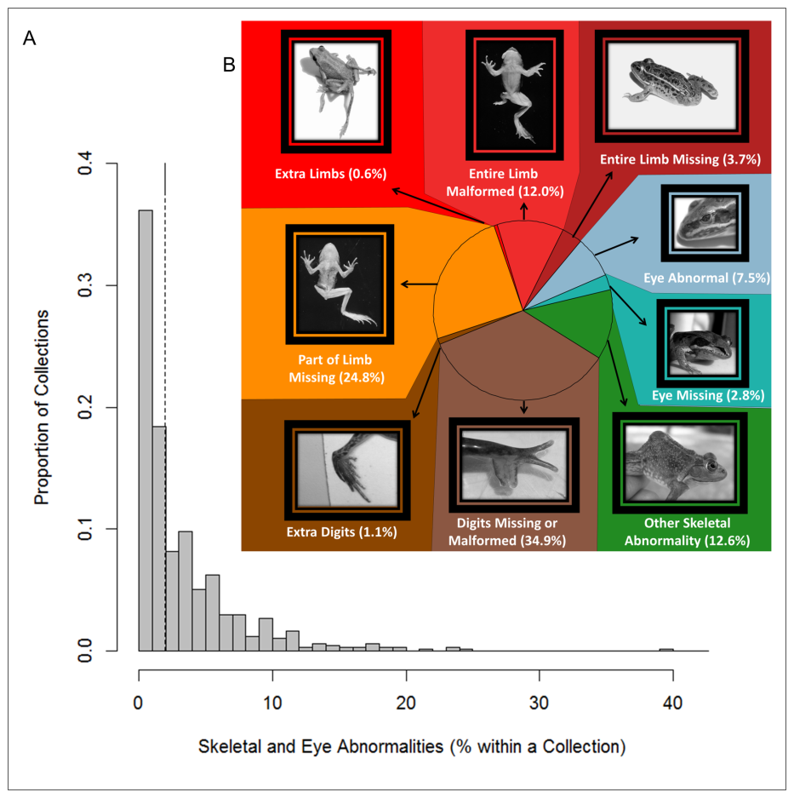

Broadly, scientists have identified a variety of potential causes for amphibian malformations: including climate change, disease (resulting from parasites, bacteria, fungi and viruses), predators, pollution and contaminants such as pesticides, metals and fertilizer, and even the thinning ozone layer and increased ultraviolet radiation. It is probable that malformations are not the result of a single cause, but are rather brought on by different factors acting synergistically in different regions. Readers wanting more information on the causes of amphibian malformations are advised to consult the primary literature for a more in-depth review of the current state of knowledge (Blaustein and Johnson 2003; Johnson et al. 2010). [One option is to have a pop-up of more detailed information appear when a mouse hovers over each oval below.]

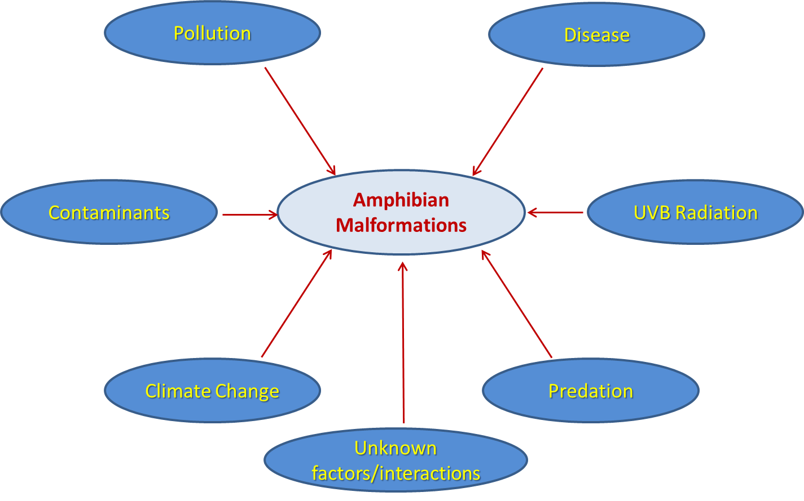

Description of field survey results from Reeves et al. (2013). Percentages in photo figure are proportions of each abnormality out of total abnormalities found in the study.

**References**

Blaustein, A. R. and P. T. J. Johnson (2003). The complexity of deformed amphibians. Frontiers in Ecology and the Environment 1: 87-94.

Johnson, P. T. J., Reeves, M. K., Krest, S. K. and A. E. Pinkney (2010). A decade of deformities: advances in our understanding of amphibian malformations and their implications.  *In* Sparling, Linder, Bishop, Krest (eds), *Ecotoxicology of Amphibians and Reptiles*, 2nd edition.  SETAC Press, Pensacola FL.

Reeves, M.K., Medley, K.A., Pinkney, A.E., Holyoak, M., Johnson, P.T.J., and M.J. Lannoo. (2013). Localized hotspots drive continental geography of abnormal amphibians on U.S. wildlife refuges. *PLoS ONE* 8(11): e77467.

**Malformation Nation**

Home About Malformations Background Species Identification Report Data Explore Data Educational Resources

In the past decade, extensive research into the amphibian malformation phenomena has been undertaken by scientists from government, academic, and non-profit sectors. Below we present information on the history of data collection from these diverse sources, all of which has been critical to obtaining a deeper understanding of the environmental factors driving patterns of amphibian malformation occurrence.

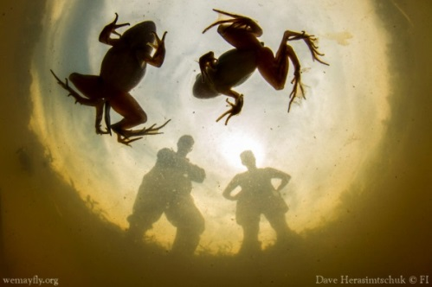

**North American Reporting Center of Amphibian Malformations**

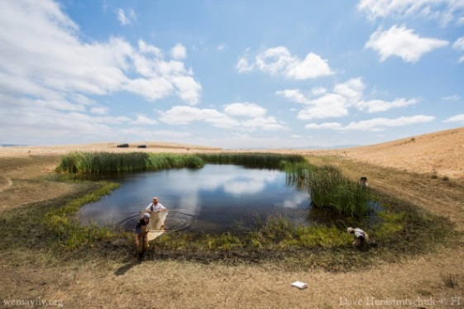Some of the earliest work in amphibian malformations arose from the U.S. Geological Survey’s North American Reporting Center for Amphibian Malformations (NARCAM; Johnson et al. 2000). NARCAM was established in June 1997, following several months of discussions among federal and state agency staff, herpetologists, and other scientists, to facilitate the flow of information in two directions. First, scientists and the public could learn about the phenomenon, as well as where malformations had been found, the rates at which they were recorded, the species involved, and the types of malformations noted. Second, suspected or confirmed malformation observations could be reported to NARCAM’s centralized database so that scientists can search for patterns and trends in the type and incidence of malformations. However, due to federal budget cuts the NARCAM program was discontinued in XXXX. Fear not though! Our website, in conjunction with that [National Geographic Society’s FieldScope environmental education platform](http://education.nationalgeographic.com/education/programs/fieldscope/?ar_a=1), serves as the new portal for learning more about and submitting reports of malformed amphibians across North America. We hope you will join us in continuing this important citizen science effort!

**U.S. Fish and Wildlife Service**

The U.S. Fish and Wildlife Service’s [Division of Environmental Quality](http://www.fws.gov/contaminants/) is also actively involved in studying amphibian declines and malformations. In 2000, the Service launched a nation-wide scientific survey to determine the extent of abnormal frogs and toads on national wildlife refuges, revealing important insights into the geographical patterns of malformed amphibians in the USA. To better study amphibians and the concerns facing them, the Service developed standard operating procedures (SOPs) for abnormal amphibian surveys on wildlife refuges. The Service’s [Amphibian Declines and Deformities](http://www.fws.gov/contaminants/Issues/Amphibians.cfm) web page provides more information about how this federal government agency is working to conserve threatened and endangered amphibians.

Recently, the USFWS was part of an unprecedented 10-year-study (Reeves et al. 2013) revealing encouraging results for frogs and toads on national wildlife refuges. The results showed that, on average, less than 2 percent of frogs and toads sampled across 152 refuges had physical abnormalities involving the skeleton and eyes; a lower rate than many experts feared based on earlier reports. This suggests that the severe malformations such as missing or extra limbs reported in the media during the mid-1990s were actually very rare on national wildlife refuges. However, it is important to point out that this study did not include surveys of amphibian malformations on private lands or other non-refuge public lands. Reeves et al. (2013) reported the presence of areas where sites with higher rates of abnormalities tend to cluster together geographically. Within these regional “hotspot” clusters—found in the Mississippi River Valley (northeast Missouri, Arkansas and northern Louisiana), the Central Valley of California, and in south-central and eastern Alaska—the frequency of abnormalities often exceeded the national average of 2 percent, affecting up to 40 percent of emerging amphibians in some individual samples. This effort represents the first nationwide survey of abnormal amphibians that uses standardized collection and evaluation methods.

**University of Colorado at Boulder**

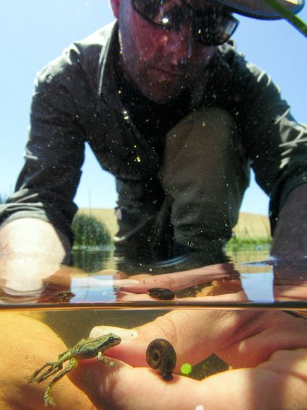

The [Johnson Lab](http://www.colorado.edu/eeb/facultysites/pieter/) in the Department of Ecology and Evolutionary Biology at the University of Colorado has been conducting research on the occurrence and causes of amphibian malformations for over a decade. Researchers in the Johnson Lab focus on bringing a broad perspective to the amphibian malformations phenomenon by combining experiments, large-scale spatial and temporal field data, molecular tools and ecological modeling in their investigations.

In cooperation with the US Fish and Wildlife Service, members of the Johnson Lab are examining parasites of amphibians collected across National Wildlife Refuges in the United States. These data will be invaluable toward understanding (i) how ecological community interactions among parasites affect the abundance of pathogenic species, (ii) exploring how parasite abundance and richness covary in response to latitudinal, longitudinal and land use gradients, and (iii) evaluating whether aquatic parasites can be use as indicators of environmental condition. To learn more about the diversity, distribution and pathology of parasitic infections in North American aquatic communities, please visit the [Aquatic Parasite Observatory](http://www.aquaticparasites.org/) website hosted by the University of Colorado.

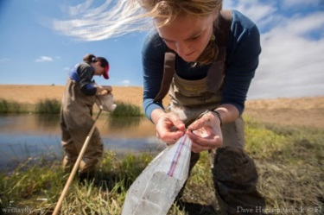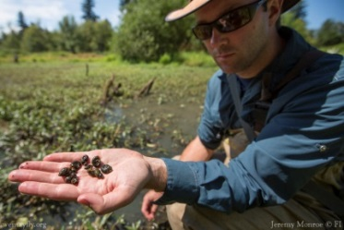

**References**

Johnson, DH, Fowle, SC, and JA Jundt. (2000). The North American reporting center for amphibian malformations. *Journal of the Iowa Academy of Science* 107: 123-127.

Reeves, M.K., Medley, K.A., Pinkney, A.E., Holyoak, M., Johnson, P.T.J., and M.J. Lannoo. (2013). Localized hotspots drive continental geography of abnormal amphibians on U.S. wildlife refuges. *PLoS ONE* 8(11): e77467.

**Malformation Nation**

Home About Malformations Background Species Identification Report Data Explore Data Educational Resources

**Species Identification Guides to Amphibians of the USA**

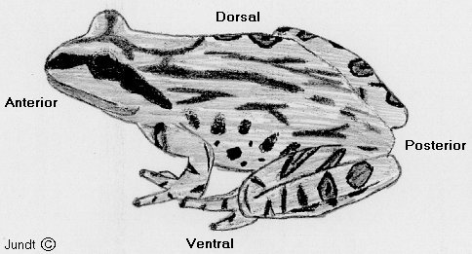The links to identification guides below—stratified by geographic region—are available to help you learn how to identify the amphibian species you are likely to encounter in your area, wherever you may be planning a field trip, or in the USA in general. These guides provide a brief description along with several pictures of amphibian species, in addition to geographic range maps showing approximate locations of where each species may be found.

Please keep in mind that being captured in a picture is far less stressful than being captured physically! A good photo often suffices for identification purposes. Also before capturing any animals make sure that you know which species are protected by law!

**Eastern USA**

[I can’t find any field guides online!]

**Central USA**

**Western USA**

In addition to the links above, there are many specific state and regional guides or checklists that may provide additional information on the amphibians in your state.

**Malformation Nation**

Home About Malformations Background Species Identification Report Data Explore Data Educational Resources

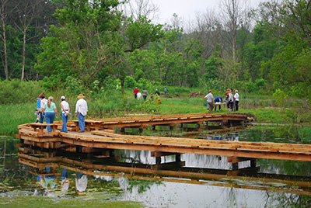

Malformation Nation is working with The National Geographic Society’s “[FieldScope” environmental education platform](http://education.nationalgeographic.com/education/programs/fieldscope/?ar_a=1) to allow science enthusiasts to report, visualize and analyze data on amphibian malformations via online GIS maps. Such “community geography” is a type of citizen science outreach that connects members of the public to the places they care about by encouraging them to conduct fieldwork, share observations and stories, explore maps and geographic data to generate and answer questions, and participate in social and scientific networks to understand and improve local areas (Switzer et al. 2012).

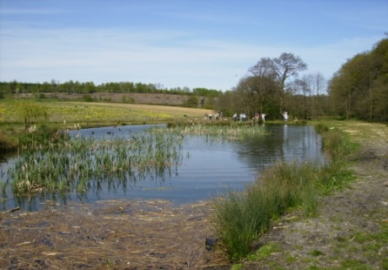Are you interested in being involved in amphibian conservation? If so, we encourage you to [**submit reports of malformed amphibians on the “Malformation Nation” FieldScope site**](http://narcam.fieldscope.org/). Reports provide important baseline data on the health and fitness of existing amphibian populations, and can be used to help identify patterns in amphibian malformation occurrence and severity. With the Malformation National FieldScope platform, citizen scientists can engage in activities such as:

* Exploring maps and data to ask and answer questions about places
* Conducting fieldwork and sharing observations and stories
* Participating in social and scientific networks to document and improve communities

**Do you care about the environmental quality of your local ponds and wetlands?**

**Do you want to be actively involved in amphibian conservation and monitoring?**

**Well then let’s get started!!!**

[**Click Here To Report Sightings of Malformed Amphibians**](http://narcam.fieldscope.org/)

(Note you will be directed to the “Malformation Nation” National Geographic Society’s FieldScope page.)

**GOT A QUESTION?**

Email us at: [malformation.nation@gmail.com](mailto:malformation.nation@gmail.com)



**References**

Switzer, A, Schwille, K, Russell, E, and D Edelson. (2012). National Geographic FieldScope: a platform for community geography. *Frontiers in Ecology and the Environment* 10: 334-335.

**Malformation Nation**

Home About Malformations Background Species Identification Report Data Explore Data Educational Resources

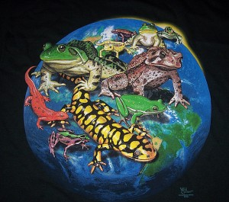

[Do we still want to keep this section? If so, do you have ideas for how to populate it?]

Photo Source: <http://www.tropicalpets.com/amphibians/pet-amphibians/>

**Malformation Nation**

Home About Malformations Background Species Identification Report Data Explore Data Educational Resources

Want to learn more about conserving amphibians? Are you interested in finding more information about how you can help to promote a society that respects and appreciates nature and wildlife? If so, please see the links below that direct you to many sources of information related to amphibian conservation and preservation. Thanks for looking!

* [Save the Frogs!](http://www.savethefrogs.com/)
* [Amphibian Specialist Group (ASG)](http://www.amphibians.org/)
* [Amphibian Research and Monitoring Initiative (ARMI)](http://armi.usgs.gov/) - U.S. Geological Survey (USGS)
* [USGS National Wildlife Health Center](http://www.nwhc.usgs.gov/disease_information/amphibian_malformation_and_decline/)
* [Center for North American Herpetology](http://www.cnah.org/)
* [USGS North American Amphibian Monitoring Program](https://www.pwrc.usgs.gov/naamp/index.cfm?)
* [Amphibiaweb](http://www.amphibiaweb.org)
* [Amphibian Ark](http://www.amphibianark.org/)
* [Partners in Amphibian and Reptile Conservation](http://parcplace.org/) -
* [Society for the Study of Amphibians and Reptiles](http://ssarherps.org/)

**What Can You Do To Help Amphibians?**

You can help keep the environment clean and the frogs healthy by changing the way you care for your yard.

Check out our [Homeowner's Guide to Protecting Frogs - Lawn and Garden Care](http://www.fws.gov/contaminants/Documents/Homeowners_Guide_Frogs.pdf) (pdf).