**IG marketing web-app project**

**Admin Panel Back-end (7 days, 350 AUD)**

Currently admin panel doesn't work properly. Also I think current theme is not good.

So I will fix everything admin panel and update the theme.

The steps for fix and update about admin panel are as follows.

**1. Admin Panel - Theme Update, Users, Hash-tags (4 days, 200 AUD)**

**1.1 Theme Update (50 AUD)**

Current theme is not very perfect. One example is Hash-tag Data.

So current theme can update to best theme. The picture below is one part of it.

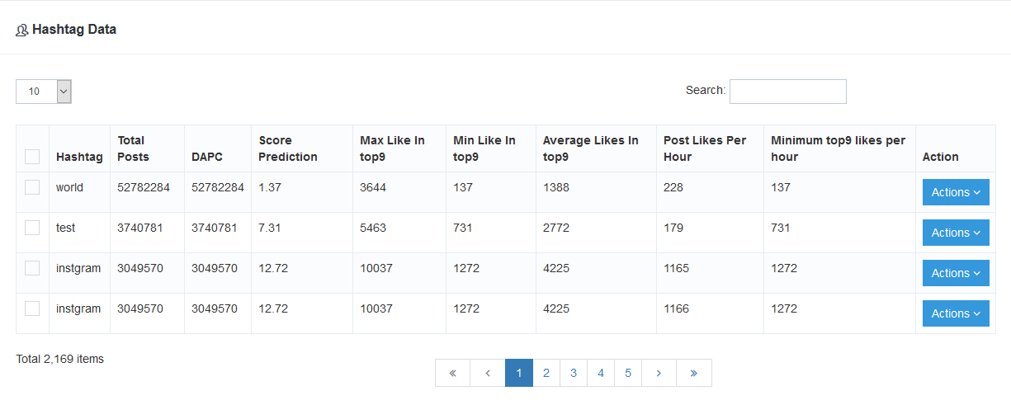Old Theme:

New Theme:

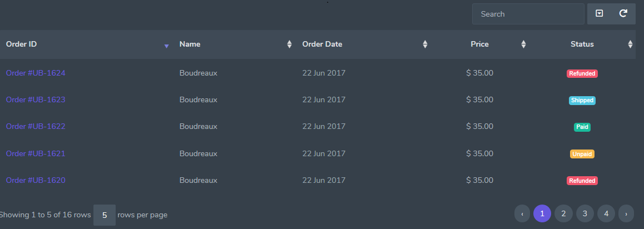

**1.2 Users (50 AUD)**

Admin can approve or suspend the users and add new users.

When changed user status now, this page is reloading. It is very inconvenient.

So I will fix it conveniently and update theme perfectly.

This theme is similar to what we have seen on 1.1 part.

**1.3 Hash-tags (100 AUD)**

Here, the admin proceeds with hash tag management.

As you said in chat, currently, this page is very low on functionality.

For example : when hash-tags logged, they duplicate...etc

**2. Admin Panel - Pages (3 days, 150 AUD)**

**2.1 Dashboard (50 AUD)**

Here admin will see the number of hash-tags, the total number of users registered, and the data of users who are not currently approved.

For example :

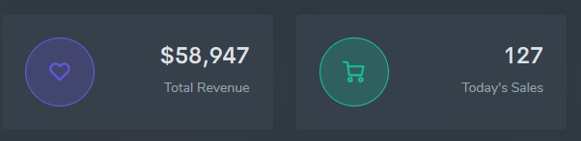The style is similar to what you show saw.

And then the table of users who are not currently pending is also included here.

**2.2 Profile page (50 AUD)**

Here, the admin can register personal information (First Name, Last Name, Email Address, photo) and change the password.

This is similar to another website profile page.

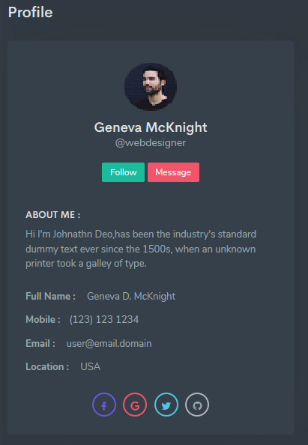

**2.3 Subscriptions (50 AUD)**

It displays and manages the subscription of the user membership.

Here, we show the type of subscription, the period and the price..

Currently this page have no any functionality.

**User Panel Back-end (8 days, 650 AUD)**

I think there are not enough features in the private panel and there are many bugs.

So the user panel should be made new.

The steps for fix and update about user panel are as follows.

**3. User Panel - Account Section (4 days, 300 AUD)**

**3.1 Dashboard (50 AUD)**

This page will be show Hash-tags count scanned today, registered users count, introduction about hash-tags, etc.

This theme is similar to what we have seen on 2.1 part.

And simple description about the website is also included here.

**3.2 Account Plan (250AUD)**

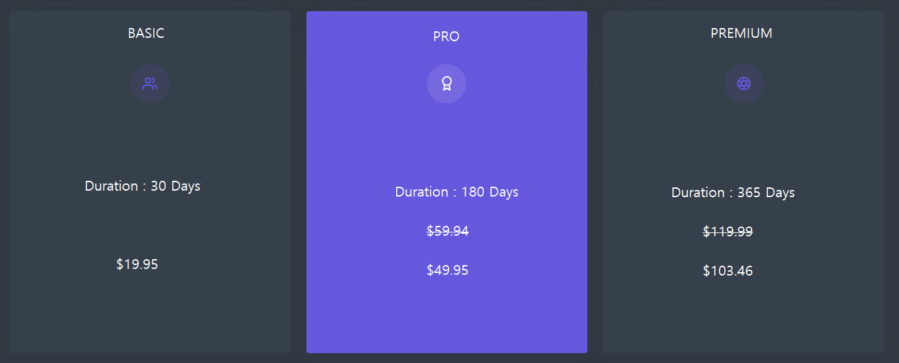 After the users log in to the site, they have to subscribe membership to use hash-tags.

There are three types of membership subscription.

Three types : BASIC, PRO, PREMUM.

The prices and date-range of each type are defined by the admin.

Payment gateway method uses Paypal.

**4. User Panel - Tags Section (4 days, 350 AUD)**

**4.1 Search (150 AUD)**

This page can search powerful hash-tags that want to query.

It will started search after edited Hash-tags and select DAPC range.

The Search results will be displayed in the table of section below.

And then that will be filtered by the hash-tags and the DAPC range.

**4.2 Mass Search (100 AUD)**

This page can search up to 30 hash-tags at once.

The search results will be filtered by the hash-tags.

**4.3 Top Hash-tags (100 AUD)**

This page can search top performing and most popular hash-tags.

The search results is very many.

So, the table that show the search results will be used pagination effectively.

**The First Step Total Estimate : 15 days, 1000 AUD**