This description has been taken from http://www.dijksterhuis.org/setting-up-nunit-for-c-unit-testing-with-visual-studio-c-express-2008/
How to run the NUnit GUI runner from within Visual Studio C# Express 2010 (works also on 2008)
Unit testing helps you verify that each individual part of your code is working as expected and keeps doing that as you change your software. You do this by adding small bits of testing code and have the unit testing frame work execute them in order. This post is about how you can install NUnit, use it and run it with / install it for Visual Studio C# 2010 Express. I will leave the nuts and bolts of unit testing to a future post but this post should get you up and running.
Installing NUnit itself is straightforward and only requires a few steps:
- Download the NUnit framework from the NUnit website (download latest version)
- Install the software on your Windows machine
Please uncomment the following line in the tested GOContactsSync's AssemblyInfo.cs to allow access to internal properties by the Test assembly
[assembly: InternalsVisibleTo("GOContactSyncMod.UnitTests")]
We can run NUnit from the Menu option it installed under [Start/Programs/NUnit] but it is more convenient to do so from Visual Studio Express itself.
Visual Studio C# Express allows you to define outside “Tools” which can be run from the menu. This is exactly what we would like to do with the NUnit GUI Runner. The GUI Runner is a tool which loads our program and executes all the unit tests it finds and reports the results in a seperate window.
Click on “Tools > External Tools…” to add NUnit’s GUI Runner.
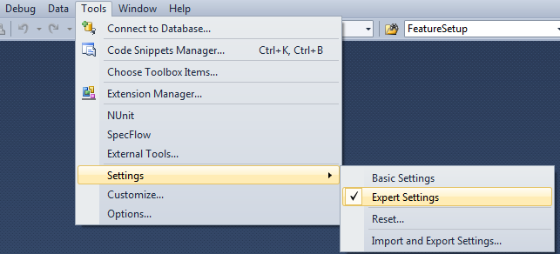
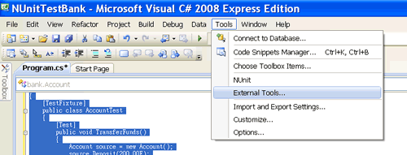
The following definition allows us to run the tests in our current project:
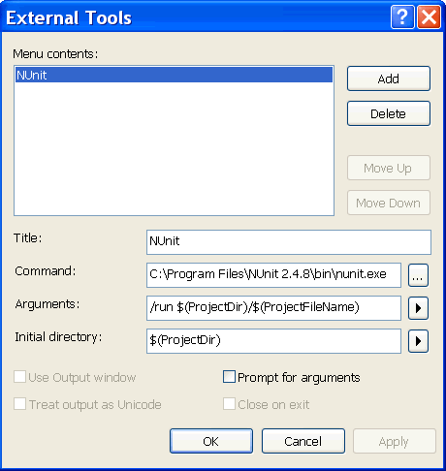
To run the unit test, simply click “NUnit” from the Tools Menu.
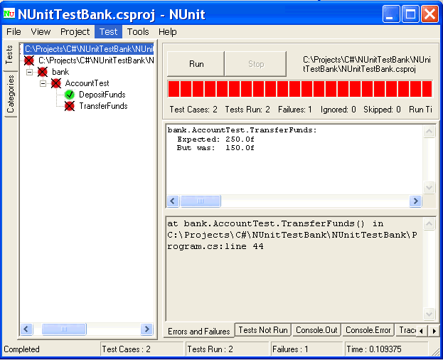
If everything went correctly you should see NUnit run the tests...

