HARVARD AIKIKAI

IS PROUD TO PRESENT
OUR ANNUAL AUTUMN INVITATIONAL SEMINAR
& INSTRUCTORS’ DEMONSTRATION
WITH SPECIAL GUEST INSTRUCTOR

DICK STROUD SENSEI,
6TH DAN SHIDOIN,
CHIEF INSTRUCTOR, MIT AIKIDO CLUB

DATE: NOVEMBER 11TH, 2006

At the Harvard University
QUADRANGLE RECREATION AND ATHLETICS CENTER (QRAC)

Tentative Schedule:

Saturday, November 11th:

11:00 am – 11:30 pm | Registration
11:30 am -12:30 pm  12:30 pm - 1:30 pm | Class  Class
1:30 pm - 3:00 pm | LUNCH
3:00 pm - 4:30 pm | Class
4:30 pm - 5:00 pm | DEMO
6:30 pm - 10:00 pm | POTLUCK DINNER/PARTY

Co-Sponsored by the Reischauer Institute for Japanese Studies
Autumn Invitational Seminar November 11th, 2006
REGISTRATION FORM

 | Name:
 | Address:
 | City: |  |  |  |  | State: |  |  |  |  | Zip Code:
 | Telephone: |  |  |  | ( ) | E-mail Address:
 | Dojo: |  |  |  |  |  | Rank:
 | Sensei:
SEMINAR FEE: $40 Adult $20 Students and Children
or best offer

Please make checks payable to the “Harvard Aikikai”

Waiver of Liability

I, the undersigned, request the privilege of admission to the Aikido seminar organized by the Harvard Aikido Club, hereinafter called the dojo, and given at the above mentioned place and time. I understand that Aikido is a martial art involving strenuous exercise and physical contact. I further understand that neither the dojo nor the organizers of the seminar offer any insurance or guarantees of any sort, nor subscribe to any insurance against injuries to the seminar participants or damage to their property. In consideration of the privilege of being admitted to participate in the seminar, of receiving the provided instruction and of using the host organization's installations for the duration of the seminar, I hereby declare that I will personally assume all responsibility concerning any injury that I may incur or that may be inflicted on me by others during the seminar, be it on or off the premises, before, after, during or between sessions. I hereby hold immune and release the dojo, its directors, employees, agents and representatives, the organizers of the seminar and the instructors of the seminar from all responsibility, accountability and any reparations concerning personal injuries, lawsuits, damages, or losses of any nature whatsoever, in law or in equity, relative to the activities mentioned above. I hereby agree and engage, in my name and in the name of my heirs and beneficiaries, never to pursue, legally or in equity, the dojo, its directors, employees, agents or representatives, nor the organizers of the seminar nor the instructors of the seminar in relation to such injuries, lawsuits, damages, responsibilities, accountabilities, reparations or losses. TO ATTEST TO THIS, I have signed this document and declare that I have read it and understand it.
Signature: |  | Date:
Signature: |  | Date:
Parent or Guardian if under 18 years old

Seminar Logistics:

The seminar will be held on the basketball courts at the Quadrangle Athletic Center (QRAC). Locker rooms (both men’s and women’s) are in the weight room next door to the basketball courts. When entering the QRAC, you will need to check in at the front desk. Please tell them that you are associated with the Aikido Seminar, and give them your name. It would also be good to bring some form of photo identification (a university ID or driver’s license should be fine) to avoid any problems. Lockers will be available in the locker, and we will have space in the seminar venue for some gear storage. Please bring a combination lock if you plan to use the locker rooms, and please bring your own towel. Lockers are also for day use only, so please take all of your belongings with you at the end of the day.

Registration will be in the seminar venue.

Public Transportation:

Parking around Harvard tends to be very difficult, so we encourage Boston-area residents to use the T. Take the Redline outbound to Alewife, and get off at the Harvard Square or Porter Square T-stops. QRAC is located at 66 Garden Street.

From Harvard Square walk north to Garden Street (the left hand side of Cambridge Common). Walk along Garden Street until you reach the corner of Garden and Linnaean Streets. On your left there will be a long driveway. The building immediately next to the driveway is the QRAC. There will be signs marking the door you should enter.

From Porter Square, walk south towards Harvard Square. When you reach Linnaean Street on your right (Next to Brooks Pharmacy), turn and walk down Linnaean Street until it ends where it meets Garden Street. Across the street you will see a driveway. The QRAC is the building immediately left of the driveway. It is large, brick, and partially buried under a grassy hill.
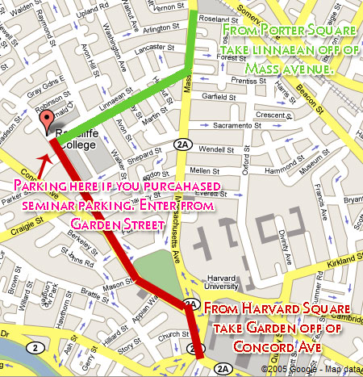

Parking:

Private parking lots are available around the square. Costs for these parking facilities will usually run about $20 a day. We will also have access to Harvard University parking lots around the QRAC. Passes for these lots cost $5 a day and can be used for both the seminar and the party. Please contact club president Maciej Godlewski at godlewsk@fas.harvard.edu by Wednesday evening before the seminar (November 8th, 2006) with your name and plate number if you would like to purchase a parking pass. We will add the cost to your seminar registration fee.

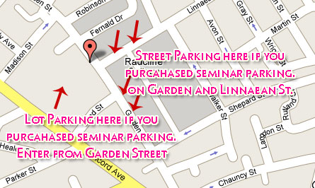

Dinner:

The seminar dinner will be held in the Gilbert Living Room of Currier House, one of the three houses in the college’s residential quadrangle. The living room comes with a complete kitchen, including a full-sized stove and oven, microwave, and refrigerator/freezer. Please e-mail Maciej Godlewski at aikido@hcs,harvard.edu in advance if you plan to make use of these facilities.

Dinner is scheduled to start at 6:30; however, feel free to come any time after 5:45. The club will be covering the cost of three main dishes: a meat dish (chicken), a salad, and a starch (rice). We will also have a very nice array of sushi appetizers provided by the Reischauer Institute. Boston-area participants are encouraged to bring a side dish or dessert if possible. And again, please come anyway if providing a dish proves to be too difficult. We will also be providing soft drinks and some alcoholic refreshments.

Staying Over:

Out-of-town participants are welcome to stay with members of the Harvard Aikikai on a first-come, first-serve basis. Please e-mail club president Maciej Godlewski at aikido@hcs.harvard.edu when doing so. Some bed and futon space is available; however, participants are highly encouraged to bring a sleeping bag if they plan to stay with a club member overnight.

Dinner Directions: (From the Harvard Coop)
1: Start out going WEST on MASSACHUSETTS AVE toward HARVARD SQ. 0.2 miles

2: Turn SLIGHT LEFT. <0.1 miles

3: Turn LEFT onto MA-2A E / MASSACHUSETTS AVE. <0.1 miles

4: Turn SLIGHT RIGHT onto GARDEN ST. 0.6 miles

5: Turn RIGHT onto LINNAEAN ST. <0.1 miles

6: End at 64 Linnaean St
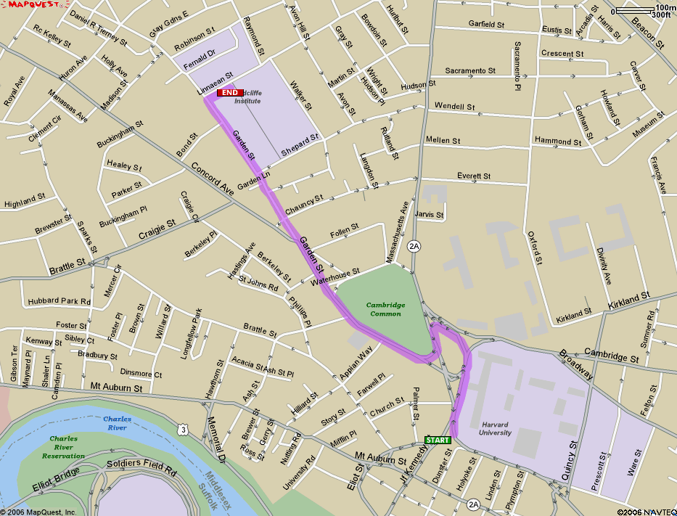
Cambridge, MA 02138-1502, US

