CSC 482 Final Project
- Introduction
  - Natural Language Processing(NLP) is very effective at identifying named entities from a text such as people, locations and organizations, but they can struggle when asked to extract relationships described in the text. Familial relations are particularly difficult because they can be expressed in many different ways both implicitly and explicitly. For example, a sentence may have that someone is a person’s father, but the same relationship could be conveyed in phrases as “raised” or “is parent of”. This variation creates ambiguity that makes reliable relationship extraction challenging.
  - Genealogical information is useful for relation extraction because family structures are common in narratives, biographies, historical documents, and personal records. However, getting these relationships from a text requires a lot more effort than just name entity recognition. A program must determine who the subject is in the paragraph and who they are related to, what specific relationship it is, and whether that is a familial relation. Small changes in wording, pronouns, or sentence structure can completely alter the meaning.
  - For our project, we created a Genealogy Extractor, an NLP model designed to take in text as input and identify immediate family relationships like parent, child, spouse, and sibling. The goal of the project is to explore how well NLP methods and classifying methods can handle the ambiguity and variability of the text’s language while still producing accurate family trees. By focusing on the specific relationships, we narrow the scope to a manageable problem that highlights key challenges in relation extraction. This project demonstrates how transforming unstructured language into a structured family tree can support broader applications in information extraction and knowledge representation.
- Data
  - Data Source: The data we use as input comes from various Wikipedia pages in the sections called Background/Early Life in order to get the familial relations. To test our classifier, we have compiled about 15 text files to use against our classifier. For our training data, we pull from Wikidata which provides the structured family relationship facts used to label the training dataset. The project queries Wikidata for people and their known relations such as parent, child, spouse, and sibling. The final dataset is stored locally as wikidata.json which contains the extracted sentence, the person, the relative, and the label relationship. This dataset contains around 3,000 relationships from 500 people. Ideally, this would be larger, however, the API timed out after 500 requests.
  - Tools:
    - Python was our main coding language
    - spaCY was used for Named Entity Recognition(NER), sentence splitting, and dependency parsing
    - Fastcoref was used as an optional coreference resolution tool
    - SPARQLWrapper was used to query Wikidata through SPARQL
    - Urllib was used to retrieve WIkipedia page content through the Wikipedia API
    - Re was used for sentence cleaning and pattern matching
    - Json was used for storing and loading the training dataset
    - Pandas was used for organizing the dataset during training
    - Numpy was used for numerical operations
    - Pytorch was used for model training and inference
    - Hugging Face Transformers was used for BERT tokenization and BERT sequence classification model
    - Sckit-learn was used for dataset splitting, cross validation, and evaluation metrics such as accuracy, classification, report, and F1 scores
  - Services:
    - Wikidata SPARQL endpoint provided structured genealogy-related facts
    - Wikipedia API provided article text used to collect example sentences

- Design and Algorithm
  - Our genealogy extractor was designed as a multi-stage NLP pipeline that converts text into structured family relationships. To improve robustness, we combined dataset construction, supervised classification, and a fallback parser with classification into one architecture. The final system includes three main components: bert_classifier for training, chatBot_bert is our original sentence parser with Bert classifier as backup, and get_wikidata for compiling dataset.
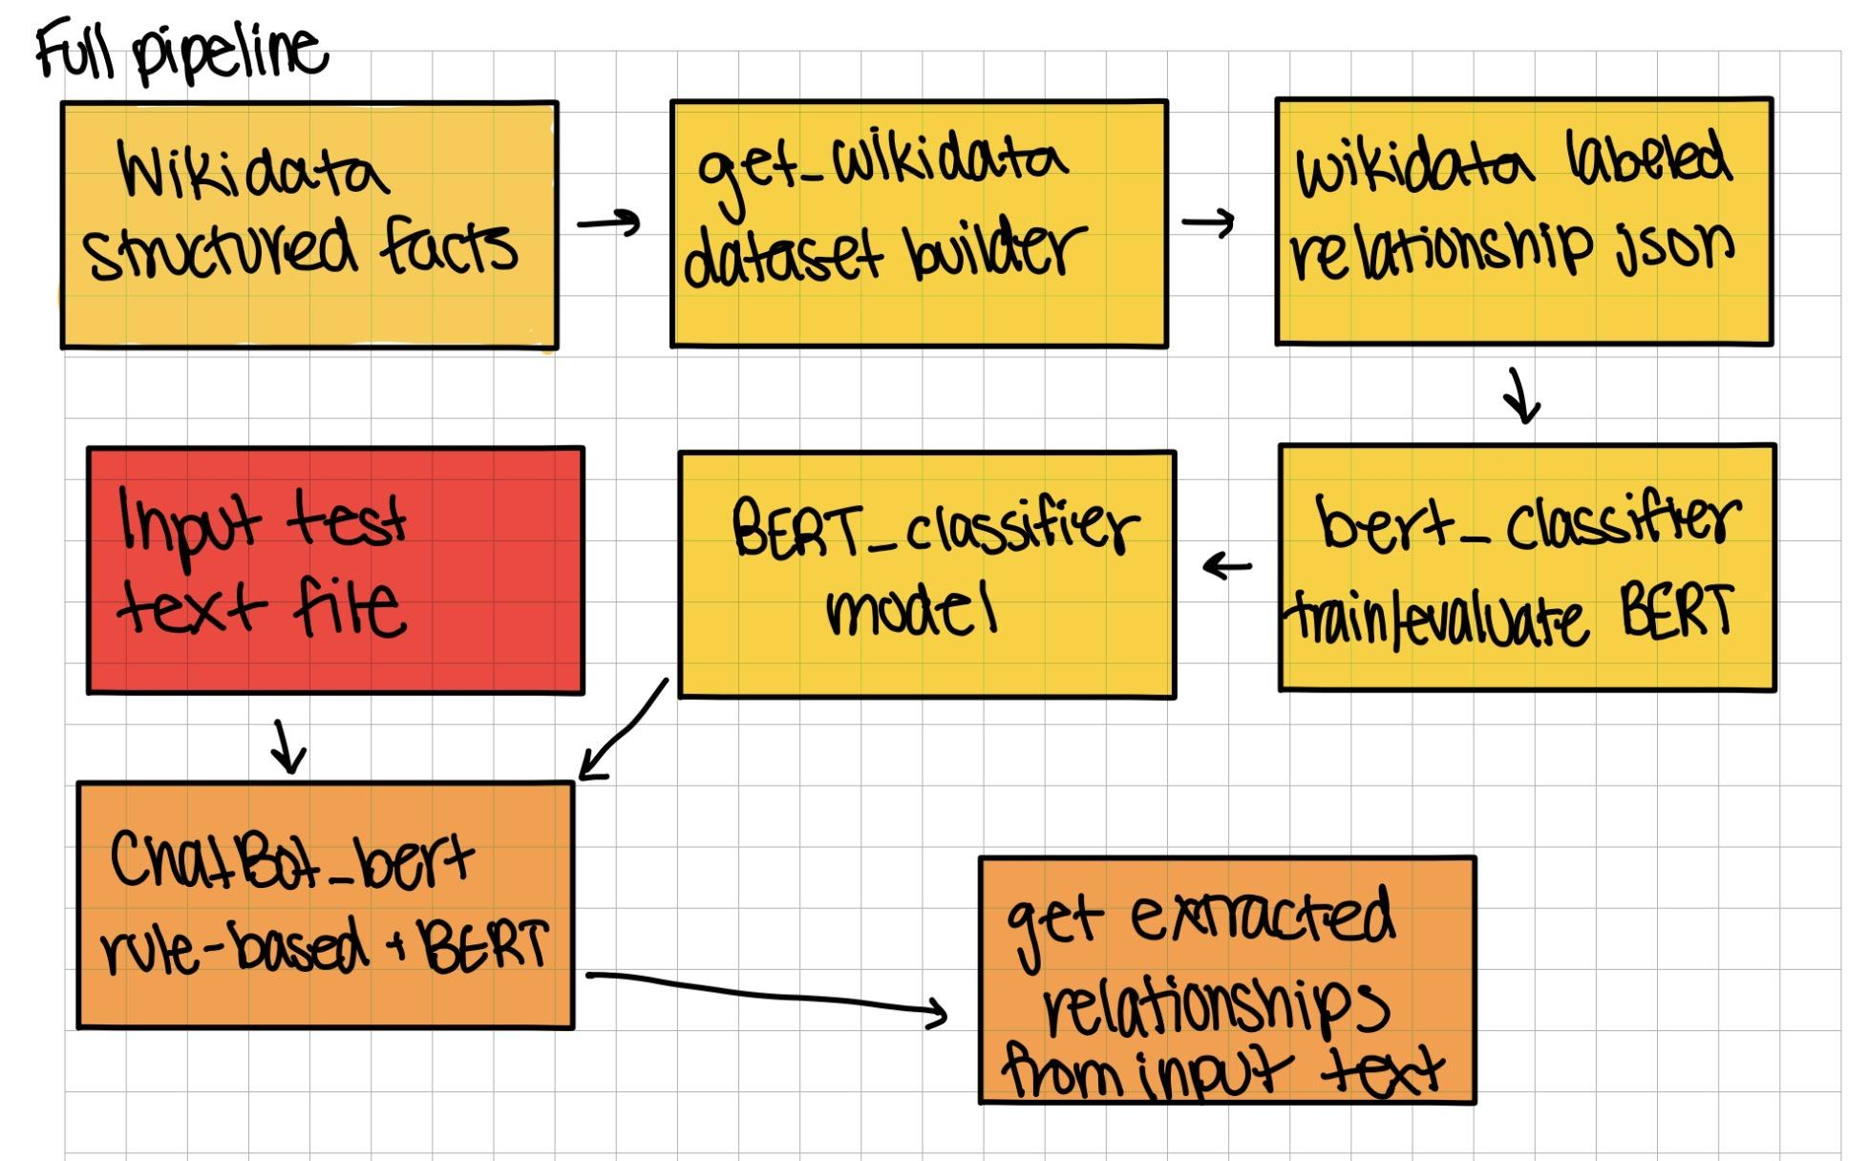

  - Initially, we run get_wikidata to compile the dataset. The program queries Wikidata for people and family relations properties such as parent, child, spouse, and sibling. Once the program has the relations, it ties the Wikipedia article URL to that person and searches through the wikipedia page to get sentences mentioning both people.. It saves the relationships into a dataset that will be used for training.
Output of get_wikidata into the wikidata.json
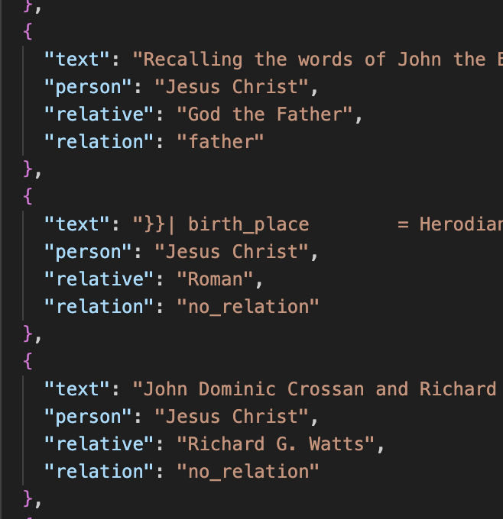
  - The bert_classifier takes this dataset with the already labeled relationships and trains a BERT-based relational classifier on these relationships and measures performance using validation, held-out test accuracy, and F1 scores.
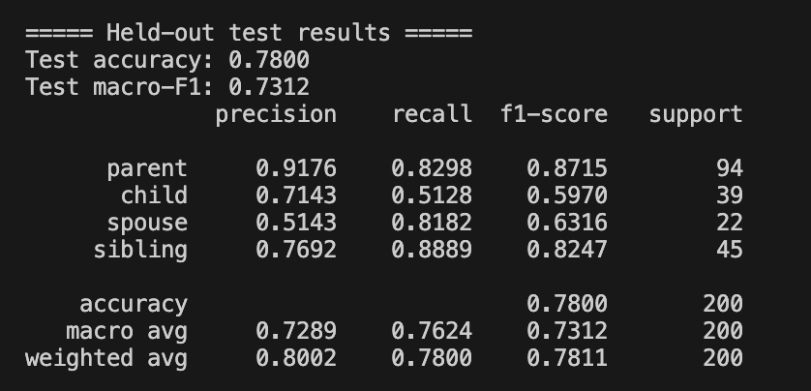

  - The input text is then put through chatBot_Bert and tries to find the familial relations in it and if not all the relationships are retrieved by our rule-based extractor, we use the BERT classifier as a backup. It is a hybrid system where it first uses rule-based extraction with spaCy dependency parsing and Named Entity recognition and then if not all the relationships were detected, it uses the trained BERT classifier that we trained prior.
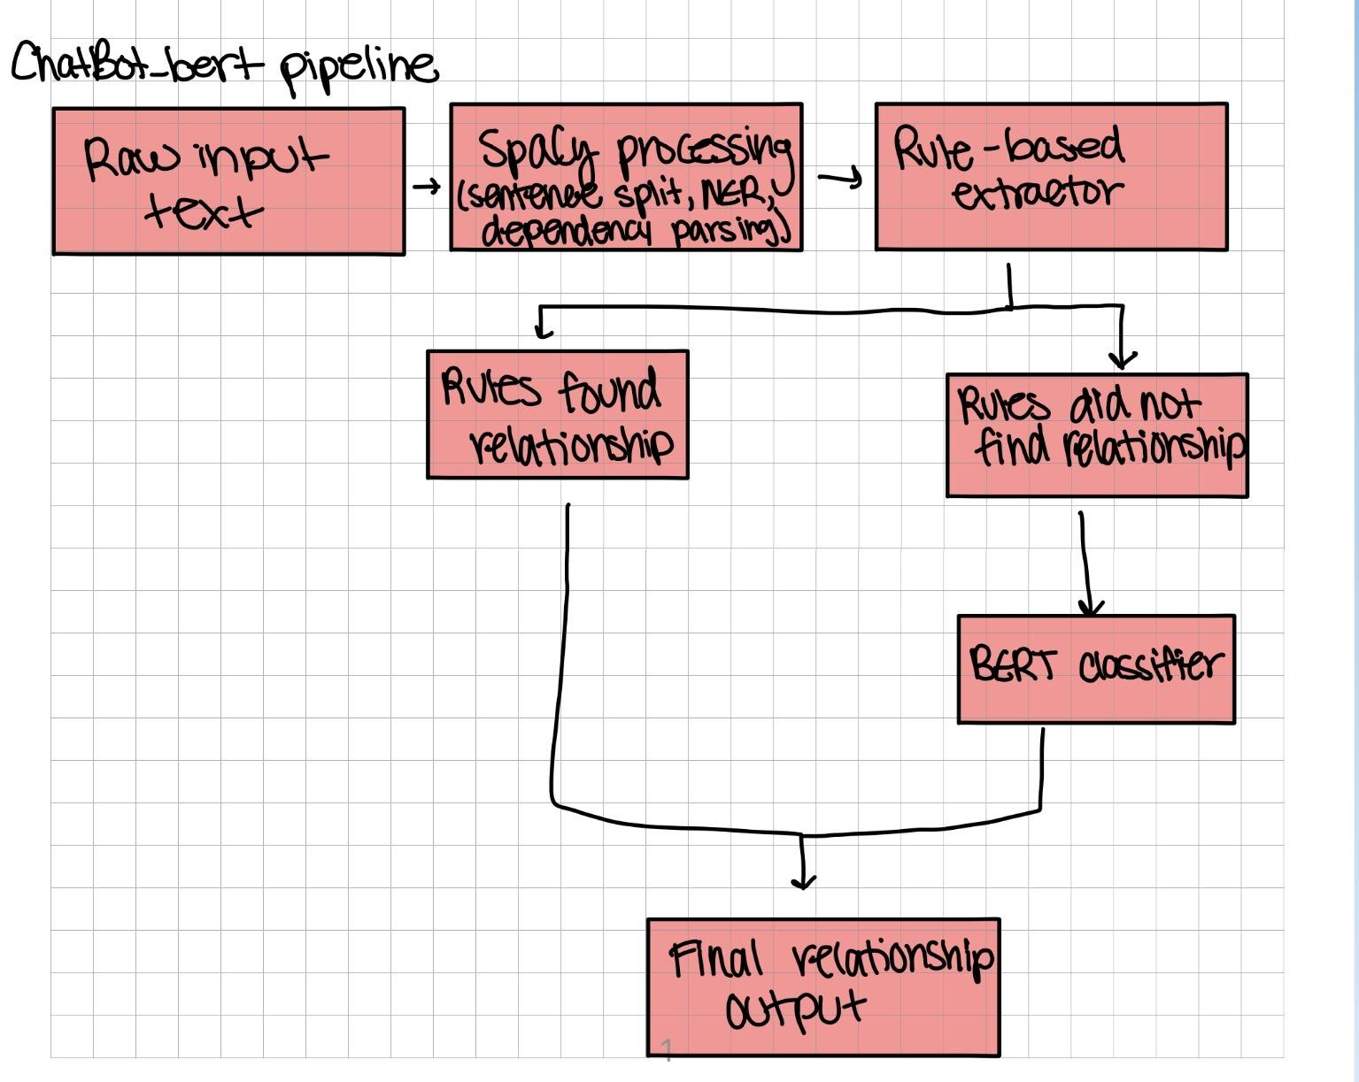
- Evaluation
  - To evaluate our classifier, we had the code output the classification report after it tested the classifier. This gave us information including accuracy, precision, recall, and F1 score which we used to base how well our model was performing. We also would put an input through the classifier and check the family tree output using the ged file.
  - To test out rule-based extractor, we would put an input file in and check the family tree output by comparing it to the ged file of the family tree.
- Results
  - Results of Hybrid system via File
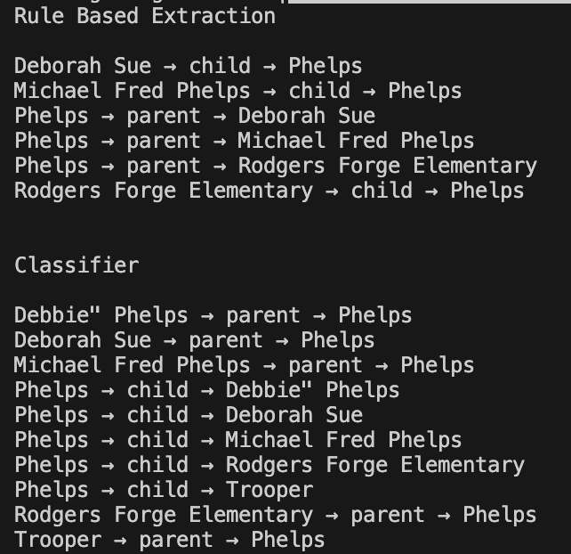
  - Results of Hybrid system via Terminal Input
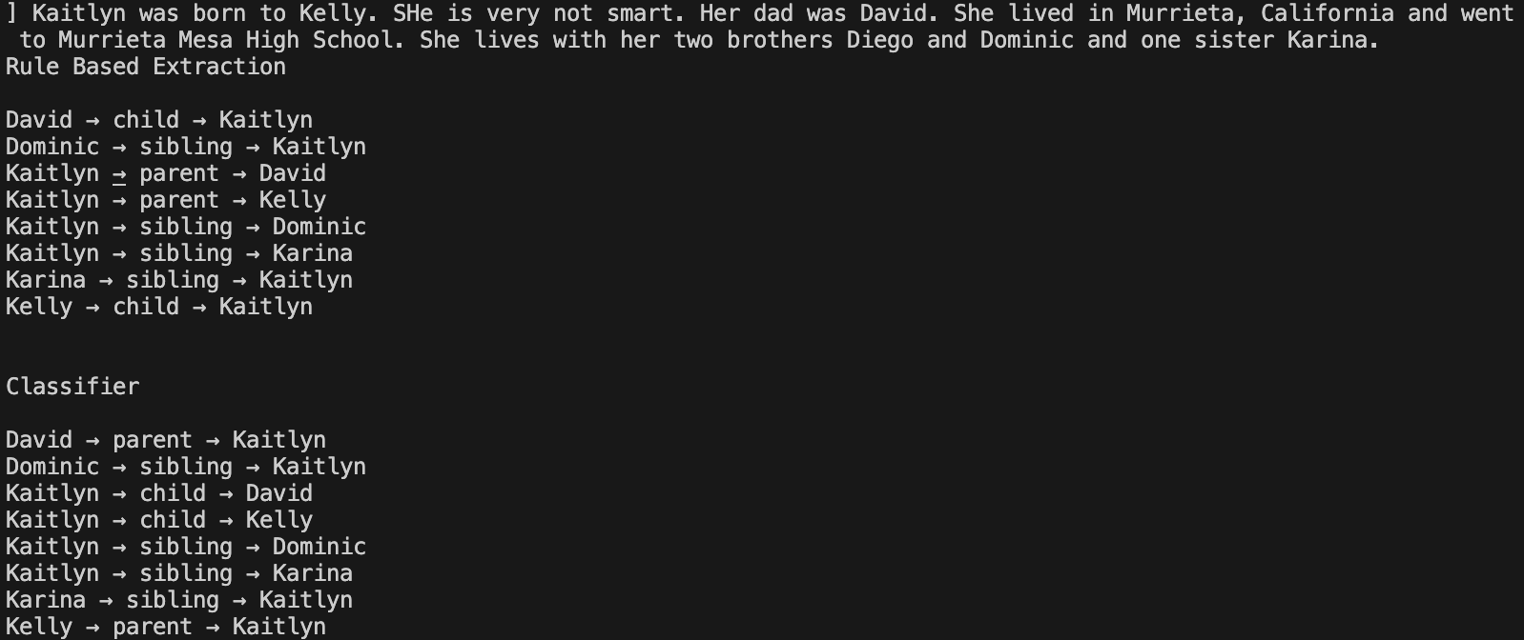
  - Terminal output for obama_in.txt (Barack Obama Wikipedia Page)
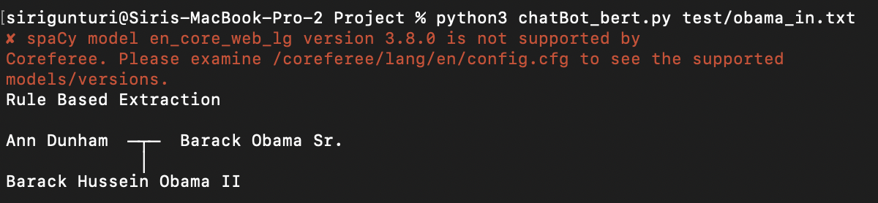
  - Terminal output for hughes_in.txt (Jack Hughes Wikipedia Page)
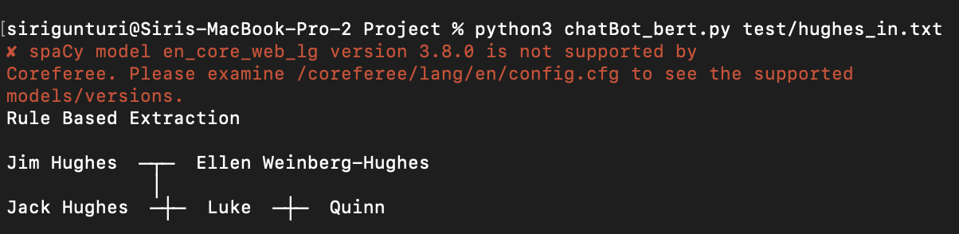

- Limitations
  - There were many limitations with our project. Firstly, spaCy Named Entity Recognition misidentifies some of the entities as “PERSON” that shouldn’t be and some of the entities that should be a person are identified as something else. This messed with the rule-based extractor and the classifier because it would sometimes classify or extract a relationship between the subject and a school.
  - Second, our code would take a long time to compute. To get the data from Wikidata, it would take around 30 minutes each time if we wanted something different from the wikidata. The get_wikidata.py would get approximately around 3,000 relationships since the API would only let 500 people to go across the API at a time. Subsequently, it would take more than an hour to run the BERT classifier as we had the classifier go through 5 folds with 3 epochs in each fold so that we could get the best accuracy across all 5 different categories of relationships.
  - Lastly, there is so much ambiguity when it comes to text and how they talk about relationships. Sentences use the last name of the subject to reference them which can confuse the extractors. Getting more data for the classifier would cause the get_wikipedia code to take longer and the classifier to take longer, but it would’ve helped to get the accuracy of the classifier higher and get the classifier to recognize relationships better.
- Conclusion and Future Work Possibilities
  - Conclusion: NLP is a very difficult subject as seen by this project. Taking the text and finding relationships proved to be harder than expected. We completed the task partially by using a rule-based extractor and classifier to get the immediate family relationships including parent, child, sibling, spouse. The hybrid system had some limitations that challenged us to get the best accuracy and output from our models. The classifier gets a lot of random relationships because some paragraphs have names that are not related to the main subject at all. The rule classifier gets most of the relationships correct, but it solely depends on the paragraph and how things are worded. The classifier and rule-based extractors got different results and one would work better than another in different cases. In all, we learned a lot about NLP and how difficult it is for a computer to understand our language.
  - Future Work Possibilities: To make this classifier and extractor better, we suggest to get more data from the wikidata and possibly add the use of an LLM to get the missing relationships or delete relationships that the classifier and extractor got. The use of an LLM would be beneficial as it would have more data on how to extract relationships and could even know the relationship itself.
Footnotes:
Google Doc link: Milestones

