**INFORMATION ARCHITECTURE 2.0**

### 

### GENERAL INFO

**Website Title:** Albertan Oil in Turmoil

**Domain Name**: albertanoil.ca

**Owner(s):** Kyrie Carritt

**Created by:** Kyrie Carrit

### STAKEHOLDER OBJECTIVES

|  |  |
| --- | --- |
| **Explicit** | **Implicit** |
| Educate users about the positive side of the oil industry. | Get people to think more about the opinions they are given. Question the other side of the story. (Most people seem to be anti-oil here) |
|  |  |
|  |  |

### 

### USER PROFILE

**Who is using the site?**

Adults, people who wish to educate themselves. People who want to read the other side of a controversial debate.

**What are they doing with the site?**

Using it as a learning tool. Expanding their previous knowledge on the topic.

**Where are they using the site?**

At home, where they can read and think about it.

**Why are they using the site?**

To further their knowledge on a topic they have likely previously explored.

### CONTENT INVENTORY

|  |  |  |
| --- | --- | --- |
| SCREEN | DESCRIPTION | LOCATION |
| Landing Page | Title of the website, as well as a summary, and some interesting photographs. | index.html |
| Environmental | A page discussing the environmental impact of oil and gas in Alberta | enviro.html |
| Economical | A page describing the economic benefits of oil and gas in Alberta | econ.html |
| Further Reading | A page linking to other resources for more information | resources.html |
| Other Viewpoints | Discussing the concerns frequently associated with oil and gas in Alberta | views.html |
| Oil Sands | Going further into one of the more controversial projects in Alberta | sands.html |
| Energy East Pipeline | Going further into one of the more controversial projects in Alberta | pipe.html |
|  |  |  |
|  |  |  |
|  |  |  |

WEB MAP

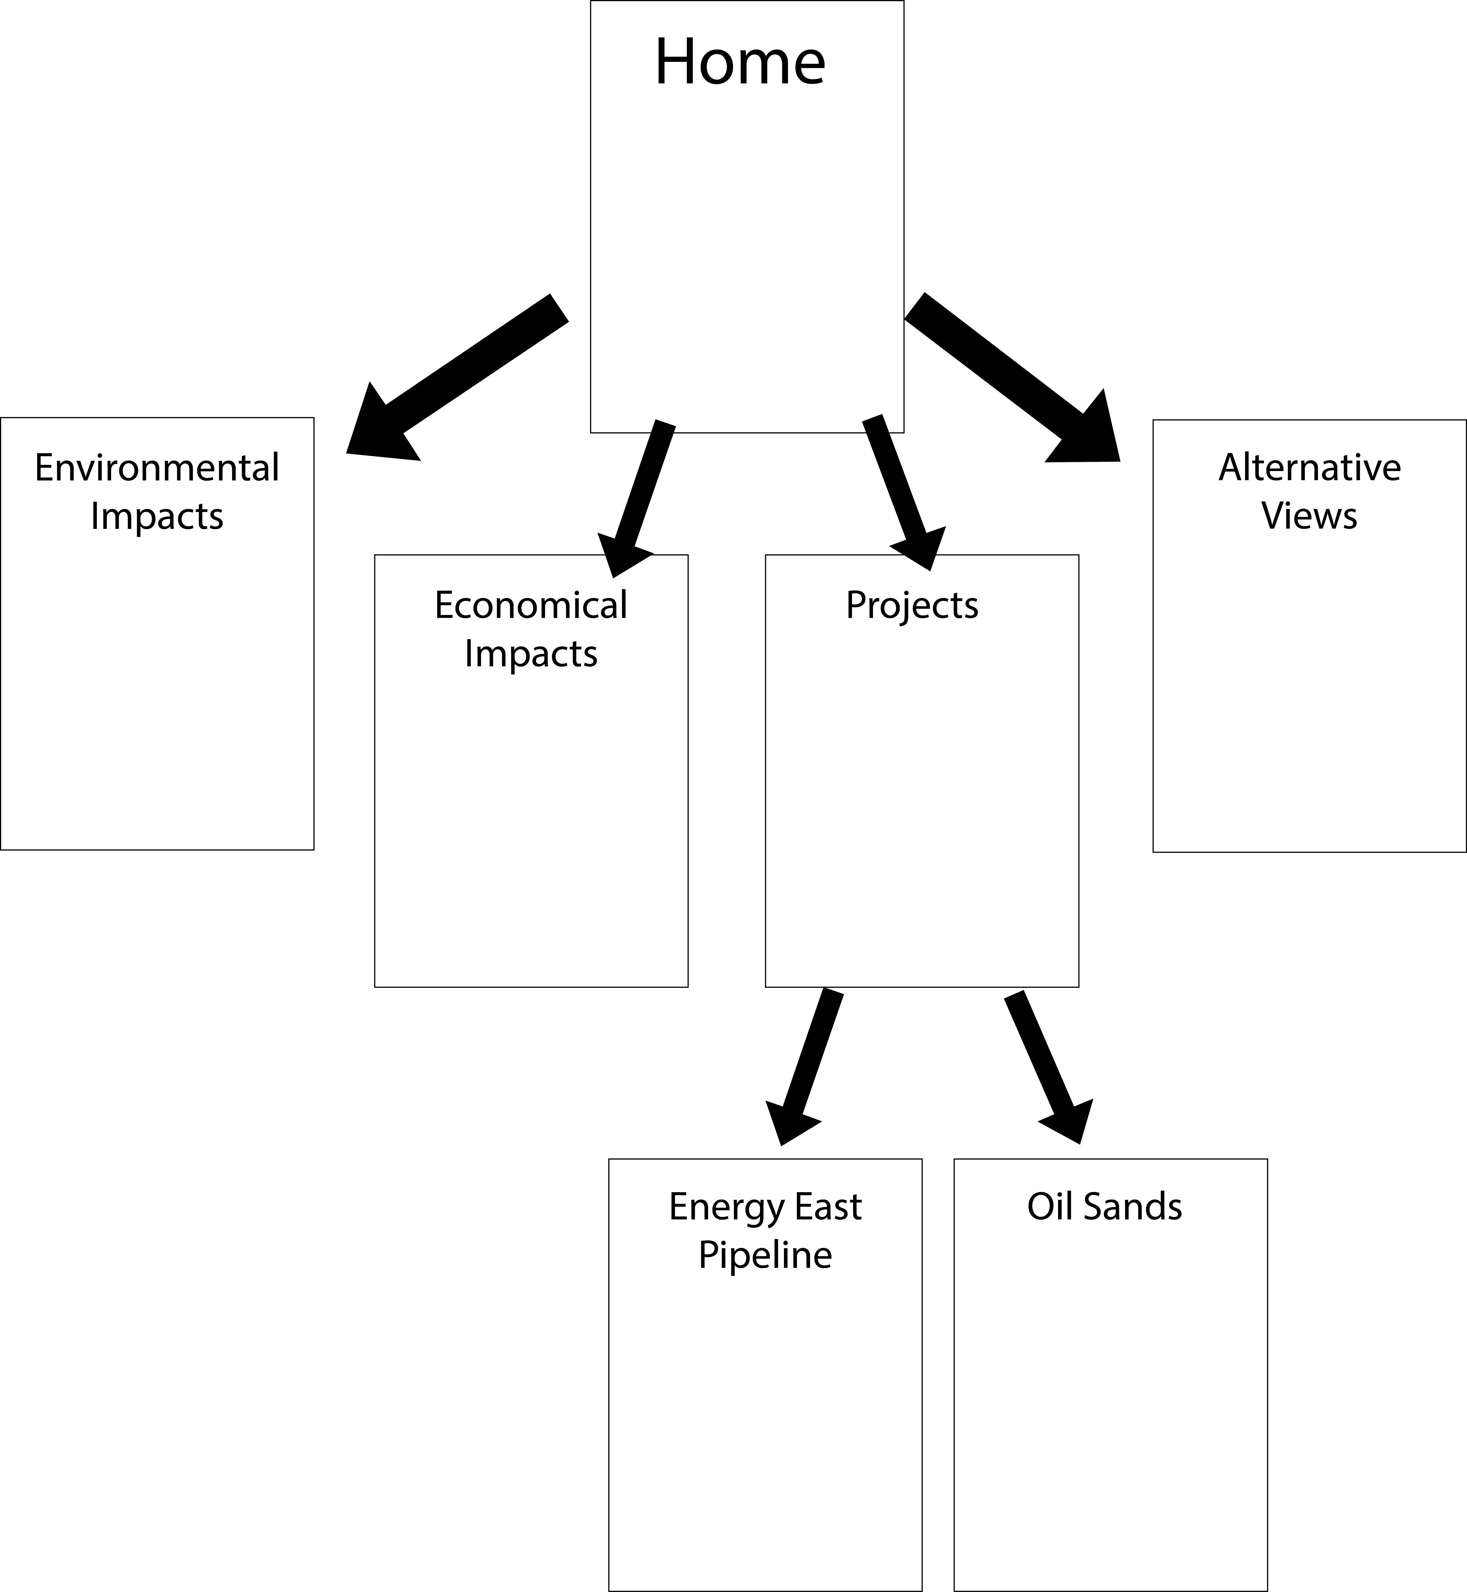

DESIGN INSPIRATION

|  |  |  |
| --- | --- | --- |
| Site URL | What I like | What I don’t like |
| Newalta.com | The cleanliness of the overall site, simple landing page with an easy summary | Too many different links, very overwhelming to look for anything specific |
| Encana.com | The photographic background, with the changing photographs. The simplicity of the layout. | Also too many options, Main page feels very empty, but then there are so many secondary pages to choose from. |
| Slb.com | Not too many options in the main bar, very slimmed down. Majority of the options are below. | Very boring grid pattern, A lot of writing on the landing page. |
| Energyeastpipeline.com | Very exciting grid, little movement in some categories to add interest. | No top option bar, but the landing page is VERY full. |
|  |  |  |