Section A. Fill in the blanks (60 points; 2 points per problem)
1. ( ) (1912–1954) was a British mathematician and pioneer of computer science. He conceptualized the T( ) machine, laying the theoretical foundation for today’s digital computers and AI processing. During WWII, his contributions at Bletchley Park proved crucial for breaking ciphers. He also devised artificial intelligence questions through the famous ( ) Test.
2. ( ) was an American mathematician, electrical engineer, computer scientist, cryptographer and pioneer known as the “Father of Information Theory” and the man who laid the foundation of the Information Age. He wrote a paper, “A Symbolic Analysis of Relay and Switching Circuits,” proved that Boolean algebra could be used to simplify the arrangement of the relays that were the building blocks of the electro-mechanical automatic telephone exchanges.

8. ________, an inventor known as the “Father of Information Theory” and the man who laid the foundation of the Information Age. He wrote a paper, “A Symbolic Analysis of Relay and Switching Circuits,” proved that Boolean algebra could be used to simplify the arrangement of the relays that were the building blocks of the electro-mechanical automatic telephone exchanges.
9. ________ is an advanced weapon launched high into the sky by a rocket. Once it reaches the upper atmosphere, it detaches from the booster. Instead of following a predictable curved path like older missiles, it falls back down toward Earth without an engine. It rides the air wave like a surfboard at extreme speeds—over five times the speed of sound. Because it flies lower than traditional missiles and can quickly change direction, modern radar and defense systems cannot easily track or stop it.
10. ________ is a web-based simulator for RISC-V Processor. It was invented by Cornell University.

Section B. In the assignments and lecture notes (60 points, 4 points per problem)
1. The following is the Verilog HDL code that designed the encoder:
module encoder8to2 (din0, din1, din2, din3, dout);
input din0, din1, din2, din3;
output reg [1:0] dout;
always @(*) begin
if(din0==1 && din1==0 && din2==0 && din3==0) dout = 2'b00;
else if(din0==0 && din1==1 && din2==0 && din3==0) dout = 2'b01;
else if(din0==0 && din1==0 && din2==1 && din3==0) dout = 2'b10;
else if(din0==0 && din1==0 && din2==0 && din3==1) dout = 2'b11;
else dout = 2'b00;
end
endmodule
why the underlying code is nesscesary?
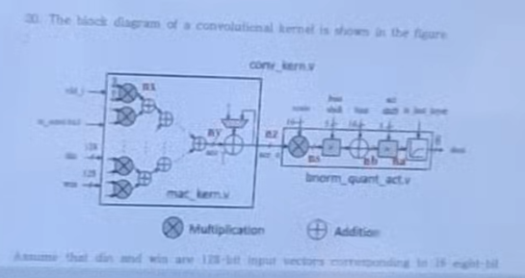
Assume that din and win are 128-bit input vectors corresponding to 10 input bits and 16 weights, respectively. In addition, one special … is used for … and after all … he added to each weight, i.e. weight = weight + 1.
1) What are the values of din and win?
2) Assume that mac_kern only supports unsigned din and win in radix(?) 7, what are the values of din and win?
3) mac_kern is used to
4) srl_shift is used to

2. De-Multiplexer design
Mobile communication standards require spatial multiplexing. A new lab experiment has the channel outputs into random arrays with a larger bandwidth. An interesting method is shown below.
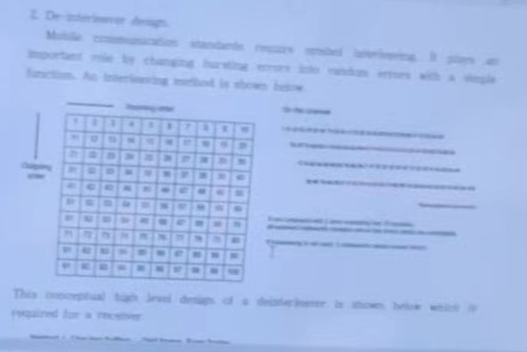
[Figure: 10 × 10 matrix, with Channel / Wire on the left and Input above; Decoupler on the right.]
This conceptual high-level design of a de-multiplexer is shown below which is required for a receiver.
Question 4. Before taking action to the process of Frequent Itemsets, there is an assumption to fulfill. Explain the Apriori Principle (or the downward closure property) with the example of the shopping cart.
Additionally, the minimum threshold requirement can be greatly increased with optimization and I want to provide working code with complexity. (??)
Hint: Use the transaction table in a shop scenario to fit the model case.
마지막 줄은 비교적 잘 보입니다.
Hint: Use the transaction table in a shop scenario to fit the model case.

3. Amdahl's law is a law used to predict the limits of performance increase due to parallel computing or system optimization. It was proposed by computer scientist Gene Amdahl in 1967. Amdahl's law uses concepts such as fraction and explains the acceleration and limitations.

Section C. Descriptive Types (40 points, 10 points per problem)
1. Describe seven performance measures that should be considered when designing an Instruction Set Architecture.

