Epistomology; logical syllogism; logical positivism; inductive versus deductive reasoning theory, law and hypothesis in science; Occam's razor; the scientific method; empiricism, experimentalism, and modeling approaches in research; and what constitutes standards of evidence standards of evidence

**Epistemology**

The study of knowledge in which for one to know something it needs to be justified, true, and believed such as to be latched to a fact. It is the part of philosophy which engages in questioning your deeply held beliefs and shows you what can and cannot be justified.

The theory of knowledge, especially with regard to its methods, validity, and scope. It is the investigation of what distinguishes justified belief from opinion.

**Logical Syllogism** syl-o-jiz-um

Rev: a logical unit of thought

A logical argument that applies deductive reasoning to arrive at a conclusion based on two or more propositions that are asserted or assumed to be true. Syllogistic arguments are usually presented in a three line form, where if a is b, and b is c, then a is c.

**Logical Positivism**

Was a movement in Western philosophy created in the 1920s-1930s by the Vienna Circle which sought to prevent confusion rooted in unclear language and unverifiable claims by converting philosophy into scientific philosophy.

A mvmt that sought clarity in language by pushing an empirical foundation to create verification in statements. “A sentence is only meaningful if it can be empirically verified in principle”, if this sentence goes beyond the 5 senses then it is deemed meaningless, such as metaphysical input since it cannot be verified, thus unfalsifiable and unverifiable. It is based on theory of knowledge which asserts that only statements verifiable through direct observation or logical proof are meaningful.

**Inductive vs Deductive Reasoning Theory**

Inductive reasoning is a method of reasoning that draws a general conclusion based off given assumptions which are viewed as being mostly true. In inductive reasoning the truth of the conclusion of an inductive argument may be probable, based upon the evidence given. Also known as bottom-up logic.

Deductive reasoning is the process of reasoning from one or more statements/premises to reach a logically certain conclusion, always true. Also known as top-down logic, a conclusion is reached reductively by applying general rules which hold over the entirety of a closed domain or discourse, narrowing the range under consideration until only the conclusion(s) is left. There is no epistemic uncertainty, i.e. unrecognizable parts of the currently available set, all parts os the currently available set are available and recognized.

**Law and Hypothesis in Science**

Following the scientific method (using logic and reasoning to explain the natural world), a testable (or measurable) statement is made: a hypothesis. A hypothesis is tested one variable at a time, these variables are tested one at a time through a controlled experiment. After testing the hypothesis, data is analyzed to gain a conclusion on what the experiments results state as opposed to how one feels about it, this helps clarify what happened. Once a hypothesis is tested a large number of times, it becomes a theory, describing something we see in the natural world, however, does not become a law. Theory describes a law, but never becomes a law. A law is a universal truth. A law becomes such through the development of theories that describe properties of the law.

Testable hypothesis- other people testing hypothesis- tested so much it becomes theory- theory never turns into law, only describes a law- law is a universal truth.

A hypothesis is a proposed explanation for a phenomenon made as a starting point for further investigation. Once a hypothesis is tested enough, it becomes a theory.

Law is a statement based on repeated experimental observations that describes some phenomenon of nature. Laws are fact, a universal truth.

**Occam’s Razor (**Synonym: Parsimony.)

The simplest solution or explanation is likely the most correct, as it removes unnecessary assumptions.

Rev: the simplest explanation is likely the most correct explanation.

**The Scientific Method**

The Scientific Method is a process for experimentation that is used to explore observations and answer questions. Understanding the steps of the scientific method can assist in focusing on the scientific question at hand, and allow for work to be done on observations and data to answer the question as well as possible.

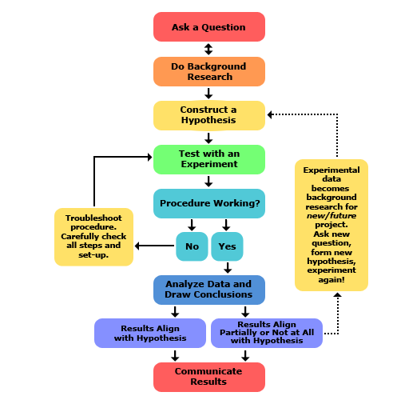

**Empiricism**

The theory that all knowledge is derived from sense-experience. Stimulated by the rise of experimental science, developed in the 17th and 18th centuries.

In philosophy, the view that all concepts originate in experience, that all concepts are about or applicable to things that can be experiences, or that all rationally acceptable beliefs or propositions are justifiable or knowable only through experience. Empiricism derives from the Greek word empeiria, “experience”.

Experimentalism

Modeling Approaches in Research

What constitutes Standards of Evidence