Task 1: A CNN from scratch on CIFAR-10
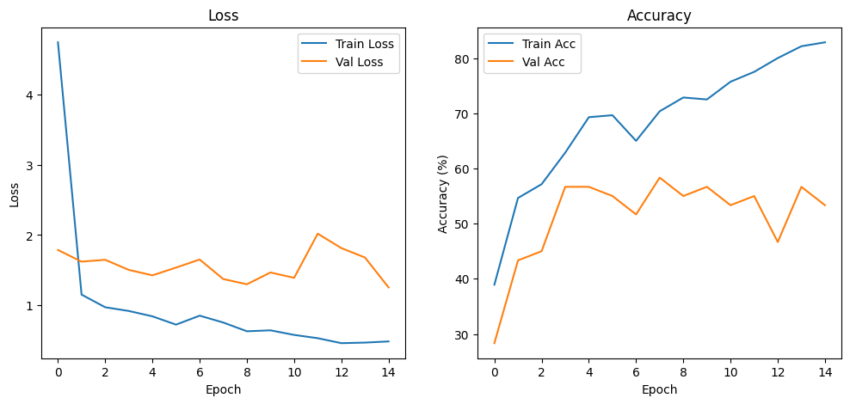
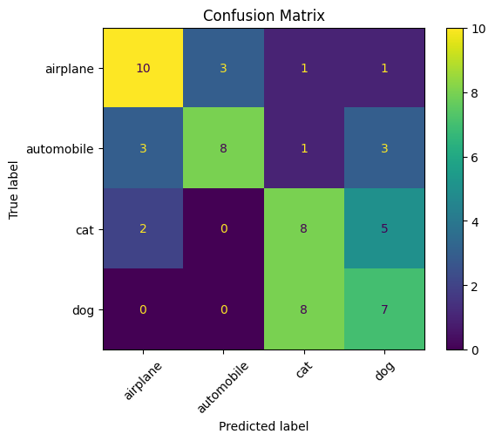
The model begins to overfit after around 5 to 6 epochs, when training accuracy continues to improve while validation accuracy stops improving consistently and begins to fluctuate. The confusion matrix shows that the model was mostly often confusing cats and dogs, which makes visual sense because they share similar textures, shapes, and poses.
Task 2: Transfer learning on your own dataset
Comparison Table
| Model | Test Accuracy | Training Time (s) |
|----------------------|---------------|-------------------|
| Scratch CNN | 70.00% | 36.6 |
| Transfer (Frozen) | 98.33% | 29.3 |
| Transfer (Fine-tuned)| 98.33% | 29.5 |

Dataset:
The dataset is an image classification dataset that contain four different object categories: Bike, Car, Cat, and Dog. Each category includes 1000 images, making a total of 4000 labelled images. It is a balanced dataset. However, in this model, a total of 75 images per class were used for training, 15 images per class for validation, and another 15 images per class for testing. The dataset was created by the author, visal regan, on kaggle and is free for academic use. For more information, it can be accessed from the link below:
https://doi.org/10.34740/KAGGLE/DSV/14807807
Augmentation
The following augmentation techniques were used:
- Resize
- Random Horizontal flip
- Random rotation
- Colour jitter
Task 3: Look inside with Grad-CAM
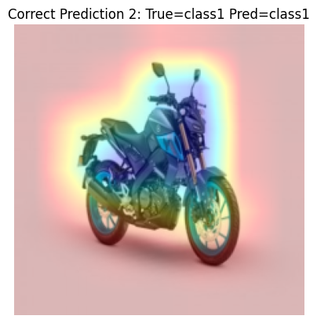 | 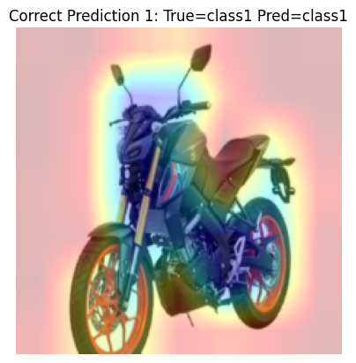 | 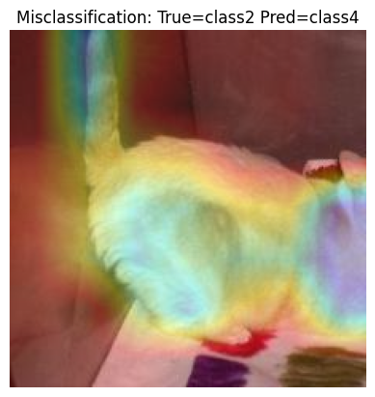
Grad-CAM visualizations show that for correct predictions (motorcycle), the network attends to the main object, confirming it has learned relevant features. For the misclassified rabbit predicted as another class, the heatmap highlights both the animal and the colourful background, indicating the model relies on contextual cues rather than distinctive object features. This suggests the dataset contains background bias and would benefit from more diverse examples or augmentation to improve generalization

Task 4: Deploy to Hugging Face Spaces
The average inference time is 11.65 ms. The results indicate that the model performs inference quickly under the tested conditions, making it suitable for an interactive educational application. However, inference time measures the model's prediction process and does not necessarily represent the total time users experience, which may also include image uploading, preprocessing, server response and network latency.
For real deployment changes, I would prioritise validating the model on realistic, independent data, protecting uploaded images, verifying the dataset's exact licence and measuring the real response time of the hosted application.
The gradio application for image classification can be accessed via the link:
https://huggingface.co/spaces/kbesa/mobilenet-image-classifier

