Task 1: Optical flow, sparse and dense
The outputs are in the location: videos/optical_flow_results

Task 2: Track through occlusion with a Kalman filter

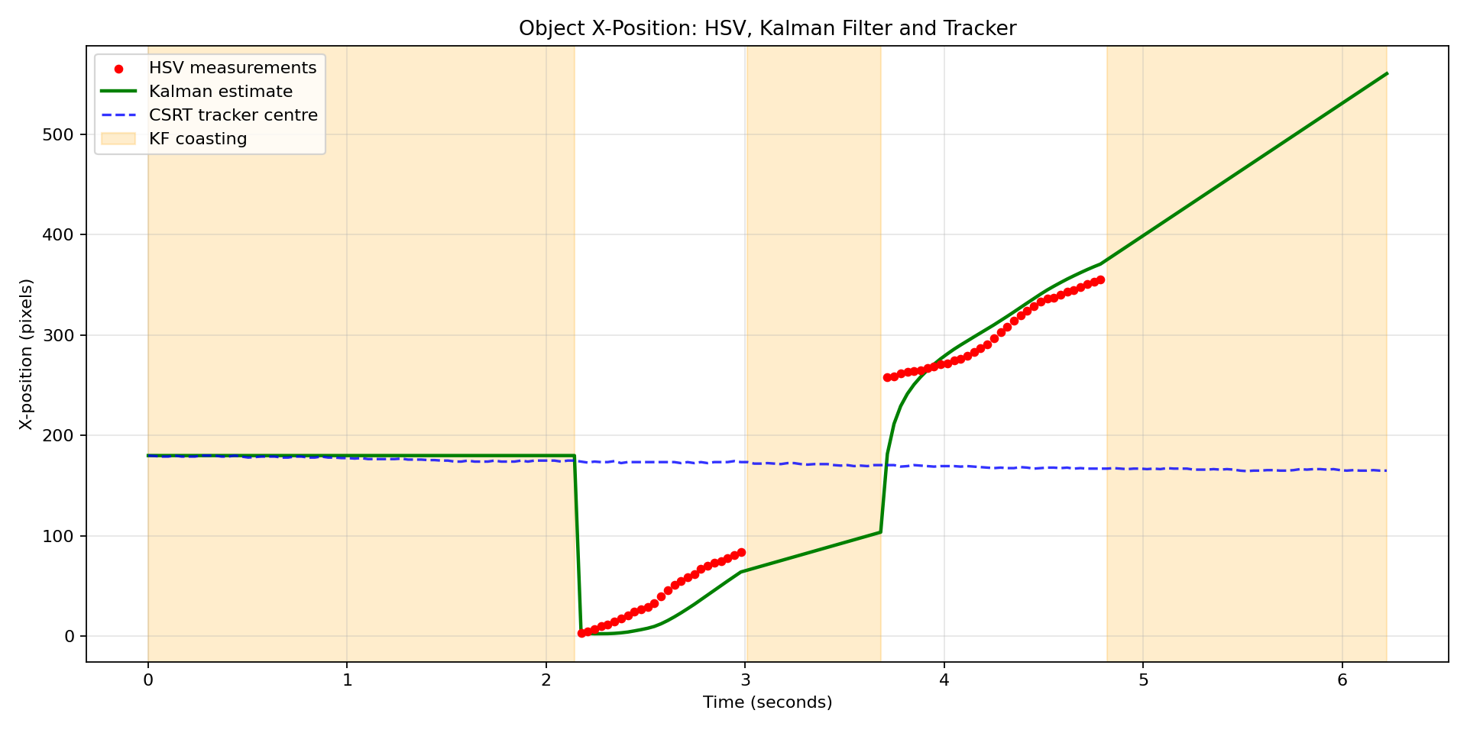

what does each approach do when the object disappears?
When the object disappears, HSV colour detection simply stops reporting. It evaluates each frame independently, and so as soon as the coloured pixels no longer match the thresholded range, detect_largest_colour_object returns None and no measurement is produced. There is no memory, no extrapolation, and no guess about where the object might be. It signals that the object is not visible.

The Kalman filter keeps going. Because it carries a constant-velocity motion model, it continues to call predict() on every frame even without a measurement, propagating the state forward using the last known velocity and inflating its covariance by the process noise Q. This is the coasting behaviour shown by the orange bands and the smooth green line running through the gaps in the plot. It produces a physically plausible trajectory in the absence of the object.

CSRT and KCF behave differently from both HSV and Kalman filter. They have no motion model, so they cannot extrapolate. Instead they keep searching for their learned appearance template and returning a bounding box for as long as the correlation response stays above their internal threshold. In practice this means they usually do not report failure during brief occlusions; they silently drift onto nearby background texture, a shadow, or a similar-looking region, and continue to return True from update(). When the object reappears, they often fail to re-lock and either stay stuck on the wrong region or eventually report TRACK LOST. The flat blue line in the plot through every coasting interval is the visual signature of this: CSRT kept returning a position, but it was not tracking the missing object.

Task 3. Calibrate your own camera
============================================================
CALIBRATION RESULT
============================================================

Camera matrix K (3x3):
[[2.82819686e+03 0.00000000e+00 1.53004752e+03]
[0.00000000e+00 2.83122865e+03 2.00296263e+03]
[0.00000000e+00 0.00000000e+00 1.00000000e+00]]

fx = 2828.197 px
fy = 2831.229 px
cx = 1530.048 px (principal point)
cy = 2002.963 px

Distortion coefficients (k1, k2, p1, p2, k3):
[ 0.13209791 -0.44242192 0.0006959 0.00140488 0.40070856]

RMS reprojection error (calibrateCamera): 1.5820 px
Mean per-image reprojection error: 0.2251 px
Min / Max per-image error: 0.1747 / 0.2807 px

~ RMS between 1 and 2 px — acceptable but could be better.

Highest-error images (candidates to drop):
20261012_150630.jpg 0.2807 px
20261012_150551.jpg 0.2524 px
20261012_152230.jpg 0.2400 px
20261012_150654.jpg 0.2370 px
20261012_152411.jpg 0.2330 px

============================================================
FOCAL LENGTH
============================================================
Sensor width (spec) : 8.16 mm
Image width : 3000 px
mm per pixel : 0.002720 mm/px

fx = 2828.20 px fy = 2831.23 px
Focal length (avg) : 2829.71 px
Focal length : 7.697 mm

Approx. horizontal FOV : 55.88°
Approx. vertical FOV : 70.48°

✔ Focal length is in the typical range for a phone wide-angle lens.

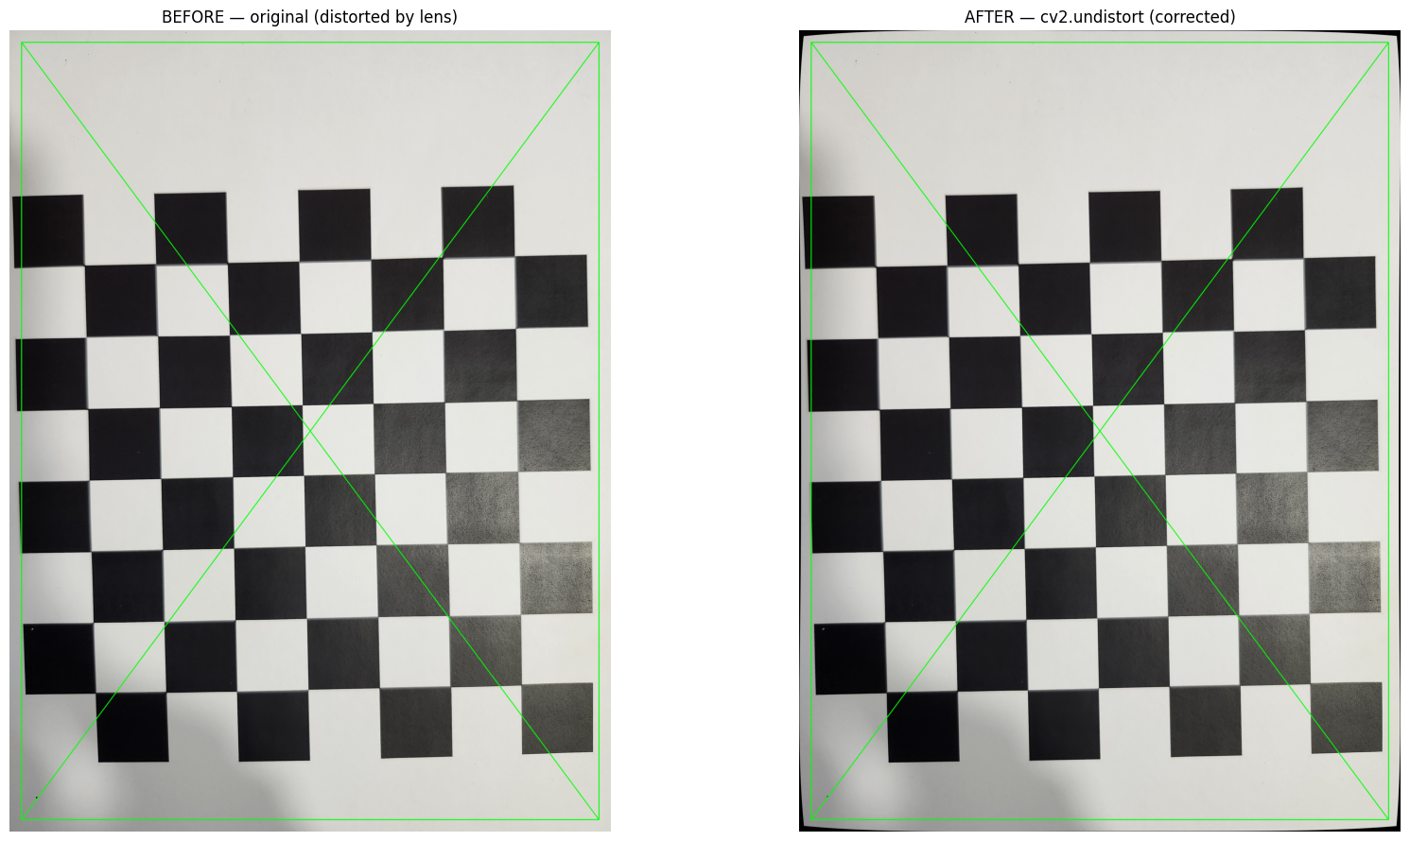Demo image: 20261012_150547.jpg
Saved side-by-side to images/calibration_photos/undistort_before_after/undistort_before_after.png
Task 4: Augmented reality: a cube on the chessboard
Available calibration keys: ['K', 'dist', 'image_size', 'fx', 'fy', 'cx', 'cy', 'focal_mm', 'sensor_width_mm', 'rms']

Camera matrix:
[[2.82819686e+03 0.00000000e+00 1.53004752e+03]
[0.00000000e+00 2.83122865e+03 2.00296263e+03]
[0.00000000e+00 0.00000000e+00 1.00000000e+00]]

Distortion coefficients:
[[ 0.13209791 -0.44242192 0.0006959 0.00140488 0.40070856]]

Chessboard points: (49, 3)
Cube vertices: (8, 3)
Axis points: (4, 3)

Processed Frames
Processed 30 frames; successful pose estimates: 30
Processed 60 frames; successful pose estimates: 60
Processed 90 frames; successful pose estimates: 90
Processed 120 frames; successful pose estimates: 120
Processed 150 frames; successful pose estimates: 150
Processed 180 frames; successful pose estimates: 180
Processed 210 frames; successful pose estimates: 210
Processed 240 frames; successful pose estimates: 240
Processed 270 frames; successful pose estimates: 270
Processed 300 frames; successful pose estimates: 300
Processed 330 frames; successful pose estimates: 330
Processed 360 frames; successful pose estimates: 360
Processed 390 frames; successful pose estimates: 390
Processed 420 frames; successful pose estimates: 420
Processed 450 frames; successful pose estimates: 450
Processed 480 frames; successful pose estimates: 479
Processed 510 frames; successful pose estimates: 509
Processed 540 frames; successful pose estimates: 539

Processing complete.
Total frames: 555
Frames with successful pose estimates: 554
Output video: videos/chessboard_ar_output.mp4

The augmented reality implementation uses cv2.solvePnP() to estimate the position and orientation to the chessboard relative to the camera. It does this by matching known three-dimensional chessboard corner coordinates with their corresponding two-dimensional positions detected in each video frame, using the camera intrinsic matrix and distortion coefficients from Task 3. Camera calibration was necessary before pose estimation because it provides the intrinsic parameters and lens-distortion information required for accurate geometric projection resulting into the projected cube appearing anchored to the chessboard as the camera moves.
Task 5: Depth from stereo
Left shape : (1080, 1920)
Right shape: (1080, 1920)

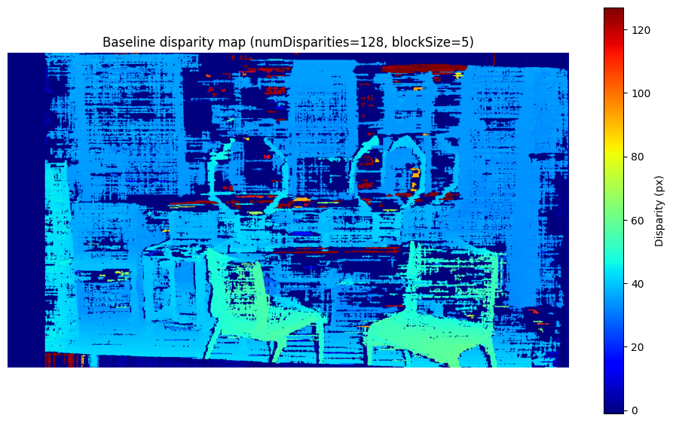

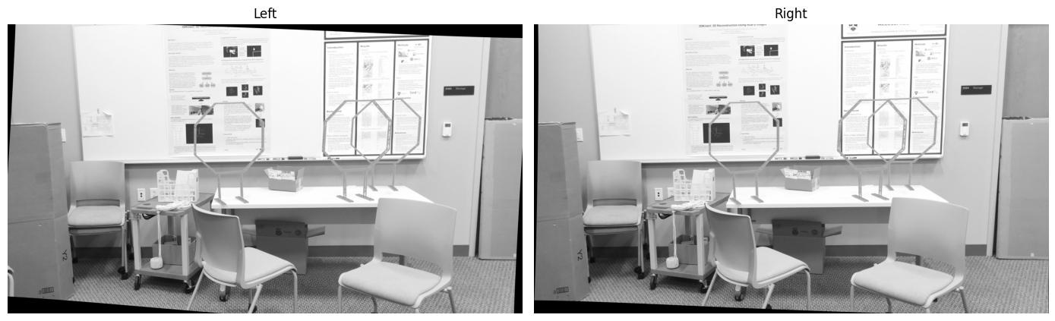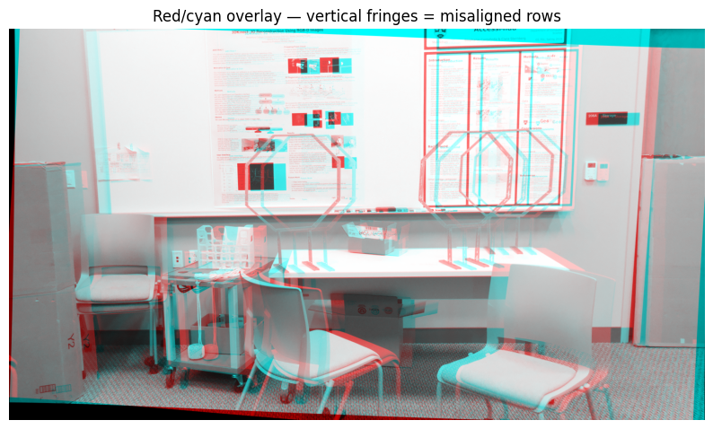

Sweep numDisparities
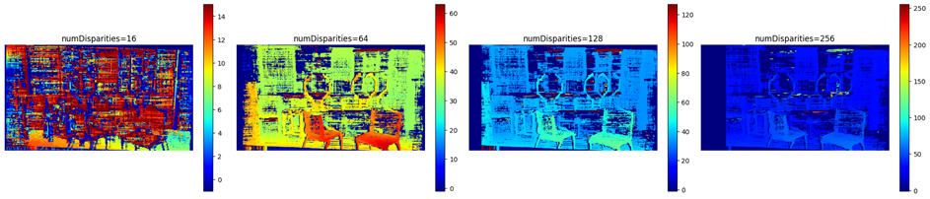
Block size
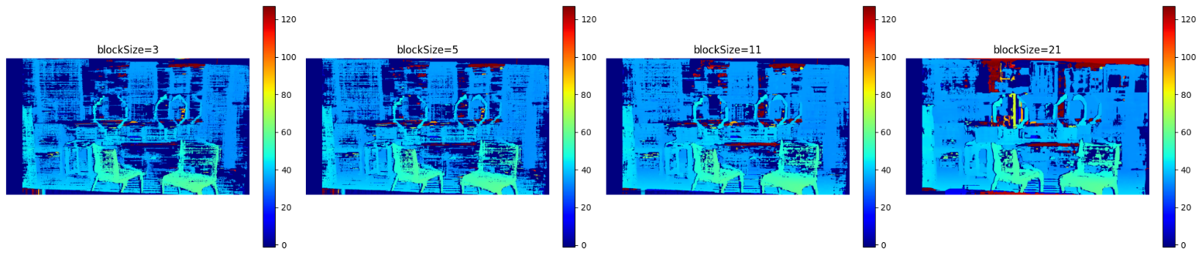
Mean disparity in near region: 24.36 px
Mean disparity in far region : 23.46 px
Expected: near > far because disparity is inversely proportional to depth.
Actual (near > far): True

Parameter effects
numDisparities extends the range of depths that can be matched. However, larger values add false matches in textureless regions and are more computationally expensive.
blockSize smooths the disparity map and reduces noise but it also blurs depth edges and can hide small nearby objects
what a proper stereo rig would fix
A properly built stereo rig uses two identical cameras rigidly mounted on a shared bar with a fixed, known baseline and synchronised shutters, so both views are captured at the same instant with matched exposure, focus, and white balance. Because the geometry between the cameras is fixed, the pair can be rectified using stereo calibration which eliminates vertical disparity and lets StereoSGBM search only horizontally. This removes vertical banding, reduces false matches, and produces a cleaner disparity map. Synchronised shutters also prevent temporal misalignment, so moving objects don't produce inconsistent disparities between the two views. Matched cameras with identical lenses and settings further minimise photometric differences, improving matching reliability in textureless regions.

