Task 1: Template matching and why it is not enough
The template matching experiment successfully detected the cropped face in the original image, achieving a very high matching score of 0.9995. However, when the same person's face appeared at a different viewing angle in the second image, the matching score decreased substantially to 0.4575 and the algorithm placed the bounding box at an incorrect location. This occurred because template matching compares the pixel-level appearance of the template with regions of the target image. Changing the viewing angle alters the appearance, shape, and relative positions of facial features, reducing the pixel-level similarity.

Template Matching Results
------------------------------
Original scene score: 0.9995
Changed scene score: 0.4575
Original match location: (821, 1095)
Changed match location: (2385, 1747)

Task 2. Viola-Jones face detection
A parameter study was conducted on the group photo by varying the scaleFactor (1.05, 1.1, 1.3) and minNeighbors (3, 5, 8). At a fine scale factor of 1.05 with minNeighbors 3 and 5, the detector produced seven detections, including some false positives. Increasing minNeighbors to 8 reduced false positives to 0 and yielded four accurate detections, but missing two faces. At 1.1 scale factor, detection reduced with increase in minNeighbors and at 1.3 scale factor, detections fell sharply, with only two faces detected at the strictest settings. This demonstrates that a smaller scale factor improves sensitivity but increases computation and false positives, while a larger scale factor speeds up detection but sacrifices accuracy. Similarly, a low minNeighbors threshold makes the detector permissive, while a high threshold reduces false positives but misses faint or partially visible faces.
Parameter Study
scaleFactor minNeighbors Detections
0 1.05 3 7
1 1.05 5 6
2 1.05 8 4
3 1.10 3 4
4 1.10 5 3
5 1.10 8 2
6 1.30 3 2
7 1.30 5 2
8 1.30 8 2
scale_1.05_neighbors_3.jpg: 7 detections
scale_1.05_neighbors_5.jpg: 6 detections
scale_1.05_neighbors_8.jpg: 4 detections
scale_1.1_neighbors_3.jpg: 4 detections
scale_1.1_neighbors_5.jpg: 3 detections
scale_1.1_neighbors_8.jpg: 2 detections
scale_1.3_neighbors_3.jpg: 2 detections
scale_1.3_neighbors_5.jpg: 2 detections
scale_1.3_neighbors_8.jpg: 2 detections

In the video experiment, 429 frames were analyzed, yielding 139 total face detections. This corresponds to an average of 0.32 faces per frame, with a maximum of two faces detected in any single frame. Notably, 298 frames contained no detections at all, highlighting the inconsistency of the method under motion, scale, and angle variations. The annotated output was saved as annotated_group_video.mp4.
VIDEO DETECTION RESULTS
===================================
Total frames processed: 429
Total face detections: 139
Average faces per frame: 0.32
Minimum faces in a frame: 0
Maximum faces in a frame: 2
Frames with no detection: 298
Video FPS: 29.94
Output video: annotated_group_video.mp4

Task 3. Matching with the ratio test
YOLO Detection Results
Running pretrained YOLOv8n on the group photo (person class) produced 8 detections at low confidence thresholds (0.1, 0.25, 0.5), dropping to 6 detections at 0.75. This shows that lowering the confidence threshold increases sensitivity, allowing weaker predictions to count as detections, while higher thresholds filter out uncertain boxes. On the street video, YOLO processed 429 frames, producing 3338 detections in total, with an average of 7.78 detections per frame. The minimum detections per frame were 3, and the maximum reached 16. The annotated output was saved as video/yolo_video.mp4.
Non-Maximum Suppression (NMS)
YOLO generates multiple overlapping bounding boxes for the same object. Non-Maximum Suppression resolves this by keeping the highest-confidence box and discarding others with high overlap (IoU above a threshold). This ensures that each person is represented by a single bounding box instead of clusters of duplicates. Without NMS, the raw output would show many overlapping boxes around the same face or body; with NMS applied, only the most confident box remains, producing cleaner and more interpretable results.
Speed and Robustness Comparison
On the video, Viola–Jones Haar required an average of 410.18 ms per frame, while YOLOv8n averaged 280.99 ms per frame on CPU. Despite being a deeper model, YOLO was faster and more efficient. Robustness was also superior: YOLO handled occlusion, angled views, and lighting changes far better than Haar cascades, which frequently missed faces or produced false positives. YOLO’s convolutional backbone and learned features allow it to generalize across varied conditions, whereas Haar features are brittle under anything but frontal, well-lit faces.

Task 4. Your first vision app
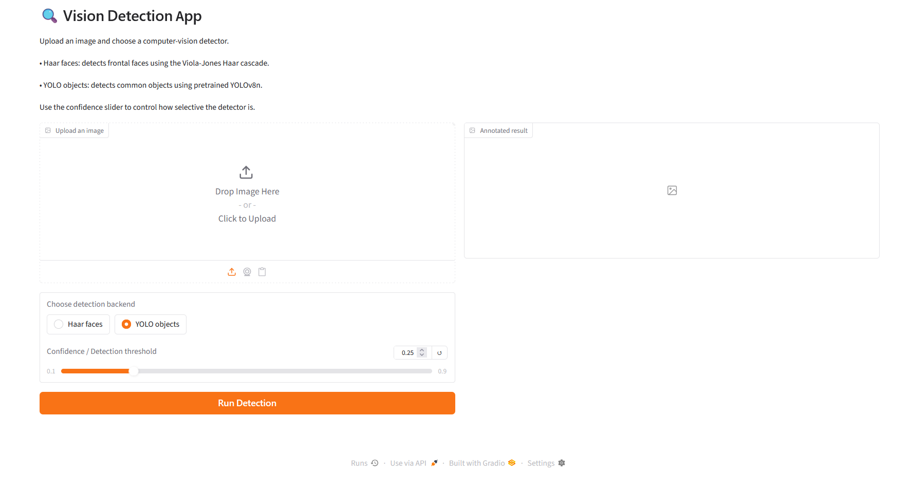
Task 5. Ethics reflection
A concrete risk of deploying a face-detection system in Zambia would be its use for CCTV surveillance in public places such as Lusaka. Although a face detector only identifies regions that appear to contain faces, widespread deployment could enable people to be monitored without their knowledge or meaningful consent. For example, a system installed in a public area could repeatedly detect and record individuals as they move through the area. This creates privacy concerns and could lead to surveillance being used for purposes beyond the original reason for collecting the images.
The safeguard I would insist on is informed consent and clear limits on how collected images can be used. For an attendance-monitoring system, for example, people should be informed that facial detection is being used, why it is necessary, what data is collected, how long it will be retained, and who can access it. Where possible, a non-biometric alternative should also be available. These safeguards help ensure that computer vision is used responsibly while reducing privacy risks and potential demographic bias. For my group photograph, however, no consent was obtained to use the images for this academic practical.

