Malaria Cell Classification Using Deep Learning
This project developed an image classification system to distinguish between parasitized and uninfected blood cells using deep learning. A pretrained ResNet-50 model was adapted through transfer learning. The classifier head was first trained and then the final convolution layer was fine-tuned to improve its ability to identify patterns relevant to the two classes. The dataset consisted of 1,400 images divided into training (1,000), validation (200), and testing (200) sets. The model was evaluated using accuracy, precision, recall, F1-score, and a confusion matrix. Further, a gradio web interface was developed to allow users to upload cell images and view the predicted class and confidence score. The project demonstrates how computer vision can be applied to medical image classification, although the system is experimental and is not intended to replace professional malaria testing or diagnosis.
Below are the necessary graphs and the confusion matrix:
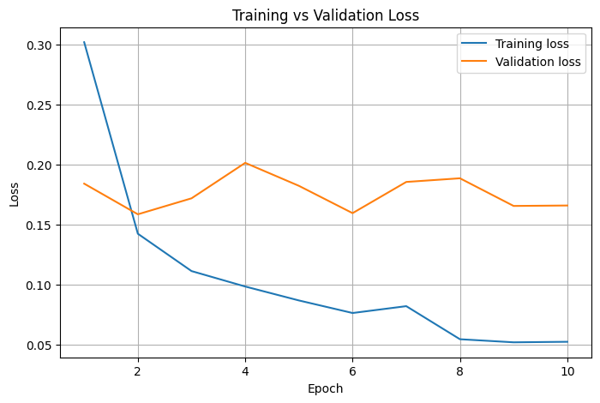
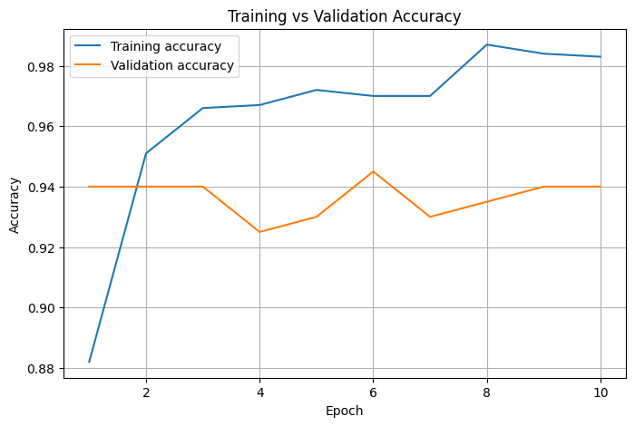

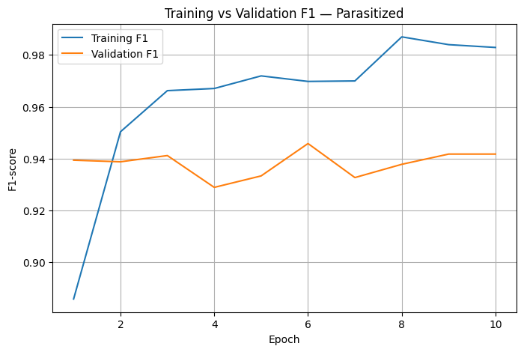

Best checkpoint epoch: 6

Test accuracy: 0.9700
Test precision (Parasitized): 0.9700
Test recall (Parasitized): 0.9700
Test F1-score (Parasitized): 0.9700

Detailed classification report:
precision recall f1-score support

Parasitized 0.9700 0.9700 0.9700 100
Uninfected 0.9700 0.9700 0.9700 100

accuracy 0.9700 200
macro avg 0.9700 0.9700 0.9700 200
weighted avg 0.9700 0.9700 0.9700 200

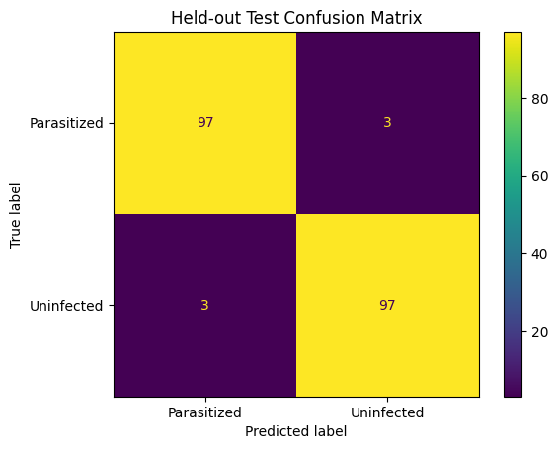

Huggingface link
https://huggingface.co/spaces/kbesa/Malaria-Cell-Classifier

