Task 1. Thresholding, honestly evaluated
Global IoU: 0.406
Otsu IoU: 0.568
Adaptive Mean IoU: 0.563
Adaptive Gaussian IoU: 0.403

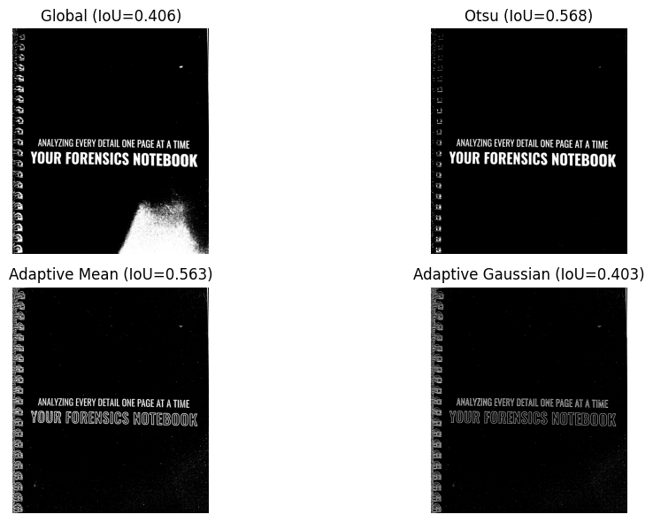
why adaptive wins (or doesn’t) on this image
While it didn't win, Adaptive Mean (0.563) performed nearly identical to Otsu (0.568) because it successfully defended against the dark shadow/artifact at the bottom-right of the document—an area that completely broke standard Global thresholding (0.406). It did not win because the lighting gradient across the page was not severe enough. Hence Otsu's method outperformed it.

Task 2. Watershed for touching objects
The count of coins is 3 tomatoes out of a manual count of 4 tomatoes.
Looking at the coloured labels, the watershed fails on the third tomato. It splits it and merges it in the second and fourth tomato. This is because the third tomato blocks the neighbouring's inner edges, destroying the visual boundary between them. In the binary mask, the three tomatoes fuse into one continuous blob. Because the side tomatoes still have clear, unobstructed outer edges, their distance-transform peaks remain strong. However, the middle tomato's peak acts as a bridge between them. When the watershed floods from the side tomatoes' seeds, there is no edge or valley to stop the flood from spilling across the middle tomato. As a result, the left and right tomatoes "invade" the middle one, splitting its pixels between them.

Task 3. GrabCut
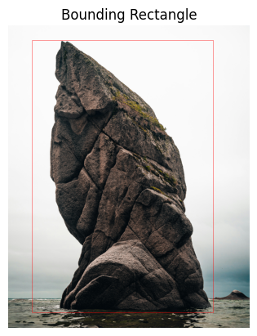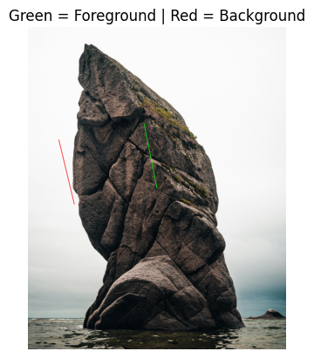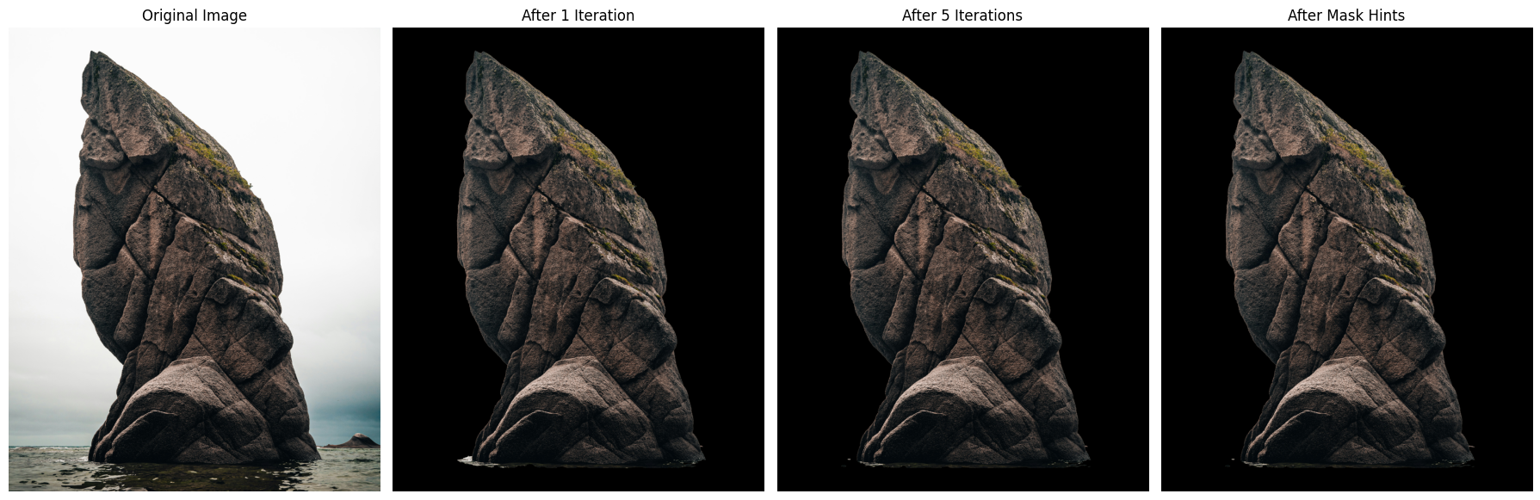
The GrabCut algorithm iteratively models the foreground and background colour distributions using Gaussian Mixture Models (GMMs) to estimate which pixels belong to the subject and which belong to the background. It then uses graph cuts (min-cut/max-flow) to refine the segmentation by minimizing an energy function based on pixel colour similarities and neighbouring pixel relationships, while respecting definite foreground and background mask hints.
Task 4. Deep segmentation, semantic vs instance
Selected device: cuda
Downloading: "https://download.pytorch.org/models/deeplabv3_resnet50_coco-cd0a2569.pth" to /root/.cache/torch/hub/checkpoints/deeplabv3_resnet50_coco-cd0a2569.pth
100%|██████████| 161M/161M [00:01<00:00, 131MB/s]
Downloading: "https://download.pytorch.org/models/maskrcnn_resnet50_fpn_coco-bf2d0c1e.pth" to /root/.cache/torch/hub/checkpoints/maskrcnn_resnet50_fpn_coco-bf2d0c1e.pth
100%|██████████| 170M/170M [00:00<00:00, 187MB/s]
Processing: /content/drive/My Drive/colab/CSC6502 - Computer Vision/cv_practical_work/csc6502-prac5-CHIPOMPO/images/street_scene.jpg
Image dimensions: (481, 640)
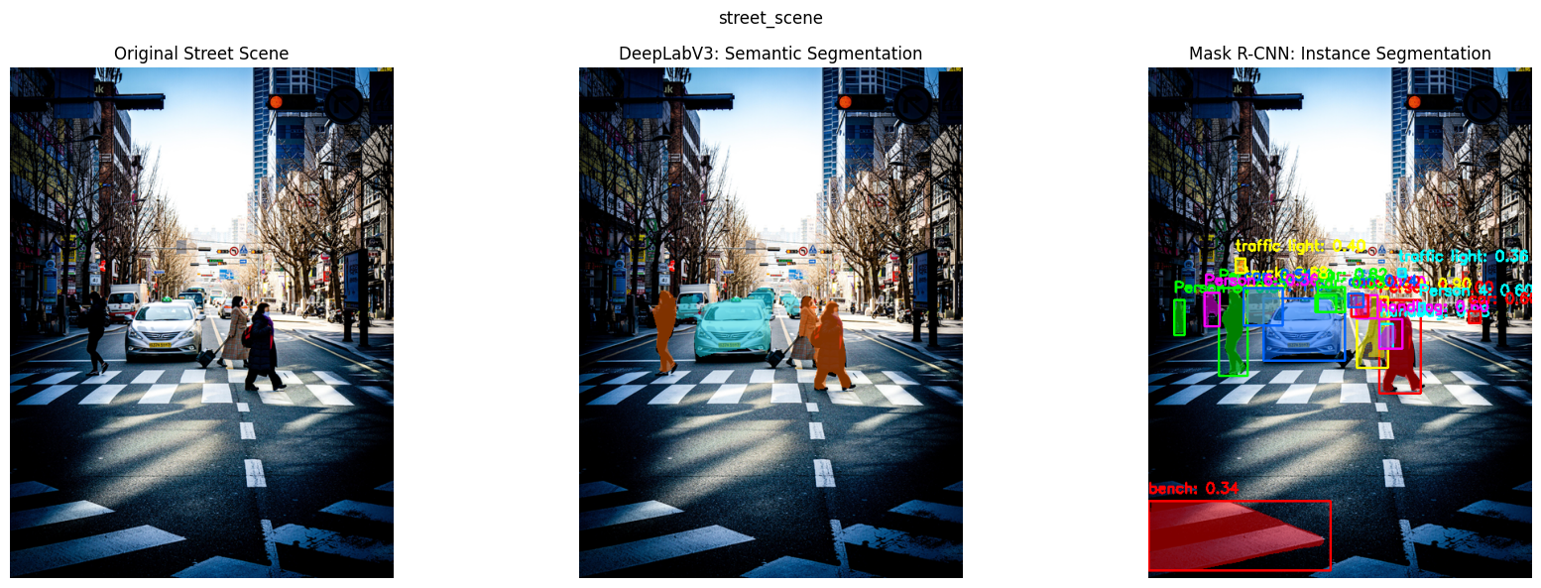CPU INFERENCE TIME: street_scene
DeepLabV3: 5.033 seconds
Mask R-CNN: 2.077 seconds

Processing: /content/drive/My Drive/colab/CSC6502 - Computer Vision/cv_practical_work/csc6502-prac5-CHIPOMPO/images/people_walking.jpg
Image dimensions: (640, 359)
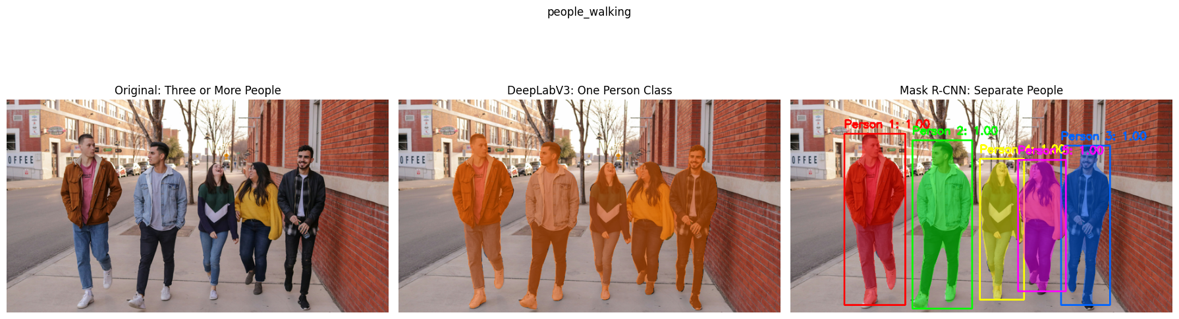SEMANTIC VS INSTANCE SEGMENTATION
DeepLabV3: All detected people share the same semantic class ('person').
Mask R-CNN: 5 separate person instances detected.

CPU INFERENCE TIME: people_walking
DeepLabV3: 8.378 seconds
Mask R-CNN: 1.839 seconds

PER-IMAGE CPU INFERENCE TIME COMPARISON
Image DeepLabV3 CPU (seconds) Mask R-CNN CPU (seconds) People Detected
street_scene 5.033 2.077 6
people_walking 8.378 1.839 5

Results saved to: task4_output/segmentation_results

DeepLabV3’s encoder-decoder structure to the U-Net
DeepLabV3 and U-Net both use the encoder-decoder concept for image segmentation. The encoder extracts important features from an image and the decoder or upsampling stage produces a pixel-level segmentation map.
U-Net uses skip connections to combine low-level spatial details with high-level features, resulting in preservation of object boundaries. In contrast, DeepLabV3 uses Atrous Spatial Pyramid Pooling (ASPP) to capture features at multiple scales and then upsamples its predictions, without U-Net's symmetrical decoder structure.
Task 5. Deploy a segmentation studio
[huggingface deployment Url](https://huggingface.co/spaces/kbesa/image-segmentation-lab)
Note: I was unable to run it in huggingface as gradio apps needed a paid up plan. But I tested it with googlecolab

