Task 1: Harris corners from scratch

Comparison table
Image Detector Points Time (ms)
--------------------------------------------------------------
Checkerboard Harris 54 13.23
Checkerboard Shi-Tomasi 56 10.83
Checkerboard FAST 8 1.73
Natural Image Harris 2000 10.00
Natural Image Shi-Tomasi 1385 10.09
Natural Image FAST 14280 6.97
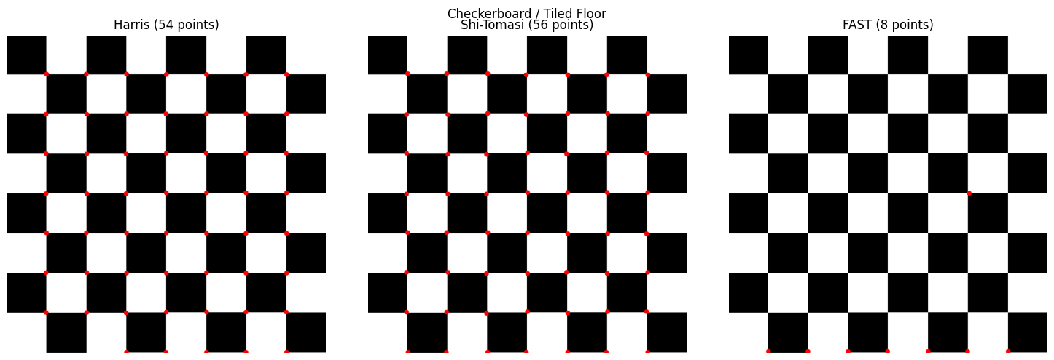
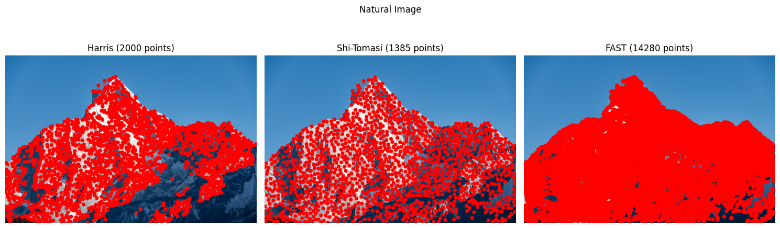

Paragraph
The three feature detectors were evaluated on a checkerboard image and a natural mountain image. On the checkerboard, Harris and Shi-Tomasi produced very similar results, detecting 54 and 56 points respectively. This is expected because both methods identify locations with strong intensity changes in two directions, particularly at the intersections of the checkerboard squares. FAST detected only 8 points, but was considerably faster, taking 1.73 ms compared with 13.23 ms for Harris and 10.83 ms for Shi-Tomasi.
On the natural mountain image, the detectors produced more varied results. Harris detected 2,000 points, Shi-Tomasi detected 1,385 points, and FAST detected 14,280 points. The larger number of features in the natural image is due to the presence of intensity and texture variations such as mountain edges, and rocky regions. FAST produced by far the largest number of points because it responds to many local intensity patterns, while Harris and Shi-Tomasi are more selective. In terms of speed, FAST was again the fastest at 6.97 ms, followed by Harris at 10.00 ms and Shi-Tomasi at 10.09 ms. Overall, Harris and Shi-Tomasi produced relatively selective and comparable corner detections, whereas FAST provided many more features at a significantly lower computational cost.

Task 2. Descriptors and an invariance experiment
Detector Transform Repeatability (%)
ORB Rotate 30° 61.85
ORB Rotate 90° 41.05
ORB Scale 0.5× 27.10
SIFT Rotate 30° 70.15
SIFT Rotate 90° 54.85
SIFT Scale 0.5× 46.40

Explanation
For the mountain image, SIFT achieved higher repeatability than ORB for all three transformations. Under a 30° rotation, ORB achieved 61.85% repeatability compared with 70.15% for SIFT. For a 90° rotation, the repeatability decreased to 41.05% for ORB and 54.85% for SIFT. Under 0.5× scaling, ORB achieved 27.10%, whereas SIFT achieved 46.40%.
The higher performance of SIFT is consistent with how the two methods achieve invariance. SIFT is designed to provide strong scale and rotation invariance. It detects features across multiple scales using a scale-space representation and assigns a dominant orientation to each keypoint based on local image gradients. This allows corresponding features to be detected and described even when the image is rotated or resized. ORB also provides rotation invariance by estimating the orientation of FAST keypoints and using an orientation-aware BRIEF descriptor. However, its scale invariance is more limited because it relies on an image pyramid rather than SIFT's scale-space approach. This is particularly evident in the 0.5× experiment, where SIFT outperformed ORB by 19.30 percentage points.

Task 3. Matching with the ratio test
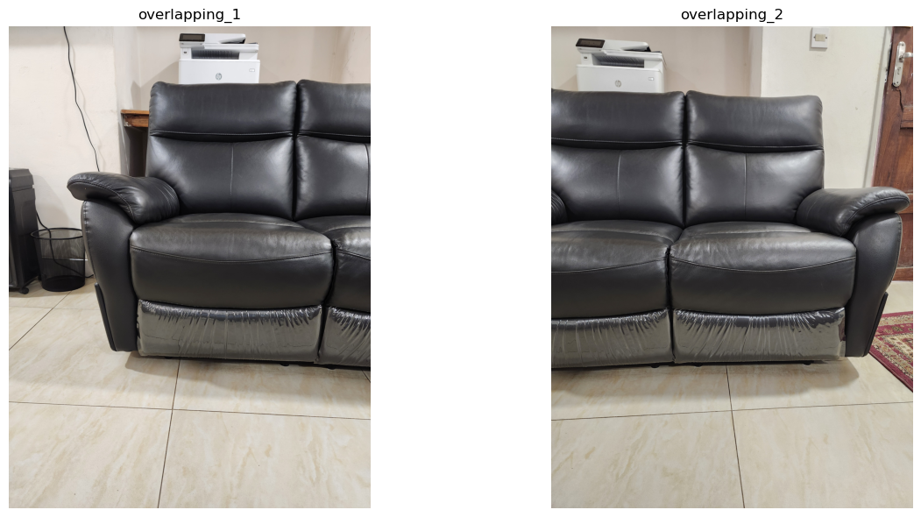
Image 1 keypoints: 2001
Image 2 keypoints: 2000

Raw nearest-neighbour matches: 2001

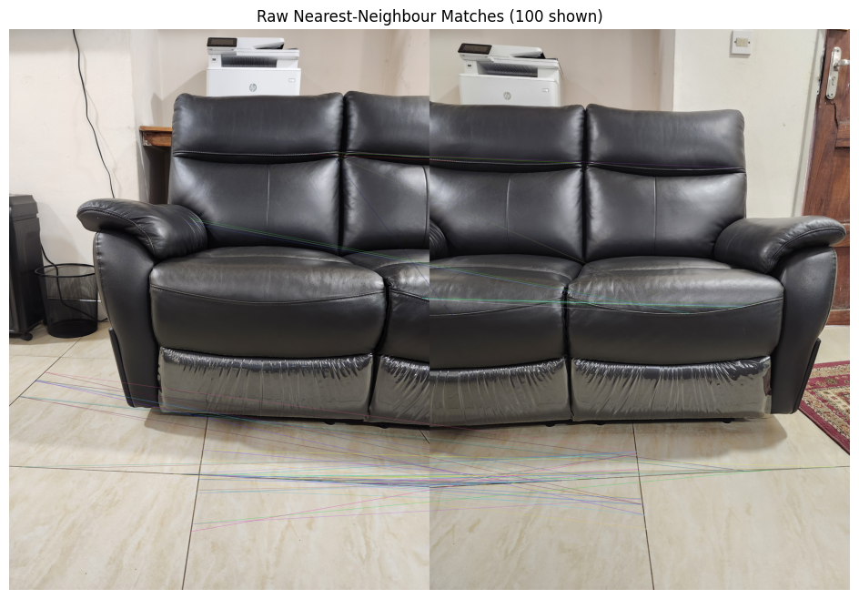
Ratio Test Results
Ratio Matches Time (ms)
0.60 9 77.90
0.75 39 73.91
0.90 286 76.27

Raw nearest-neighbour matching produced, 2001 matches, essentially one for every keypoint. However, most of the matches were incorrect, leading to a cluttered and unreliable set of connections. This means the matching process was noisy.
Lowe’s ratio test introduced a way to filter matches by comparing the distance of the best match to the second-best. This method effectively reduced false positives by ensuring that only strong, unambiguous matches were retained.
At a low ratio threshold of 0.60, the test was very strict with only 9 matches survive, but they were highly reliable. This setting is useful when precision is more important than quantity. At a moderate threshold of 0.75, 39 matches remained, which provided enough correspondences while still filtering out most false matches. At a high threshold of 0.90, 286 matches passed. While this yielded many correspondences, it also allowed weaker or ambiguous matches through, increasing the risk of noise.
Task 4. Panorama from a homography
Task 4 Results
========================================
Good matches: 39
RANSAC inliers: 10

Homography:
[[ 5.82308478e-01 2.01508397e-01 1.18913117e+03]
[-1.52379786e-01 9.56474136e-01 2.82763729e+00]
[-1.48132796e-04 1.58264264e-05 1.00000000e+00]]

Using the filtered matches from Task 3, a homography was estimated with cv2.findHomography(..., cv2.RANSAC). The RANSAC procedure identified 10 inliers, which represent geometrically consistent correspondences between the two overlapping images. This homography was then applied with cv2.warpPerspective to warp one image into the coordinate frame of the other.
For compositing, a simple overwrite blending strategy was used directly overlaying the warped image onto the base image. This producing a panorama without additional smoothing.
The final panorama successfully aligns the two input images, extending the field of view. Despite the relatively small inlier count (10), the homography was robust enough to produce a relatively coherent stitched result.
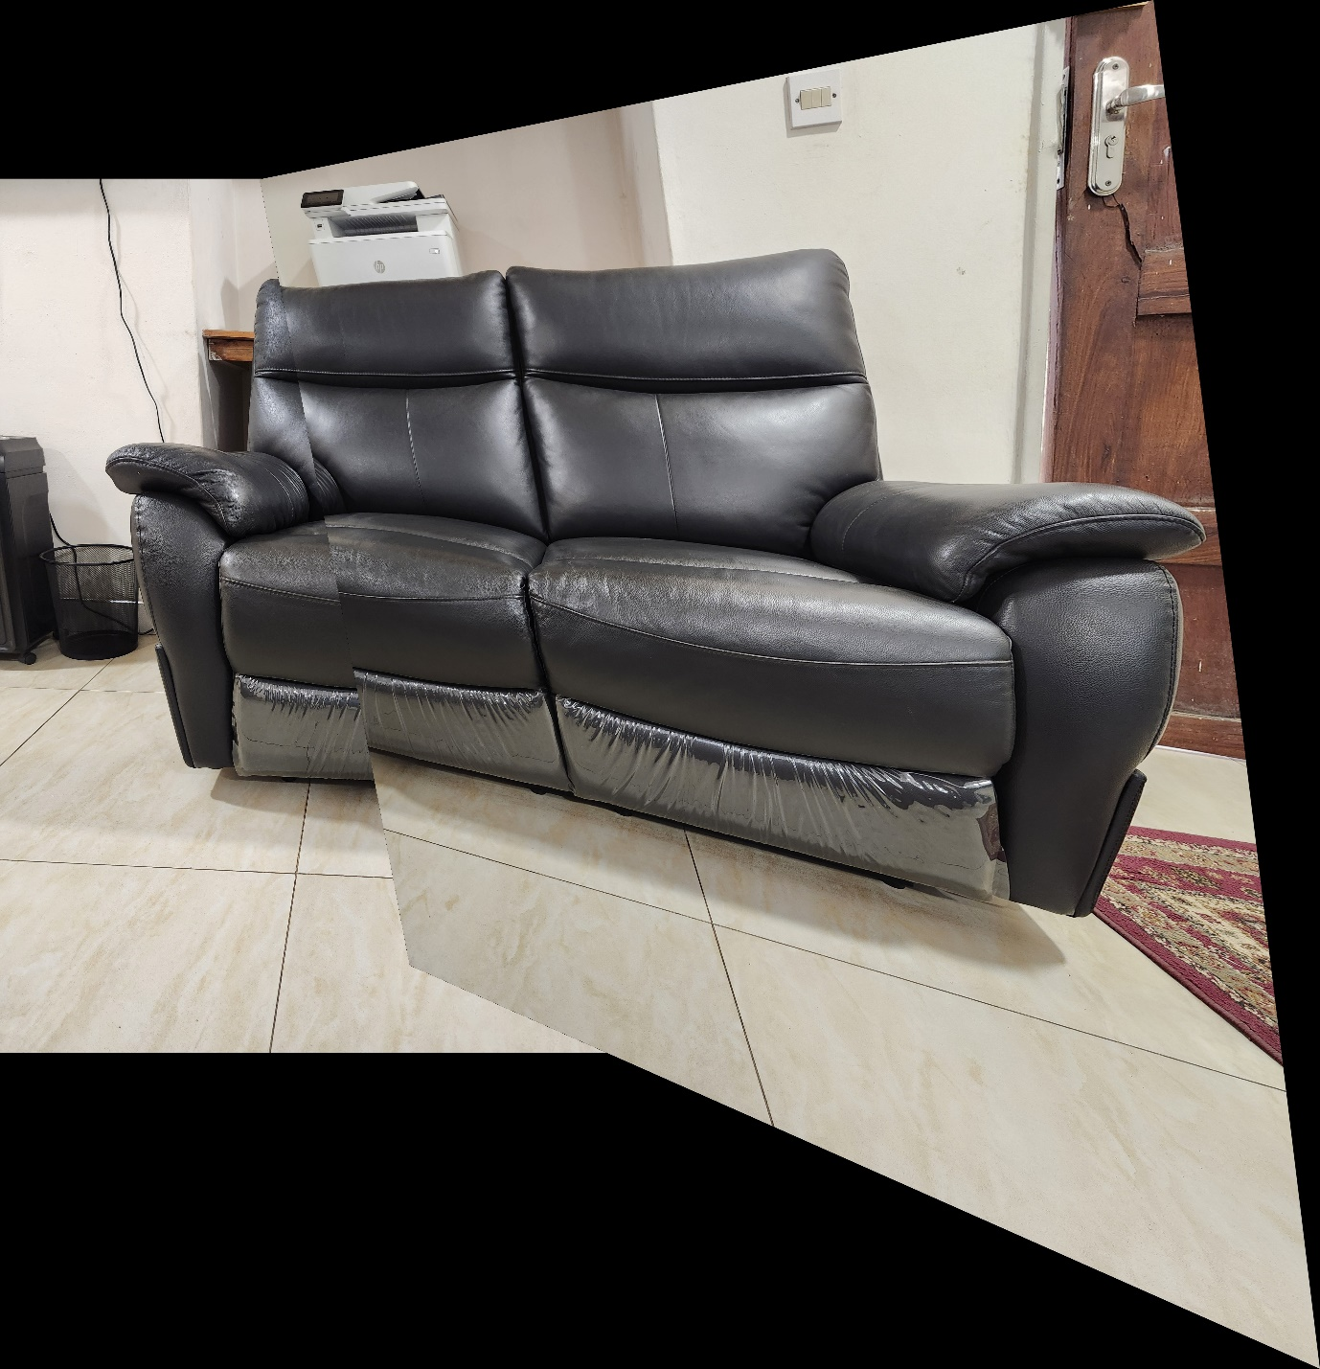
Task 5. Robustness study
Degraded image results
========================================
Good matches: 38
RANSAC inliers: 7

Original RANSAC inliers: 10
Degraded RANSAC inliers: 7
Change in inliers: -3

Inlier decrease: 30.00%

When one image was degraded, the number of RANSAC inliers dropped from 10 to 7. This reduction shows that feature matching becomes less reliable under image degradation, as fewer consistent correspondences survive the geometric verification step.
After the 30% decrease in inliers, the panorama still survived some degradation.
