Name: Krishnacharan Bhola

Batch**:** T8

PRN**:** 2020BTECS00102

**Assignment No. 12**

**Spatial and Geographic Data**

**Geospatial is the natural domain for Graph Database**

**Use Neo4j and Neo4j Spatial**

**Problem Statement : Finding Things Close to Other Things.**

Application in : location-based services on the web

Task :

1. Use Neo4j graph database installed in previous assignments.

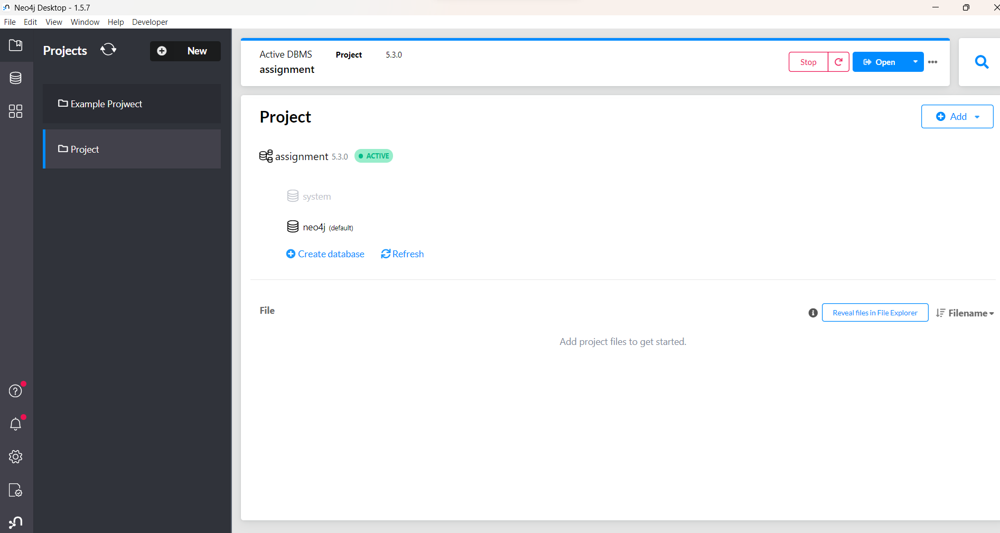

1. Install/configure Neo4jSpatial [(https://github.com/neo4jcontrib/spatial)](https://github.com/neo4j-contrib/spatial) from GitHub. It is the Neo4j plug-in that facilitates geospatial operations on data stored in Neo4j.

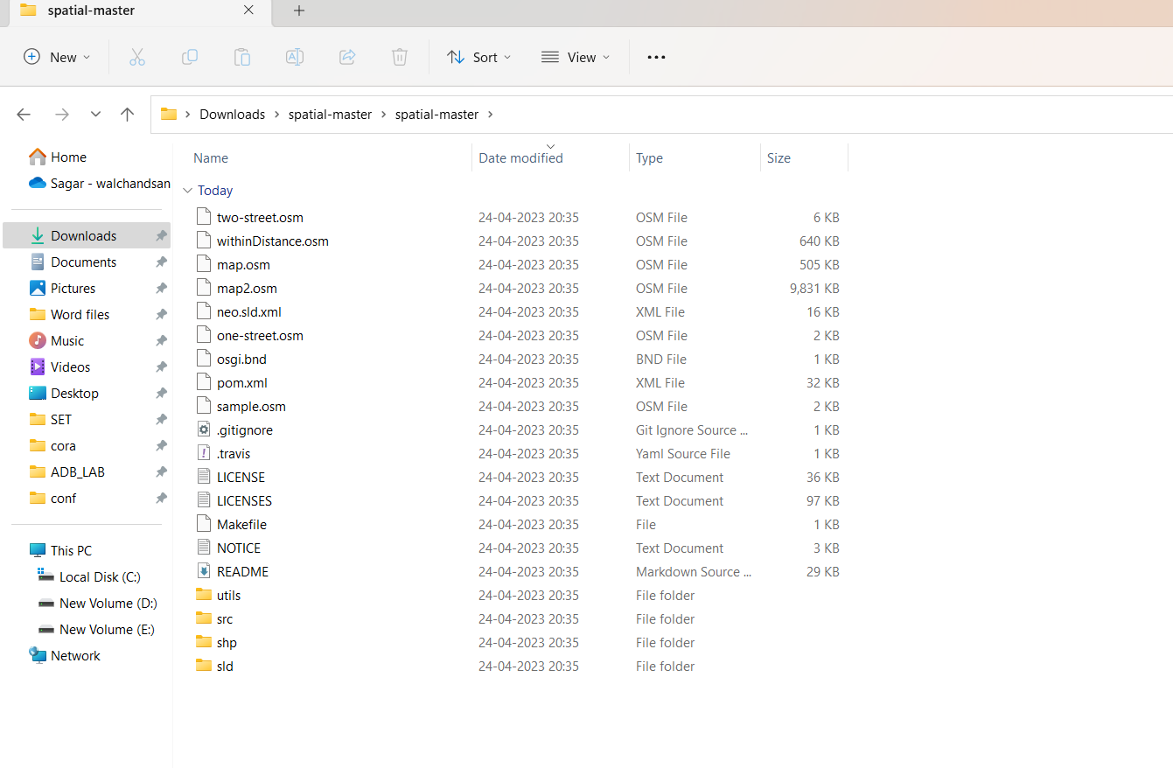

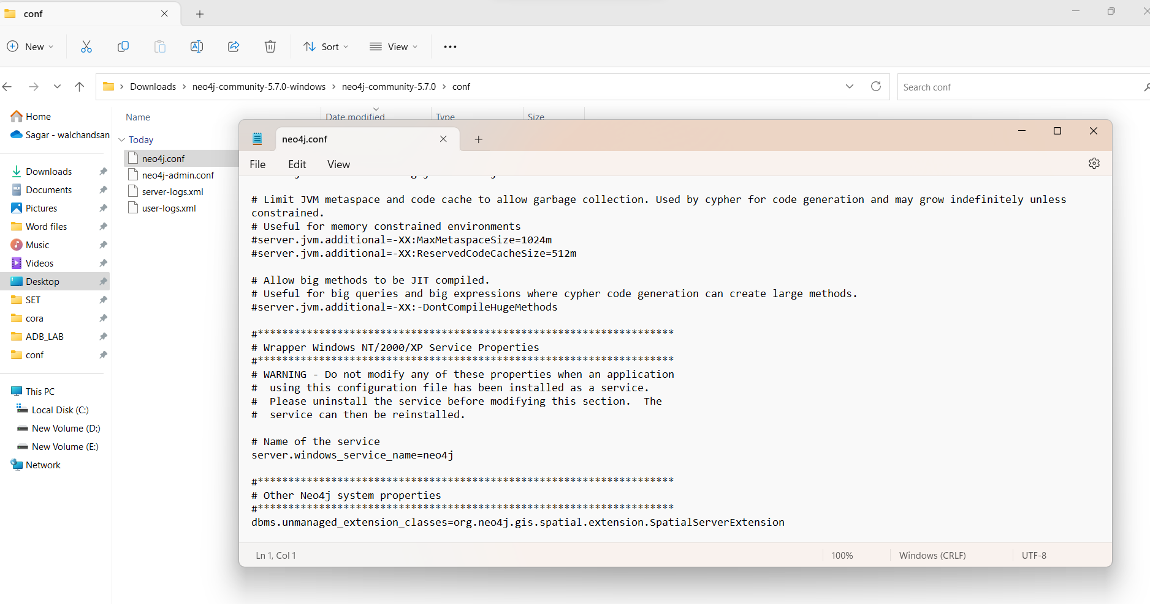

1. Write CQL (Cypher Query Language) script to add randomly 10,000 location points as follows. Assume any data.

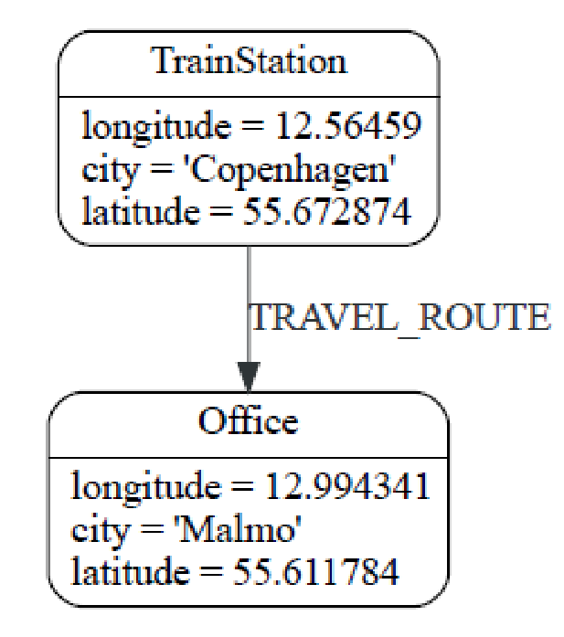

Cypher script :

// Create 10,000 Train Station nodes

UNWIND range(1, 10000) AS i CREATE (:TrainStation {location: point({latitude: 55.672874 + rand()*0.5, longitude: 12.56459 + rand()*0.5}), city: 'Copenhagen'});

// Create 10,000 Office nodes

UNWIND range(1, 10000) AS i CREATE (:Office {location: point({latitude: 55.611784 + rand()*0.5, longitude: 12.994341 + rand()*0.5}), city: 'Malmo'});

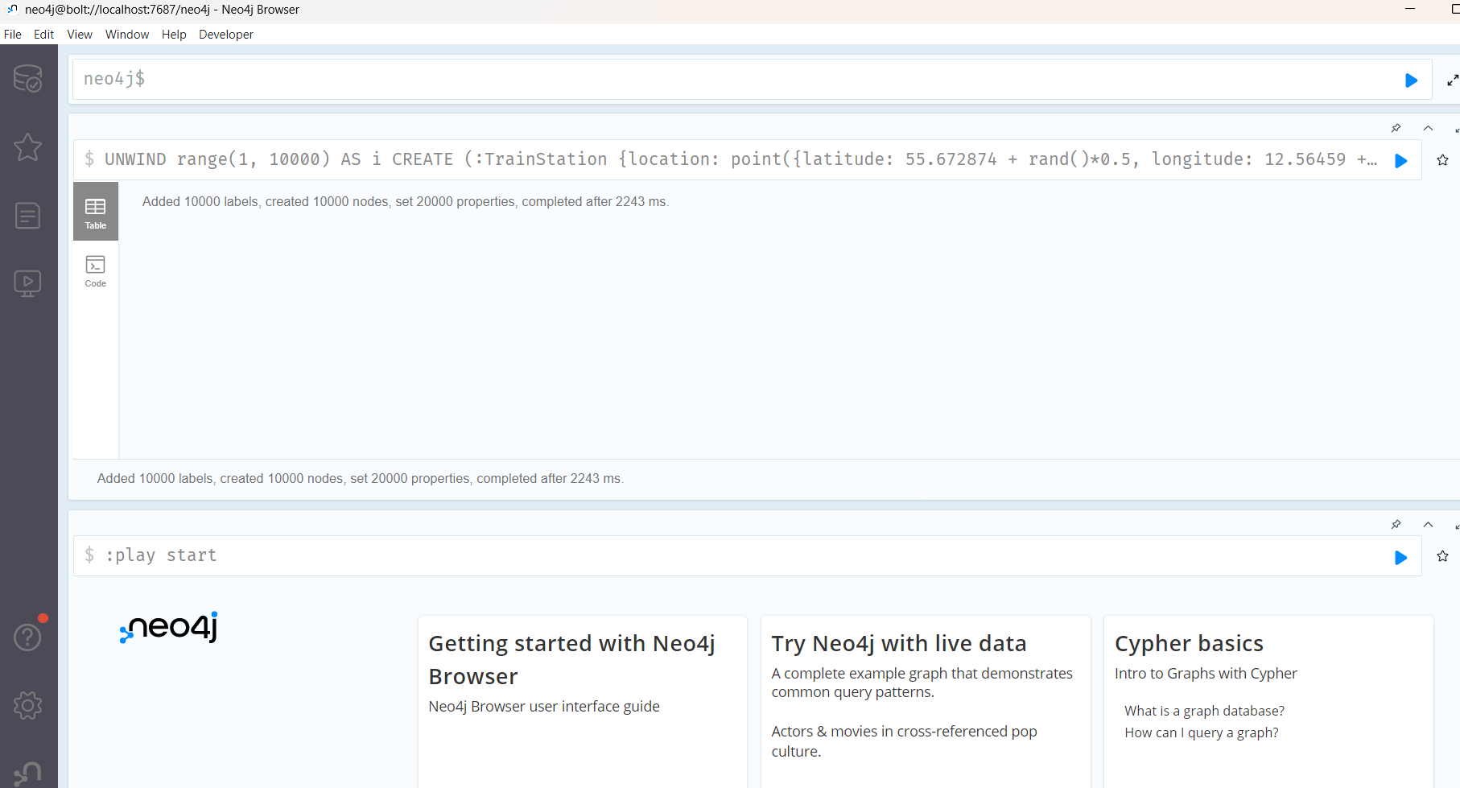

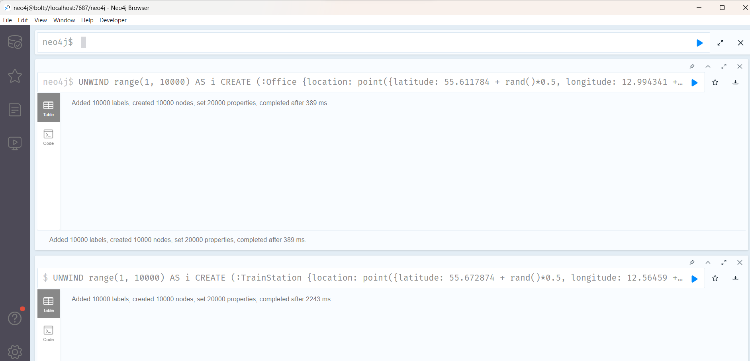

1. Use the point() , distance() function of Neo4j to answer the queries “***which things close/nearest to which other things***”.
2. Demonstrate the result by firing different cypher queries (write CQL statement).
3. Find the nearest train station to each office in Malmo:

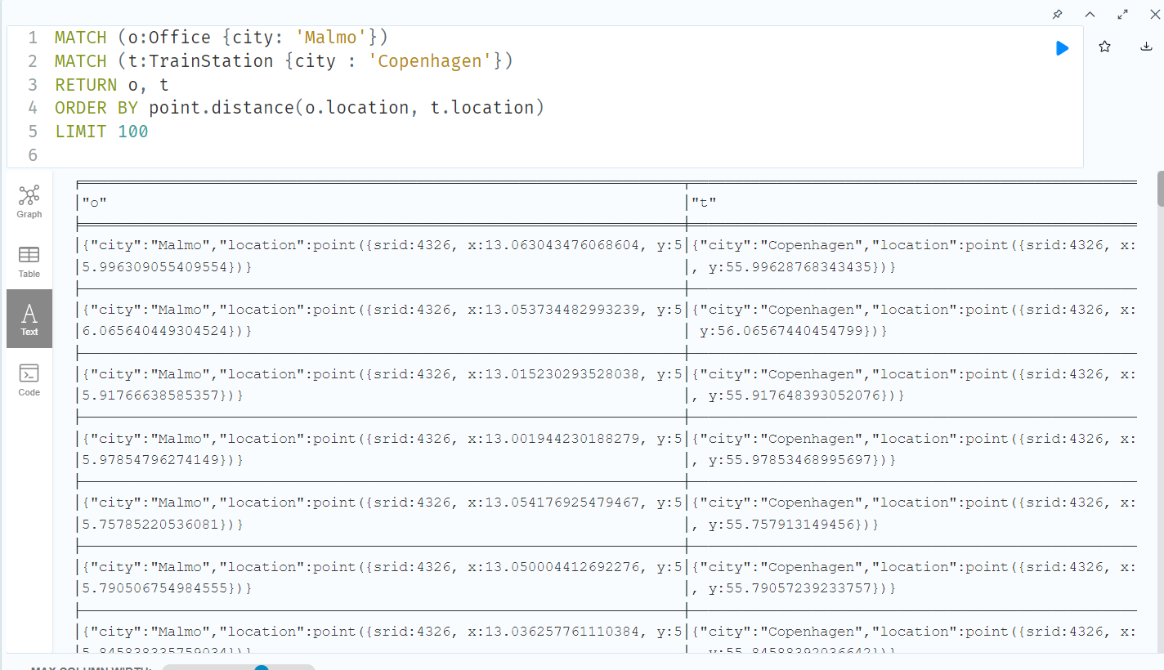

2. Find the closest Office to each Train Station in Copenhagen:

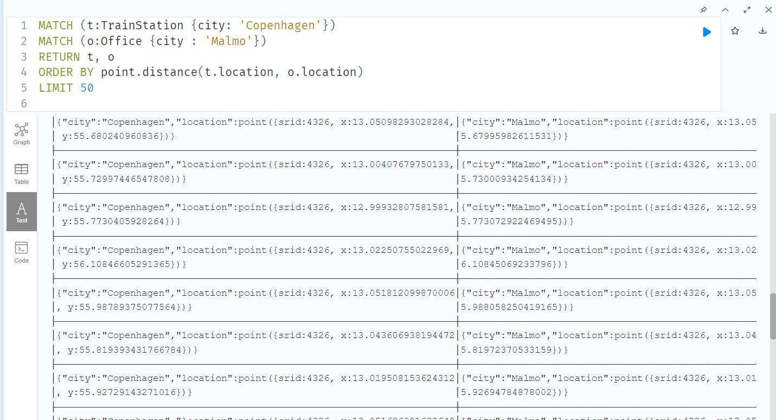

1. Find the closest Office to each other Office in Malmo.

