CS 5593 – Team Project:
Checkpoint 1: First Results and Plan Revision
Steps we have to go through to meet with our checkpoint.
Step 1: Load and inspect the dataset
We load IBM Telco Customer datasets and verify numbers of records, missing values and churn distributions.
Step 2: Clean and prepare the data
We convert total charges to numeric values, handles missing entries, encode categorical variables and create early-tenure indicators.
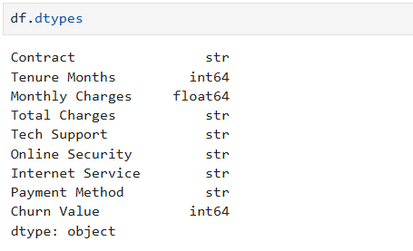
Step 3: Perform exploration data analysis (EDA)
We compare churn rates. We do analysis by tenure group, contract type, monthly-charge range, technical support, and online security. We use Logistic and decision tree classification , estimate the relationship between churn and the selected account characteristics. Report coefficients, odds ratios, and model performance.
Step 4: produce Preliminary results
We train logistic regression baseline and a decision tree. We compare their performance and extract interpretable high risk customer rules,

Our first proposal planned to use IBM Telco Customer Churn dataset to Identify behavioral patterns associated with early customer churn, do data processing, proper analysis, apply logistic regression and then interpretable decision tree method. At checkpoint 1, the project focused on completing all the steps mentioned above like cleaning datasets, doing analysis, producing results, doing comparison and model development.

We make this workflow diagram to connect all theses steps together.
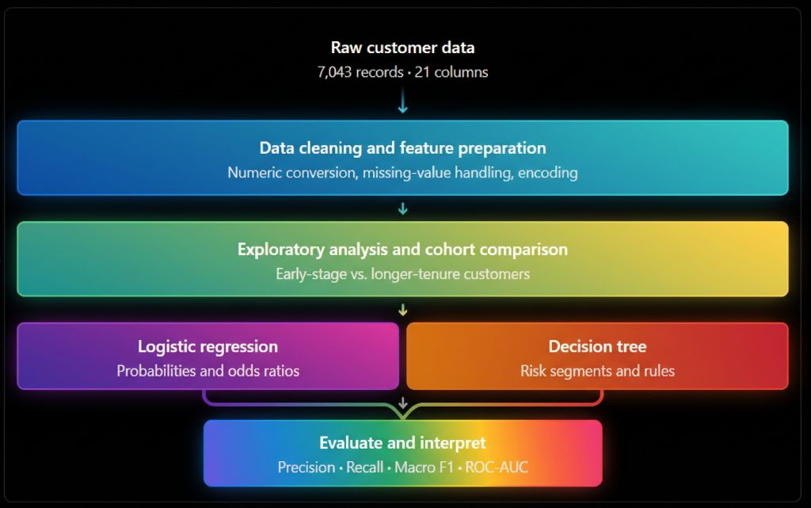
Limitation: The dataset does not contain a sequence of monthly customer data that represent how behavior changes before churn. The churn label indicates whether a customer left within the last month, while tenure explains their recorded length of service. Therefore, our analysis can identify associations with churn and develop a preliminary classification model, but it cannot establish exactly when a customer will leave in the future.
Revised Research Question: Which customer, contract, billing, and service-related characteristics are associated with churn among early-tenure subscribers, and how effectively can interpretable classification models identify high-risk customer segments?

checkpoint 1
Dataset inspection
1.Verify row count, columns, missing values, and churn distribution.
2.Preprocessing
Clean TotalCharges, encode features, and define the early-stage cohort.
3.Exploratory analysis
Produce group-level churn rates and at least one meaningful chart.
4. Preliminary modeling
Train and evaluate models if completed; otherwise state what remains.
5. Result artifacts
Include actual tables, charts, statistics, and model metrics where available.
6.Interpretation
Explain patterns, connection to the hypothesis, and uncertainty.
7.Next-stage plan
Describe model improvements, validation, and the remaining work.

